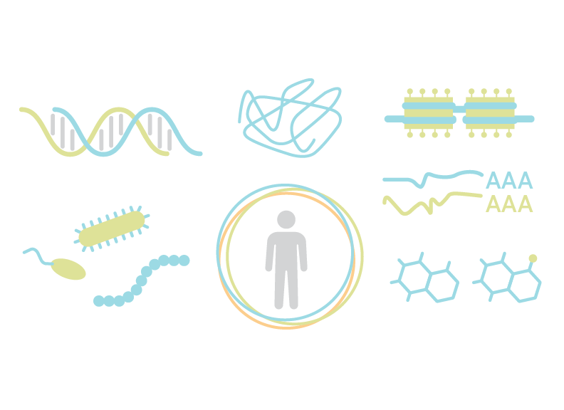
Multi-omics Boot Camp
Analysis of Omics Data for Research Studies

Day 1: Wednesday June 22, 2022

8:45 – 9:00 PT  11:45 – 12:00 ET | Login to Zoom
9:00 – 9:45 PT  12:00 – 12:45 ET | Welcome and Introduction | David Conti, PhD
9:45 – 10:00 PT  12:45 – 1:00 ET | Break / One-on-one questions
10:00 – 11:00 PT  1:00 – 2:00 ET | Session 1. Introduction to Observational Studies and Omic Data (Lecture) | David Conti, PhD  TA: Yinqi Zhao
11:00 – 11:15 PT  2:00 – 2:15 ET | Break / One-on-one questions
11:15 – 12:00 PT  2:15 – 3:00 ET | Session 2. Interaction (Lecture) | William Gauderman, PhD  TA: Yinqi Zhao
12:00 – 1:00 PT  3:00 – 4:00 ET | Networking Meal Break
1:00 – 1:45 PT  4:00 – 4:45 ET | Session 3. Interaction (Lab) | William Gauderman, PhD  TA: Yinqi Zhao
1:45 – 2:00 PT  4:45 – 5:00 ET | Break / One-on-one questions
2:00 – 3:00 PT  5:00 – 6:00 ET | Session 4. Advanced Interactions (Lecture/Lab) | Juan Pablo Lewinger, PhD  TA: Yinqi Zhao
3:00 – 3:15 PT  6:00 – 6:15 ET | Questions and Day 1 Wrap Up

Multi-omics Boot Camp
Analysis of Omics Data for Research Studies

Day 2: Thursday June 23, 2022

8:45 – 9:00 PT  11:45 – 12:00 ET | Login to Zoom
9:00 – 9:45 PT  12:00 – 12:45 ET | Session 5. Polygenic Analyses and Summary Statistics (Lecture) | Nicholas Mancuso, PhD  TA: Zeyun Lu
9:45 – 10:00 PT  12:45 – 1:00 ET | Break / One-on-one questions
10:00 – 10:45 PT  1:00 – 1:45 ET | Session 6. Polygenic Analyses and Summary Statistics (Lab) | Nicholas Mancuso, PhD  TA: Zeyun Lu
10:45 – 11:00 PT  1:45 – 2:00 ET | Break / One-on-one questions
11:00 - 12:00 PT  2:00 – 3:00 ET | Session 7. Advanced Polygenic analysis and Summary Statistics (Lecture/Lab) | Nicholas Mancuso, PhD  TA: Zeyun Lu
12:00 – 1:00 PT  3:00 – 4:00 ET | Networking Meal Break
1:00 – 1:45 PT  4:00 – 4:45 ET | Session 8. Clustering (Lecture) | Kimberly Siegmund, PhD  TA: Yinqi Zhao
1:45 – 2:00 PT  4:45 – 5:00 ET | Break / One-on-one questions
2:00 – 3:00 PT  5:00 – 6:00 ET | Session 9. Clustering (Lab) | Kimberly Siegmund, PhD  TA: Yinqi Zhao
3:00 – 3:15 PT  6:00 – 6:15 ET | Questions and Day 2 Wrap Up

Multi-omics Boot Camp
Analysis of Omics Data for Research Studies

Day 3: Friday June 24, 2022

8:45 – 9:00 PT  11:30 – 12:00 ET | Login to Zoom
9:00 – 10:00 PT  12:00 – 1:00 ET | Session 10. Advanced Clustering (Lecture/Lab) | Kimberly Siegmund, PhD  TA: Yinqi Zhao
10:00 – 10:15 PT  1:00 – 1:15 ET | Break / One-on-one questions
10:15 – 11:00 PT  1:15 – 2:00 ET | Session 11. Mediation/Latent Variable (Lecture) | David Conti, PhD  TA: Yinqi Zhao
11:00 – 11:15 PT  2:00 – 2:15 ET | Break / One-on-one questions
11:15 – 12:00 PT  2:15 – 3:00 ET | Session 12. Mediation/Latent Variable (Lab) | David Conti, PhD  TA: Yinqi Zhao
12:00 – 1:00 PT  3:00 – 4:00 ET | Networking Meal Break
1:00 – 2:00 PT  4:00 – 5:00 ET | Session 13. Advanced Mediation/Latent Variable (Lecture/Lab) | David Conti, PhD  TA: Yinqi Zhao
2:00 – 2:15 PT  5:00 – 5:15 ET | Break / One-on-one questions
2:15 – 3:00 PT  5:15 – 6:00 ET | Session 14. Bringing it all Together: Multi-omic Analysis in Real Data | Jesse Goodrich, PhD
3:00 – 3:15 PT  6:00 – 6:15 ET | Questions and wrap-up | All Instructors

