Target detection

General Approach
To detect the target we use thresholding and chamfer matching. Our thresholding range does not detect the the whole target when it is in front of the green or red joint due to the target’s semi-transparency. However, the range does detect the target when it is in front of a link.

Details
To speed up chamfer matching, we first detect a small window which contains both the orange objects and only then do chamfer matching. To deal with the cases when the target is not visible, we remember predicted positions and assume that the target continues along a straight line as defined by the last two predicted positions. Losing the target is detected by a difference in position between two consecutive predictions.

Results
Figures 1, 2, 3 below show the plots of predicted x, y and z positions against the true positions. The target was perfectly visible in these tests.
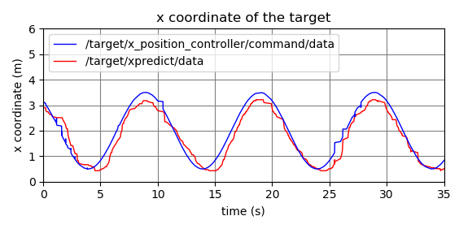Figure 1: The plot of the predicted x coordinate of the target (show in red) against its true position (shown in blue)
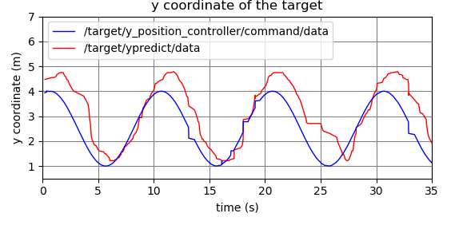Figure 2: The plot of the predicted y coordinate of the target (show in red) against its true position (shown in blue)
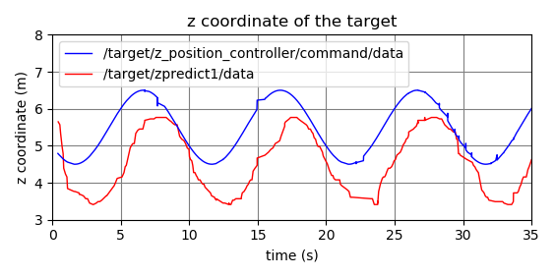Figure 3: The plot of the predicted z coordinate of the target (show in red) against its true position (shown in blue)

Conclusion and discussion
Our approach seems produce good results. We have identified the following sources of error:
- The target changes depth with respect to the cameras as it moves. This explains, for example, why the predicted y values are larger than the true y values. We assume that the target is at the same depth as the robot, but the target is actually closer. Since the target is in the right half of the view of the camera, this makes the target look like it is further to the right than it actually is.
- There seems to be quite a big error in the predicted z values but the simple reason is that we use the center of the yellow joint as the base frame while the true target positions are probably with respect to a frame that is on the ground level.
- There is some horizontal error in the graphs because of delays due to image processing.

