MaxAir provides an ‘Away’ option, which can operate in two different modes, either using a time schedule or not.

In Scheduled Mode, an overriding schedule is used to control the operation, while the ‘Away’ function is operating.

In Non-Scheduled Mode, the system is placed in the OFF state, with Frost Protection activated.

Both modes are activated by clicking on the ‘Away’ button on the ‘Home’ screen. While activate the status indicator will change from blue to red.

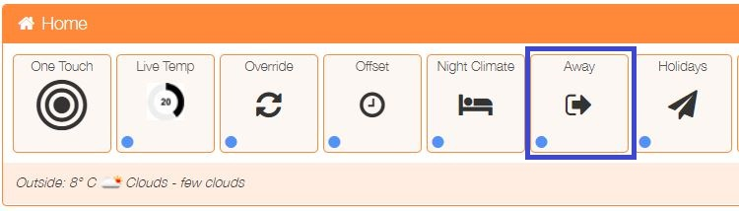

In order for ‘Away’ to operate in scheduled mode a time schedule must be created and linked to the Away function. The schedule is created in the normal manner, with start time, end time, zone selection and temperature configured as required to define the system operating parameters to be used while ‘Away’ is active. The only difference is that the ‘Enable Away schedule’ must be checked.

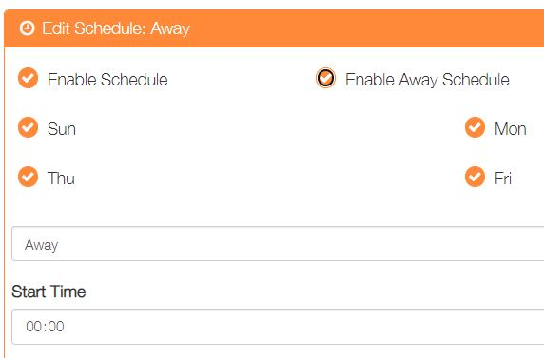

Note 1: Only one ‘Away’ schedule can be active at any point in time. Once an ‘Away’ schedule has been activated, the ‘Enable Away Schedule’ checkbox will be disabled for any other schedule, until the active ‘Away’ schedule is either deleted or disabled or ‘Enable Away Schedule’ checkbox is un-ticked.

Note 2: When operating in Scheduled Mode, the system will swap to ‘Timer’ Mode irrespective of the Mode set on the ‘Home’ screen, the original mode will be restored when ‘Away’ is deactivated.