Relays are created as control devices; they need to be attached to nodes using a ‘node_id’ and ‘child_id’. The nodes can be of any type, e.g., ‘MySensors Controllers’, ‘i2C Controllers’ or ‘GPIO Controllers’.

### Identify the Node_ID and Child_ID

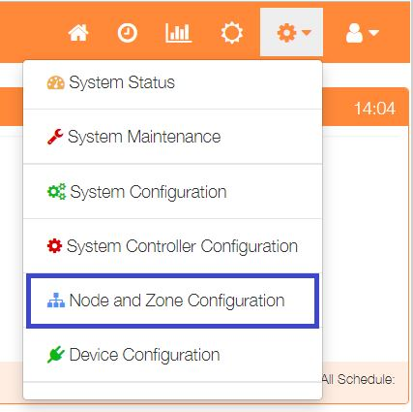To show the nodes currently available select Node and Zone Configuration from the Settings dropdown list, then click the ‘Nodes’ button.

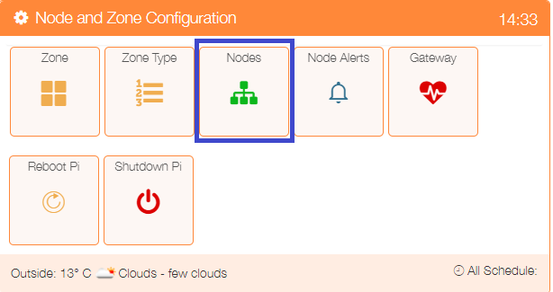

The listing shows a number of Sensor nodes and a GPIO Controller Node. For this example, three relay devices will be attached to the GPIO Controller Node.

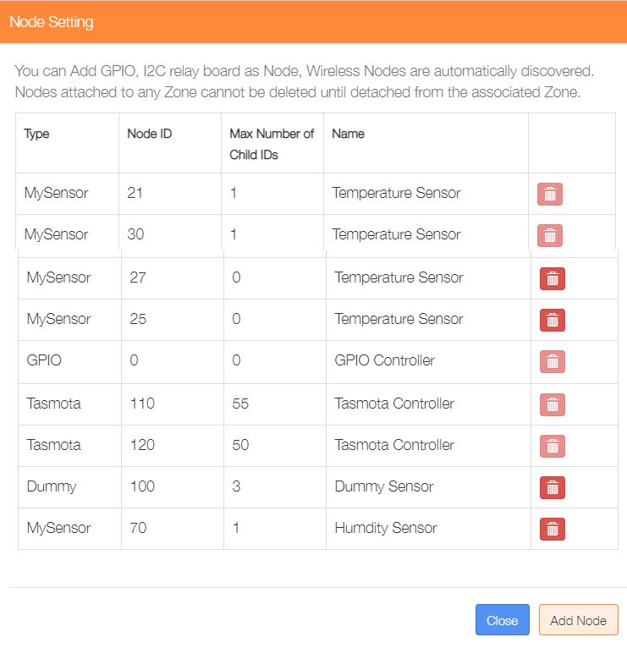

In order to use the GPIO Controller, we need to know something about the hardware in use. Available GPIO pins will depend on the controller being used. For example, if we are using a Raspberry Pi Model 3B+ the pins 11, 13 and 15 (corresponding to GPIO17. GPIO27 and GPIO22) should be available, if not being used by another application.

The GPIO controller is node_id of 0, we will use child_ids of 11, 13 and 15 for our three relays.

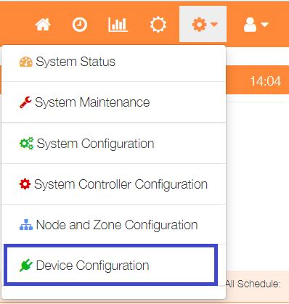

Select Device Configuration from the Settings dropdown list, then click the ‘Relays’ button.to display a list of any currently configured relays.

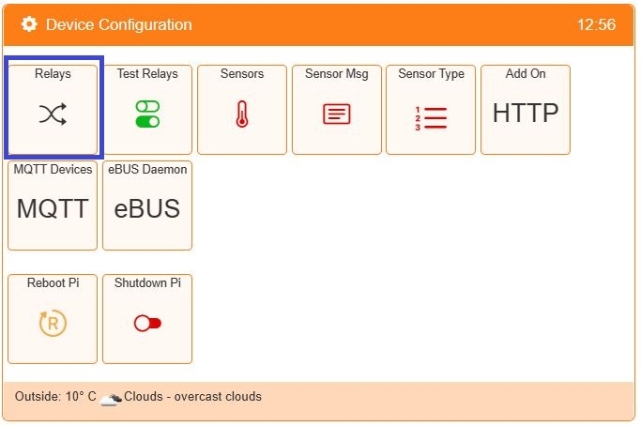

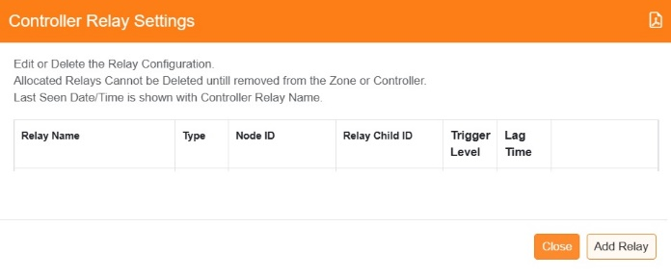Click on the ‘Add Relay’ button to configure the first relay

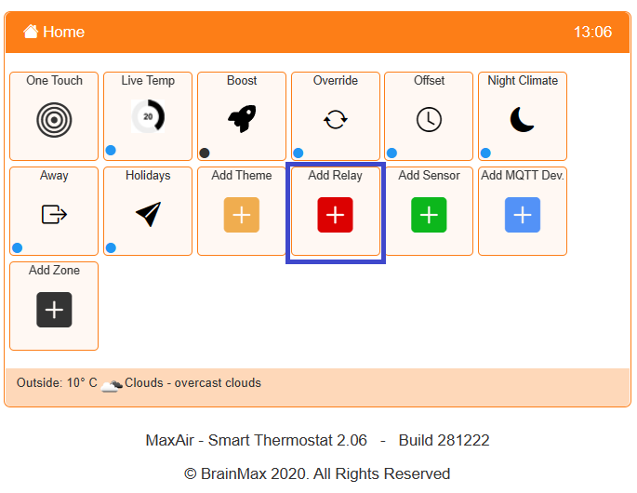

An alternative method to go directly to the Add Relay dialogue, is from the Home screen click on the ‘One Touch’ button then select the ‘Add Relay’ menu item.

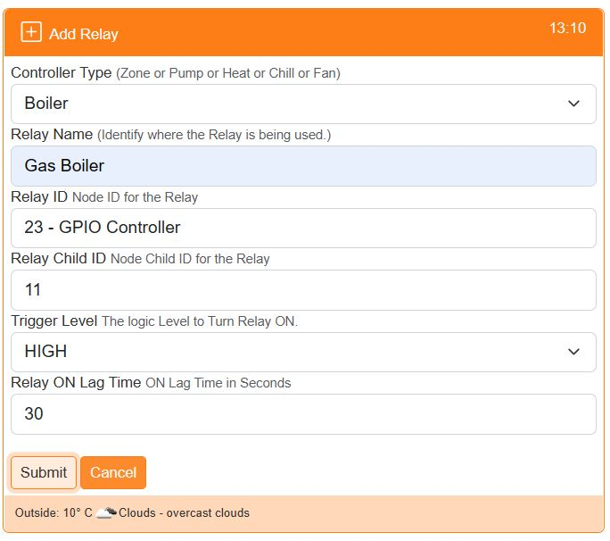

Select the Controller Type e.g. Boiler

Provide a name for this relay device

Select the Relay ID from the dropdown list of available Nodes

Choose the Child ID from the dropdown list.

Select HIGH or LOW trigger level for relay ON.

Set any desired delay time before switch ON.

Click on ‘Submit’ to add the device.

Repeat the process for the other relays.

Entries will be created in the ‘messages_out’ queue for each relay.

Reselect the Relays menu item from the Settings/Node and Zone Configuration menu to display the updated list of newly configured relays.

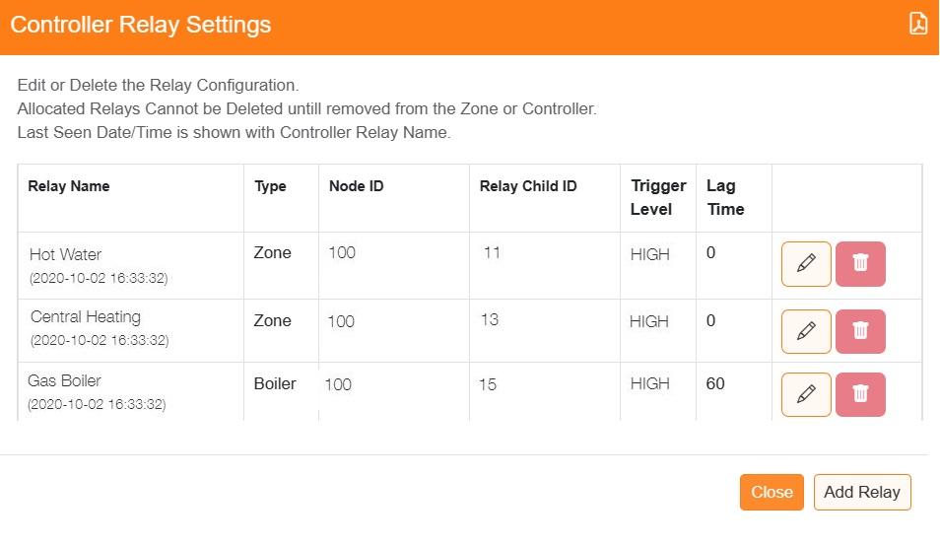

From this menu the relay configurations can be edited and deleted.

Note: relays can only be deleted when they are NOT currently allocated to either a zone or the system controller. The act of deleting a relay will remove the corresponding entry in the ‘messages_out’ table.