The ‘look’ of MaxAir can be customized through the use of colour themes. There are currently seven selections available, Blue, Orange, Dark, Red, Violet, Amber and Teal. Each theme is also available with the tiles either left or centre justified.

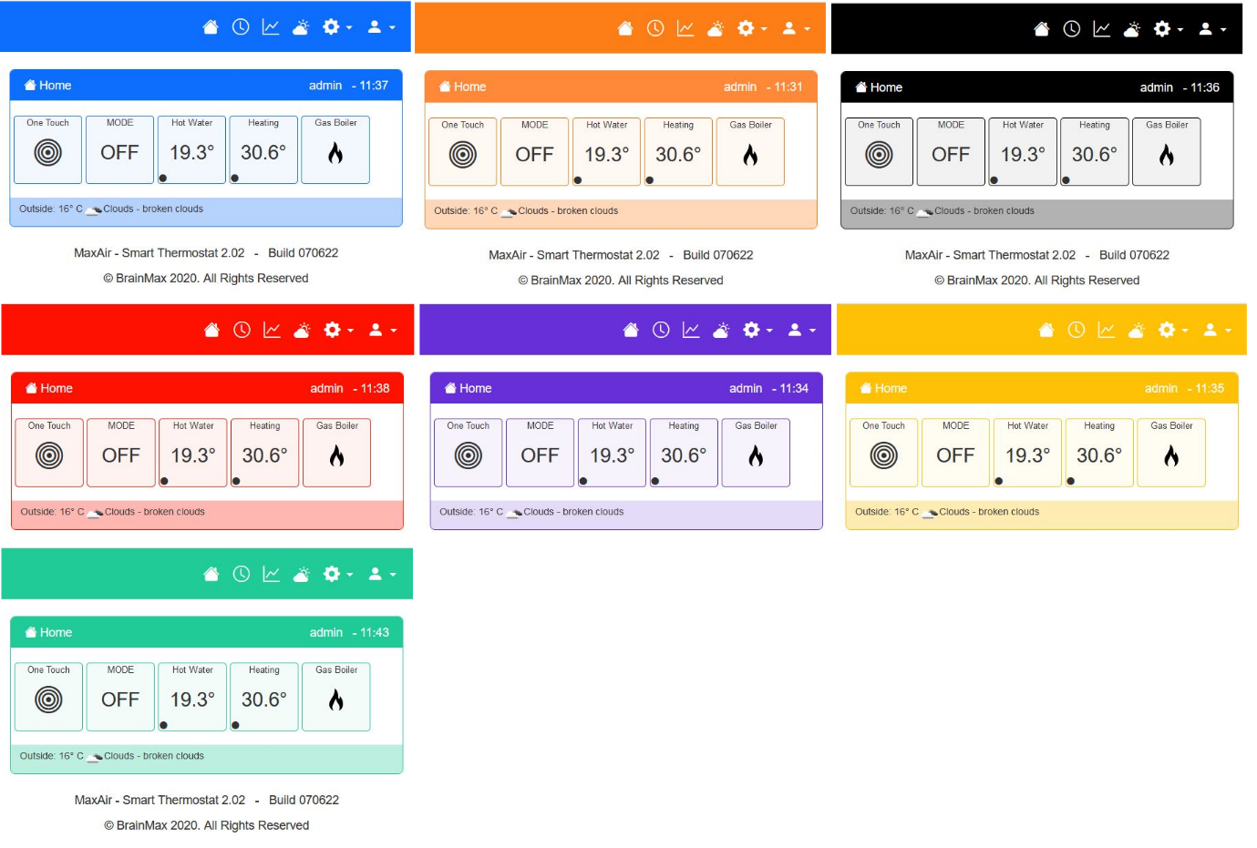

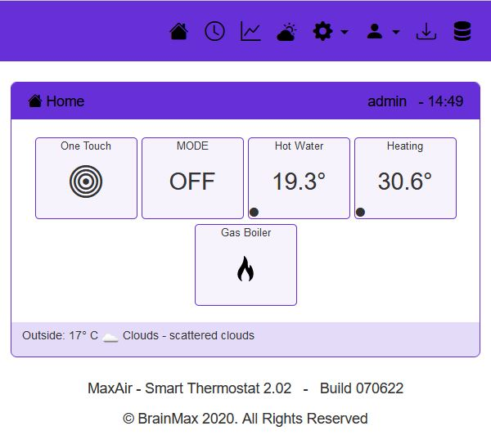

In addition, the ‘look’ can be further customized by changing the colour of the text and/or the size of the home screen tiles and/or the justification of the tiles on the screen. For example, a violet theme, with black text, centre justified and with wide tiles is shown:

## Selecting Themes, Adding New Themes and Editing Existing Themes

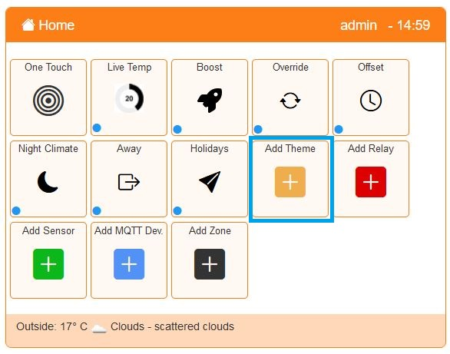

New themes can be configured from the One Touch screen using the Add Theme option.

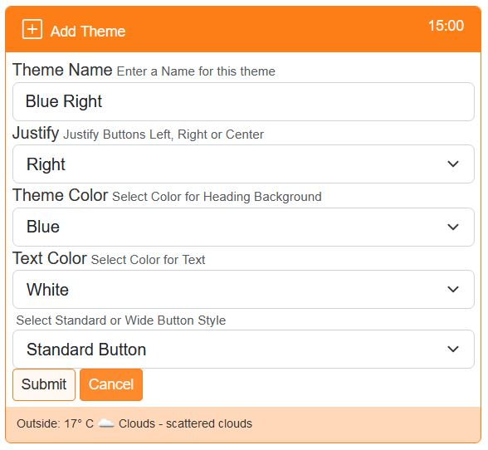

Enter a descriptive name.

Select either left, centre or right.

Select the background colour.

Sect the text colour.

Select the home screen tile width.

Click Submit to save the new theme.

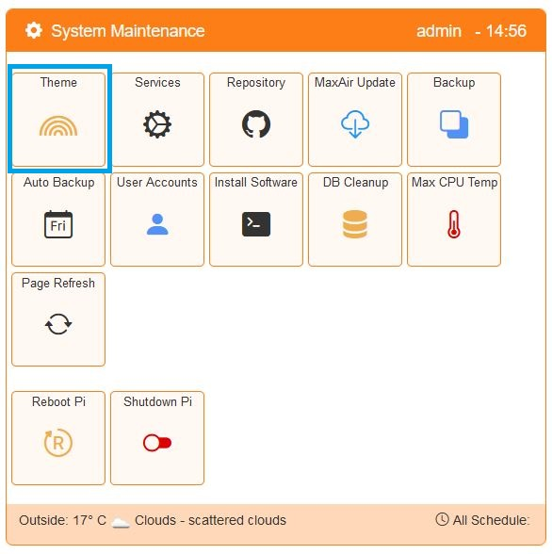

The Theme is select using the Settings/System Maintenance/Theme option.

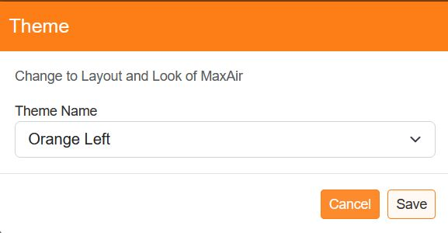Select the theme required from the list of available options

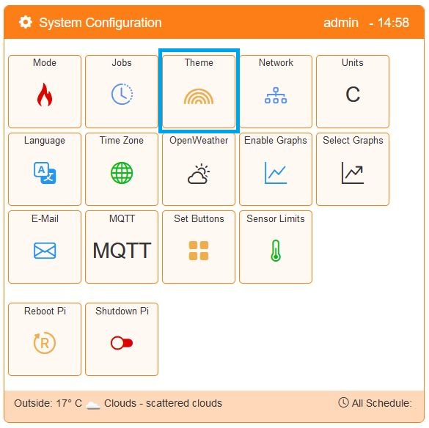

Themes can also be added or edited from the Settings/System Configuration/Theme option.

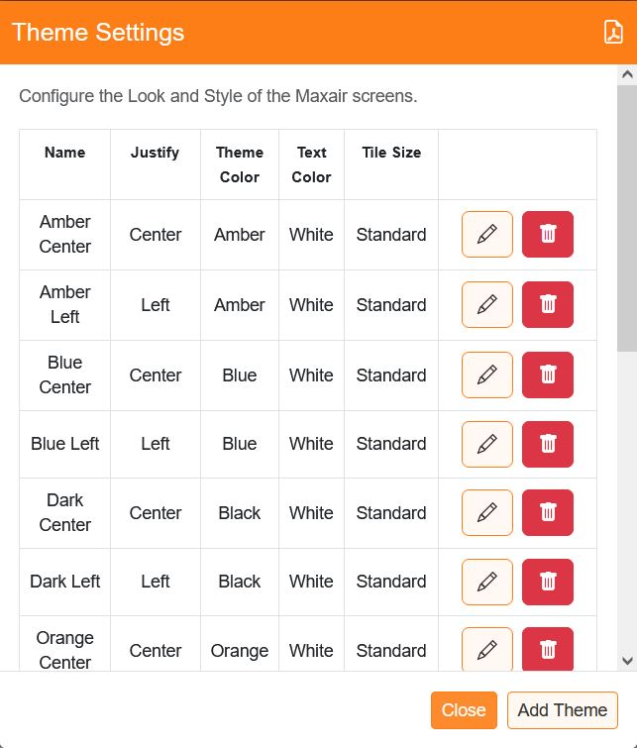

A list of the current themes will be displayed, where they can be edited or deleted or new themes added.