MaxAir provides the capability to control temperature using a negative profile, that is to control a cooling device to reduce a zone temperature until it reaches a set point value.

This is achieved through the use of a ‘Cooling’ type zone.

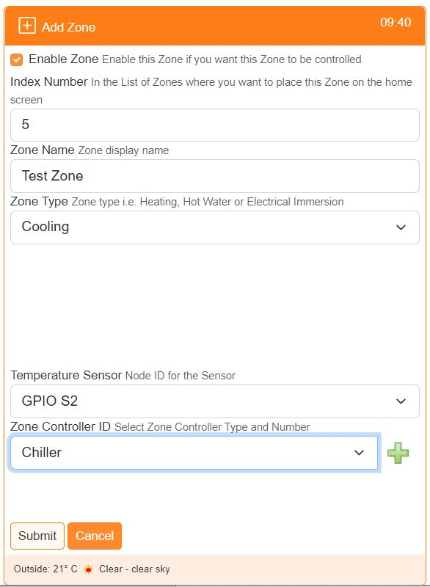

‘Cooling’ type zones are allocated a sensor to determine the environment’s temperature and a relay or relays to control the chilling device/s.

The zone is controlled through the use of a schedule as with other zone types.