MaxAir provides an ‘Holidays’ option, which allows the definition of a schedule which will override the ‘normal’ schedules between a start date/time and an end date/time.

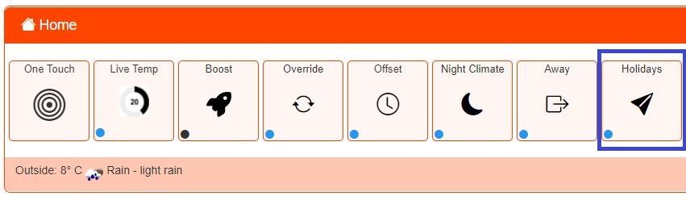Holidays mode is activated by clicking on the ‘Holidays’ button on the ‘Home/One Touch’ screen. While active the status indicator will change from blue to red.

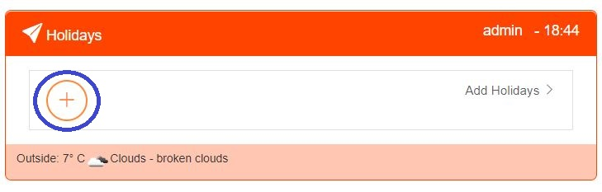

Click on the + icon to create a new ‘Holiday Period’.

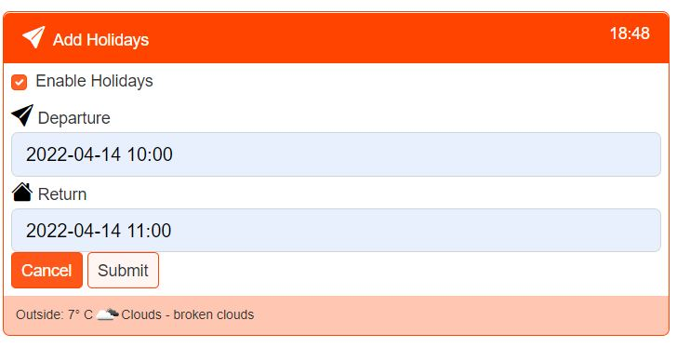

Enable and set the Depart and Return Date/Time values, then click on the ‘Submit’ button.

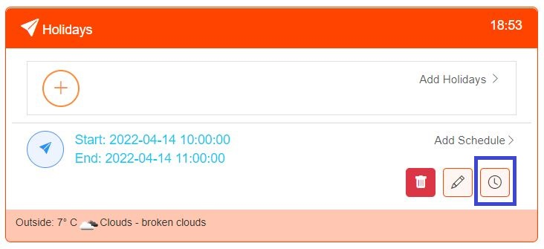

Click on the Timer icon to create a schedule in the usual Manner.

