MaxAir communicates with devices (sensors, relays etc) by the use of two message queues, one for incoming messages, the other for outgoing messages. These queues are linked to two tables in the MaxAir MySQL database, ‘message_out’ and ‘messages_in’.

## ‘messages_out’

The ‘messages_out’ table is used by the Python script ‘/var/www/cron/gateway.py’ to set the required state for relays/controllers.

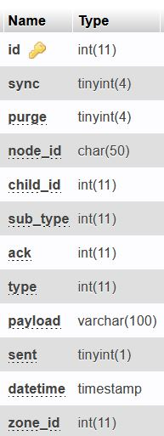The table is comprised of 13 fields, as shown. The gateway script uses the fields ‘node_id’ and ‘child_id’ to identify the device to be actioned, the field ‘payload’ is used to set the state of the device (high or low) and the field ‘sent’ is set to 0 to instruct the gateway script to set the state of the identified device to the state set by the ‘payload’ value. Once the gateway has processed the command, the value of the ‘sent’ field is set back to 1.

The ’ack’ field is set to 1 by default, so that the device will send a message back, via the ‘messages_in’ queue, to indicate that the device has been seen by the gateway script (used by the system to indicate potential device communication issues).

The ‘datetime’ field will contain a timestamp for the action.

The fields ‘id’, ‘sync’, ‘purge’, ‘sub_type’, ‘type’ and ‘zone_id’ are used for non-queue management purposes.

The ‘messages_out’ table is populated when ‘zones’ are created (not when the actual relay/controllers are created, in order that non-active devices are not processed). The ‘payload’ and ‘sent’ fields are acted upon by the main MaxAir processing function ‘/var/www/cron/controller.php’.

## ‘messages_in’

The ‘messages_in’ table is used by the Python script ‘/var/www/cron/gateway.py’ to capture data from input devices such as sensors.

The table is comprised of 13 fields, as shown. 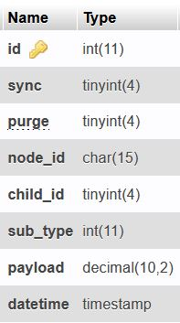The read data from input devices in a continuous loop, the data generated by the device will be compromised of a ‘node_id’ and ‘child_id’ to identify the device, a ‘sub_type’ to identify the type of device ( eg. Binary sensor, temperature sensor, humidity sensor, etc ) and a ‘payload’ value that represents the data being passed to the system from the device in question.

The ‘datetime’ field will contain a timestamp for the reading.

The fields ‘id’, ‘sync’ and ‘purge’ are used for non-queue management purposes.

The ‘messages_in’ table is acted upon by a number of functions, including the main MaxAir processing function ‘/var/www/cron/controller.php’, the process used to update the Home screen temperature indicator ‘/var/www/ ajax_fetch_data.php’ and any other function which needs to read a sensor value/state.