MaxAir provides the capability to control zone conditions using a negative gradient, for example; to control a cooling device to reduce a zone temperature until it reaches a set point value.

This is achieved through the use of a **‘Controller, Sensor and NO System Control (Negative Sensor Gradient)’** zone category. By default, a ‘Cooling’ zone type has been created with such a categorisation and is used in the following example (but the Zone Type name is arbitrary and can be any suitably descriptive name, for example ‘Dehumidifier’).

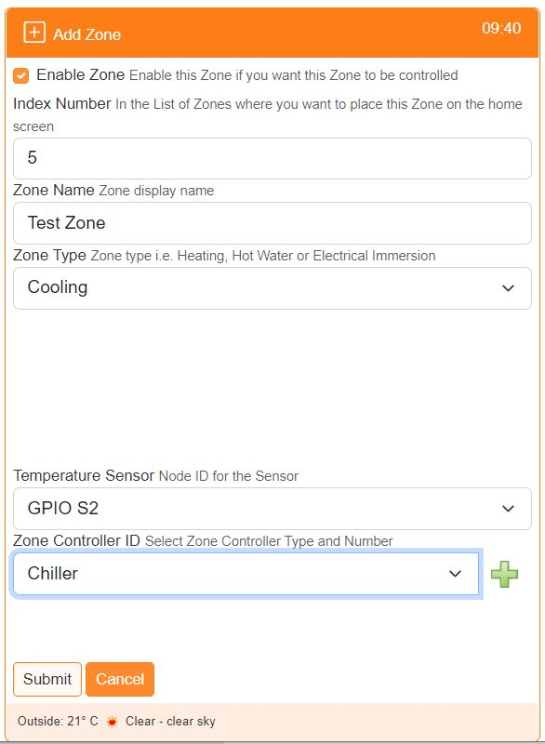

The ‘Cooling’ type zone is allocated a sensor to determine the environment’s temperature and a relay or relays to control the chilling device/s.

The zone is controlled through the use of a schedule as with other zone types.