A backup of the current MaxAir database can be created and Emailed to any chosen recipient.

In order to use this feature, an Email account must already have been configured.

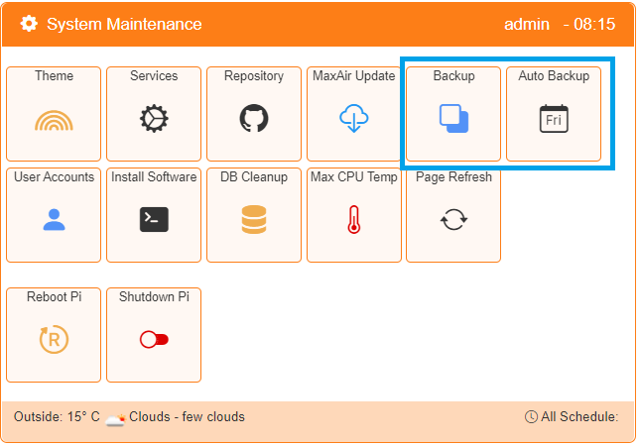There are two types of backup available, the first provides an immediate backup and the second allows scheduled backups to be configured.

## Immediate Backup

Select the Backup option from the Settings/System  Maintenance menu.

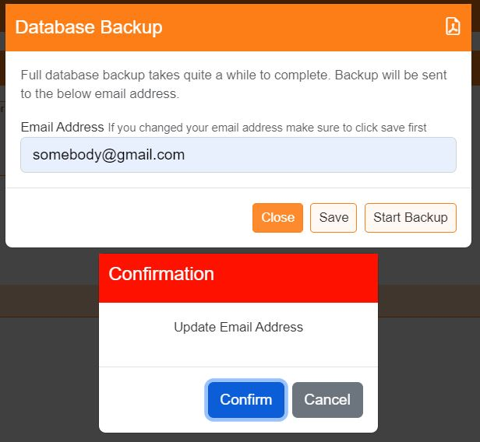

If required enter a new Email address or update an existing Email address for where to send the database backup. Click on ‘Save’ to update the address.

Once the Email address is set, click on ‘Start Backup’.

A compressed copy of the database will be created in directory /var/www the name of the file will be of the form ‘**maxair_2021-12-19_18:34:20.sql.gz**’, where the current date and time are included in the filename.

A copy of this file will be sent to the Email address set above.

## Scheduled Backup

Scheduled Backups use the ‘Job Scheduler’ to perform database backups on a periodic basis, aged archives are deleted after a set period and the destination location for the archive must be selected.

Select the Auto Backup option from the Settings/System  Maintenance menu.

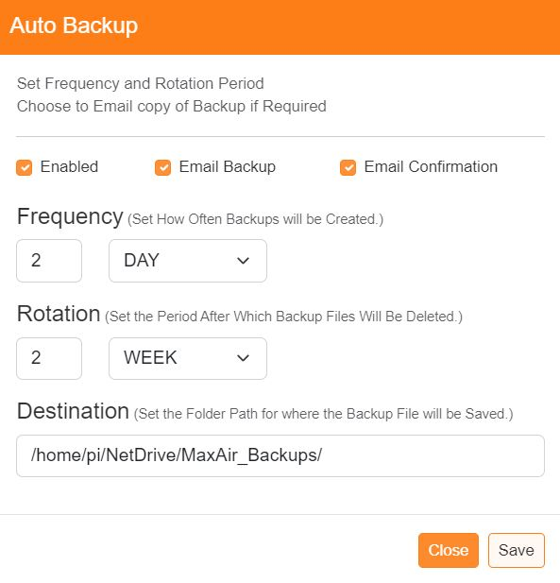

Select to enable the automatic backup, select if an email copy of the archive file is required and also if a confirmation email is required (the email option will only be selectable if and email address has been configured, as described earlier).

Set how often to perform the backup and also how long to retain the archives before deletion.

Finally set the destination folder for storage of the archive file (this can be a network attached device).

Click ‘Save’ to store the configuration.

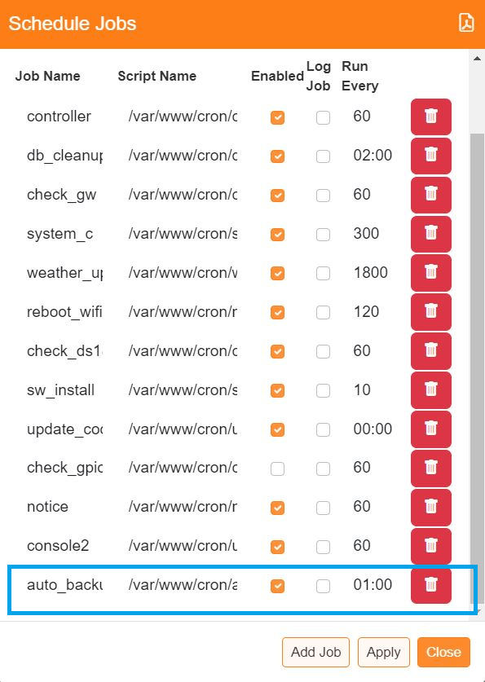

By default, the check for scheduled backups will take place at 01:00 hours each day, this is determined by the Scheduled Job ‘auto_backup’ and can be changed if required.