MaxAir database backups are created in three different ways.

In the first case they are created automatically when database updates are applied by the update process, these archives are created as ZIP files, where the files names are of the format ‘**Full Path Name/maxair_mysql_2022‑06‑11_11‑03-49.zip**’.

In the second case they are created by the Immediate Backup process and in the third case they are created by the Auto Backup process, in both instances the archives are created as GZ files, , where the files names are of the format ‘**Full Path Name/maxair_2022‑06‑11_11‑03-49.gz**’.

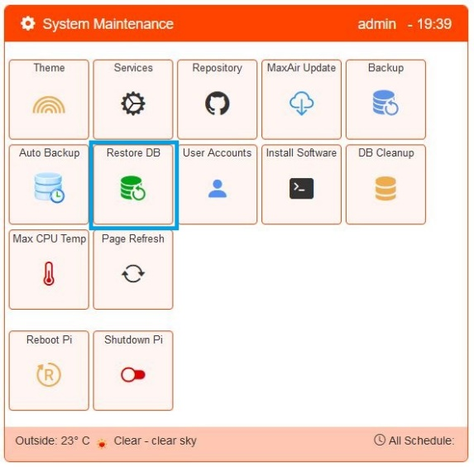

In Database Archives can be restored from the System Maintenance/Restore DB menu.

## 

A list of all available backup archives is displayed in date order.

Select the required archive and click to select, a confirmation message will be displayed.



**THIS ACTION WILL OVERWRITE YOUR EXISTING CONFIGURATION.**