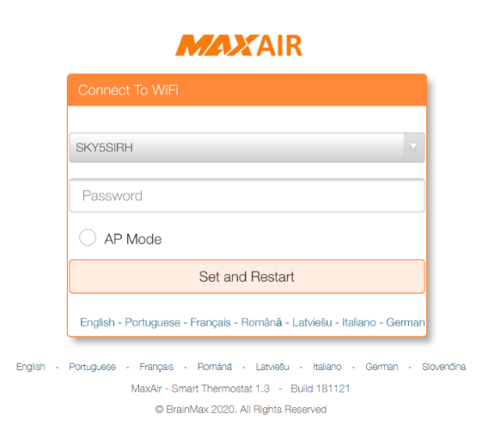MaxAir will initially be configured as a WiFi AP (Access Point) named MaxAirHotspot, connect to the AP using the password **1234567890** and browse to IP address **192.168.50.5** where you will be presented with the initial connection screen.

Select your local WiFi SSID from the dropdown list and enter the associated password.

Alternatively, if you want MaxAir to operated as a ‘stand-alone’ AP, just click to select AP Mode.

Finally click on ‘Set and Restart.

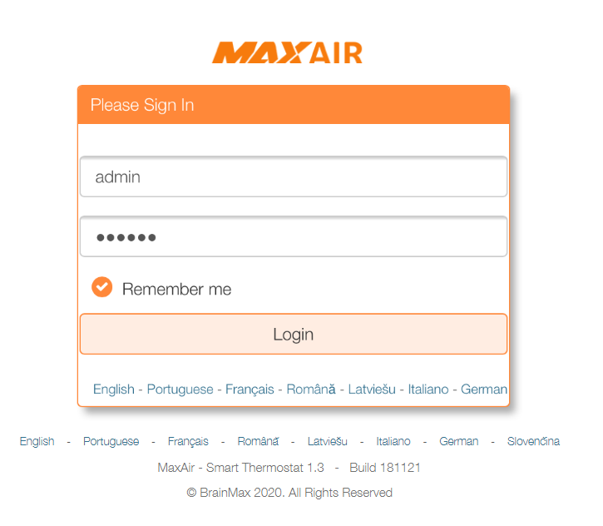If working in AP Mode you will be presented with the MaxAir login screen, otherwise reconnect to your local AP and browse to the IP address associated with MaxAir (if your AP is using DHCP, then access your router to determine which IP address has been allocated).

The system can be accessed from a suitable WEB browser using its IP address on the local network. The system can be configured with both a wireless and/or an Ethernet wired connection.

The default login credentials are username – **admin** and password - **pihome**

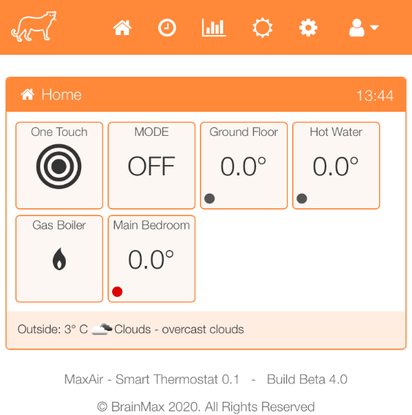The Home screen layout will be dependent on whether the system is operating in HVAC or Boiler Mode. The example shows a system operating in Boiler Mode with two zones. Ground Floor is the central heating zone and Hot Water is the hot water zone. The example system is configured with a ‘stand-alone’ temperature sensor located in the Main Bedroom.

Before use the system must be configured to match the local system to be controlled.

## Configuration

The system configuration follows a four-layer model: -

|  |
| --- |
| **Schedules** |
| **Zones** |
| **Devices** |
| **Nodes** |

Each layer is built from the previous layer e.g. Devices are built using Nodes and Schedules are built using Zones.

### Nodes

The nodes are the basic hardware devices that control the system. Some nodes are auto‑detected, others must be defined manually.

Examples of auto‑detected nodes are MySensors temperature sensors and MySensors relay modules, while examples of manually defined devices are GPIO connected relays, I2C relay modules and Tasmota type switches.

### Devices

Devices define how the system recognises the nodes hardware, devices are either Temperature Sensors or Relays. The devices are defined manually.

### Zones

The zones define the areas of the system which need to be controlled, examples are Central Heating and Hot Water zones. A further example would be a Lamp zone which includes Tasmota switch/s.

### Schedules

Schedules are time related definitions which dictate when the system performs actions and the parameters associated with those actions. An example would be a schedule to control the hot water zone, with a start time 0f 0600 hours, a stop time of 0930 hours and a maximum temperature of 40°C.

## Example Configuration

The system to be configured comprises the following elements:

1. A gas boiler, controlled by a 240volt trigger signal
2. A 240volt zone value for the central heating zone
3. A 240volt zone value for the hot water zone
4. A MySensors Temperature to control the central heating zone
5. A MySensors Temperature to control the hot water zone
6. A MySensors Temperature to measure a bedroom temperature

The above will determine the MaxAir nodes requirements as follows:

1. Three MySensors Temperature Sensors
2. Three GPIO pins for relays
3. A serial gateway device to send/receive messages to/from 1 and 2

### Step 1 – Configure the Gateway

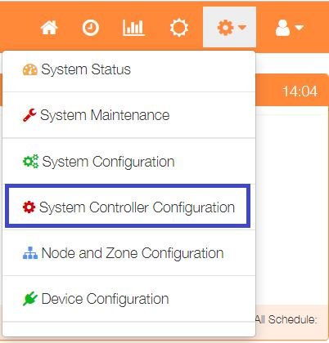

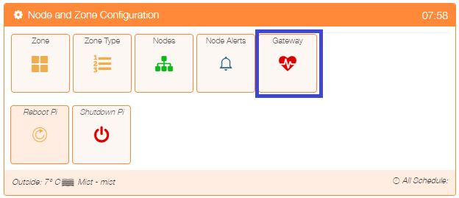 The gateway is configured by selecting ‘Node and Zone Configuration’ from the Settings dropdown list, then clicking the ‘Gateway’ button.

.

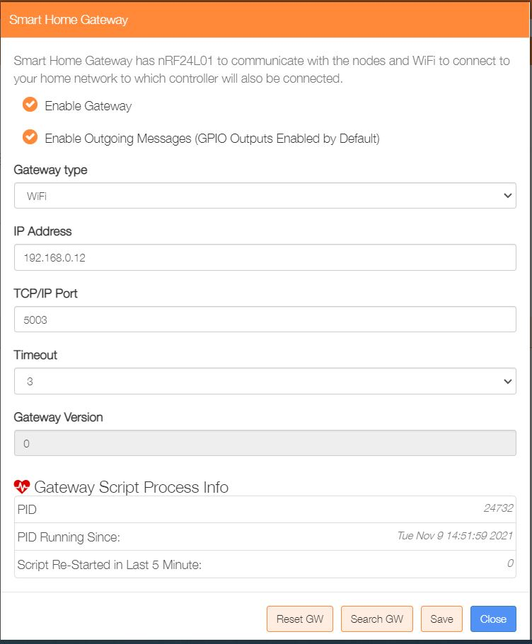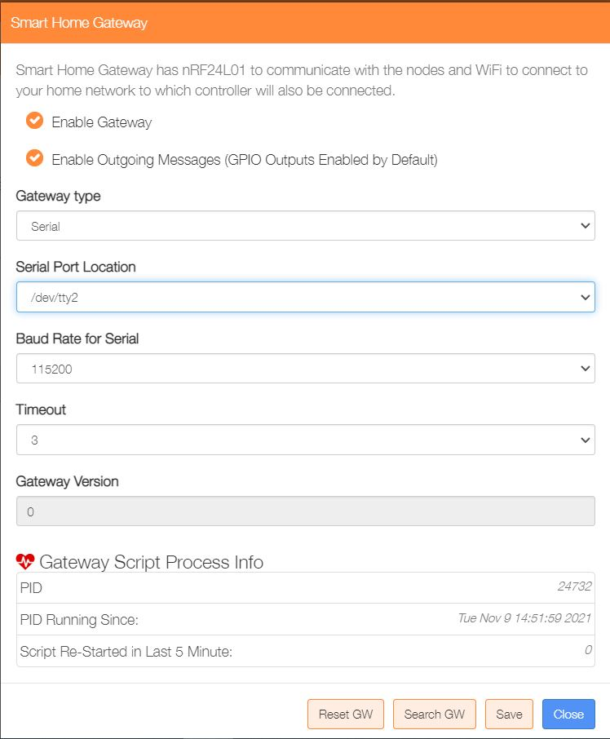For this example, a MySensor gateway is required and should be configured as either Serial or WiFi.

If no MySensors gateway is required eg where both sensors and relays are connected to the GPIO port or when MQTT devices are used, then configure as a Virtual gateway (this is the initial default configuration).

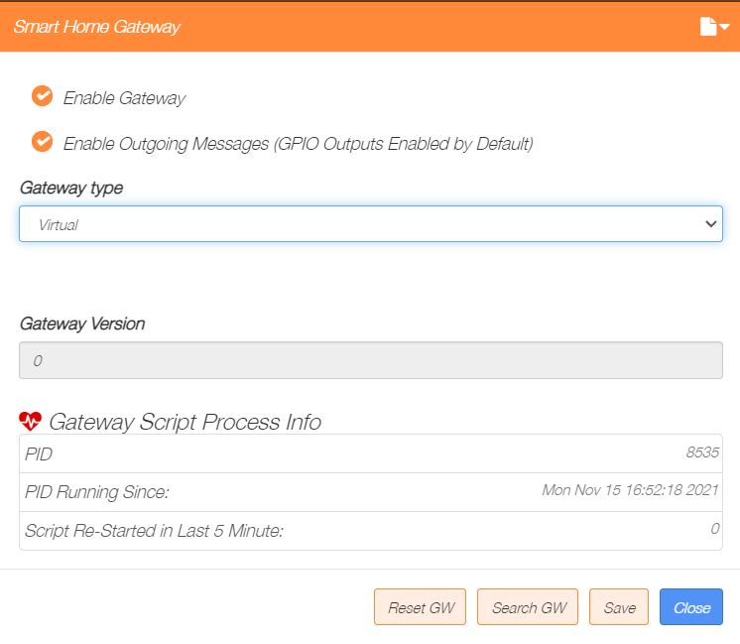

Once the gateway has been configured, the script file which executes the task on a regular time interval will be executed by the ‘Job Scheduler’, which is configured by default. It can be accessed by selecting ‘System Configuration’ from the Settings dropdown list, then clicking the ‘Jobs’ button.

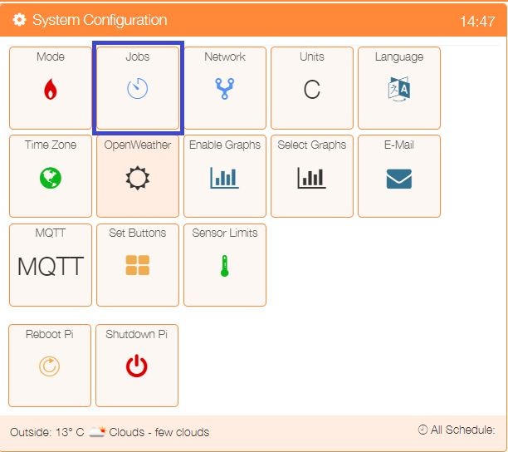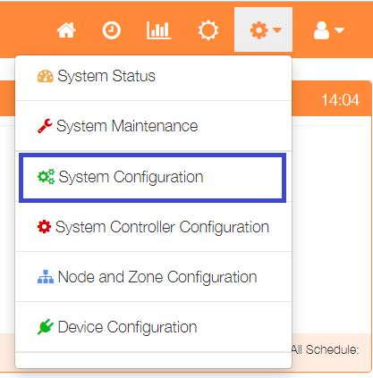

To show the list of active tasks, select ‘System A listing of the scheduled jobs will be displayed. New Jobs can be added or the settings for existing Jobs modified or deleted.

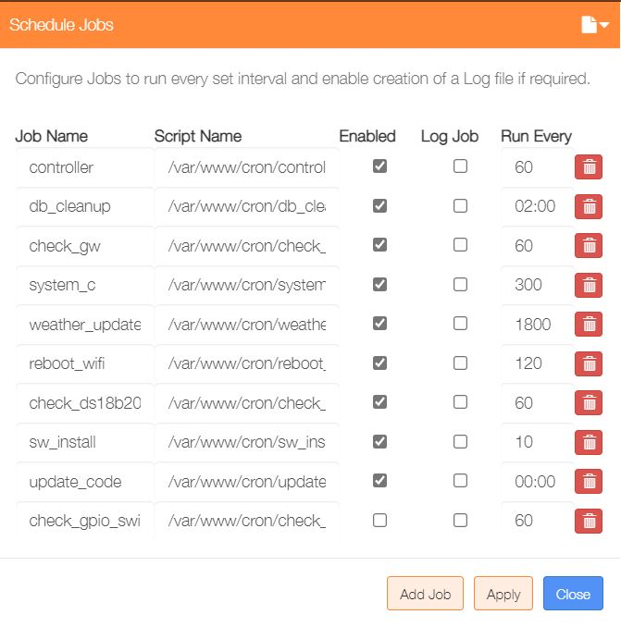

### Step 2 – Layer 1 Configuration - Connect the Nodes

Once the gateway is running, connect the MySensors Temperature Sensor devices, so that they can be detected.

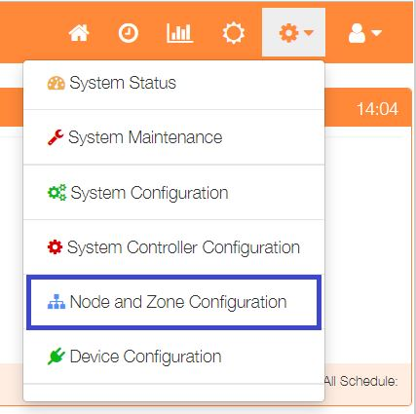

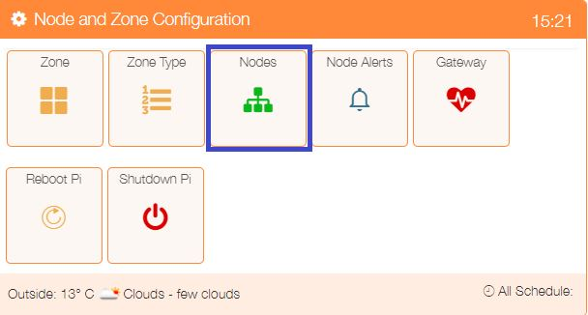To show the nodes currently available, select ‘Node and Zone Configuration’ from the Settings dropdown list, then click the ‘Nodes’ button.

The example configuration uses relays connected via GPIO pins, the GPIO node is created by default as part of the initial setup process.

The Nodes menu option will show the default GPIO node plus the 3 autodetected MySensor nodes.

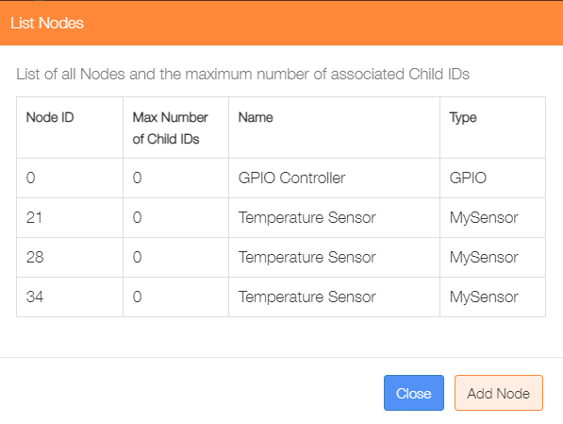

**This completes the Layer 1 configuration.**

### Step 3 – Layer 2 Configuration - Add Devices

This step will add the Relay and Temperature Sensor devices.

#### Relays

The example system will require 2 zone relays and 1 boiler relay.

### Step 2 – Layer 2 Configuration - Add Devices

This step will add the Tasmota Switches as Relay devices.

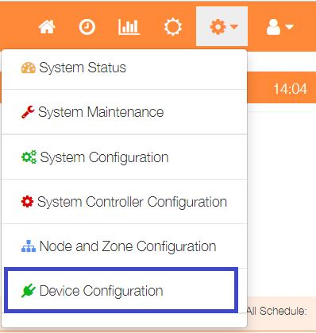

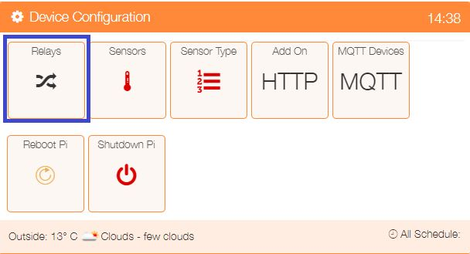 Select Device Configuration from the Settings dropdown list, then click the ‘Relay’ button.to display a list of any currently configured relays.

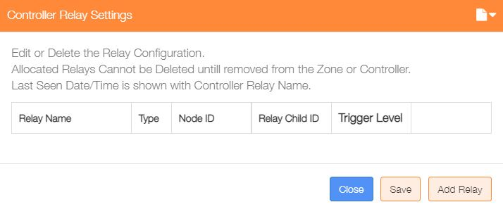

Click on the ‘Add Relay’ button to configure the first relay

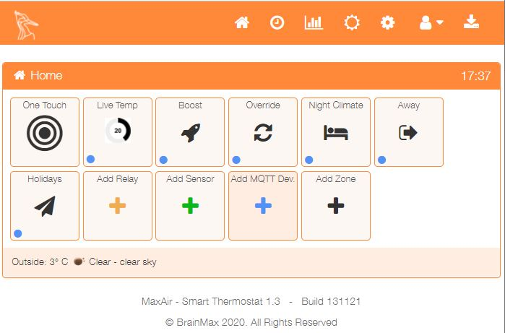

An alternative method to go directly to the Add Relay dialogue, is from the Home screen click on the ‘One Touch’ button then select the ‘Add Relay’ menu item.

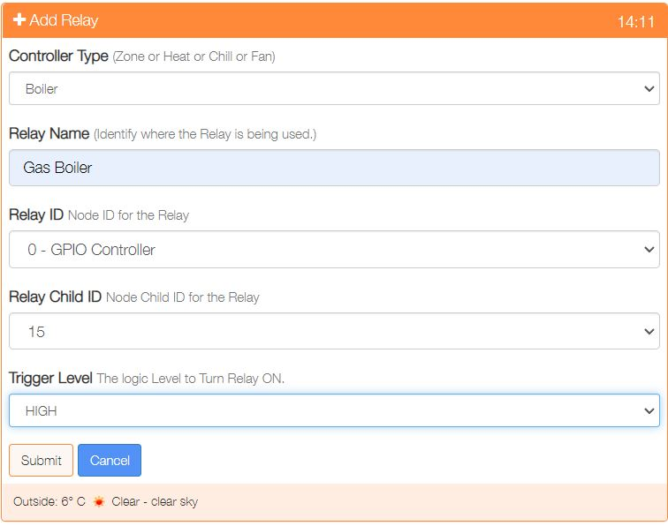

Select the Controller Type e.g. Boiler

Provide a name for this relay device

Select the Relay ID from the dropdown list of available Nodes

Choose the Child ID from the dropdown list, in the case of a GPIO controller, the GPIO pin.

Select the level to trigger relay ON.

Click on ‘Submit’ to add the device.

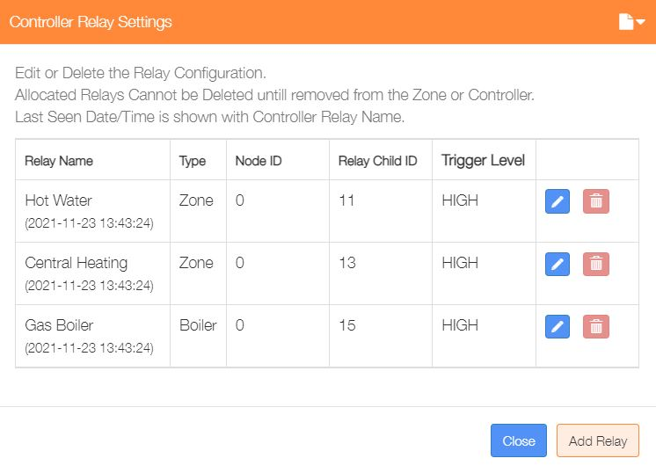Repeat the process to add the two Zone Controller relays.

Re-selecting the Relays menu item from the Settings/Node and Zone Configuration menu will display the updated list of currently configured relays.

This dialogue can be used to Add/Delete/Edit the relay configurations.

### Temperature Sensors

The example system will use 3 temperature sensors, one for the Central Heating, one for the Hot Water and a third to monitor a bedroom temperature. The configuration process is very similar to that used to configure the relay devices.



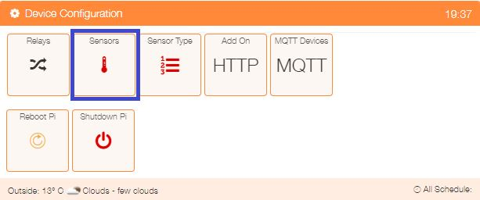 To display a list of any currently configured sensors, select ‘Device Configuration’ from the Settings dropdown list, then click the ‘Sensors’ button.

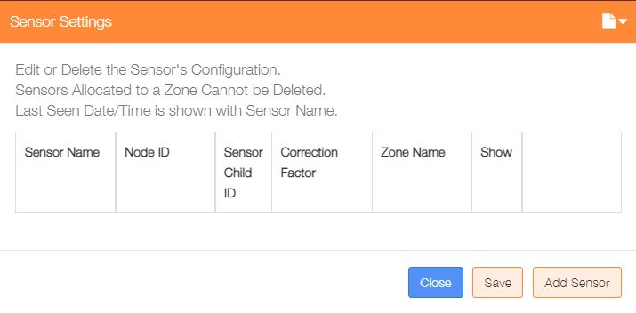

Click on the ‘Add Sensor’ button to configure the first sensor



An alternative method to go directly to the Add Sensor dialogue, is from the Home screen click on the ‘One Touch’ button then select the ‘Add Sensor’ menu item.

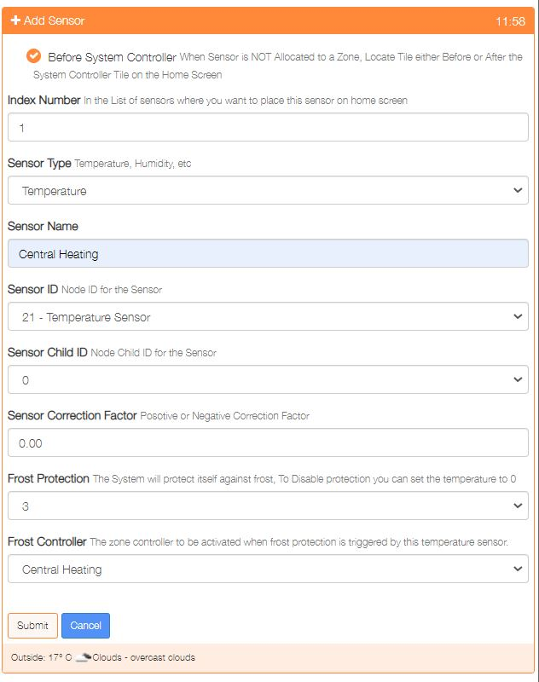

Show either before or after the system controller on the Home screen

Used to order where on the Home screen the sensor is displayed

Either Temperature or Humidity

Provide a name for this sensor device

Select the Sensor ID from the dropdown list of available Nodes

Choose the Child ID from the dropdown list, for nodes with only 1 sensor, this will be 0

Positive or Negative correction to be applied to the sensor reading. correction factor

Select the frost protection temperature or 0 to disable this feature

If frost protection is enabled, then select the zone to be activated on protection

Click on ‘Submit’ to add the device.

Repeat the process to add any other temperature sensors.

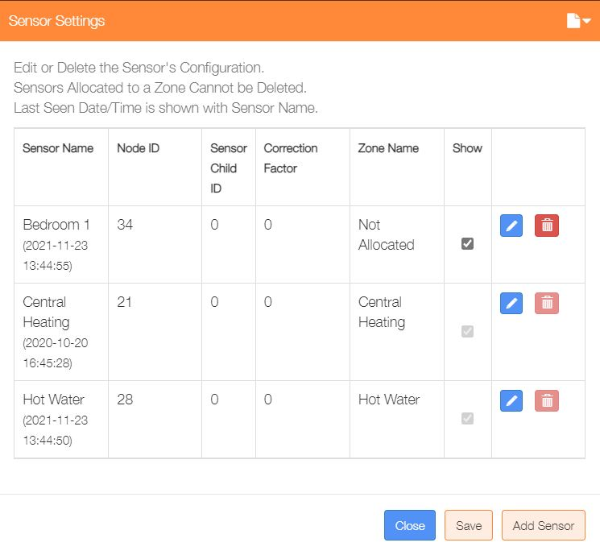Re-selecting the Sensors menu item from the Settings/Node and Zone Configuration menu will display the updated list of currently configured temperature sensors.

This dialogue can be used to Add/Delete/Edit the sensor configurations.

The ‘Show’ tickbox can be used suppress displaying a sensor on the Home screen, with the exception of any sensors allocated to a zone.

This example shows one unallocated and two allocated sensors.

#### System Controller Configuration

A relay is used as a trigger for activating the boiler, this relay was added as a relay device above and now need to be associated with the ‘system Controller’.



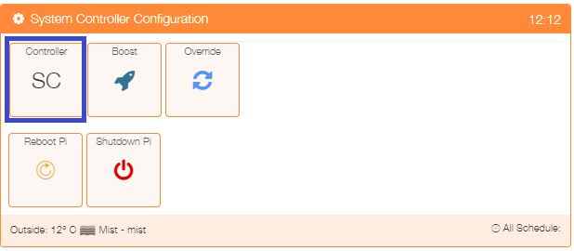Select ‘System Controller Configuration’ from the Settings dropdown list, then click the ‘SC’ button.

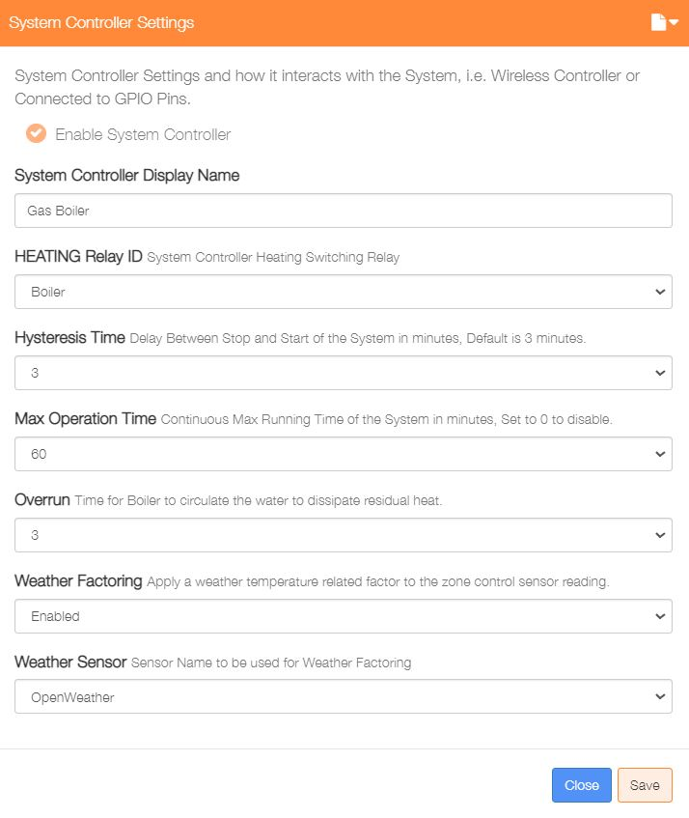

Enable the Controller

Enter a name for this controller

Select the relay from the dropdown list

Enter a hysteresis value in minutes

Enter a maximum running time in minutes

Enter overrun time in minutes

Enable or Disable Weather Factoring

Chose which sensor to use for Weather Factoring, can be OpenWeather

Click on ‘Save’ to update

Note: Weather Factoring will be subtracted from the Zone Target temperature. The factors are 0.3 for temperature <= 5°C, 0.4 for temperatures 6°C to 10°C, 0.5 for temperatures 11°C to 15°C, 0.6 for temperatures 16°C to 20°C and 0.7 for temperatures 21°C to 30°C.

**This completes the Layer 2 configuration.**

**Layers 1 and 2 define the basic hardware configuration of the system.**

### Step 4 – Layer 3 Configuration - Add Zones

The example configuration will have two zones, one for the Central Heating and a second for the Hot Water.

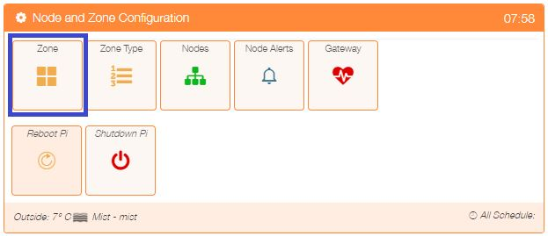To display a list of any currently configured sensors, select ‘Node and Zone Configuration’ from the Settings dropdown list, then click the ‘Zones’ button.

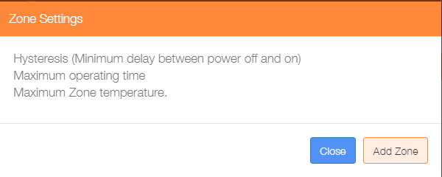

Click on the ‘Add Zone’ button to configure the first zone.



An alternative method to go directly to the Add Zone dialogue, is from the Home screen click on the ‘One Touch’ button then select the ‘Add Zone’ menu item.

There are currently seven types of zone, Heating, Water, Immersion, Switch, HVAC, Humidity and Binary. The format of the Add Zone dialogue will depend on the type of zone selected, for example Immersion type zones will disable ‘System Controller’ selection, while Switch type zones will disable all temperature sensor related selections, together with the ‘System Controller’ selection, as these parameters do not apply to these zone types.

The example below shows a typical Heating zone configuration. A similar configuration would be used for the Hot Water zone, with the exception that the ‘Zone Type’ selected would be ‘Water’. Once the parameters have been entered, click on the ‘Submit’ button.

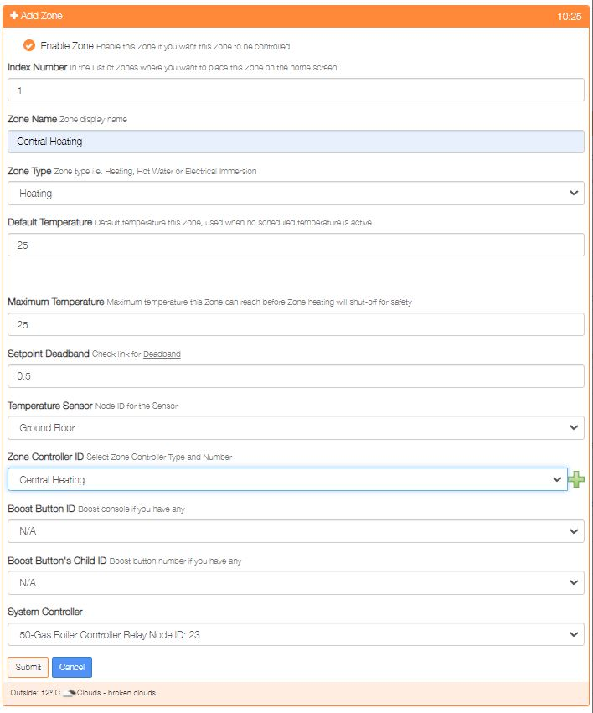

Repeat the process to add any other zones.

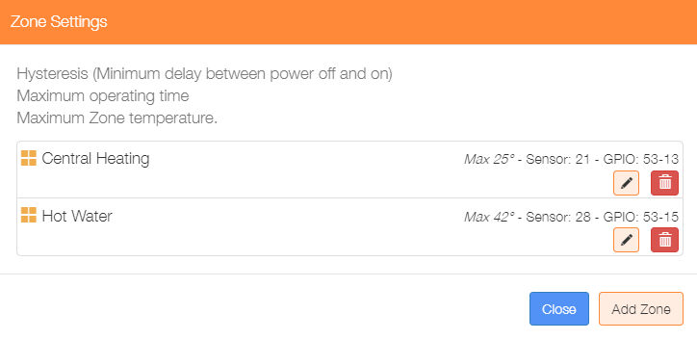

Re-selecting the Zone menu item from the Settings/Node and Zone Configuration menu will display the updated list of currently configured zones.

This dialogue can be used to Add/Delete/Edit the zone configurations.

**This completes the Layer 3 configuration.**

### Step 5 – Layer 4 Configuration - Add Schedules

The example configuration will have a single schedule to control the Central Heating and Hot Water zones.

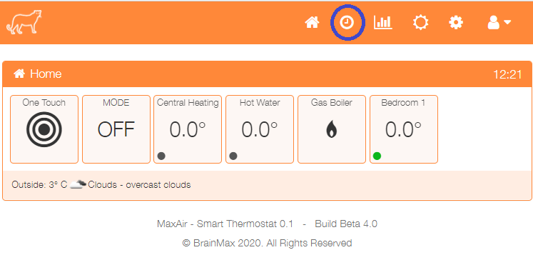Click on the toolbar clock icon to configure the first schedule.

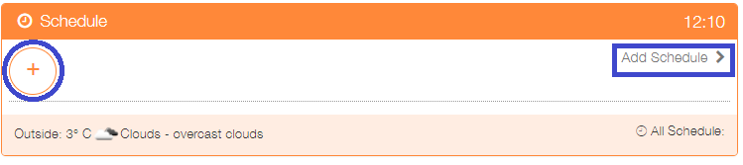

Click on + or ‘Add Schedule’

The Add schedule screen will be presented, the example below shows:

* An enabled schedule
* Operated Monday to Friday
* Titled Weekdays AM
* Operated between 0630 hours and 0930 hours
* Controls both the Central Heating and Hot Water Zones
* Uses 40°C as the Hot Water Zone cut-off temperature
* Uses 19.5°C as the Central Heating Zone cut-off temperature

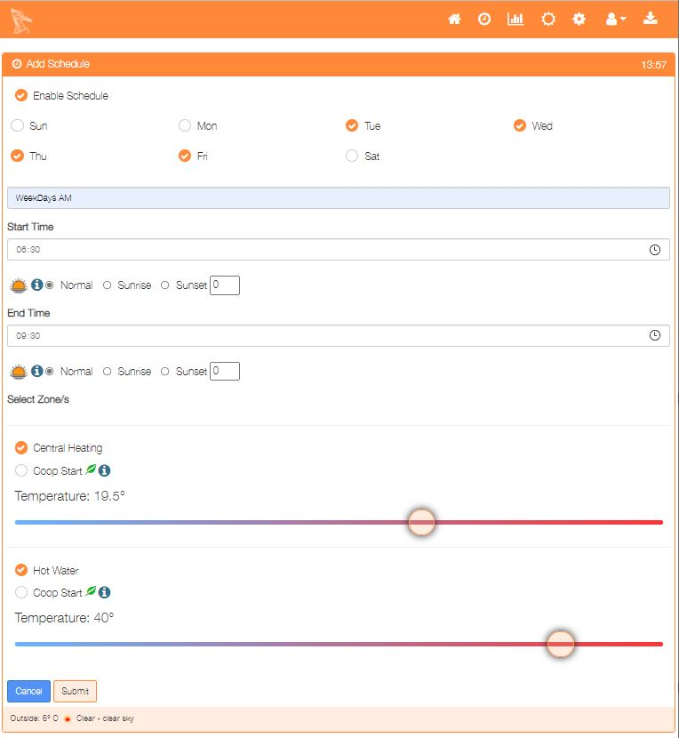

Once configured, click on the ‘Submit’ button to add the schedule.

Add any other schedules as required.

**This completes the Layer 4 configuration.**

### Step 6 – Scheduled Jobs

In order for the system to function a number of tasks need to operate at pre-determined time intervals. These tasks are configured as part of the initial setup process.



 To show the list of active tasks, select ‘System Configuration’ from the Settings dropdown list, then click the ‘Jobs’ button.

The default configuration is as shown and for example, as can be seen the ‘check_ds18b20’ is not enabled, this job is only required if 1-Wire temperature sensors are connected to the GPIO bus.

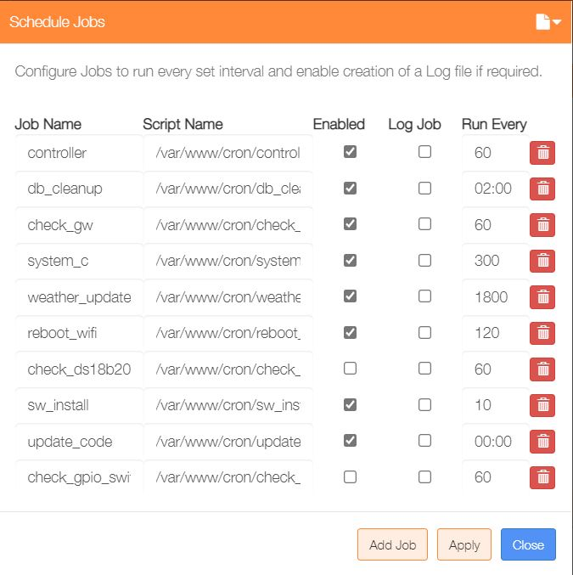

New scheduled tasks can be added by clicking on the ‘Add Job’ button.

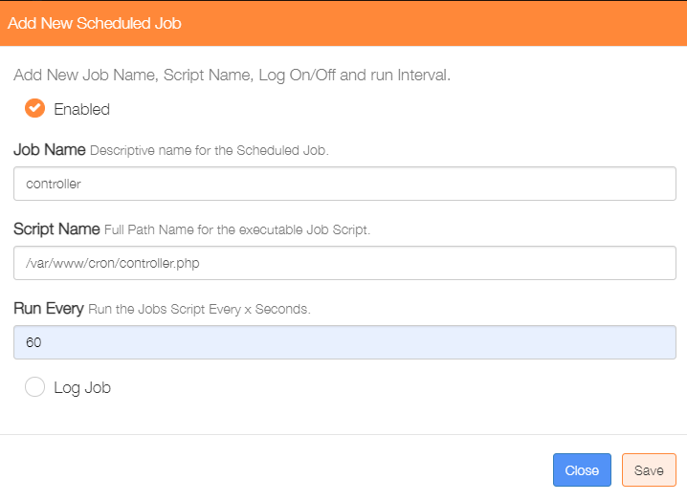

**THIS COMPLETES THE BASIC SETUP**

**This configuration is available as an example database at:**

**/var/www/MySQL_Database/eu_example_231121.sql**