MaxAir can be configured to enable monitoring and control from Home Assistant. There are currently two ways of achieving this integration, the first is by using MQTT together with a Mosquitto Broke and the second is to use HTTP together with the Homebridge add-on.

## MQTT/Mosquitto Broke

This integration requires Home Assistant together with a Mosquitto Broker add-on running on the same or separate device. Please see [the](https://github.com/home-assistant/addons/blob/master/mosquitto/DOCS.md) document ‘Setup Guide MQTT Devices’ for details of basic MQTT setup. The MaxAir Gateway script /var/www/gateway.py together with the Python library paho-mqtt are used to send and receive MQTT data, the MaxAir service HA_integration.service is used to pass data between MaxAir and Home Assistant using MQTT as the transport mechanism.

MaxAir will require an account on the Mosquitto Brocker which it can access.

### Functionalities

* MaxAir CPU Usage - sensor
* MaxAir CPU Load (1m, 5m and 15m) - sensors
* MaxAir CPU temperature - sensor
* MaxAir Memory Use - sensor
* MaxAir Swap Usage - sensor
* MaxAir Disk Use - sensor
* MaxAir Host Ip - sensor
* MaxAir Last Boot - sensor
* MaxAir Network throughput (up & down) - sensors
* MaxAir Wifi Strength - sensor
* MaxAir updates - sensor
* Boiler or HVAC Status - binary sensor
* Climate entity for each zone with the following attributes
  + Away Status (this is the same for all zones)
  + Zone Current Mode (this is the same for all zones)
  + Zone Current Temperature (for each zone)
  + Zone Target Temperature (for each zone)
  + Zone Current Status (for each zone)
  + Zone Boost (for each zone)
  + Zone Live Temperature (for each zone)
  + Zone sensor Last Seen time and date (for each zone)
  + Zone sensor battery percentage (for each zone using a MySensor sensor)
  + Zone sensor battery voltage (for each zone using a MySensor sensor)
* Temperature sensor for each stand-alone temperature sensor in MaxAir with the following attributes
  + Sensor Current Temperature (for each zone)
  + Sensor Last Seen time and date (for each zone)
  + Sensor battery percentage (for each zone using a MySensor sensor)
  + Sensor battery voltage (for each zone using a MySensor sensor)
* Humidity sensor for each stand-alone humidity sensor in MaxAir with the following attributes
  + Sensor Current Humidity (for each zone)
  + Sensor Last Seen time and date (for each zone)
  + Sensor battery percentage (for each zone using a MySensor sensor)
  + Sensor battery voltage (for each zone using a MySensor sensor)

### Setup

#### Home Assistant

In Home Assistant follow the steps bellow to install the Mosquito MQTT add-on:

1. Navigate in your Home Assistant frontend to Supervisor -> Add-on Store.
2. Find the "Mosquitto broker" add-on and click it.
3. Click on the "INSTALL" button.
4. Navigate in your Home Assistant frontend to Supervisor -> Mosquitto broker.
5. Click on Configuration and edit the configuration file as needed. Below is an example of a basic configuration that supports both MQTT Nodes for MaxAir and the MaxAir Home Assistant integration. 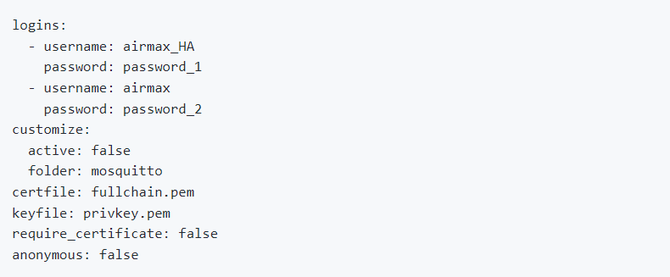
6. Start the add-on. Have some patience and wait a couple of minutes.
7. Check the add-on log output to see the result.
8. Navigate in your Home Assistant frontend to Configuration -> Integrations.
9. MQTT should appear as a discovered integration at the top of the page. Select it and check the box to enable MQTT discovery, and hit submit.

#### Configure MaxAir to Communicate Using MQTT

##### Create an MQTT Connection

From Settings/System Configuration/MQTT select ‘Add’

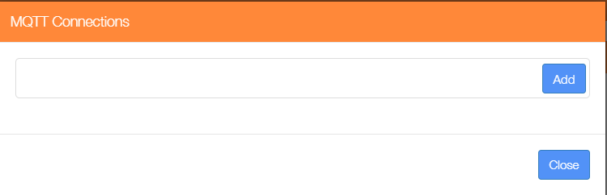

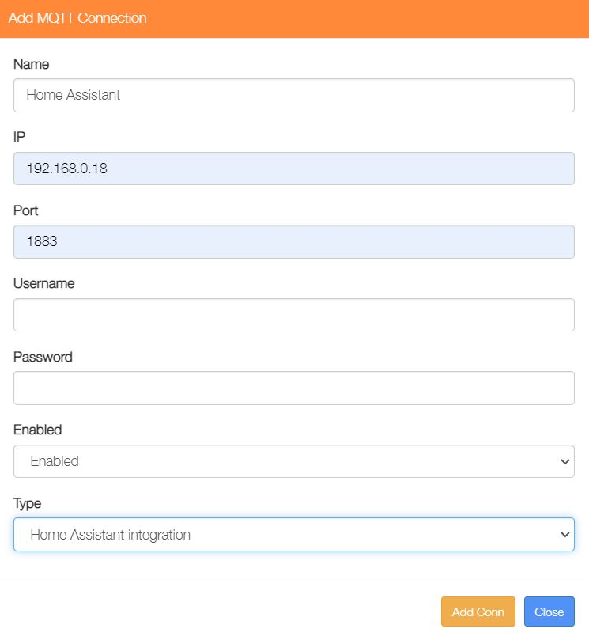The example shows is using the Mosquitto Broker IP address of 192.168.0.18, with a default Port number of 1883, the Username and Password were as setup when configuring the broker, the connection is Enabled and the Type is selected as ‘Home Assistant integration’.

#### Install the MaxAir Home Assistant Integration Service

From Settings/System Maintenance/Install Software and select the ‘Install’ option for ‘Install Home Assistant Integration’.

This will install any required dependencies, install and start the service.

Please note that this integration will search for new zones and sensors only at start up. If new sensors or zones are added to the system reboot the system or restart the integration using 'systemctl restart HA_integration.service'.

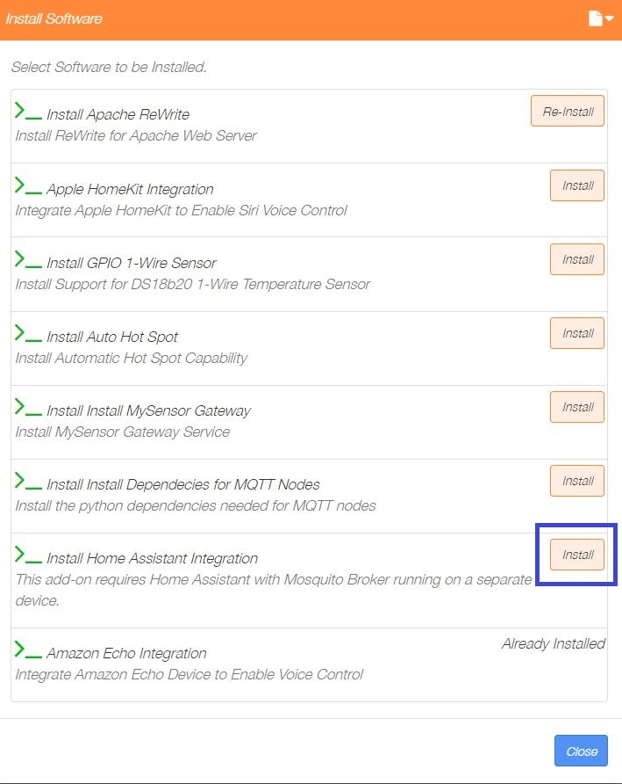

The installation will start and run as a scheduled background task, please be patient, once complete the ‘Installing Software’ dialogue will be updated.

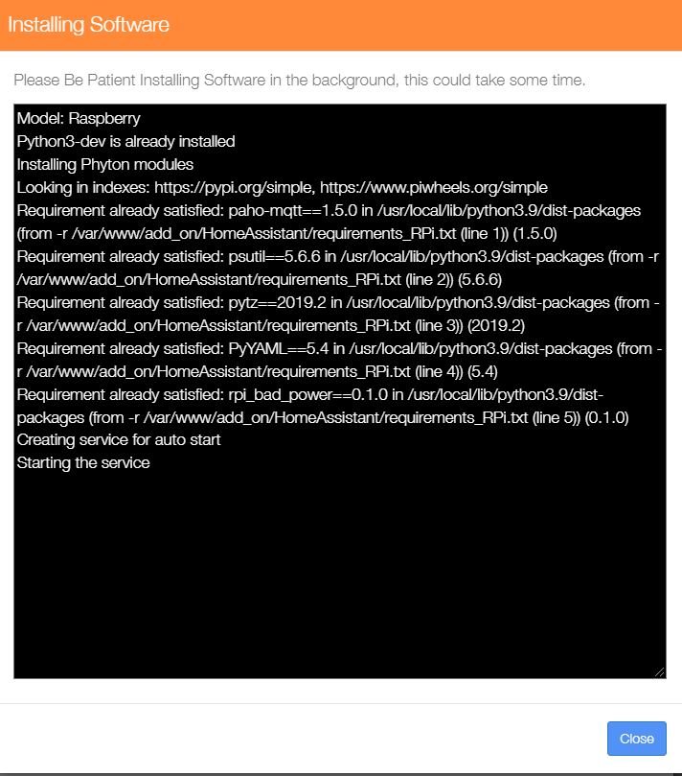

#### Creation of Home Assistant Entities

The Home Assistant entities will be automatically created via MQTT auto discovery.

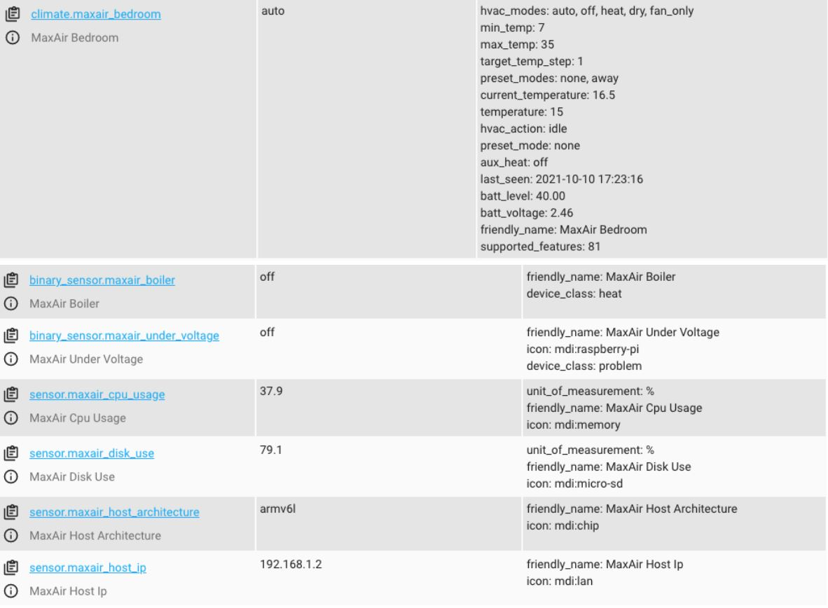

The Climate entity allows to trigger the MaxAir Boost function (Aux Heat in Home Assistant) for each zone, adjust the Live Temperature for each zone (Temperature in Home Assistant), enable or disable the MaxAir Away status (Pre-set in Home Assistant) and change the MaxAir Mode (Operation in Home Assistant).

## HTTP/Homebridge

The ‘homekit’ add-on was initially created to allow voice control using Apple’s Siri, the add-on uses ‘Homebridge’ together with its associated ‘Webhooks’ plugin to create a HomeKit Bridge device, this can then be accessed using Apple’s HomeKit app.

Home Assistant has a ‘Homekit Controller’ add-on which enables communication with Homekit compliant devices and hence can be used as a mechanism for integration of MaxAir with Home Assistant.

### Setup

#### Homebridge plus Webhooks Plugin

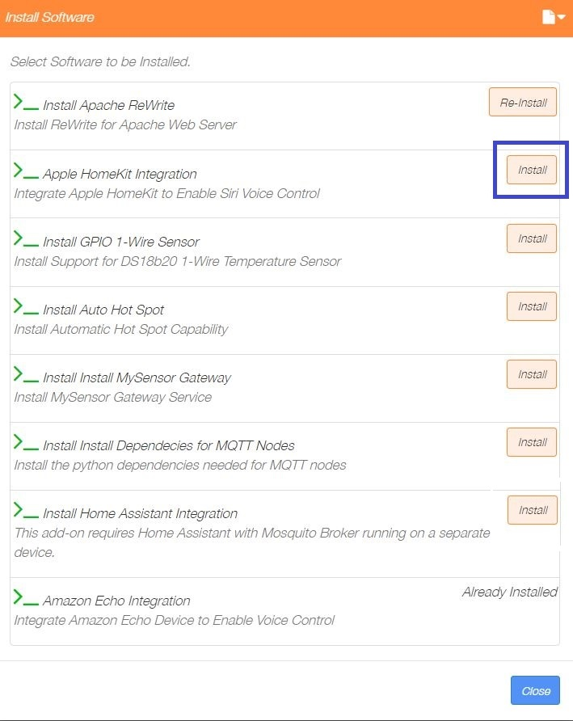From Settings/System Maintenance/Install Software and select the ‘Install’ option for ‘Apple HomeKit Integration’.

This will install any required dependencies, install and start the services for both Homebridge and the data transfer to Webhooks.

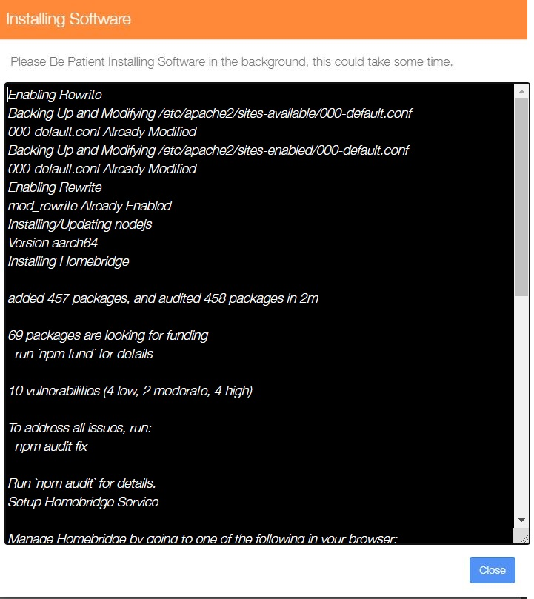

Please note that this integration will search for new zones and sensors only as part of the initial installation. If new sensors or zones are added to then the configuration file /var/lib/homebridge/config.json will need to be re-created, yhis can be achieved by at a console prompt issuing the command python3 /var/www/add_on/homekit/config_json.py.

The [Homebridge UI](https://github.com/oznu/homebridge-config-ui-x) web interface will allow you to install, remove and update plugins, and modify the Homebridge config.json and manage other aspects of your Homebridge service.

Login to the web interface by going to http://<ip address of your server>:8581.

The default user is **admin** with password **admin**.

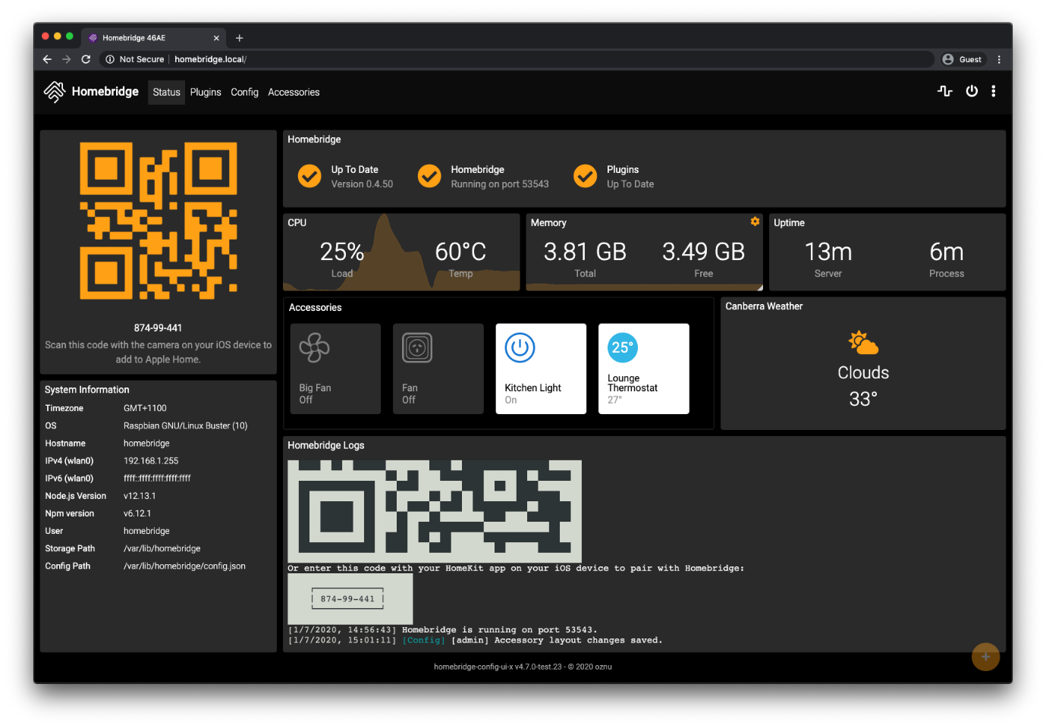

#### Configuration Reference

This table contains important information about your setup.

|  |  |
| --- | --- |
|  | **File Location / Command** |
| **Config File Path** | /var/lib/homebridge/config.json |
| **Storage Path** | /var/lib/homebridge |
| **Restart Command** | sudo hb-service restart |
| **Stop Command** | sudo hb-service stop |
| **Start Command** | sudo hb-service start |
| **View Logs Command** | sudo hb-service logs |
| **Systemd Service File** | /etc/systemd/system/homebridge.service |
| **Systemd Env File** | /etc/default/homebridge |

#### Example Configuration File

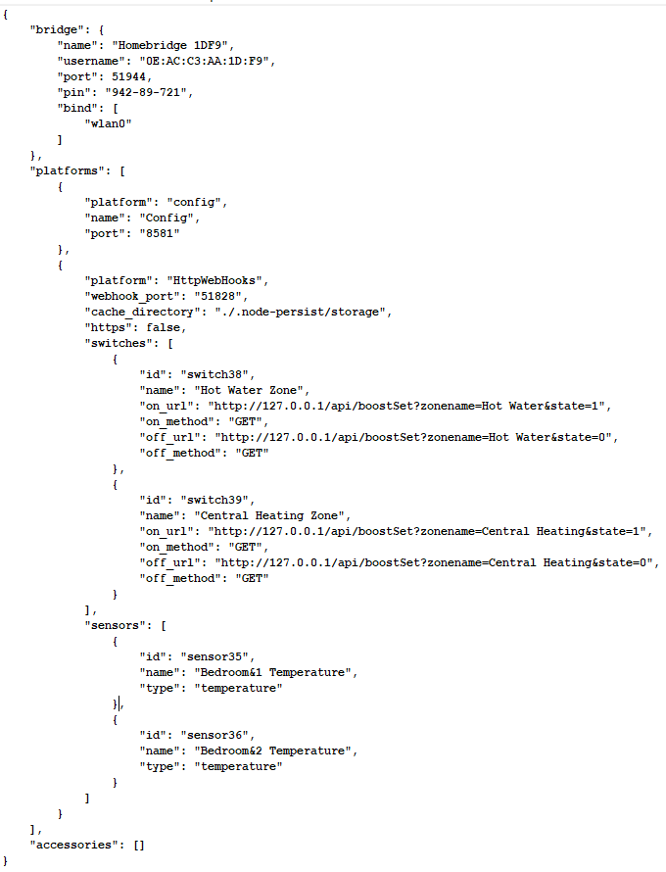This configuration shows 2 switch zones to control Hot Water and Central Heating Boost, together with 2 temperature sensors.

#### Home Assistant

In Home Assistant follow the steps bellow to install the HomeKit Controller Integration:

1. Navigate in your Home Assistant frontend to Configuration
2. Select the Devices and Services option
3. Click on + ADD INTEGRATION
4. Search for HomeKit Controller and select

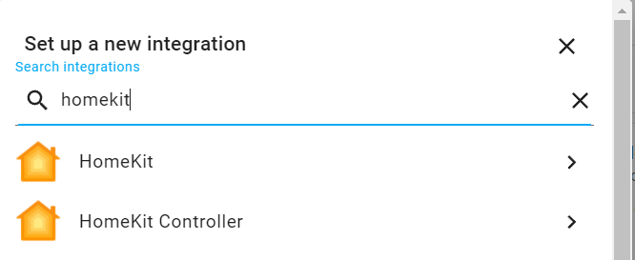

1. 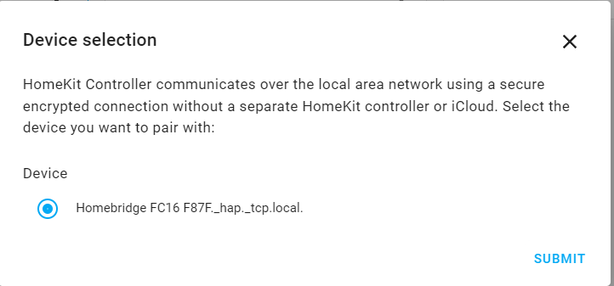Homebridge will be identified, click on SUBMIT
2. 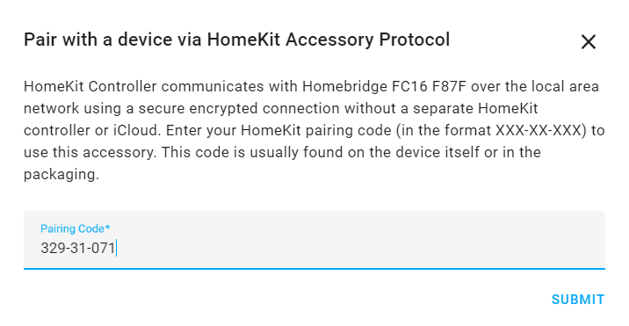You will be prompted for a Pairing Code, this can be found on the Homebridge Status screen, enter and click on SUBMIT
3. The setup should then complete, automatically creating the entices.

### Creating a Home Assistant Dashboard

Get started with setting up a dashboard in home assistant for your MaxAir system. There is a default card created once the home assistant has imported the settings from MaxAir. Follow the directions below to start creating your MaxAir dashboard

* 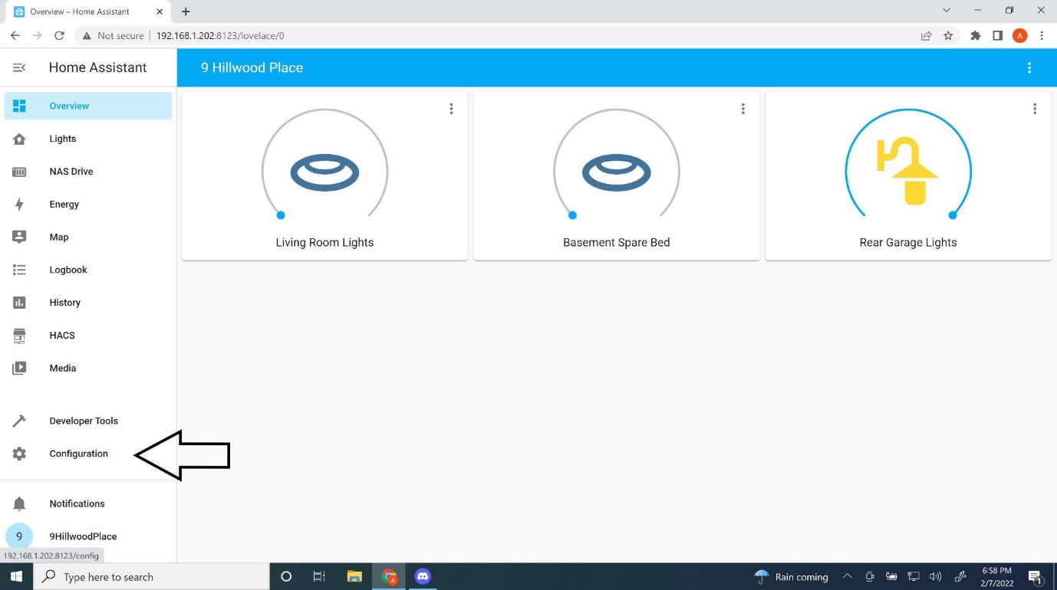From home assistant, Select configuration from the left side pane
* Select Dashboards

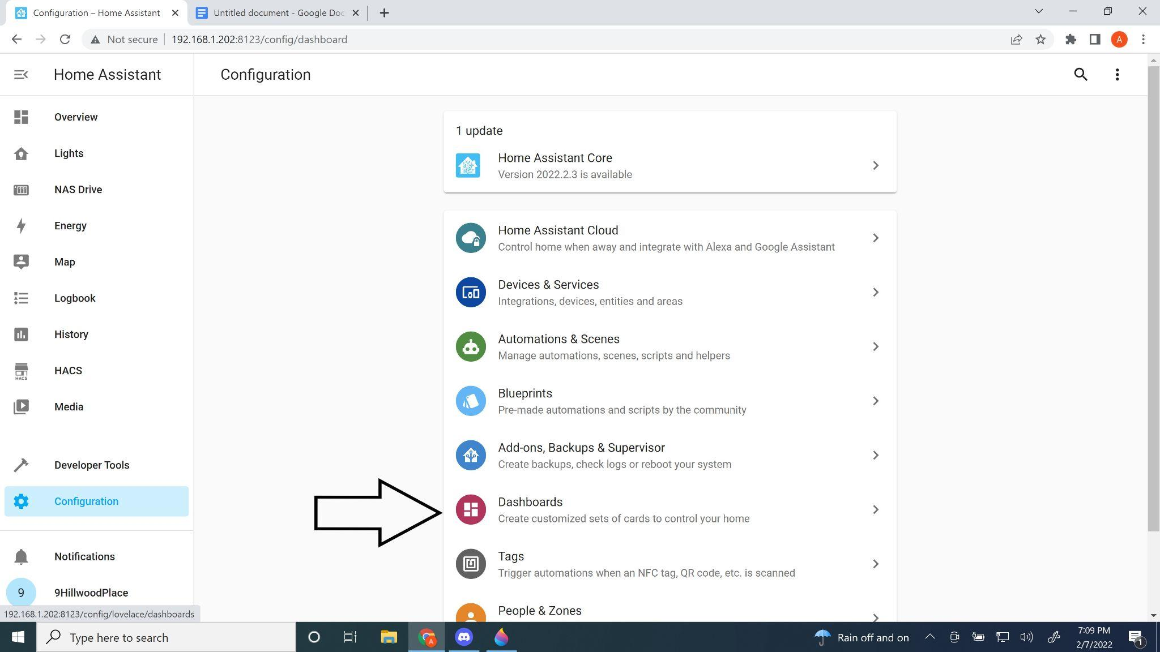

* Select Add Dashboard

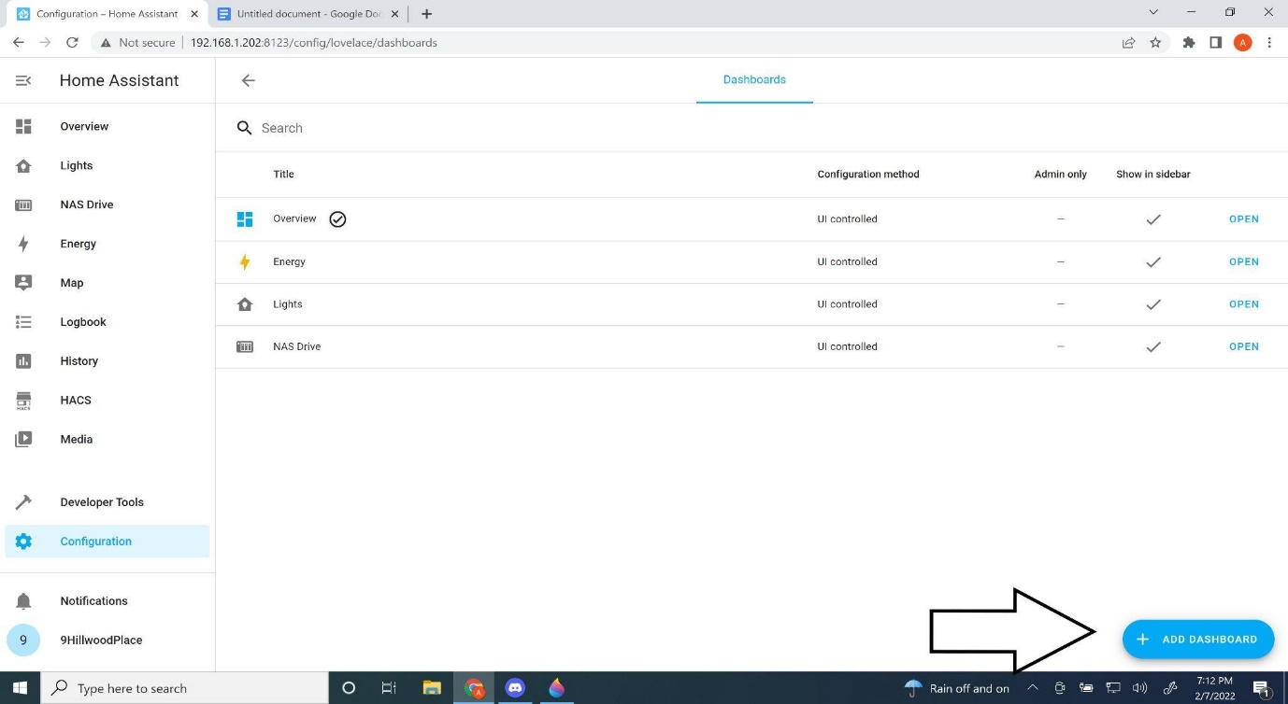

* Give your dashboard a title and icon. Start typing THERM in icon to bring up temperature related icons or choose anyone you want. Then Click create.

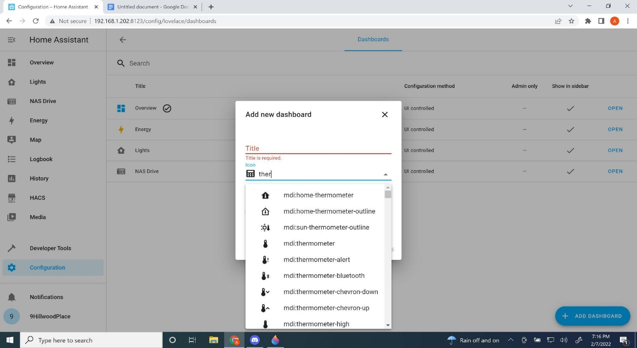

* You will see your newly created dashboard which will appear in the left pane and in the dashboard setting page

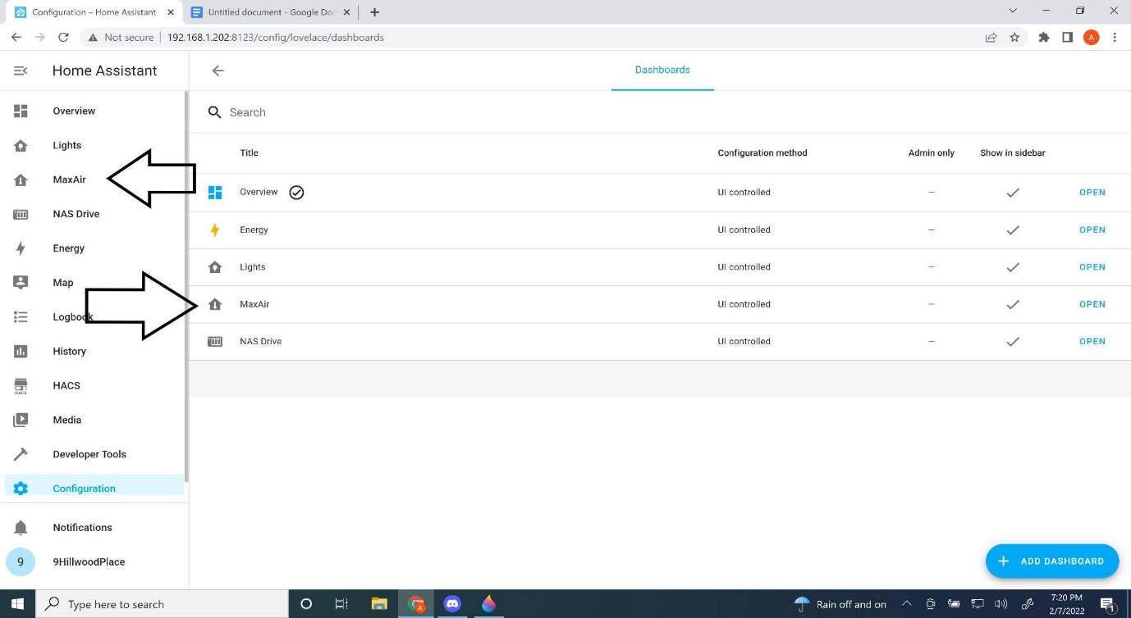

Click open

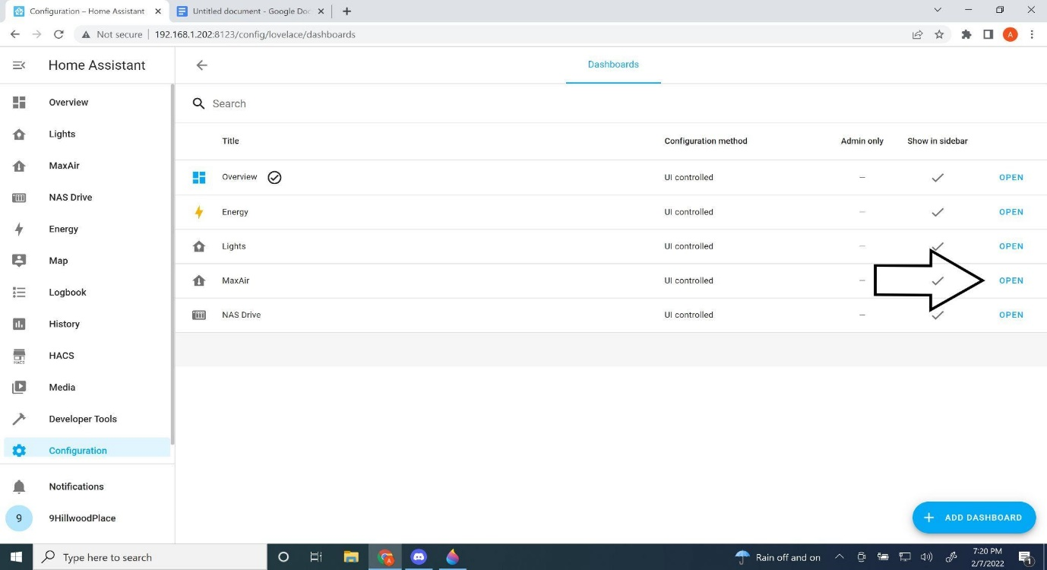

* Click the 3 dots, then click edit dashboard

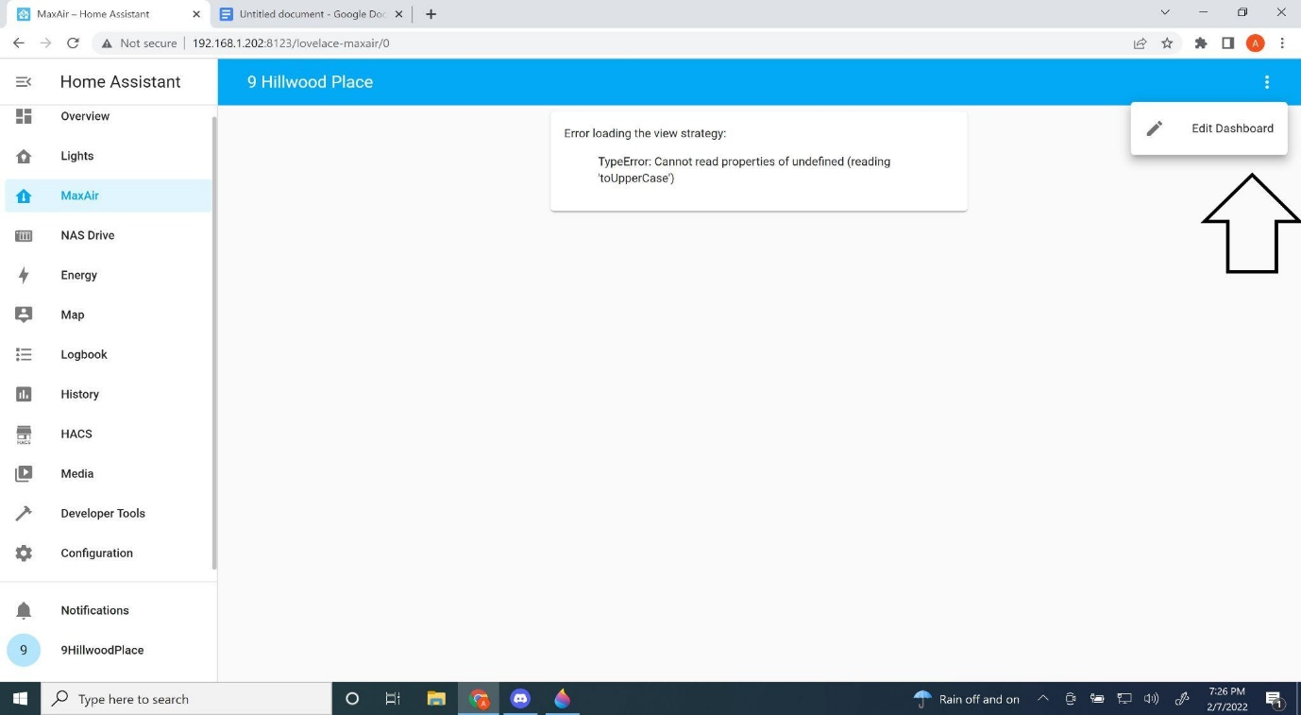

* Click “start with an empty dashboard”, then click “take control”

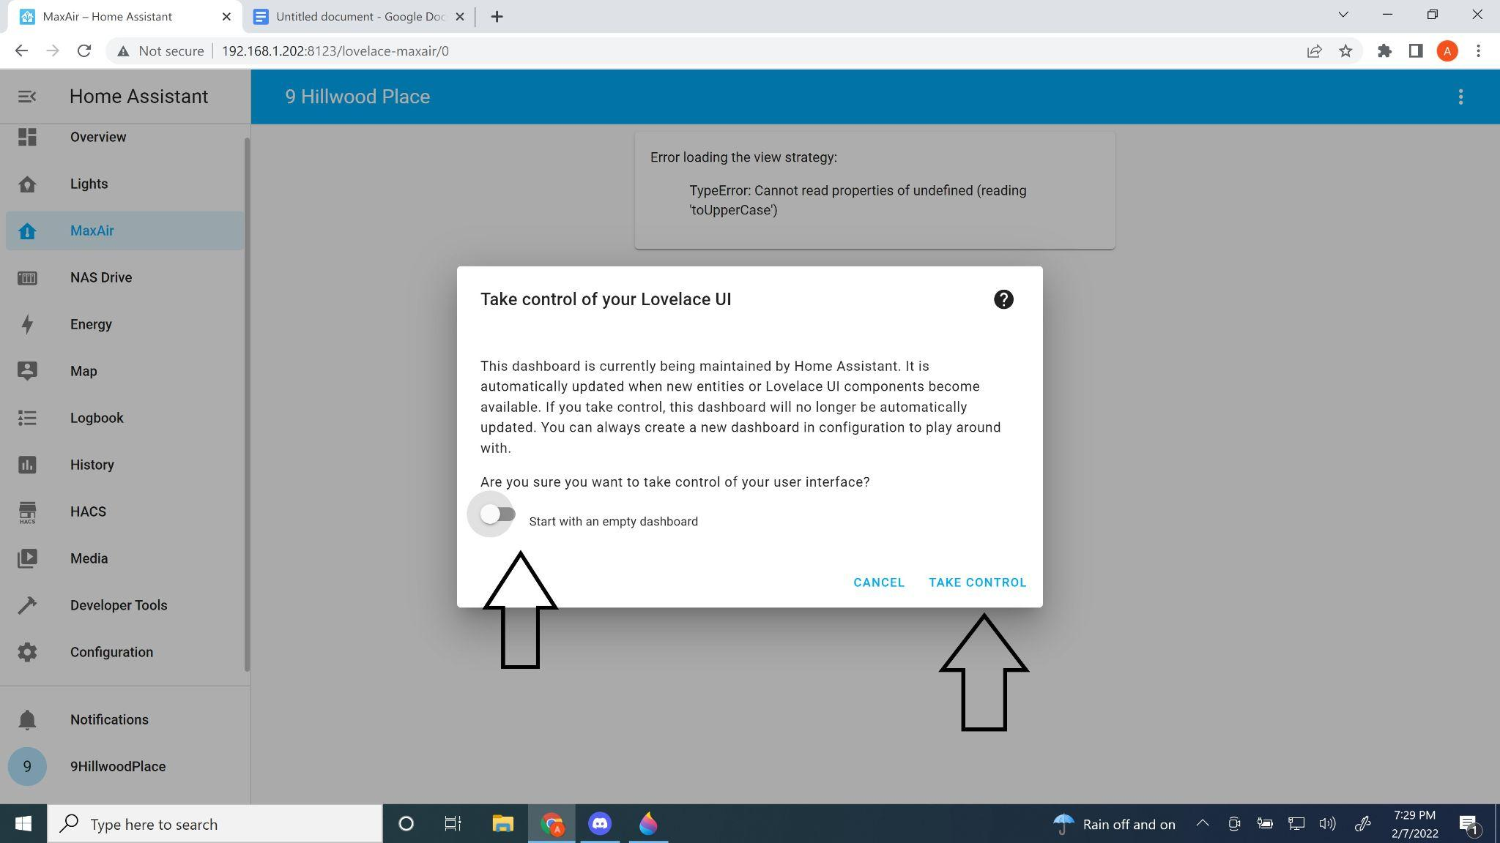

* 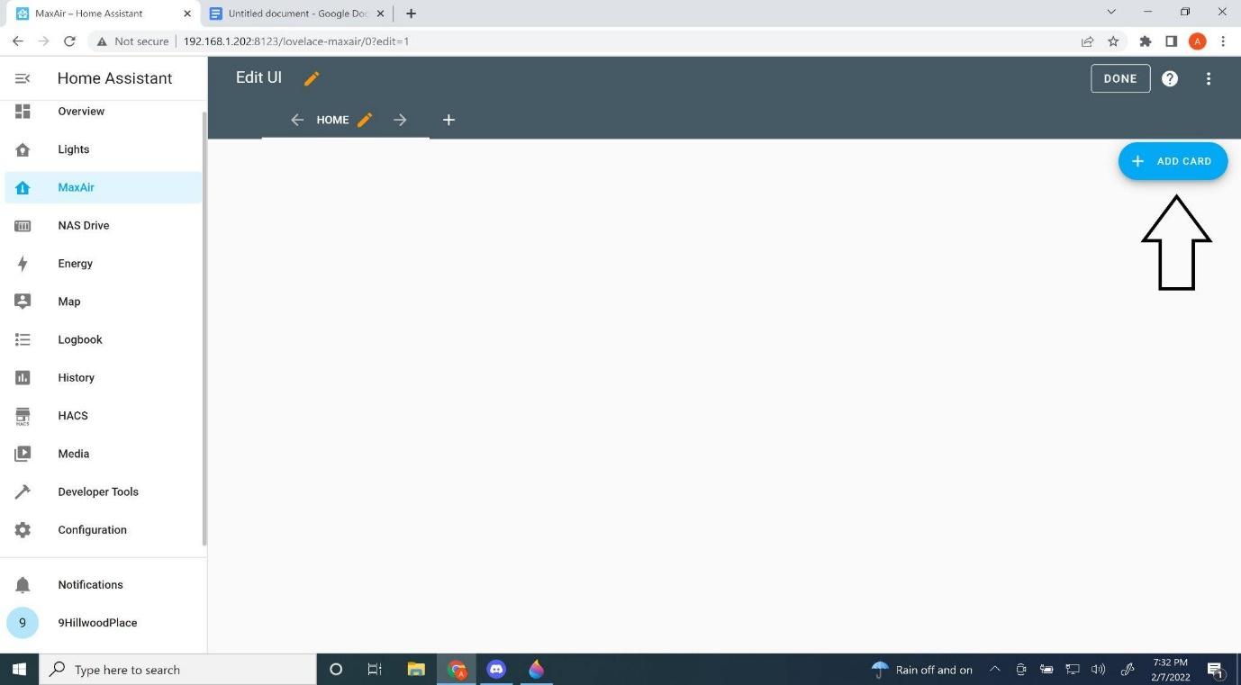Click add card
* Scroll down until you find “thermostat” card

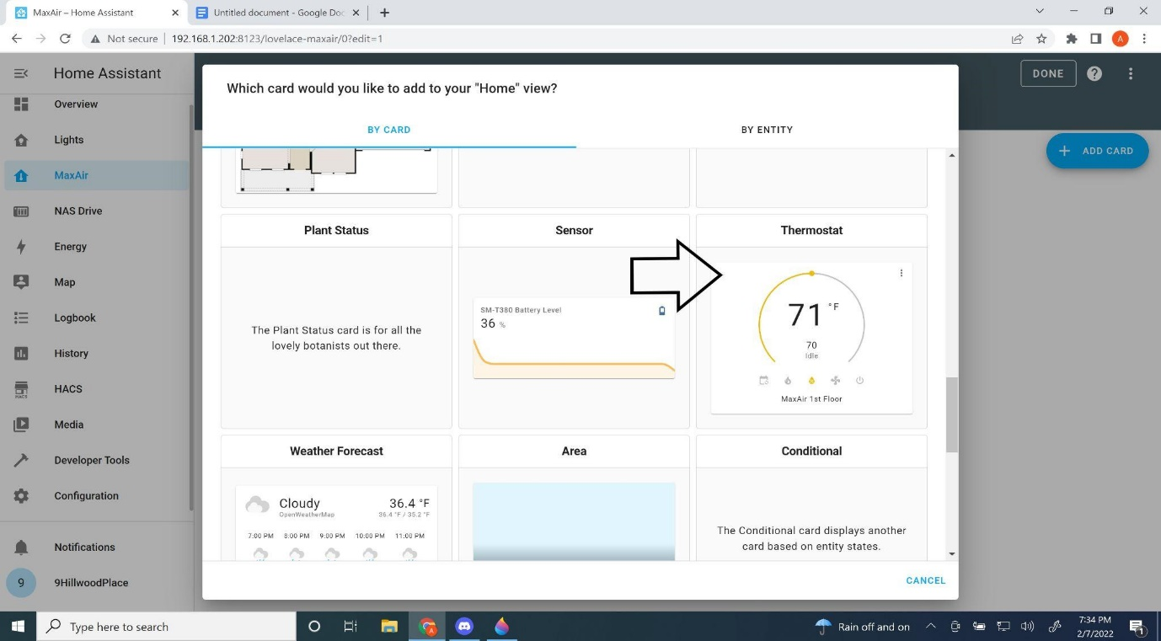

* Give a name and optional Theme. Giving a name is recommended or else it will be named by the entity title. Then click “save”

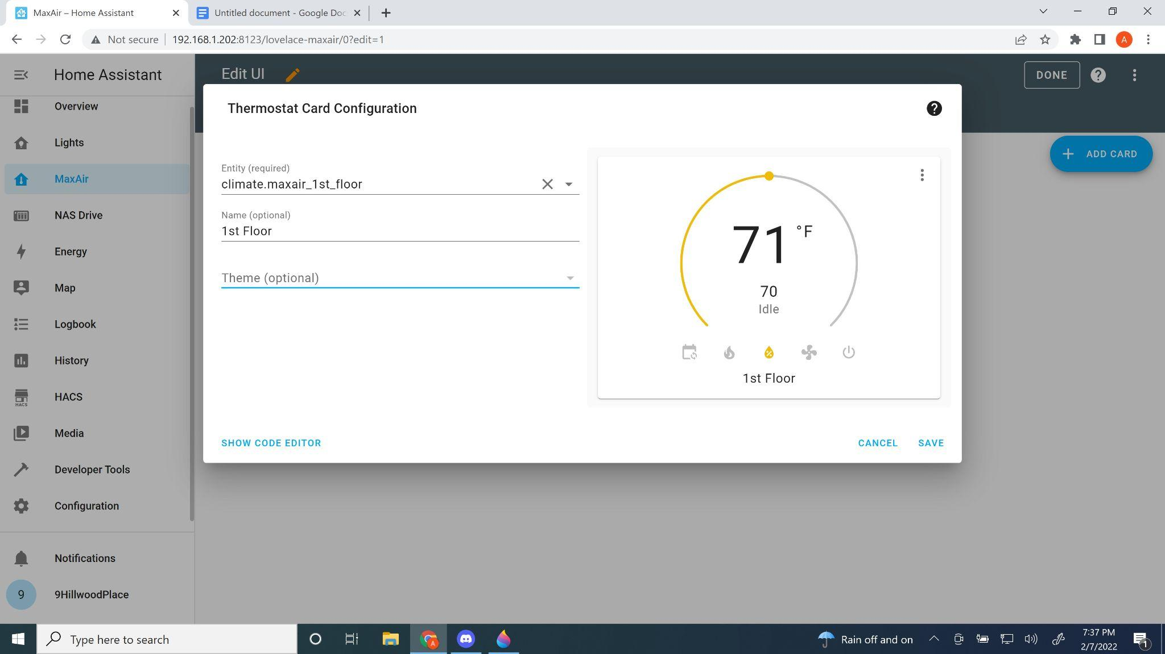

* Continue to click add card until you have added all of your zones.

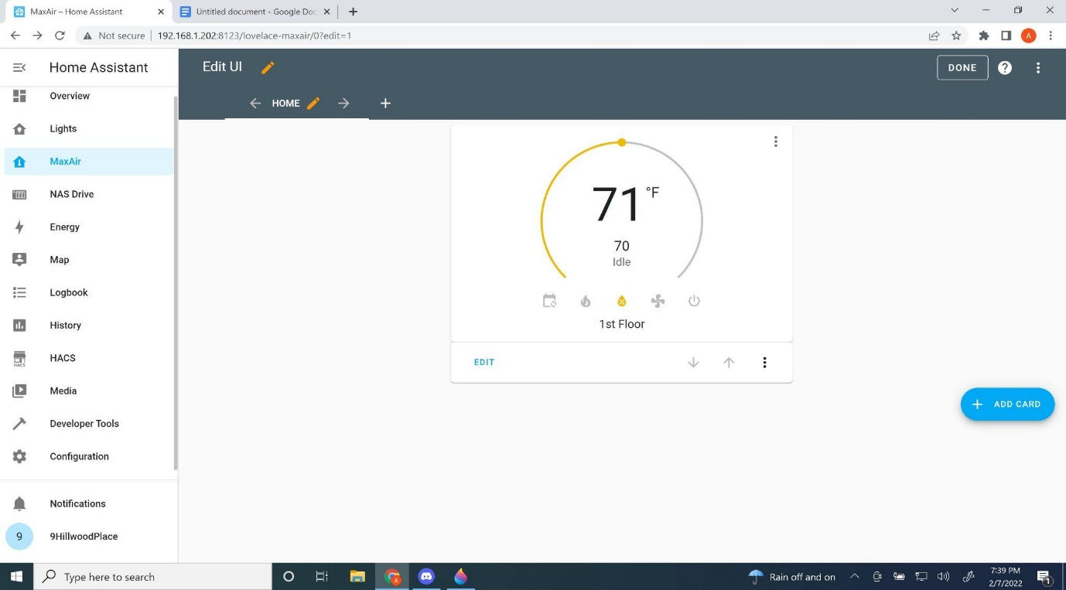

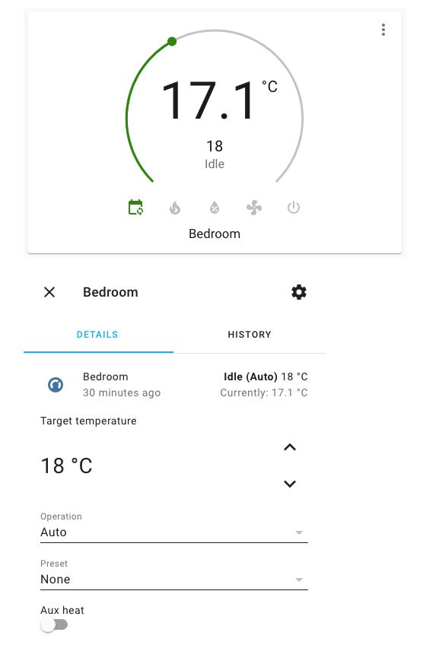

Unfortunately, the climate entity in Home Assistant supports only the following operations: off, auto, heat, cool, fan only and dry. When MaxAir is operating in boiler mode the Home Assistant operations are mapped as follow:

0 OFF -> off

1 Timer -> auto

2 CH -> heat

3 HW -> fan_only

4 Both -> dry

When MaxAir is operating in HVAC mode the Home Assistant operations are mapped as follow:

0 OFF -> off

1 Timer -> dry

2 Auto -> auto

3 Fan -> fan only

4 Heat -> heat

5 Cool -> cool

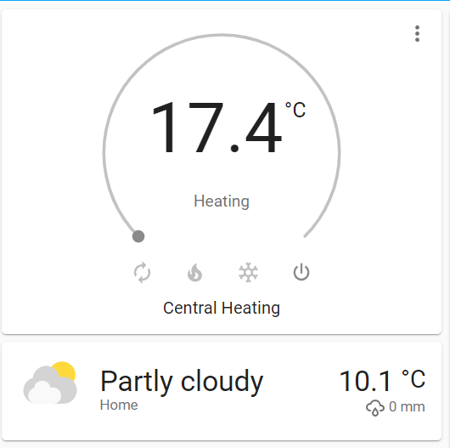

Unfortunately, the climate entity in Home Assistant supports only the following operations: off, auto, heat, cool, fan only and dry. When MaxAir is operating in boiler mode the Home Assistant operations are mapped as follow:

0 OFF -> Off

1 Timer -> Heat/Cool

2 CH -> Heat

3 HW -> Cool