A backup system image file of MaxAir database can be created and stored on a NAS drive.

A prerequisite is that a NAS drive should have been attached and mounted at either /mnt or /media.

## Scheduled Image File Creation

Scheduled Image File Creation use the ‘Job Scheduler’ to perform image creation on a periodic basis, aged archives are deleted after a set period and the destination location for the archive must be selected.

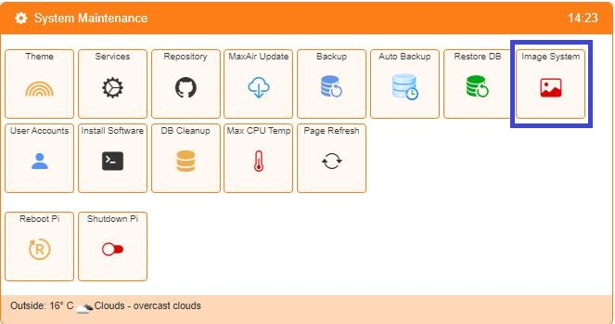Select the System Image option from the Settings/System  Maintenance menu.

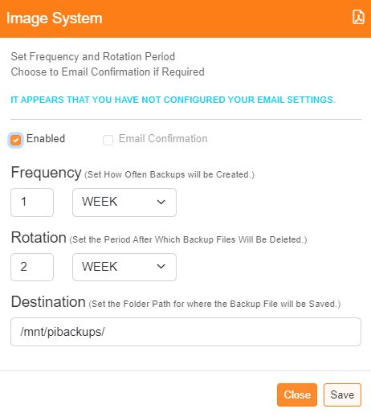

Select to enable the automatic system image creation and also if a confirmation email is required (the email option will only be selectable if and email address has been configured, as described earlier).

Set how often to perform the image creation and also how long to retain the archives before deletion.

Finally set the destination folder for storage of the archive file (this can be a network attached device).

Click ‘Save’ to store the configuration.

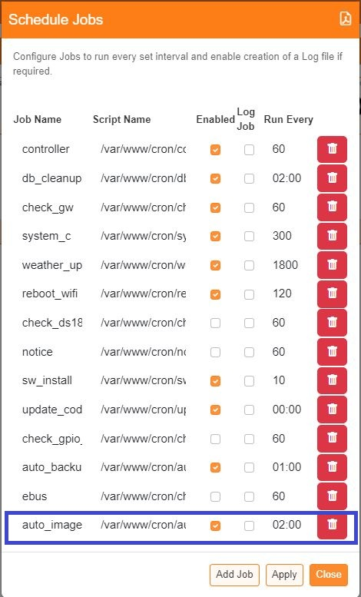

By default, the check for scheduled image creation will take place at 02:00 hours each day, this is determined by the Scheduled Job ‘auto_image’ and can be changed if required.