MaxAir implements status indicators, which reflect the current operational state of the system. These indicators vary depending on the function of the on-screen tile.

## Zone Tiles

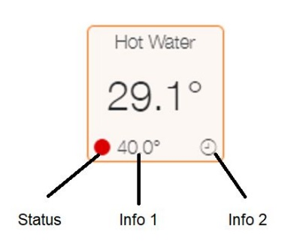

|  |  |
| --- | --- |
| **Status** | **Meaning** |
|  | Fault or Idle |
|  | Deadband or Coop |
|  | Away, Holidays or Hysteresis |
|  | Running |
|  | All other states |

|  |  |
| --- | --- |
| **Info 1** | **Meaning** |
| Numeric Value | Target Temperature for the Zone |

|  |  |
| --- | --- |
| **Info 2** | **Meaning** |
|  | Controller or Sensor Fault |
|  | Schedule Running |
|  | Zone Overrun |
|  | Manual Mode |
|  | Override in Operation |
|  | Maximum Zone Temperature Exceeded |
|  | Night Climate in Operation |
|  | Away in Operation |
|  | Holiday Schedule in Operation |
|  | Boost in Operation |

## Sensor Tiles

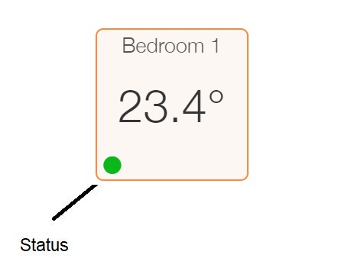

|  |  |
| --- | --- |
| **Status** | **Meaning** |
|  | Normal Operation |
|  | Sensor has Not Reported within timeout |

## System Controller Tile

The System Controller Tile uses colour coding of the flame to indicate the current state.

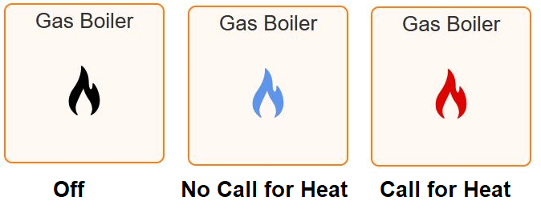

Addition information is shown by the right corner status indicator.

