MaxAir supports zones based on a category, which defines the basic capability of the zone, the available categories are:

|  |  |
| --- | --- |
| **Category** | **Description** |
| 0 | Controller, Sensor and System Control |
| 1 | Controller, Sensor and System Control (Positive Sensor Gradient) |
| 5 | Controller, Sensor and System Control (Negative Sensor Gradient) |
| 6 | Controller, Binary Sensor and System Control |
| 3 | NO Controller, Sensor and System Control (HVAC) |
| 4 | Controller, Sensor and System Control (HVAC Multi Zone) |

**Note: Category 1 and Category 5 are essentially the same, the only difference being the way in which the Controller is activated. Category 1 zones switch as the sensor reading increase to a target value, while Category 5 zones switch as the sensor reading decreases to a target value. For example, an electrical Immersion Heater would be Category 1, while a De-Humidifier would be Category 5.**

‘Zone Types’ can be created with a meaningful name and one of the above categories, for example a ‘Heating’ Zone would control the boiler relay and zone relay/s based on the readings taken from a temperature sensor and hence would use category 0. Above.

A number of Zone Types are pre-defined:

* Heating – category 0.
* Water – category 0.
* Immersion – category 1.
* Switch – category 2.
* HVAC – category 3.
* Humidity - category 1.
* Binary – category 1 or category 5, using a Binary type sensor.
* HVAC-M – category 4.
* Cooling - category 5.

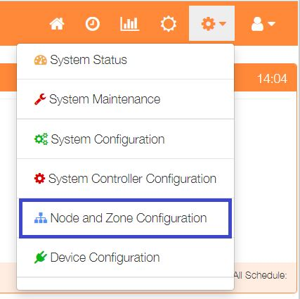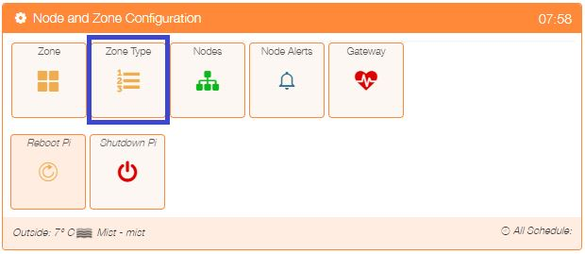The currently defined Zone Types can be viewed by selecting ‘Node and Zone Configuration’ from the Settings dropdown list, then clicking the ‘Zone Type’ button.

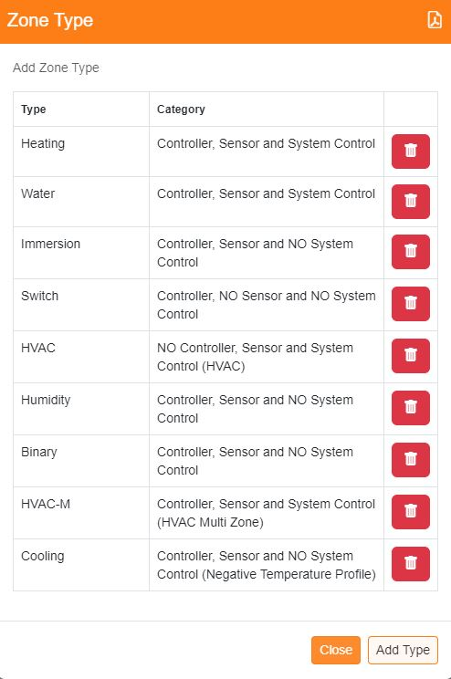

Zone Types can be deleted by clicking on the ‘trash’ icon or addition ones added by clicking on the ‘Add Type’ button.

New Zone Types are added by entering a ‘meaningful’ name for the new Zone and selecting the appropriate ‘Category’ from the dropdown list and finally clicking on the ‘Save’ button.

