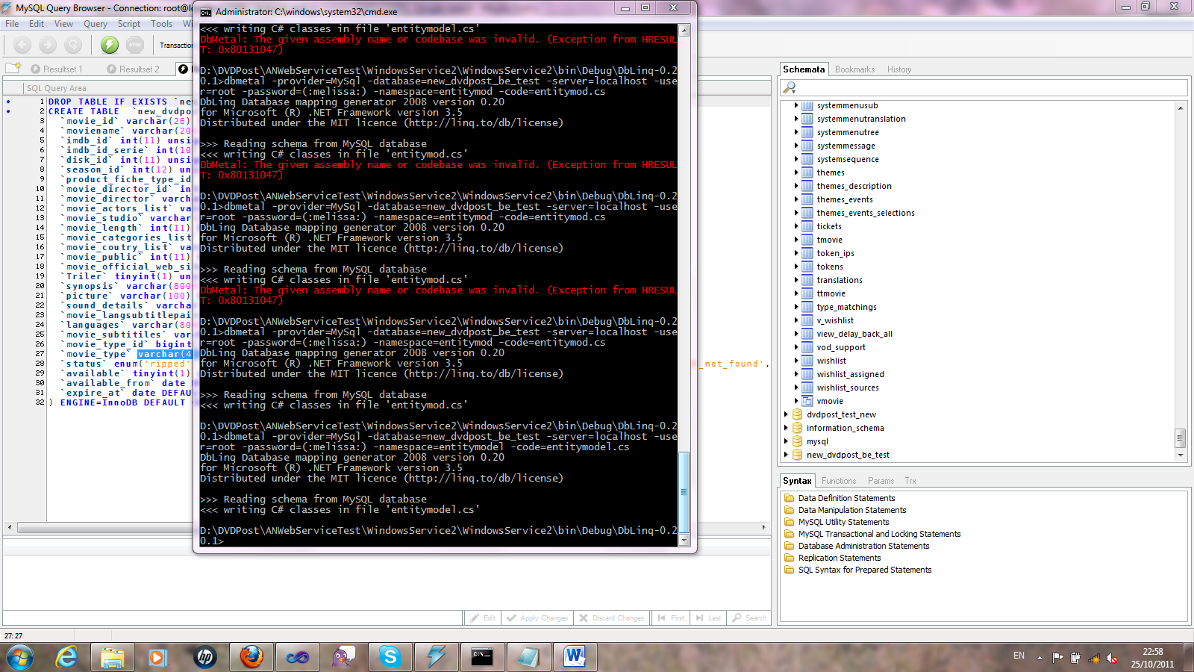

dbmetal -provider=MySql -database=dvdpost_mobile_api_ws -server=localhost -user=root -password=(:melissa:) - namespace=MobileDevicesService -code=mobilemodel.cs