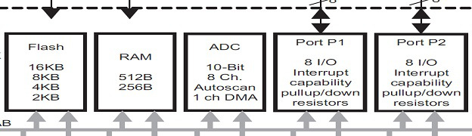

MSP430 ADC Tutorial
In this MSP430 ADC tutorial the MSP430G2253 will be used as an example. Texas Instruments ships the MSP430G2253 microprocessor with the latest Launchpad, the datasheet for the MSP430G2253 can be downloaded here
The MSP430G series devices are supplied in a number of packages with different specification and peripherals, there are 2 types of ADC, ADC10 and ADC12. The ADC10 is a 10bit analog to digital conversion and the ADC12 is a 12bit analog to digital conversion. The MSP430G2253 only incorporates the ADC10, apart from having greater resolution the ADC12 does not differ that much from the ADC10. Suggested reading on the main differences between the 2 types of ADC is the MSP430x2xx Family User’s Guide, which at the time of writing is release SLAU144J here
Before reading further if you are having trouble understanding how the registers work, and how the C code updates the individual register settings? It would be worth reading my MSP430 Programming Tutorial, Part 1 covers the basics and Part 2 gives clear examples. You can find them here Part 1 and Part 2.

ADC10 Resolution
Firstly lets clarify what 10bit resolution is and how this maybe relevant to the accuracy of a project. 10bit means 2 to the power of 10, or 2x2x2x2x2x2x2x2x2x2x2 which equals 1024, the 1024 is the number of sample steps taken over a given range (in the case of microcontrollers it’s actually 0 to 1023).
So now we understand the term regarding bit size, we need to find the range. The range is defined as what voltage range the ADC accepts, to find this we need to consult the datasheet for the MSP430G2253, an extracted image from the datasheet can be seen below.
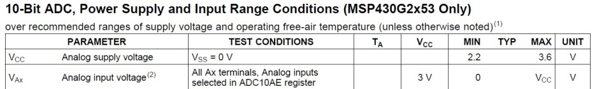
So from this the voltage range for the ADC can be determined as 0-3 volts. So now that we have the range and the number of sample steps, we can now determine the resolution of the ADC with some simple maths. The ADC12 has also been shown to help illustrate the step size changes and how this affects accuracy.
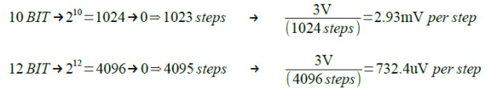
So using an example we can see what this would mean in real terms, if 1.5V was fed into the ADC input.
Now the value of 512 or 2048 is the value that would be stored as a variable by the ADC, this can actually be seen in Code Composer Studio and will be demonstrated later on in this tutorial.

ADC10 Registers
The ADC10 module on the MSP430G devices is configured by the user through software. There are various registers used to change the way the ADC10 operates dependent on the application requirements.
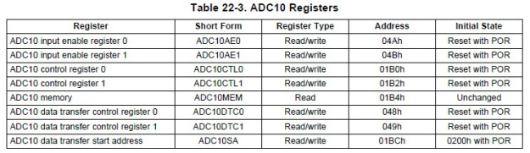

ADC10 Analog Input Enable Register 0
This allows the user to enable the specific GPIO pin/s for analog input. The command used for this register looks something like this ADC10AE0 |= 0x02; (0x02 is selecting the ADC A1 or port P1.1).

ADC10 Analog Input Enable Register 1
This is not available on the MSP430G2253 device.

ADC10 Control Register 0
Control register 0 has various parameters that can be set which are listed below, the MSP430 Family Guide SLAU144J has a full list of all these parameters with more in depth descriptions. The command used for this register looks something like this ADC10CTL0 = SREF_1 + ADC10SHT_2 + REFON + ADC10ON + ADC10IE;
SREFx – Select Reference. There are varies parameter options that can be set for select reference.
ADC10SHTx – Sample and Hold Time. This adjust how many clock cycles the sampling period will be.
ADC10SR – Sampling Rate. Adjusts the sampling rate between ~200ksps or ~50ksps
REFOUT – Reference Output. Reference voltage output to GPIO pin with Vref capability
REFBURST – Reference Burst. Disables the internal reference voltage automatically when the ADC10 is not converting.
MSC – Multiple Sample Conversion. Allows multiple samples to be taken automatically.
REF2_5V – Reference Generator Voltage. selectable between 1.5V and 2.5V
REFON – Reference Generator On. Turns on the internal reference voltage.
ADC10ON – ADC10 On. Turns on the ADC10
ADC10IE – Interrupt Enable. Enables interrupts for the ADC10
ADC10IFG – Interrupt Flag. Enables Interrupt flag for the ADC10
ENC – Enable Conversion. Enables the conversion and can be used to stop a conversion by resetting ENC.
ADC10SC – Start Conversion. Starts the conversion on the ADC10

ADC10 Control Register 1
Control register 1 has various parameters that can be set which are listed below, the MSP430 Family Guide SLAU144J has a full list of all these parameters with more in depth descriptions. The command used for this register looks something like this ADC10CTL1 = INCH_10 + ADC10DIV_3 + CONSEQ_2;
INCHx – Input Channel Select. This selects the GPIO pin/s used for the ADC input.
SHSx – Sample and Hold Source Select.
ADC10DF – Data Format. Straight binary or 2s compliment.
ISSH – Invert Signal Sample and Hold.
ADC10DIVx – Clock Divider. Allows the chosen clock source used for the ADC to be divided down.
ADC10SSELx – Clock Source Select. Allows the user to select which of the MSP430 clocks to be used for the ADC.
CONSEQx – Conversion Sequence Mode. Allows difference conversion sequences on single or multiple channels.
ADC10BUSY – Busy. Indicates an active sample or conversion operation.

ADC10 Memory
This is the conversion memory register. The command used for this register looks something like this ADC_data = ADC10MEM;

ADC10 Data Transfer Control Register 0
Data transfer control (DTC) register 0, has various parameters for the control of the data transfer. The DTC automatically transfers conversion results from ADC10MEM to other on chip memory locations. The command used for this register looks something like this ADC10DTC0 |= ADC10TB + ADC10CT;

ADC10 Data Transfer Control Register 1
Data transfer control register 1, defines the number of transfer in each block. The command used for this register looks something like this ADC10DTC1 = 0x20;

ADC10 Data Transfer Start Address
ADC10SAx – Start Address. The command used for this register looks something like this ADC10SA = 0x0200;

