Hasura Training

 Figure 1: https://tinyurl.com/mvf2ecee

What We Will Need

http://cloud.hasura.io

https://www.heroku.com/

What We Will Need (Optional)
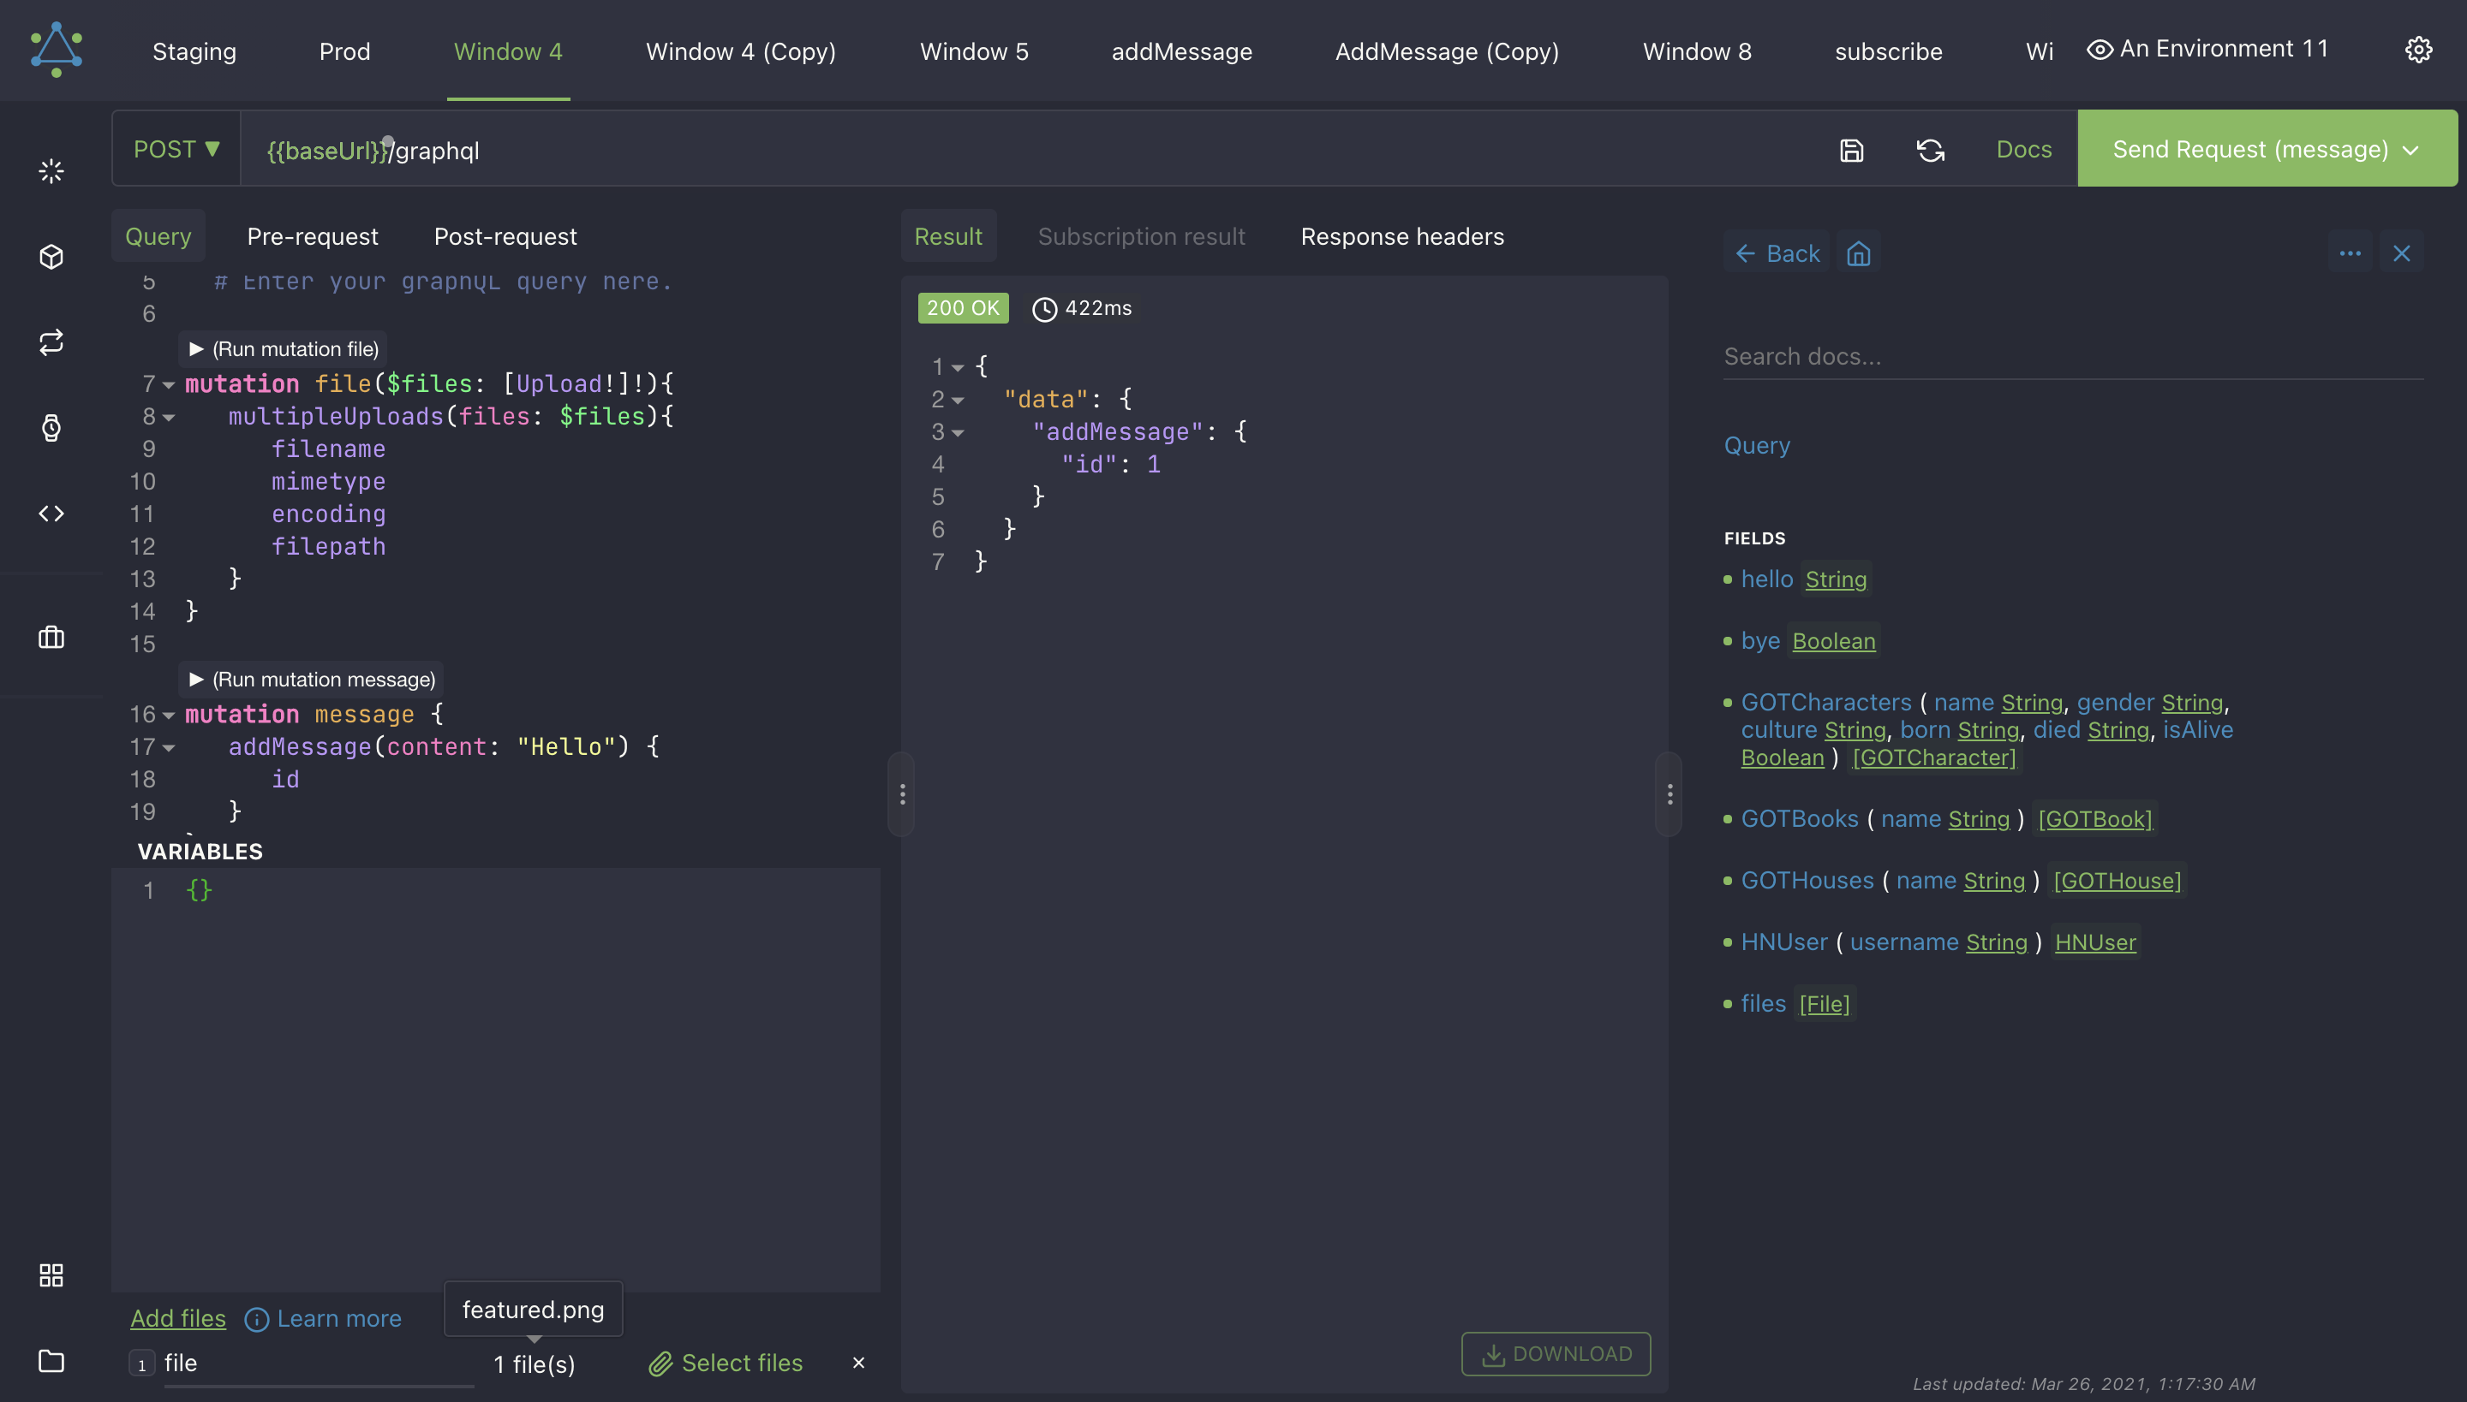
https://altairgraphql.dev/

What We Will Cover
- What is GraphQL?
- What is Hasura?
- How do we use them?
- How do we use them well?
- What are the general principles?
- What are the particular details?
- What is the proper mental model?
- How do we get there?

What is GraphQL?
- Query Language
- Schema
  - Types
    - Fields
- Types relate to Types
- Sound familiar?
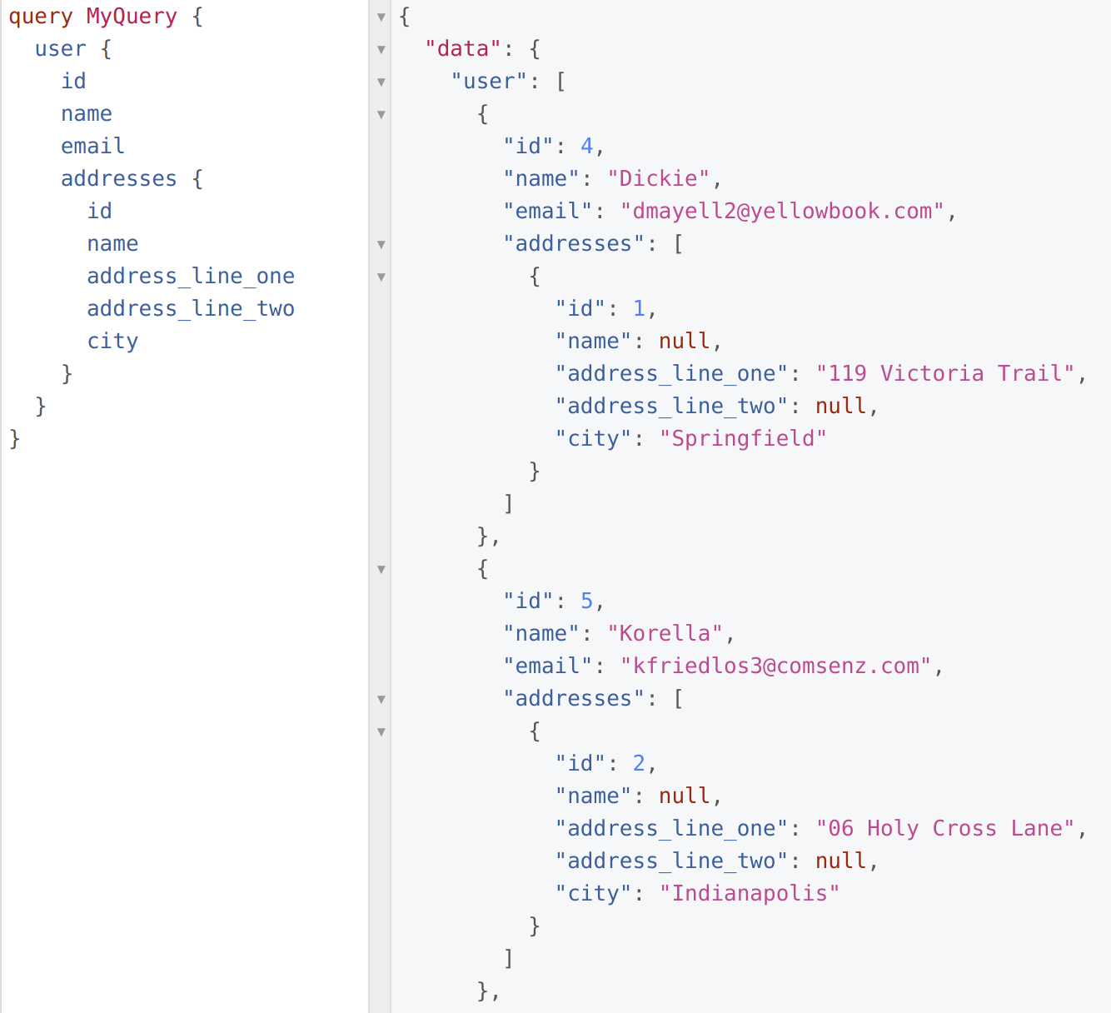

What is Hasura?
- API Server
- Development Environment

How do we use them?
- Build network applications faster, more reliably, and cheaper with GraphQL.
- Build GraphQL applications faster, more reliably, and cheaper with Hasura.
- Apply the general principles with training from Hasura Developer Relations.
- Apply the particular details with support from Hasura Developer Success.

How do we use them well?
- Adopt a principled approach.
- Develop a proper mental model.

What are the general principles?
- Build for humans.
- Build with personas.
- Build in the database.
- Build a data model.
- Remember OLTP vs OLAP.

What is the proper mental model?
- Hasura graphql-engine is the API server, is on the data plane, and is on the critical path.
- Hasura console is part of the development environment, is on the control plane, and is off the critical path.
- Hasura CLI is part of the development environment, is on the control plane, and is far off the critical path.

What is the proper mental model?
- The key functional concerns are: data modeling, API development, security, and integrations.
- The key non-functional concerns are: deployment, caching, monitoring.

How do we get there?
- Track 1: Development
- Track 2: Deployment

Track 1: Development
- Setup
- Modeling
- Security
- Actions
- Events
- APIs
- Remote Joins
- Remote Schema

Track 2: Deployment
- Self-Hosted vs Cloud
- Development Environment
- CI/CD

