Hasura Training

Pre-Work

David A. Ventimiglia

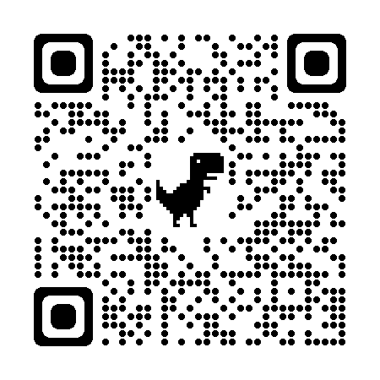 Figure 1: https://tinyurl.com/ytxjjck7

Step 1: Log into Neon
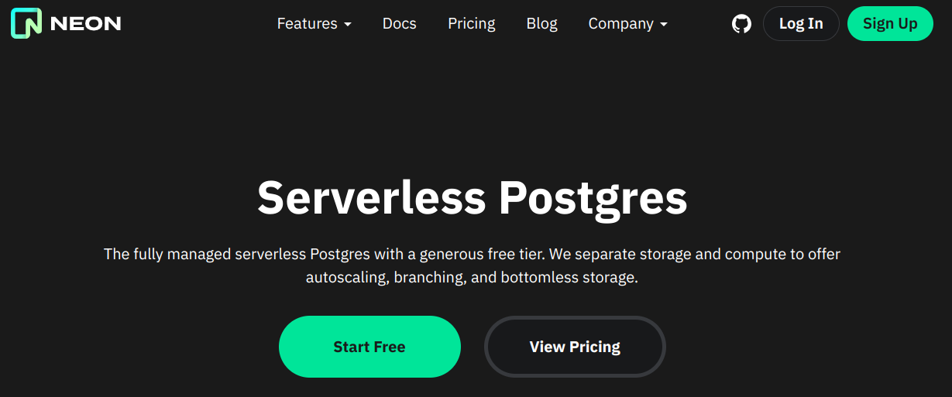

Step 2: Log into Hasura Cloud
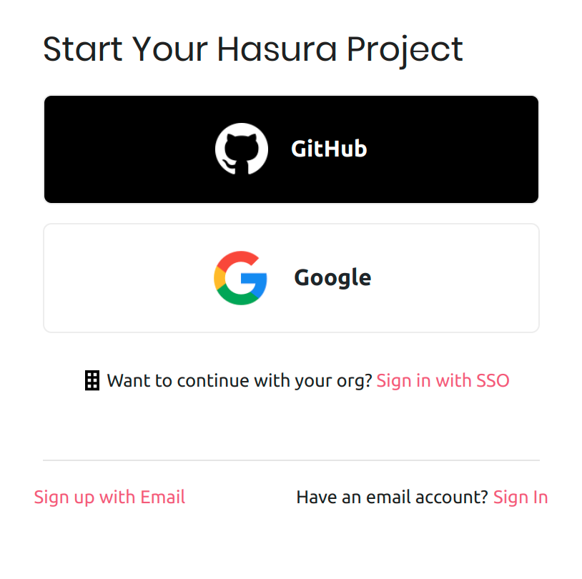

Step 3: Connect Neon to Hasura Cloud
My Account › Connections
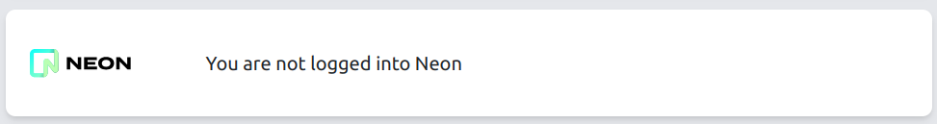

Step 4: Create a new Hasura Cloud Project
Projects › New Project
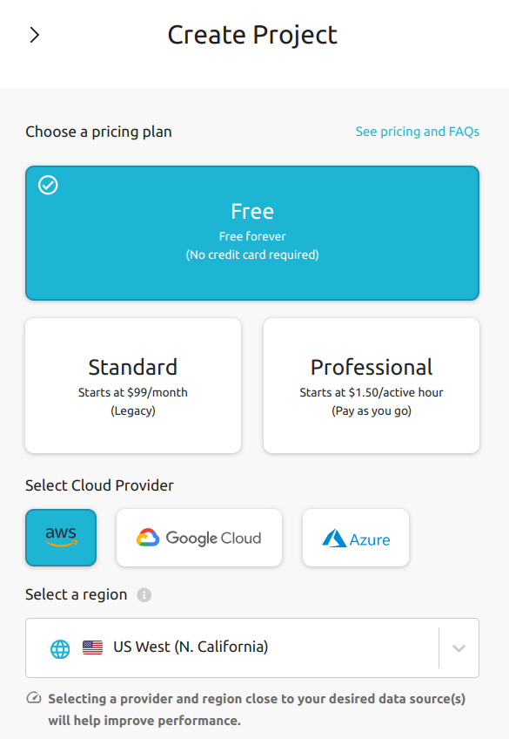

Step 5: Launch Console
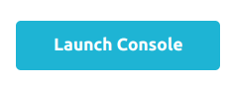

Step 6: Create a new Neon database
Console › Data › Connect Your First Database
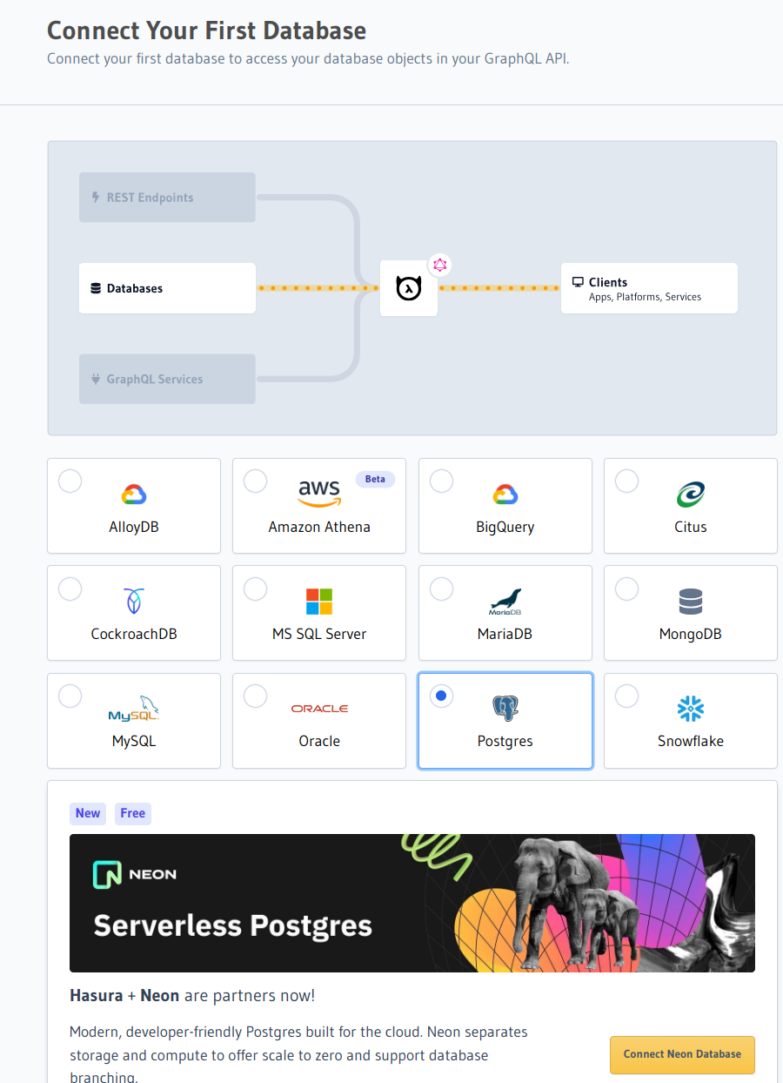

Step 7: Create the Data Model
Console › Data › Run SQL
https://tinyurl.com/367p55ca
-- -*- sql-product: postgres; -*-

CREATE EXTENSION IF NOT EXISTS pgcrypto;

-- account table

CREATE TABLE "public"."account" ("id" uuid NOT NULL DEFAULT gen_random_uuid(), "name" text NOT NULL, "created_at" timestamptz NOT NULL DEFAULT now(), "updated_at" timestamptz NOT NULL DEFAULT now(), PRIMARY KEY ("id") );
CREATE OR REPLACE FUNCTION "public"."set_current_timestamp_updated_at"()
RETURNS TRIGGER AS $$
DECLARE
_new record;
BEGIN
_new := NEW;
_new."updated_at" = NOW();
RETURN _new;
END;
$$ LANGUAGE plpgsql;
CREATE TRIGGER "set_public_account_updated_at"
BEFORE UPDATE ON "public"."account"
FOR EACH ROW
EXECUTE PROCEDURE "public"."set_current_timestamp_updated_at"();
COMMENT ON TRIGGER "set_public_account_updated_at" ON "public"."account"
IS 'trigger to set value of column "updated_at" to current timestamp on row update';

-- product table

CREATE TABLE "public"."product" ("id" uuid NOT NULL DEFAULT gen_random_uuid(), "created_at" timestamptz NOT NULL DEFAULT now(), "updated_at" timestamptz NOT NULL DEFAULT now(), "name" text NOT NULL, "price" integer NOT NULL, PRIMARY KEY ("id") );
CREATE OR REPLACE FUNCTION "public"."set_current_timestamp_updated_at"()
RETURNS TRIGGER AS $$
DECLARE
_new record;
BEGIN
_new := NEW;
_new."updated_at" = NOW();
RETURN _new;
END;
$$ LANGUAGE plpgsql;
CREATE TRIGGER "set_public_product_updated_at"
BEFORE UPDATE ON "public"."product"
FOR EACH ROW
EXECUTE PROCEDURE "public"."set_current_timestamp_updated_at"();
COMMENT ON TRIGGER "set_public_product_updated_at" ON "public"."product"
IS 'trigger to set value of column "updated_at" to current timestamp on row update';

-- order table

CREATE TABLE "public"."order" ("id" uuid NOT NULL DEFAULT gen_random_uuid(), "created_at" timestamptz NOT NULL DEFAULT now(), "updated_at" timestamptz NOT NULL DEFAULT now(), "account_id" uuid NOT NULL, PRIMARY KEY ("id") , FOREIGN KEY ("account_id") REFERENCES "public"."account"("id") ON UPDATE restrict ON DELETE restrict);
CREATE OR REPLACE FUNCTION "public"."set_current_timestamp_updated_at"()
RETURNS TRIGGER AS $$
DECLARE
_new record;
BEGIN
_new := NEW;
_new."updated_at" = NOW();
RETURN _new;
END;
$$ LANGUAGE plpgsql;
CREATE TRIGGER "set_public_order_updated_at"
BEFORE UPDATE ON "public"."order"
FOR EACH ROW
EXECUTE PROCEDURE "public"."set_current_timestamp_updated_at"();
COMMENT ON TRIGGER "set_public_order_updated_at" ON "public"."order"
IS 'trigger to set value of column "updated_at" to current timestamp on row update';

create index on "order" (account_id);

-- order_detail table

CREATE TABLE "public"."order_detail" ("id" uuid NOT NULL DEFAULT gen_random_uuid(), "created_at" timestamptz NOT NULL DEFAULT now(), "updated_at" timestamptz NOT NULL DEFAULT now(), "units" integer NOT NULL, "order_id" uuid NOT NULL, "product_id" uuid NOT NULL, PRIMARY KEY ("id") , FOREIGN KEY ("order_id") REFERENCES "public"."order"("id") ON UPDATE restrict ON DELETE restrict, FOREIGN KEY ("product_id") REFERENCES "public"."product"("id") ON UPDATE restrict ON DELETE restrict);
CREATE OR REPLACE FUNCTION "public"."set_current_timestamp_updated_at"()
RETURNS TRIGGER AS $$
DECLARE
_new record;
BEGIN
_new := NEW;
_new."updated_at" = NOW();
RETURN _new;
END;
$$ LANGUAGE plpgsql;
CREATE TRIGGER "set_public_order_detail_updated_at"
BEFORE UPDATE ON "public"."order_detail"
FOR EACH ROW
EXECUTE PROCEDURE "public"."set_current_timestamp_updated_at"();
COMMENT ON TRIGGER "set_public_order_detail_updated_at" ON "public"."order_detail"
IS 'trigger to set value of column "updated_at" to current timestamp on row update';

create index on order_detail (order_id);

create index on order_detail (product_id);

-- product_search function

create or replace function product_search(search text)
returns setof product as $$
select product.*
from product
where
name ilike ('%' || search || '%')
$$ language sql stable;

-- product_search_slow function

create or replace function product_search_slow(search text, wait real)
returns setof product as $$
select product.*
from product, pg_sleep(wait)
where
name ilike ('%' || search || '%')
$$ language sql stable;

-- non_negative_price constraint

alter table "public"."product" add constraint "non_negative_price" check (price > 0);

-- index account(name)

create index if not exists account_name_idx on account (name);

-- status enum

CREATE TYPE status AS ENUM ('new', 'processing', 'fulfilled');

-- add status to order table

alter table "public"."order" add column "status" status null;

create index on "order" (status);

-- region dictionary table

create table if not exists region (
value text primary key,
description text);

-- add region to order

alter table "public"."order" add column "region" Text
null;

alter table "public"."order"
add constraint "order_region_fkey"
foreign key ("region")
references "public"."region"
("value") on update restrict on delete restrict;

create index on "order" (region);

Step 8: Insert Sample Data
Console › Data › Run SQL
https://tinyurl.com/392tvc9p
-- -*- sql-product: postgres; -*-
insert into account (name) values ('Christel Seaborn');
insert into account (name) values ('Emalia Oliveras');
insert into account (name) values ('Arin Maker');
insert into account (name) values ('Gregor Gwilliam');
insert into account (name) values ('Calypso Meyer');

insert into product (name, price) values ('Plastic Wrap', 71);
insert into product (name, price) values ('Arizona - Green Tea', 377);
insert into product (name, price) values ('Wine - Prosecco Valdobienne', 220);
insert into product (name, price) values ('Sproutsmustard Cress', 771);
insert into product (name, price) values ('Spinach - Baby', 740);

with
account as (
select
account.id,
name,
(random()*5)::int orders
from account)
insert into "order" (account_id)
select
account_id
from (
select
account.id account_id,
row_number() over (partition by account.id order by account.name) ordinal
from account, generate_series(1, 5)) orders
join account on account.id = orders.account_id
and orders.ordinal <= account.orders;

with
"order" as (
select
"order".id,
(random()*9 + 1)::int items
from "order")
insert into order_detail (order_id, product_id, units)
select
order_id,
product_id,
(random()*9 + 1)::int units
from (
select
"order".id order_id,
product.id product_id,
row_number() over (partition by "order".id) ordinal
from "order", product) user_item
join "order" on "order".id = user_item.order_id
and user_item.ordinal <= "order".items;

update "order" set status = ((array['new', 'processing', 'fulfilled'])[floor(random()*3+1)])::status;

insert into region (value, description)
values
('NORTHEAST', 'New England'),
('MIDWEST', 'Great Lakes'),
('SOUTH', 'Dixie'),
('PLAINS', 'Great Plains'),
('APPALACHIA', 'Pennsylvania and West Virginia'),
('MOUNTAIN', 'Rocky Mountains'),
('NORTHWEST', 'Rainy'),
('WEST', 'California'),
('SOUTHWEST', 'Cacti');

update "order" set region = ((array[
'NORTHEAST',
'MIDWEST',
'SOUTH',
'PLAINS',
'APPALACHIA',
'MOUNTAIN',
'NORTHWEST',
'WEST',
'SOUTHWEST'
])[floor(random()*9+1)])::text;

commit;

