

**THE INTERNSHIP TEST**

***Time: 60 minutes***

**1.** Which is the odd one out?

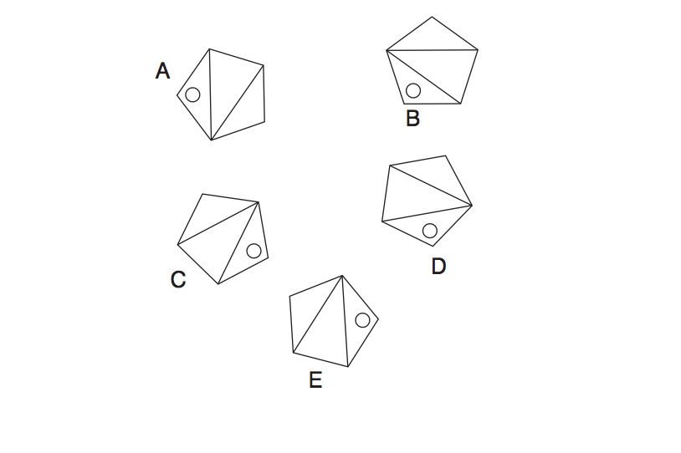

**2.** If 12593 is to 35291 and 29684 is to 46982. Therefore 83467 is to ?

**3.** Insert the numbers listed into the circles so that – for any particular circle – the sum of the numbers in the circles connected to it equals the value corresponding to that circled number in the list. For example:

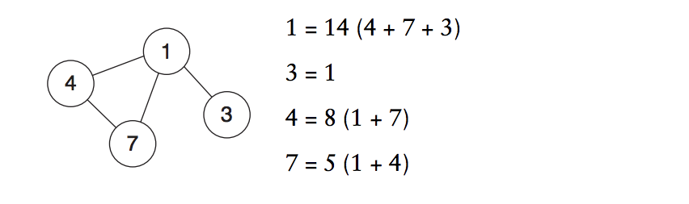

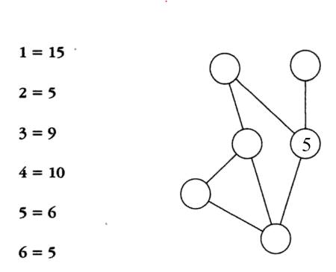

**4.** A large volume of water is gushing through a pipe which narrows at the outlet. At which point, A, B, C or D will the water flow fastest?

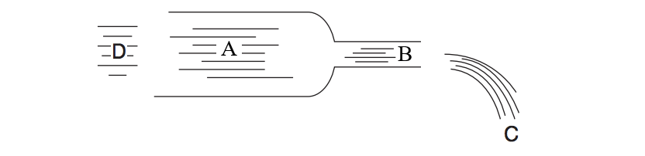

**5.**

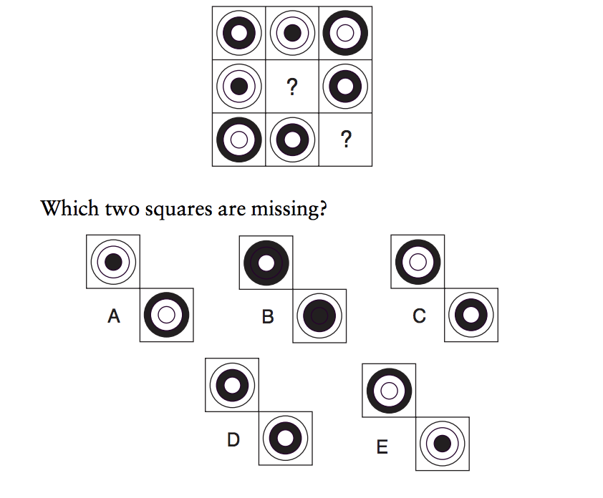

**6.**

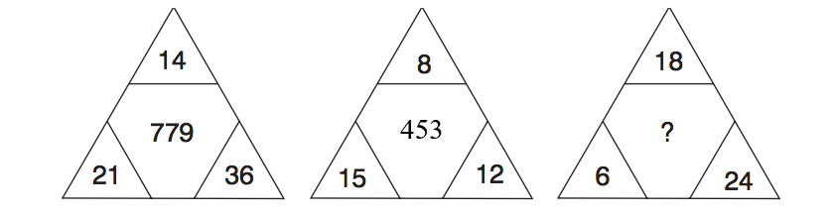

What number should replace the question mark?

**7.**

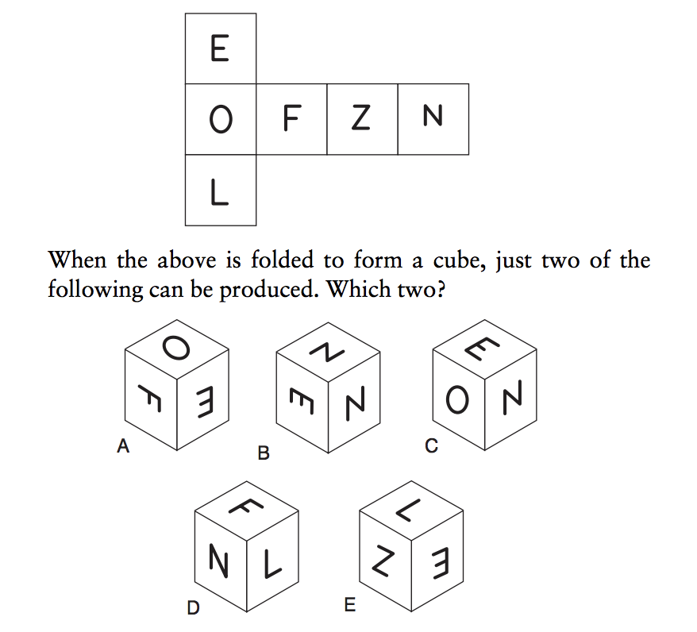

**8.** If a char is 1 byte wide, an integer is 2 bytes wide and a long integer is 4 bytes wide then will the following structure always occupy 7 bytes?

struct ex  
{  
 char ch;  
 int i;  
 long a;  
};

|  |  |
| --- | --- |
| a) No | b) Yes |

**9.** malloc() allocates memory from the heap and not from the stack.

|  |  |
| --- | --- |
| a) False | b) True |

**10.** What will be the output of the program ?

#include<stdio.h>  
  
int main()  
{  
 enum days {MON=-1, TUE, WED=6, THU, FRI, SAT};  
 printf("%d, %d, %d, %d, %d, %d\n", ++MON, TUE, WED, THU, FRI, SAT);  
 return 0;  
}

|  |  |
| --- | --- |
| a) -1, 0, 1, 2, 3, 4  b) 0, 1, 6 , 3, 4, 5 | c) Error  d) 0, 0, 6, 7, 8, 9 |

**11**. Which of the following TCP/IP protocol is used for transferring electronic mail messages from one machine to another?

|  |  |
| --- | --- |
| a) FTP  b) SNMP  c) IMAP | d) SMTP  e) None of above |

**12.** What will be the output of the program ?

#include<stdio.h>  
  
int main()  
{  
 char str[] = "Nagpur";  
 str[0]='K';  
 printf("%s, ", str);  
 str = "Kanpur";  
 printf("%s", str+1);  
 return 0;  
}

|  |  |
| --- | --- |
| a) Kagpur, Kanpur  b) Error | c) Kagpur, anpur  d) Nagpur, Kanpur |

**13**. Which of the following concepts means wrapping up of data and functions together?

|  |  |
| --- | --- |
| a) Abstraction  b) Inheritance | c) Encapsulation  d) Polymorphism |

**14.** To remove duplicate rows from the results of an SQL SELECT statement, the ________ qualifier specified must be included

|  |  |
| --- | --- |
| a) ONLY  b) DISTINCT | c) UNIQUE  d) SINGLE |

**15.** What SQL command can be used to delete columns from a table?

a) MODIFY TABLE *TableName* DROP COLUMN *ColumnName*

*b) MODIFY TABLE TableName DROP ColumnName*

*c) ALTER TABLE TableName DROP ColumnName*

*d) ALTER TABLE TableName DROP COLUMN ColumnName*

**16**. Which of the following is not a type of constructor?

a) Copy constructor

b) Parameterized constructor

c) Default constructor

d) Friend constructor

**17**. What is the language used by most of the DBMSs for helping their users to access data?

a) Query language

b) High level language

c) SQL

d) 4GL

e) None of the above

**18.** How many swaps are required to sort the given array using bubble sort - {5, 1, 4, 2, 8}

a) 7

b) 4

c) 6

d) 5

**19.** HTTP is ____ protocol

1. Network layer
2. Application layer
3. Transport layer
4. None of the mentioned.

**20**. Predict output of following program

#include<stdio.h>

int fun(int n)  
{  
 if (n ==5)

return n;

else return 2*fun(n+1);   
}

int main()  
{  
 printf(“%d ”, fun(2));

return 0;  
}

1. 4
2. 8
3. 16
4. 40
5. Runtime Error

Question: *How would you describle yourself? And what are your short-term job goals?*

***----------------- Thank you! ------------------***