ONE-WEEK EQUAL-SPEND TEST
Marketing Campaign Analysis Report
Recommendation for the strongest campaign and channel investment under equal weekly spend
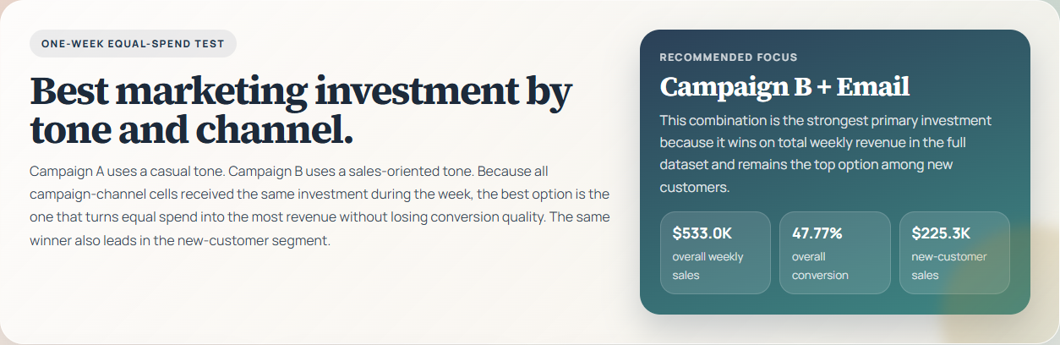
Primary Recommendation: B + Email
This option generated $533,036.65 in total weekly sales and remained the top performer among new customers.
Prepared on 2026-04-20 | Source: Marketing_Campaign_Data.csv

1. Executive Summary
- Decision basis: one-week controlled test with equal investment across all campaign-channel combinations, so realized sales is the primary selection metric.
- Top recommendation: B + Email generated $533,036.65 and outperformed the runner-up by $118,324.43.
- Risk check: the same combination also ranked first among new customers at $225,285.52, confirming both revenue and acquisition strength.

2. Business Question and Method
- Campaign A uses a casual tone and Campaign B uses a sales-oriented tone.
- The dataset covers a one-week controlled test with equal investment across all campaign and channel combinations.
- The analysis compares results by campaign, channel, customer type, and campaign-channel combination.
- Statistical checks were used to verify whether the conversion-rate gap between Campaign A and Campaign B was decisive.
The analytical logic is straightforward: because every campaign-channel cell received the same investment during the one-week test period, the option with the strongest realized revenue is the best primary investment candidate. Conversion rate, sales per interaction, and customer-segment confirmation are used as secondary checks to validate whether the top option is commercially robust rather than an isolated spike.

3. Dataset Overview
Metric | Value
Rows | 100,000
Columns | 7
Missing values | 0
Duplicate interaction IDs | 0
Total observed sales | $2,314,742.53
New-customer share | 42.60%
Average time on site | 134.57 seconds
The dataset is analytically usable without remediation. There are no missing values and no duplicate interaction identifiers, which means the recommendation is not being driven by obvious data-quality distortions. The file therefore supports direct comparative analysis across campaigns, channels, and customer segments.

4. Customer Segment Analysis
Customer Type | Interactions | Conversion | Total Sales | Sales / Lead | Avg. Time
Existing | 57,403 | 47.59% | $1,326,214.03 | $23.10 | 134.42 sec
New | 42,597 | 47.86% | $988,528.51 | $23.21 | 134.76 sec
Customer performance is balanced across existing and new audiences, with new customers showing slightly higher conversion and revenue per interaction. This matters because it means the final recommendation is not only a retention-friendly choice. It also supports acquisition growth, which strengthens the business case for scaling the recommendation into the next budget cycle.

5. Key Findings
- Email was the highest-revenue channel overall at $947,748.87.
- Email also led the new-customer view at $402,652.49, confirming acquisition strength.
- Instagram was the most efficient new-customer channel at $23.46 per interaction, but it did not surpass Email on scale.
- Campaign B produced more revenue than Campaign A overall, but the conversion-rate difference was not statistically decisive (p = 0.965).
- The new-customer conversion gap was also not decisive (p = 0.384), which means the winning recommendation is driven by revenue volume rather than a clear conversion-rate lift.
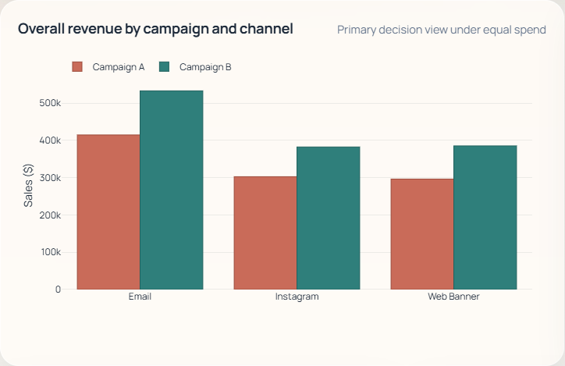
Figure 1. Campaign B + Email leads the portfolio on total weekly revenue under equal spend.
The strongest result in the portfolio is Campaign B delivered through Email. That combination wins because it pairs the highest scale with strong enough conversion quality to dominate total revenue. Under equal-spend conditions, that is the decisive business outcome. If investment is the same, the best option is the one that monetizes the traffic most effectively in absolute dollar terms.

6. Channel Performance Summary
Channel | Interactions | Conversion | Total Sales | Sales / Lead
Email | 41,136 | 47.48% | $947,748.87 | $23.04
Instagram | 29,339 | 48.16% | $685,223.08 | $23.36
Web Banner | 29,525 | 47.57% | $681,770.59 | $23.09
Email is the largest revenue engine in the dataset at $947,748.87, while Instagram is the efficiency leader on sales per interaction. That split matters operationally: Email should receive the primary budget because it produces the biggest absolute return, while Instagram should be retained as a secondary optimization lane because it remains commercially efficient.

7. Overall Ranking of Campaign and Channel Combinations
Rank | Campaign | Tone | Channel | Interactions | Conversion | Total Sales | Sales / Lead
1 | B | Sales-oriented tone | Email | 23,065 | 47.77% | $533,036.65 | $23.11
2 | A | Casual tone | Email | 18,071 | 47.11% | $414,712.22 | $22.95
3 | B | Sales-oriented tone | Web Banner | 16,694 | 47.55% | $385,345.70 | $23.08
4 | B | Sales-oriented tone | Instagram | 16,459 | 47.76% | $382,487.78 | $23.24
5 | A | Casual tone | Instagram | 12,880 | 48.68% | $302,735.29 | $23.50
6 | A | Casual tone | Web Banner | 12,831 | 47.60% | $296,424.89 | $23.10
The revenue gap between the top option and the runner-up is $118,324.43. This is material enough to justify a clear investment decision rather than a split allocation. The runner-up remains useful as a benchmark, but it does not offer a better primary choice under the test conditions.

8. New-Customer Confirmation
The acquisition view confirms the same decision. B + Email ranked first among new customers, delivering $225,285.52 in new-customer sales from 9,700 interactions. This consistency reduces execution risk because the same choice supports both short-term revenue and customer acquisition goals.
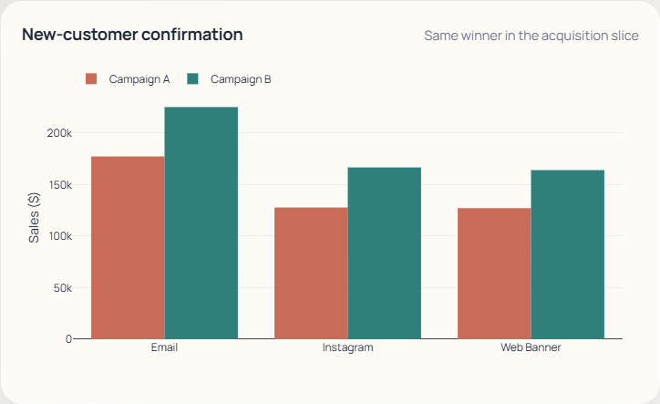
Figure 2. The same top recommendation also wins in the new-customer acquisition slice.
Rank | Campaign | Channel | Leads | Conversion | Total Sales
1 | B | Email | 9,700 | 48.18% | $225,285.52
2 | A | Email | 7,683 | 47.22% | $177,366.97
3 | B | Instagram | 7,100 | 48.30% | $166,722.17
4 | B | Web Banner | 7,110 | 47.64% | $164,125.79
5 | A | Instagram | 5,456 | 48.72% | $127,814.93
6 | A | Web Banner | 5,548 | 47.12% | $127,213.12
The acquisition view points to the same answer: B + Email is also the leading new-customer combination. That consistency reduces the risk of optimizing for short-term revenue at the expense of future customer growth, which is a common failure mode in campaign decision-making.

9. Campaign Tone Comparison
Campaign | Tone | Overall Sales | Overall Conversion | New-Customer Sales | New-Customer Conversion
B | Sales-oriented tone | $1,300,870.14 | 47.70% | $556,133.48 | 48.05%
A | Casual tone | $1,013,872.40 | 47.72% | $432,395.02 | 47.63%
The sales-oriented message tone outperforms the casual tone on revenue, but not because of a dramatic change in conversion rate. Instead, the stronger commercial outcome comes from winning at the high-scale combinations, especially Email. This is an important strategic distinction: the case for Campaign B is revenue productivity, not simply persuasion rate.

10. Channel-Level Tone Effect
The chart below shows how much additional revenue Campaign B generated versus Campaign A inside each channel. Email delivered the largest absolute revenue advantage, which is why it remains the best primary investment option.
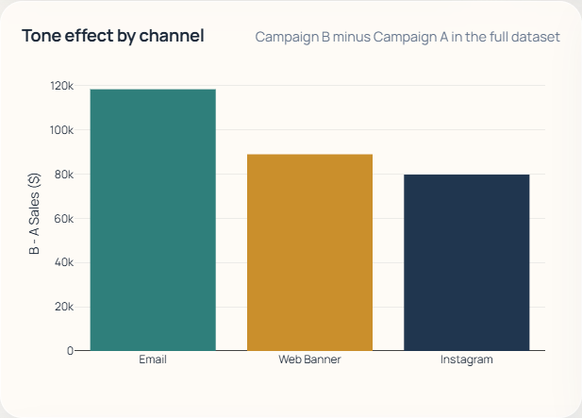
Figure 3. Email creates the largest revenue gap in favor of Campaign B.
Channel | B - A Sales | B - A Conversion | B - A Sales / Lead | p-value
Email | $118,324.43 | +0.67 pp | $0.16 | 0.180
Web Banner | $88,920.81 | -0.05 pp | $-0.02 | 0.927
Instagram | $79,752.49 | -0.93 pp | $-0.27 | 0.116

11. Statistical Interpretation
What the statistical checks mean
Overall campaign-level conversion difference: p = 0.965.
New-customer campaign-level conversion difference: p = 0.384.
These results indicate that the recommendation should not be framed as a statistically proven conversion-rate winner.
It should be framed as the strongest commercial performer under equal spend because it delivers the most revenue with stable conversion quality.
This distinction improves the quality of the business recommendation. It prevents overclaiming that Campaign B is universally more persuasive while preserving the correct operational conclusion: when spend is equal, Campaign B + Email is still the best investment because it produces the strongest realized sales outcome.

12. Recommendation and Action Plan
- Primary investment: allocate the next wave of budget to Campaign B + Email.
- Secondary optimization lane: maintain Campaign B + Instagram as the most attractive efficiency-oriented follow-up test.
- Creative benchmark: keep Campaign A + Instagram as the reference point for casual-tone social messaging.
- Next test design: add spend, CPA, and margin so the next decision can be made on full ROI rather than revenue alone.
- Execution priority: refine Campaign B email subject lines, value framing, and calls to action before changing the broader channel mix.
In practical terms, the business should not spread budget evenly across all cells in the next wave. The evidence is strong enough to support concentration: use Campaign B + Email as the main deployment, keep Campaign B + Instagram as the secondary optimization track, and preserve Campaign A + Instagram as the reference benchmark for social creative learning.

13. Implementation Roadmap
- Phase 1: shift the highest share of near-term budget into Campaign B + Email.
- Phase 2: run controlled creative tests inside the B + Email lane on subject lines, offer framing, and CTA intensity.
- Phase 3: maintain B + Instagram as a parallel learning lane to preserve efficient audience reach.
- Phase 4: add media cost, CPA, margin, and retention tracking to support a full ROI decision in the next measurement cycle.

14. Limitations
- The dataset does not include media cost, CPA, or margin, so this is a revenue-optimization recommendation rather than a complete ROI model.
- The sample covers one week only, so seasonality, fatigue, and longer-term retention effects are not observable.
- The statistical checks focus on conversion-rate differences and do not estimate incremental lift against a no-campaign control group.

15. Appendix: Data Dictionary
Field | Description
Interaction ID | Unique identifier for each observed campaign interaction.
Campaign Type | Creative family used in the test: A = casual tone, B = sales-oriented tone.
Channel | Transmission channel used to deliver the campaign message.
Customer Type | Whether the observation belongs to an existing or new customer.
Converted (1=yes, 0=no) | Binary outcome indicating whether the interaction converted.
Time on Site (seconds) | Observed engagement time after the interaction.
Sales ($) | Observed revenue associated with the interaction.

16. Approval Request
Decision requested from stakeholders
Approve Campaign B + Email as the primary investment option for the next budget wave.
Approve Campaign B + Instagram as the secondary optimization lane for efficient follow-up testing.
Approve a next-test measurement upgrade that adds spend, CPA, and margin so the following decision can be made on full ROI.
The recommendation is ready for action because B + Email generated $533,036.65 under equal spend and also remained the top-performing option in the new-customer view. The remaining uncertainty is not about which option won this test. It is about what additional cost and profitability data should be tracked in the next cycle.
- Decision owner: approve the next campaign allocation using the current revenue-based recommendation.
- Execution owner: deploy the B + Email creative and targeting updates first, before expanding broader channel changes.
- Measurement owner: add spend, CPA, margin, and retention tracking in the next experiment design.
Prepared from the completed notebook analysis, dashboard, and stakeholder presentation outputs.

