Executive Memo: Marketing Investment Decision
Prepared on 2026-04-20 | One-week equal-spend campaign test
Primary Recommendation
Invest in B + Email.
It generated $533,036.65, beating the runner-up by $118,324.43.
It also ranked first for new-customer sales at $225,285.52.
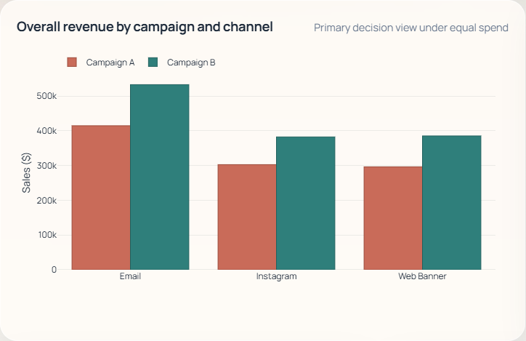
Executive view. Revenue leadership by campaign and channel under equal spend.

1. Decision Context
This memo summarizes a one-week equal-spend test used to identify the best campaign and channel for the next investment wave. Because every campaign-channel cell received the same spend, the right decision rule is to prioritize the option that generated the most revenue while confirming that the result also holds in the new-customer view.

2. Why This Decision Holds
- Email is the highest-revenue channel overall at $947,748.87, so it offers the largest commercial upside.
- The winner is stable in acquisition as well, which reduces risk for future growth objectives.
- The overall conversion difference between Campaign B and Campaign A is not statistically decisive (p = 0.965), so this is a revenue-and-scale decision rather than a conversion-lift decision.

3. Supporting Evidence
- Primary winner: B + Email produced $533,036.65 from 23,065 interactions.
- Runner-up gap: the next-best option trailed by $118,324.43, which is large enough to support a concentrated investment decision.
- Acquisition check: B + Email also ranked first among new customers at $225,285.52.
- Secondary lane: B + Instagram remains attractive for efficiency testing at $23.46 per new-customer interaction.
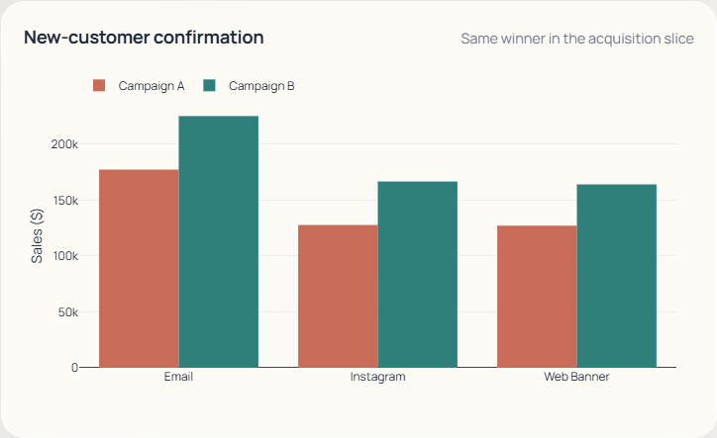
Acquisition view. The same recommendation leads in the new-customer slice.

4. Immediate Actions
- Allocate the next budget wave to Campaign B + Email.
- Keep Campaign B + Instagram as the secondary optimization lane.
- Add spend, CPA, and margin tracking in the next test so the next decision can be based on ROI as well as revenue.

5. Risks and Caveats
- The dataset does not include media cost, margin, or CPA, so this is a revenue-based recommendation rather than a full profitability ranking.
- The test covers one week only, and the conversion gap is not statistically decisive, so the recommendation should be framed as the strongest commercial performer under equal spend.
Dataset snapshot: 100,000 interactions, no missing values, $2,314,742.53 in observed sales.

