***Face Landmarks Detection***

***Goal***

To create a mesh or a grid like structure to identity different key facial features and mark them accordingly for further classification and processing.The input can be still images or video streams These landmarks include points around the eyes, nose, mouth, and jawline, which can be used for various applications .

***Methodology***

1.Media Pipe-

It is an open source framework developed by google which specialises in human facial landmark detection using machine learning pipelines.

2.Input-

The input can be in the form of an image or streaming video

3.Preprocessing-

This involves resizing and normalizing the input to ensure consistent results. It helps in managing different lighting conditions and image qualities.

4.Face Detection:

MediaPipe uses machine learning models to detect faces. It draws boundaries around the detected faces, which gives us the ROI or the region of intrest ,helps in focusing on the relevant area .

5.Landmark Detection-

MediaPipe’s facial landmark detection model identifies and tracks 468 key points on the face. These points correspond to important facial features like the eyes, nose, mouth, and jawline.This is done by projection

Postprocessing:

The detected landmarks can be used for various applications, such as overlaying virtual objects on a face (augmented reality), analyzing facial expressions, or improving face recognition systems.

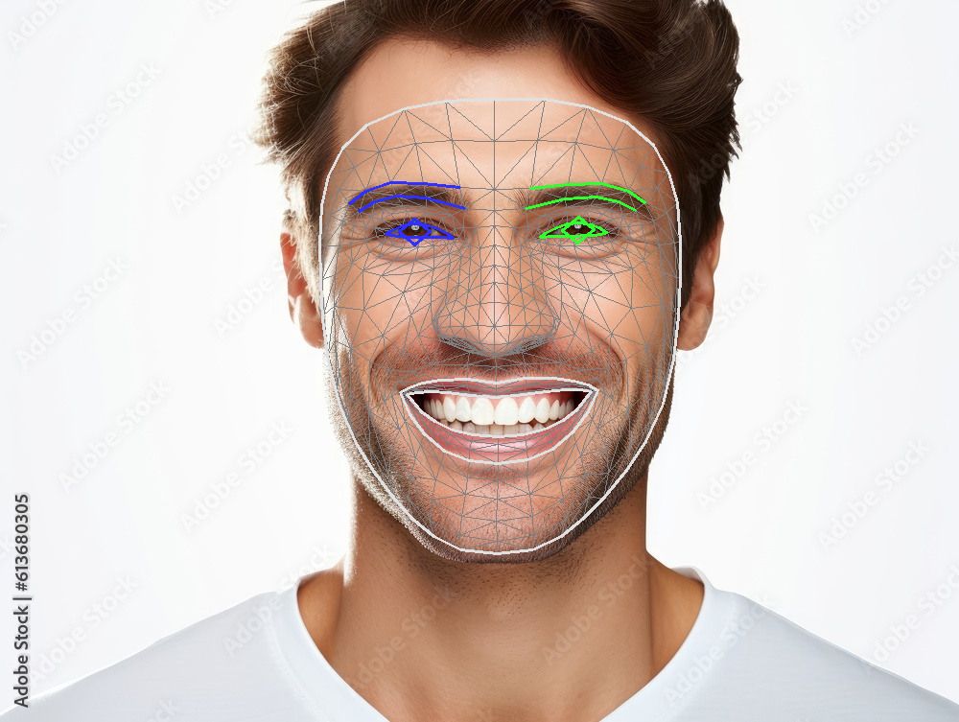Working Examples

1.Case 1

Over here we are using a stock image of man and processing it under our model that we developing

It generates Landmarks on the image itself-

The eyes , eyeborws and lips have their own border which helps in distinguishing their borders.

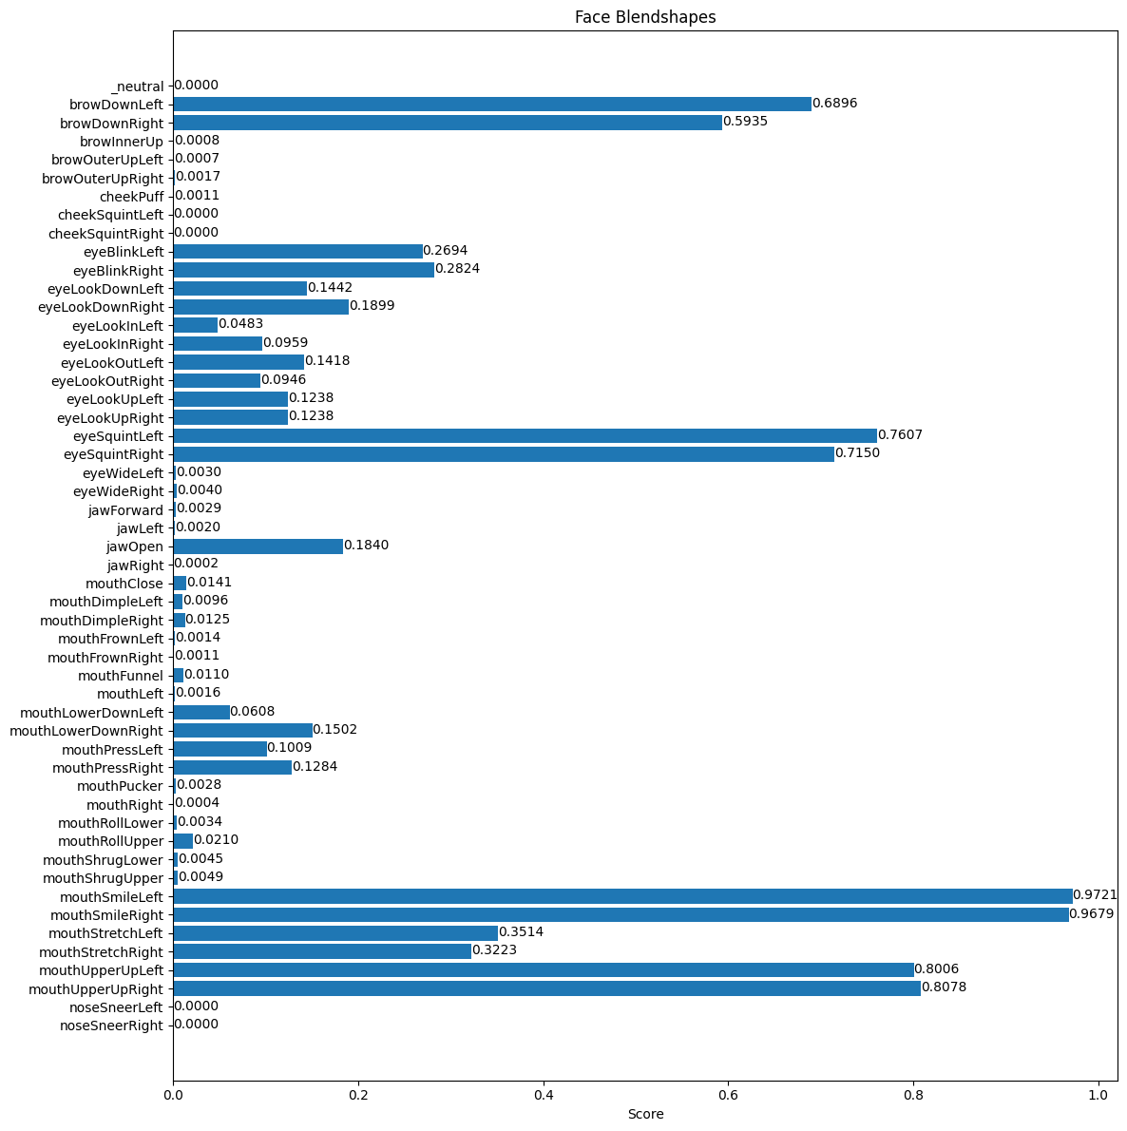

The provided information offers a comprehensive analysis of the facial landmark points generated by MediaPipe Face Mesh. This technology essentially creates a detailed map of a face, pinpointing 468 key locations. Imagine each colored dot as a specific landmark, such as the tip of the nose or the corner of the mouth.

The values accompanying these landmark names (e.g., "mouthSmileLeft: 0.97") represent the model's confidence level in detecting that particular feature. A value closer to 1 signifies a high degree of certainty that the feature is present. In the given example, a value of 0.97 suggests a strong leftward smile with a confidence level of 97%.

Using this data we can compare the sides of the face , for eg

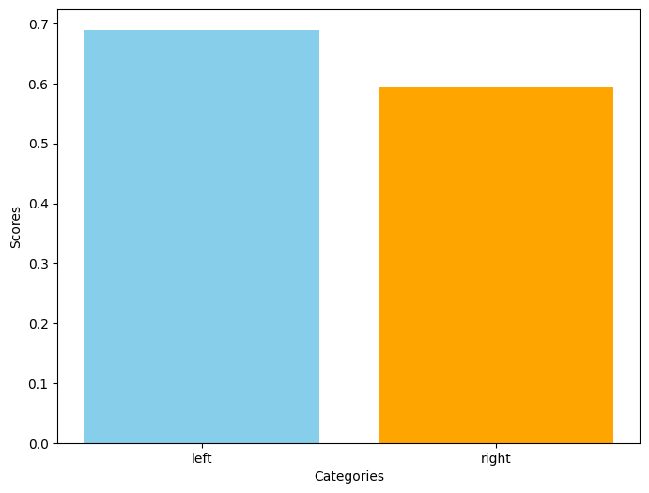

This graph is the comparison between the browDownLeft and brownDownRight

2.Case 2

This is an image of a woman .

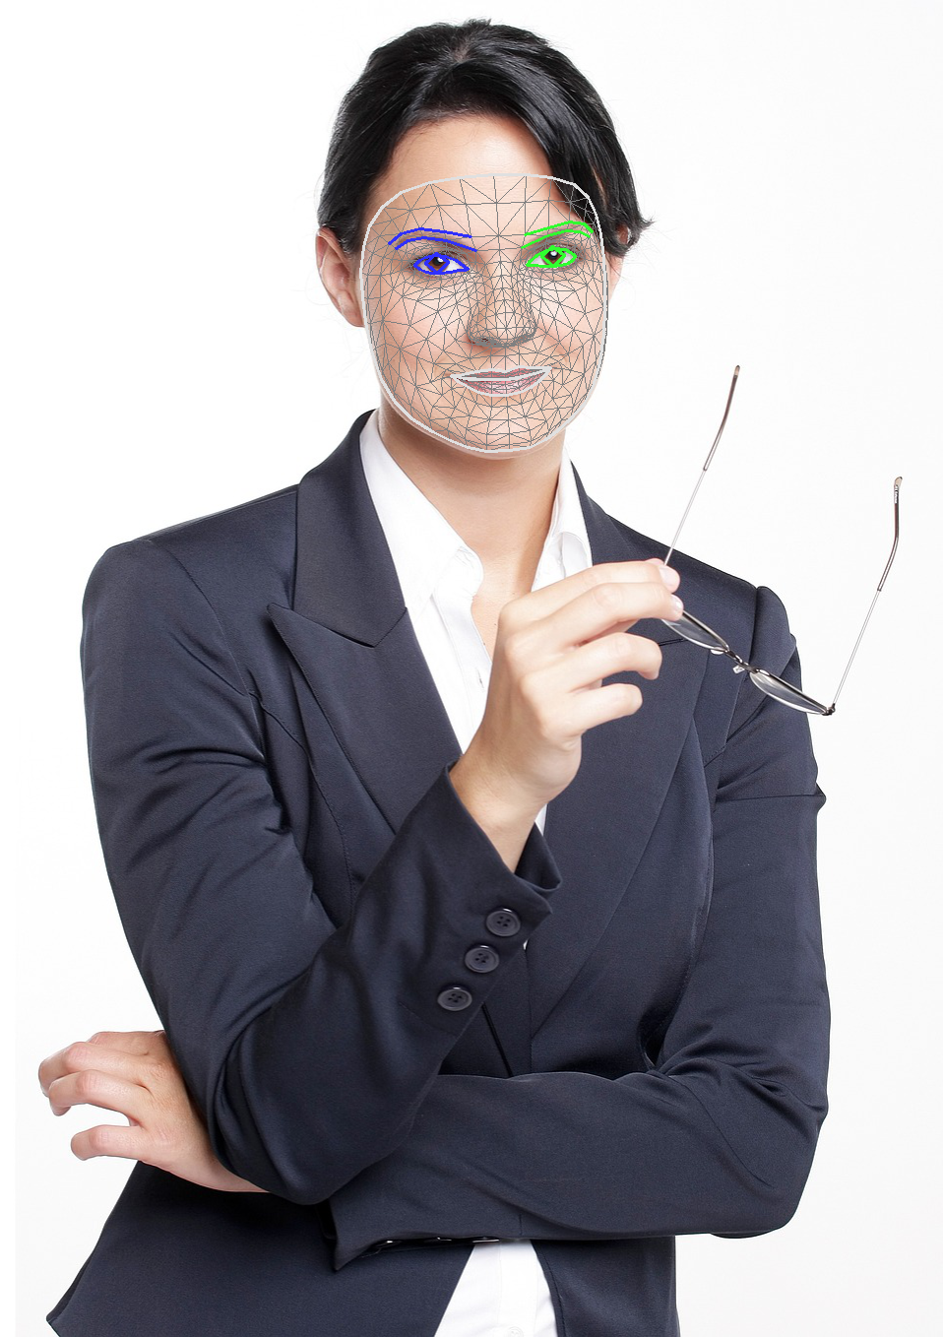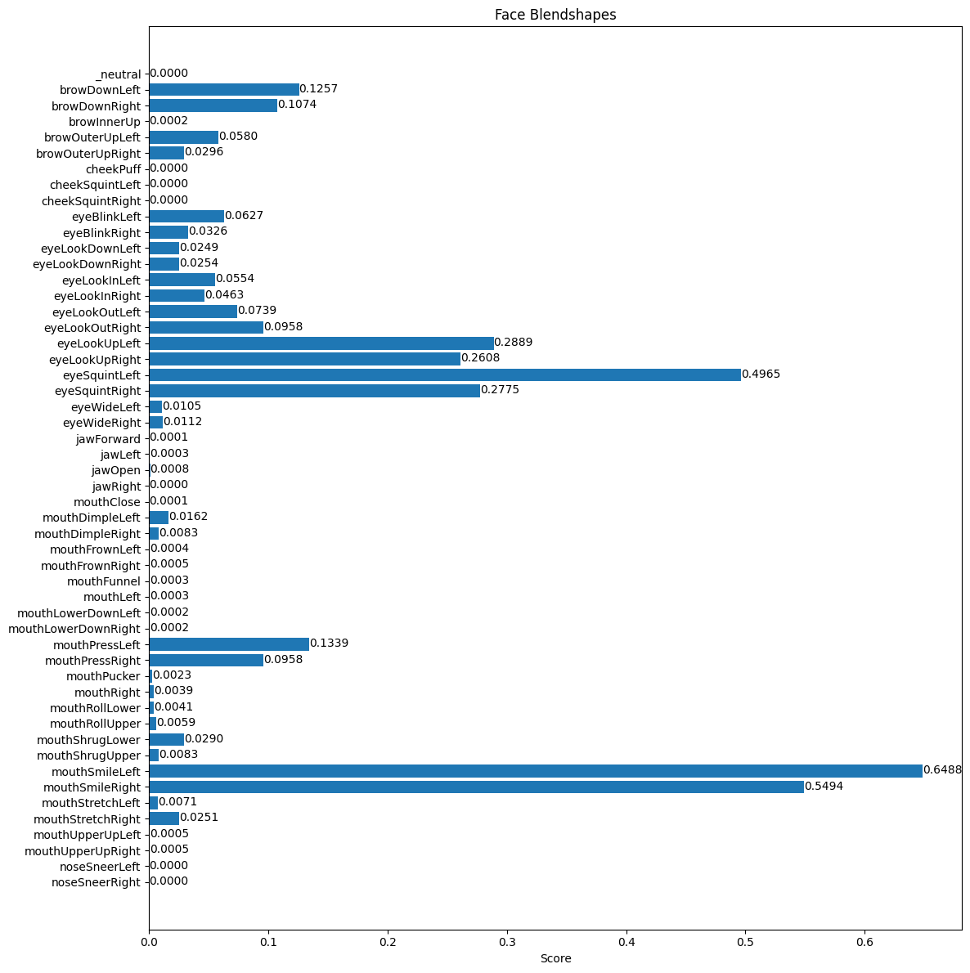Image after processing

Graphical Data

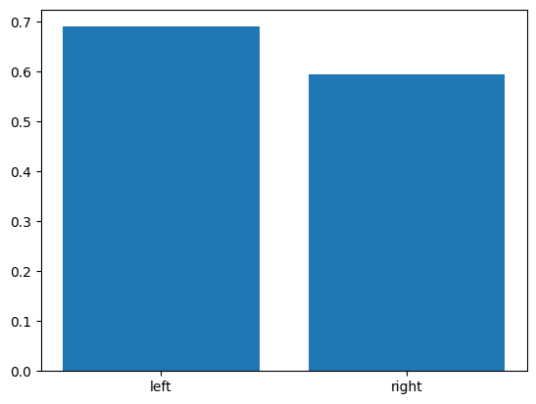 Left brow vs Right brow

**Future Applications -**

This model can be used for many applications which revolve around a depth analysis of the human face .