CloudLab: A Cloud-based Development Environment for Introductory Programming Courses

Daniel Vijayakumar, Michael Delong, Qusay H. Mahmoud
School of Computer Science
University of Guelph, Guelph, ON, N1G 2W1 Canada

Abstract
Both students and instructors of introductory computer science courses are faced with unique challenges in labs and assignments due to the many problems encountered as a result of the obligatory use of specific hardware and software resources, and thus the inevitable installation and configuration thereof. In this paper we present a simple, unified and platform-independent integrated development environment (IDE) based in the cloud for use in such academic courses.
Keywords: CloudLab, Cloud, CS, Lab, IDE, Development, Amazon Web Services, 3-Tier Model, EC2, S3.

Introduction
Computer science students and instructors at universities such as the University of Guelph face a number of routine technical issues during their course of study that tend to inhibit learning at varying levels of significance. These problems are primarily encountered during applied practices for courses that involve programming components such as labs, tutorials and assignments. The most significant of the issues can be summed up as follows: the unique challenge of applying computer science concepts through programming assignments/projects and at the same time ensuring an application development process that is consistent among all students for academic purposes.

In order to address this problem, instructors of courses today, usually supported by one or many teaching assistants (TA), develop protocols that must be followed by all students. These generally entail important details regarding the working of the assignments as well as their submission. For example students may have to submit C programs that compile successfully without warnings under the ANSI C89 standard. Such rules are a literal solution to the problem of ensuring consistency and should be very effective in theory. In order to assist students in following the protocol, two valid options are generally provided: 1) provision of computer labs consisting of many computer systems that are setup and configured homogeneously; and 2) granting of freedom for students to use their personal computer systems at the cost of ensuring that program submissions correctly compile and run under the targeted system as specified by the instructor. But these solutions bring about their very own problems.

If development environments are provided for students by the school, they run into significant performance issues. School-provided computer labs are generally not suited for large numbers of concurrent users performing CPU-intensive tasks such as compilation and execution of code. Even worse, user disk space is generally implemented remotely as network filesystems, which are certainly not appropriate for the large number of I/O operations that are performed by many programs running concurrently. Both of the student authors can attest to this due to their severely negative experiences of major network interruptions and latency issues during the final assignments of one of their core programming courses (CIS*2750). Such issues are faults at the infrastructure level and are thus near impossible to address during the limited time period of an academic semester, let alone a few weeks.

On the other hand, many students may prefer to work on their own machine for reasons of convenience and familiarity. This generally means having to manually setup and configure their system according to the target environment, which in most cases is a distribution of Linux. While this may not be an issue for a few experienced students, the majority of students face a myriad of technical issues that are prevalent when migrating to a different computing platform entirely. Even if such a feat is accomplished in a reasonable amount of time, students still struggle to submit programs that compile cleanly as per the specifications of the instructor. The obligatory debugging of these quirks takes up a lot of limited and valuable time.

When it comes to assignment submission, we have a separate breed of issues. The three primary methods uses are: 1) e-mailing a compressed archive of the deliverables; 2) uploading a compressed archive to a specified location, usually the course website; and 3) submitting through the mechanics of a version control system, usually Subversion. Using e-mail for assignment submission is generally frowned upon as the various

The common theme from the above discussion is frustration among both students and instructors that ultimately only inhibits progress in learning. It therefore stands to reason that both students and instructors would benefit from a solution that addresses the issues of concurrency and scalability while simultaneously providing availability as well as accessibility from a unified interface.

Goals
The main purpose of this project is to develop an integrated development environment (IDE) tailored towards students and instructors of university computer science courses. Emphasis must be placed on five of the most important features that are necessary for an academic setting. These features are now discussed below.

The most important feature is platform-independence. Users of the system must not be constrained by any platform so that the need for manually consolidating to a specific submission protocol (as described before) can be eliminated. In order for this to be effective, the solution must strive to provide an interface that is unified and desirable to all possible users. Secondly, the system must be very capable of handling large numbers of concurrent processes with ease. Although the user traffic in such an environment is not heavy at all times during the semester, such scalability is required to accommodate for the sudden bursts that occur due to predictable events such as approaching deadlines.

As a consequence of scalability, the solution must be highly reliable and available. It is not acceptable for users to be inhibited from access to their tools and resources at any time during the semester. This allows students and instructors to follow through with their rigid schedules and deadlines that are commonplace in academia. Finally, the solution must adhere to strict standards of security and implement a strong access control system. This is crucial for minimizing academic misconduct, particularly plagiarism.

Ultimately, we desire to enhance the interactions and experiences of both students and instructors by abstracting away from them the problems of uniform development processes, controlled environments and submission logistics.

Proposed Solution
After much thought and consideration of existing and related solutions (discussed in detail in section 4), we decided to implement our own solution using a composition of a variety of existing tools and services that were customized to meet our needs.

Addressing the goal of platform-independence, our solution is a browser-based service powered by Amazon's cloud-based web services (AWS). Despite the large number of possible computing platforms (not to mention the vast number of Linux distributions), web-browser clients are ubiquitous and most of the popular ones provide compiled binaries (or at least stable source code with instructions for compiling) for the major operating systems []. Instead of having students and instructors install and configure various software on their own systems in order to comply with the course requirements as mentioned in section 1, they would simply have to access a web URL using a browser for all their programming and development resources. An issue that can arise with a browser-based solution is cross-browser compatibility. As a consequence of the ease of access offered by a uniform browser-based environment, the issues of reliability and availability are also satisfied.

In order to tackle issues of scale, portions of the system will be built on the recently popular NodeJS framework []. Finally, the solution must be highly secure and must respect high standards of privacy in order to address issues of academic misconduct.

The above goals are achieved through the following list of features supported by our system:
- Secure and private access controls for students and instructors
- Organize all programming assignments by course or topic
- Allow users to conveniently manage their files and folders
- A high-fidelity code editor
- Full support for compiling and executing (currently) C and C++ files
- Optional support for building entire projects
- Full access to administrative controls from within the application (by special administrative users with such privileges), including creating course/topic areas and enrolling students to them

Our solution was only briefly outlined in this section and carries a more specific set of implementation design as well as issues. These are discussed in detail from section 5 onwards.

Related Work
The idea of an integrated development environment in the cloud is hardly a new one. A good number of such services exist including open-source projects that are well-received and are popular. A few of the most interesting ones are discussed below. - many such services exist including Cloud9 [2], CodeRun [7], and Kodingen [8]. All of these services offer completely browser-based development environments. However, these systems do not meet our needs for the following reasons:
- Although virtually all offer free accounts, server-side compilation/execution often requires a paid subscription, as we discovered with Cloud9’s service.
- Many services do not offer support for Java, C, and C++ compilation/execution, which are primary languages used in many CS courses at Universities.
- These services do not offer access control access control for various types of users as they encourage open-collaboration and public access. While this works well for their intended audience, our vision is to create an environment that complements an academic setting where instructors could create projects and students could work within the constraints established by the project template and have access to only their own files and files made visible by instructors.
- These systems do not have built-in services for assignment submission. Although Cloud9 allows users to upload files to a GitHub repository [4], these services do not provide a built-in means of project submission (such as emailing an instructor or submitting to their account on the school’s SVN repository).

With regards to existing resources at the University of Guelph, physical computer labs are located in various buildings of the University campus for student and TA/instructor usage. These resources typically do provide a unified development environment, avoid the pitfalls of cross-platform software incompatibility, and help students to avoid the burden of installing software on their personal machines. However, students may often prefer to use their personal machines for convenience reasons and instructors may wish to avoid applying too much stress on the school’s networking and computing resources.

There are various existing solutions such as Moss [] that have proven to be very effective in detecting similarities in software and consequently reducing plagiarism. However, it is well-known among all practices and industries that prevention is better than cure. Thus, we hope that preventing students from access to each others' work would prove significantly beneficial by attempting to prevent events of academic misconduct from occurring in the first place.

Design and Implementation
In this section we present in detail the design and implementation of our proposed solution. The architecture of our system is shown in Figure 1. The system is composed of three layers according to the 3-Tier model [] and these layers are expanded upon in the following sub-sections.

Presentation Tier
The presentation tier of our system is designed to allow users to view and interact with data. This component consists of a web interface that is hosted on an Amazon EC2 instance (see section 6). It is implemented using HTML5, CSS3 and JavaScript technologies along with the assistance of the popular frameworks Twitter Bootstrap and jQuery that provide a more aesthetic look-and-feel and efficient DOM manipulation respectively.

The Presentation tier is designed with access control in mind. There are three types of users for this system: students, instructors and administrators.

The following is a list of the main features that are supported for students:
- View and access all courses (or topics) that the student is enrolled in
- View and access all assignments (or projects) that exist in the course
- View, edit (and save changes) and delete all files that are associated with the assignment that are owned by the student
- Create new files for the assignment
- Upload any files to the assignment
- Compile source files (currently *.c and *.cpp files) and execute them
  - For security reasons, students should not be able to type in shell commands that will be executed on the server, but will rather compile and/or execute code through a menu option in the web interface.
- View all compilation and execution output

The following are some of the main features that are supported for instructors:
- View and access all courses that the instructor is enrolled in
- View, edit, delete and access all assignments that exist in the course
- Create new assignments for the course
- View, edit (and save changes) and delete all files associated with the assignment that are owned by the student
- View (but not edit or delete) all files that are owned by other students in the same course
- Upload any files to the assignment
- Instructors must be able to create a project based on one of the following templates: C, C++, or BlackBerry WebWorks (support for more project types may be added in the future). When students create new source files, it will be in the context of the project type selected by the instructor (e.g. if the project type is C/C++, the student may only create .cpp or .h source files)

Finally, the following are the features that are supported for administrators:
- View a list of all existing student and instructor accounts
- Edit or delete any existing student or instructor account
- View a list of all existing courses
- Edit or delete any existing course
- Create new users
- Create new courses
- Enroll existing users in existing courses

The interface consists of three separate pages from a student user's perspective: a login/authentication screen, a list of available labs or projects to work on, and an in-browser code editor.
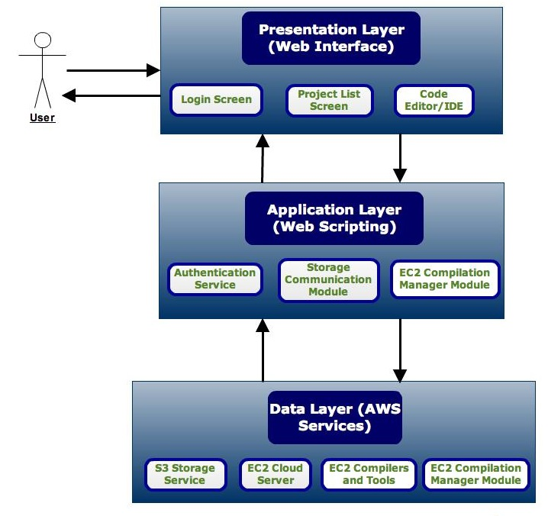
Figure 1: Architecture of CloudLab

The code editor MUST allow the student to perform the following tasks:

The student may also have the ability to perform one or more of the following tasks from the IDE, time permitting their implementation:
- Download a compressed version of all project source files in .tar or .zip format
- Email a compressed version of all project source files in a .tar or .zip attachment to the instructor
- Upload the project source files to his/her University of Guelph Subversion repository
- Customize the editor appearance using preference settings

An instructor’s view of the web interface is somewhat different, and will consist of three separate pages as well: a login/authentication screen, a list of all created labs or projects, and a configuration screen for creating a new lab project with the desired configuration. Lab project creation and configuration MUST have the following requirements:

- Instructors must receive some notification feedback for events such as creation success or failure after the project has been created and saved
- After an instructor creates a project, all students must be able to view and edit their own versions of the project
- A default set of source files is provided for each project type and will be automatically created and saved when the project is created. The instructor may be provided the option of uploading his/her own desired source files for the project as a template instead of the defaults
- Instructors should also be able to upload lab instructions and descriptions in PDF or other desired format

The Presentation tier will not be hosted in the same location as the back-end services provided by AWS in the Data and Application tiers but will instead obtain and send data to these remote services through the Application tier. As previously mentioned, the role of the web interface in this tier is purely to allow users to view, edit, and manage data - it provides no storage or any of the application’s core services, which are provided by Amazon Web Services. The Presentation tier must not communicate directly with these services in the Data tier, but instead calls methods in the Application tier in response to user inputs to communicate indirectly with the core services.
Currently, our Presentation Tier/web interface is hosted on the same EC2 server that provides compilation services. This decision helps to reduce network traffic and latency, is easier to implement, and avoids the complexity of creating a remote web service ourselves. Since AWS does not provide API functions to move files to and from an EC2 instance, or to run shell commands (for security reasons), it makes sense at the moment to host the compilation service on EC2. However, this does violate our system’s policy of not permitting direct communication between the Presentation and Data tiers, since compilation requests will be sent directly from the web interface to the compilation service in the data tier. In the future, we may possibly modify this design to provide better separation between the Presentation Tier and the compilation service in the Data tier.

Application Tier
The Application tier of our system primarily consists of code that serves as an intermediary between the Presentation and Data tiers. The software components in this tier are located on Amazon’s EC2 cloud servers out of necessity, as discussed in Section 4.1. The role of the software components in this tier will be to receive data from the Presentation Tier after their commands are invoked based on user input, communicate in an appropriate way with the AWS remote services provided in the Data Tier, and possibly transfer data to and from the Data Tier services. These components are implemented in a Web scripting language so they can easily be invoked from the web interface and should utilize existing AWS SDKs to ensure reliability, scalability and performance.

Data Tier
The Data tier of our system consists of cloud-based web services provided by Amazon Web Services. The role of this tier is primarily to store data (source files), and process data (compilation, running, file management). Data and requests are transferred to these services through the components in the Application tier, except for the Compilation and Execution service, which receives data directly from the Presentation tier. Since the majority of components in this tier are pre-existing services provided by AWS, there is very little need for us to manually implement this portion of the system. However, to provide compilation and running functionality, some code will need to be written to command the EC2 server instance to compile and run the provided source files, and to communicate results back to the Application layer.

Implementation Technology Overview
We have currently established most of the technologies and tools that will be needed to provide our application’s core services.

Web Storage and Amazon S3
Amazon’s S3 web storage service is used to create and store projects and source files. Projects are created by instructors, and are saved as S3 ‘buckets’ [3] into which students’ source files can be placed. When the instructor creates a project, a default set of source code files is created in the bucket, depending on the project type. When a student begins editing the project for the first time, these default source files are copied to his/her simulated directory in the S3 bucket. After this happens, students will always access only their own privately modified versions of the source files.

All student users will create and save their own source files for the project inside this bucket, so all students should have access to the bucket. Since this system should support multiple users and each student should only have access to his/her own files, students must have their access limited only to their own folders within the S3 bucket. Although S3 does not support creation of real folders, folders can be simulated by appending the username to the front of the S3 object, directory-style.

In order to allow users to create projects, save source files, and delete projects or source files, there is a need for software components to transfer data between the web interface and the S3 service. These are implemented as PHP scripts on the web server side. PHP was chosen because it is the only familiar Web scripting language which has an API provided by Amazon, and also because it is easy to call from HTML web pages (which is required because the web interface needs to invoke these PHP operations).

Server-Side Compilation and Execution
The compilation and execution service will be provided by a Linux instance of Amazon’s EC2 cloud server. In order for the service to be deployed on this server, the instance must be configured to run with the required tools and compilers, which include:

- GCC and G++ compilers to compile C and C++ programs
- BlackBerry WebWorks applications don’t require a compiler to be viewed in the Ripple browser extension, but if they are to be signed and packaged server-side, the WebWorks SDK should be installed and the instructor must be provided with one signing key per class (these will be issued to all students).

As with the web storage service, communication between the web interface and the EC2 instance is handled through PHP scripts, mainly because PHP is an effective server-side language that provides support for execution of shell commands. When a user requests to compile a source code file, a temporary directory is created inside the EC2 home directory, and all the user’s source files are copied from the project’s S3 bucket. The source code is then compiled with the appropriate compiler; all compiler output is piped to a compile.log file. After compilation is finished, the content of the compile.log file is forwarded to and displayed on the web interface, so the user can view compilation results. To run the compiled program, the user selects another button or menu option through the web IDE, and the server-side script simply executes the compiled source code contained in the temporary directory; all program output is piped to a results.log file, and this content is forwarded to and displayed on the web interface after program execution has finished. When the user closes the IDE page, all temporary folders and files created for that user will be deleted.

One challenge we are currently facing is how long to wait for program execution to finish before forwarding the results to the user, since many programs can potentially have long runtimes. One potential solution is to check the results.log file at specified intervals, and forward any new additions to the web interface.

Web Interface and Code Editing
Editing of source files is provided through a browser-based code editor. Our original plan was to utilize Cloud9 IDE [1], an existing open-source code editor written on the Node.js framework [11], and replace its back-end implementation for saving, compiling, and running applications with our own code that communicates with Amazon Web Services. (ace ajax)

However, we ran into numerous technical issues with including the Knox library [9] for Node.js communication with S3; because Cloud9 requires an older build of Node.js and Knox is kept up-to-date, there were issues integrating the two libraries, and we ultimately determined that using Cloud9 would not be a viable option, and decided to use our own browser-based IDE, coded using HTML, CSS, and JavaScript, and using the Ace [10] open-source code editor library. Our CloudLab IDE offers the following benefits:

- Provides source code templates for all application types targeted by our service (C, C++, WebWorks - HTML, CSS, JavaScript)
- Provides syntax highlighting and some auto-completion of code
- Provides auto-indenting and code organization
- Extensive support for key-shortcuts and special key-bindings for various systems and environments
- Full browser support for all 4 major web browsers (Firefox, Chrome, Internet Explorer, and Google Chrome)

Creating an effective, slick IDE is a very time-consuming and challenging task, and is easily enough work to become a project of its own. Our current plan is to either find another effective open-source web IDE or continue to improve our existing implementation.

Prototype Implementation
In order to measure our success in designing and implementing this cloud computing service, we instituted certain goals and milestones. The overall goal was to provide full virtual lab functionality for three types of programming applications: C, C++, and BlackBerry Web Apps. This involved implementation and testing of the following features and requirements:

- Instructors should be able to successfully sign in, create a specific lab/assignment project type, upload all necessary descriptions/instructions, and view all student submissions. With our current implementation, instructors can successfully sign in and create new labs. There is no current provision for uploading instructions or viewing student submissions.
- Students should be able to successfully sign-in and view a list of available labs and assignments. When a student selects a lab, he/she should be able to create, edit, and save source files via a web interface. The student should be able to successfully compile and run the application and view the program compilation and run-time outputs/results online. In our implementation, all of the above features except creating, compiling, and executing source files are complete. Students can work on and save the existing default files for the project.
- Students should be able to view only their own files, and not those of other students or their instructors. This security feature has been partially implemented in our system, although it is still possible for a clever user to modify the URL and access other students’ work.
- Students should be able to view the lab/assignment instructions uploaded by the instructor. Our implementation does not currently provide the ability to upload or view lab instructions.
- At an absolute minimum, all of the above should successfully work for a small number of users (2-3). However, the service should preferably be scalable (able to potentially handle a large number of users).

Current Implementation
We have created an AMI (Amazon Machine Image) for our EC2 web server and compilation service, with all required tools installed. Our current web interface is also contained in this AMI, and we have successfully downloaded and tested the web interface with Apache Tomcat running, to ensure that web hosting is working correctly.

The back-end PHP scripts for file management with S3, server-side compilation, and running of compiled source files have been implemented, and have been thoroughly tested at this point. All the pages of the web interface have been implemented. At the moment, instructors can successfully create projects and even delete or edit them. All users can also view their projects, while students alone can proceed to edit the project in more detail by deleting and editing the default source files provided by the project. Thus, access roles have been successfully implemented and users receive different views of the system depending on their roles, student or instructor. Despite our client-side successes, complete integration with server back-end functionality is still underway. Although server-side scripting is thorough and complete, it has been an ongoing challenge to fully integrate the two sub-systems together in order to achieve the functional requirements we have outlined. Figure 2 shows a snapshot of CloudLab.

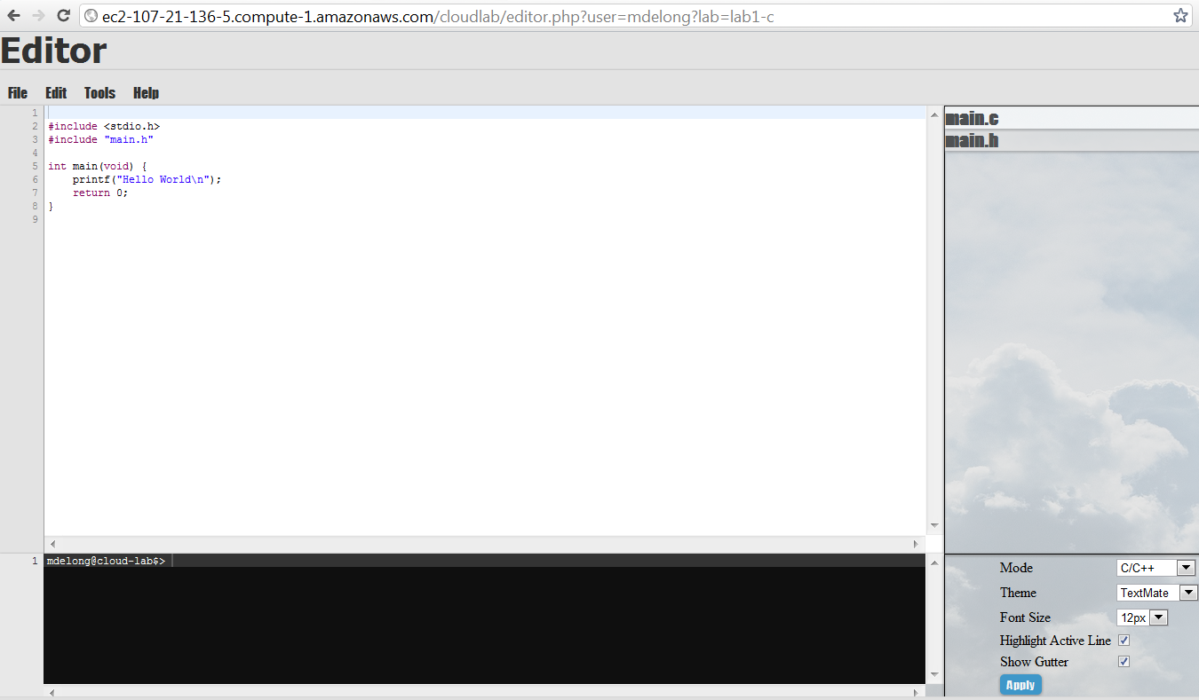
Figure 2: A snapshot of CloudLab

Figure 3 shows an example of creating a new source file in CloudLab.

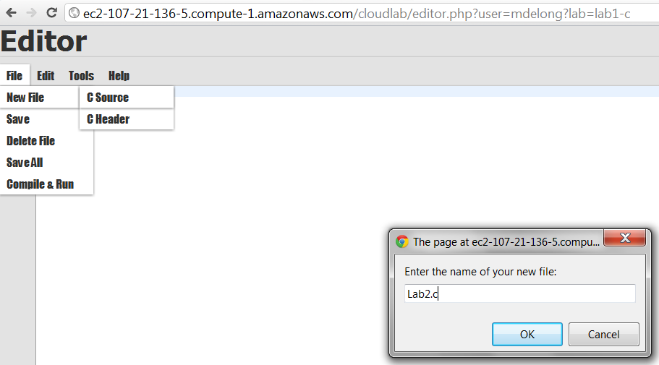

Figure 3: Creating a new source file in CloudLab

Challenges
Many of the challenges we faced during the course of researching and implementing this project have been discussed in other sections of this paper. However, we will provide an overview and summary of all challenges faced during the semester in this section.
Our first challenge was to find a suitable code editor or IDE for our project. As mentioned earlier, we discovered the Node.js-written Cloud9 IDE on GitHub [13], and were very impressed with its sleek interface and extensive functionality. Utilizing this interface for our system would simply involve replacing existing Node plug-ins for file management and server-side compilation and execution. Unfortunately, due to Node.js-related issues, we were unable to integrate existing S3 Node libraries with the Cloud9 interface, and thus could not use this application’s interface for our project. As a fallback plan, we had earlier created a prototype of a web-based code editor, using the Ace open-source JavaScript code-editing library, along with standard HTML, CSS, and JavaScript. We decided to use this as our project’s IDE page.

Another challenge was determining how to integrate the EC2 and S3 services provided by AWS into our application. This involved some research into the APIs provided by both, and it was discovered that AWS provides an SDK for various programming languages (PHP, .NET, Java, Ruby) to communicate with S3 and EC2 [12]. Although this SDK was not provided for JavaScript (as we had hoped), we were familiar with PHP and so decided to use that API. Implementation of S3 communication was fairly straightforward and easy to code. EC2 however, did not provide API functions for transferring files to the server or executing shell commands, which we needed to provide compilation and program execution services. Our options were to host the web interface on EC2 and call server-side PHP functions from the IDE’s JavaScript, or create a web service, deploy it on EC2, and invoke the web service from the IDE. Given time constraints and the simplicity of implementation, we chose the former option, although this choice did not strictly fall under our system’s design policy. In the future, we will likely attempt to implement the latter option in order to obtain better separation of interface and the services it interacts with.

As a result of developing the web interface and server-side functionality as separate units, we faced the challenge of integrating these two sub-systems and making them work together as desired. The main problem we encountered was that JavaScript can not natively instantiate and access PHP classes and objects, and our PHP scripts were developed using an OO approach through class abstractions. This can be done through an interface script however we were not able to afford this approach due to time constraints. However, we performed more research and discovered an API known as PHPLiveX, which is an AJAX library and framework for PHP [14]. The main feature that we found extremely useful is its ability to instantiate an object in the PHP script (known as the PHPLiveX object) which contains a method known as AjaxifyObjectMethods. This allows the instantiation of a PHP object from JavaScript. An obstacle that we still encountered was that we could not find a way to pass parameters into the PHP class constructor from JavaScript at the time on object creation. The best solution we realized was to execute an AJAX POST request to the PHP script thereby passing the necessary parameters to the script itself. The object would be instantiated in the execution of the PHP script and a reference to this object would be accessible from JavaScript. However, due to time constraints we were unfortunately unable to fully realize this solution.

Finally, when compiling source files, our application needs to pull them from S3 storage to local EC2 storage. Currently this is done by creating a temporary directory for the user making the compilation request, and storing all source files in this directory for compilation. This is quite simply a temporary workaround and is not best practice; in the future we will solve this problem by attaching an EBS (Elastic Block Storage) [8] Linux volume for each authenticated user to the EC2 instance; all their EC2 file storage and compilation will be done on this volume’s file system rather than the main server volume. This should be done for both technical correctness and security.

Conclusion and Future Work
CloudLab is intended to simplify the many issues that arise with lab assignment development and submission, for both computing students and instructors. It is also intended to explore a possible useful application of cloud computing and web services. The various problems and issues outlined truly echo the same obstacles that we had faced during our academic pursuits in our undergraduate studies. Our hope is that the proposed cloud computing service will significantly enhance the user experience of both students and instructors and facilitate increased learning by reducing the impact of the problems mentioned above.

References
- “Cloud9 IDE – Your code anywhere, anytime” http://c9.io/.
- “Amazon Simple Storage Service (Amazon S3)” http://aws.amazon.com/s3/.
- “Amazon Elastic Compute Cloud (Amazon EC2)” http://aws.amazon.com/ec2/.
- “Cloud9 IDE – The Features that Make a Difference” http://c9.io/site/category/features/.
- “Cloud9 IDE Pricing” http://c9.io/site/pricing/.
- “CodeRun Studio: A free, cross-platform browser-based IDE” http://coderun.com/.
- “Kodingen: The Cloud Development Environment and Code Editor” https://kodingen.com/.
- “Amazon Elastic Block Store (Amazon EBS)” http://aws.amazon.com/ebs/.
- “Knox GitHub Repo ” https://github.com/LearnBoost/knox.
- “Ajax.org Cloud9 Editor” http://ace.ajax.org/
- “Node.js” http://nodejs.org/.
- “AWS SDK” http://aws.amazon.com/code/.
- “Cloud9 GitHub Repo” https://github.com/ajaxorg/cloud9.
- “PHPLiveX – The easiest way to use ajax with php. Enrich your applications with ultimate php-js interaction” http://www.phplivex.com/faq.php.
- http://theory.stanford.edu/~aiken/moss/

