
Developing Apps for BB10 with BlackBerry HTML5 WebWorks

GeoGryph: An interactive campus map for University of Guelph students using Google Maps and HTML5 Geolocation
Introduction
The objective of this tutorial is to further expose you to mobile application development using BlackBerry 10 HTML5 WebWorks by working on a feature-rich application. The featured application in this hands-on tutorial bears witness to the fact that interesting features can be developed by harnessing contemporary web technologies. Among the wide range of services that they offers, the folks at Google are very well-known for providing their Maps and Places services, which work in tandem to allow users to locate and interact with points of interest on a dynamic interactive map. We will be leveraging these services along with services offered by the HTML5 specification to create an interactive campus map experience for staff and students at the University of Guelph in order to solve some of the navigational problems that this academic community frequently faces due to the distributed nature of the campus.
In a previous tutorial, you developed a location-aware application that helps users locate previously visited points of interest by saving their locations persistently and then reusing them at a later time to draw a path to them. Let us see how we can significanly improve on this feature and add an array of more interesting functions that together form a complete application that could perhaps make signs and static maps obsolete.
Required Knowledge & Skills
- Basic exposure to HTML, CSS and JavaScript
- Important programming concepts in JavaScript
  - Anonymous/Lambda functions
  - Asnchronous programming paradigm
  - Callback Functions
- Successful completion of Lab 1 of BB10 Apps with HTML5 WebWorks
- Basic understanding of Google Maps objects such as Map, Markers and Polylines (from Lab 1)
Required Tools & Configurations
Please first refer to Lab 1 once again and read from section "Setting up the HTML5 Webworks SDK, Ripple, and the BB10 Simulator" until the end of "Notes on BB10 WebWorks Applications" for instructions on setting up the required tools and configurations. As you read it, please look at the following important notes:
- Here is a better link for the Ripple emulator, WebWorks SDK and BB10 Dev Alpha simulator
  - Note on VMWare Player: Version 5.x is currently buggy with the BB10 simulator. Download version 4.x or earlier instead
- The latest WebWorks SDK (1.0.2 beta at the time of writing) no longer provides the simulator as part of the package. You will have to download it separately from the link above
- A Google Maps Access API Key
Features
The following are the main features of this application:
- Display the current location of the user on an interactive map
- Trip recorder (à la Lab 1)
- Find a particular building at the university campus
- Find any point of interest (POI) within the campus area
- Display a path for walking from the user's current location to any other location identified by the above
Testing & Debugging
It is encouraged that you frequently test your application using the tools and methods mentioned in Lab 1. The simulator virtual machine is your most accurate measure of the correctness of your application at your disposal, however it requires a fairly fast machine with enhanced threaded optimization to be able to smoothly run it. Therefore, do most testing within the Ripple emulator and perform regular testing of major changes to your application on the simulator.
User Interface
This tutorial focuses on showcasing the backend JavaScript functionality. As such, the entire user interface has been made ready for you with some related dynamic code being minimally covered. No external UI libraries are used, thus you should easily be able to apply existing HTML/CSS knowledge to understand the markup and stylesheet for this application.

Dynamic UI Functions

Enable Search Using Keyboard
The very first feature we would like is to be able to submit a search query by pressing Enter as opposed to clicking on the GO button in the interface. This is a very trivial task: Set the variable search_box to store a reference to the search text entry field element and bind to it a keypress event listener. As for the callback function that processes the event, create an anonymous function that takes in the argument e, which represents the event object. Within this function, create a variablekey and store in it the key code of the pressed key. Then check if this value is 13 (the code representing the Enter key) and if yes, then call the search() function. The code for everything should look something like this:
// Invoke the search function directly when the user presses Enter after typing the query in the input box
var search_box = document.getElementById("search");
search_box.addEventListener("keypress",
function (e)
{
var key = e.keyCode ? e.keyCode : e.which;

if (key == 13)
search();
}
, false);

Show/Hide More Options
We complete the user interface by implementing the toggle show/hide feature of the options overlay. We will need to add some JavaScript code for this. Go ahead and open up the index.html file in the root folder in your favorite text editor. Locate the toggleOptions function that exists as part of a script that is inserted once all DOM elements have been created and examine it. The options variable stores the DIV element tagged by the id options_overlay. This is our overlay element. The visibility variable stores the current value of the display attribute of the overlay element. This attribute determines whether the element is hidden or not. Its possible values are the strings "none" (hidden), "inline" (visible) or "block" (visible). The overlay is obviously a block element since it will not be rendered in line with text, so we implement a toggle mechanism that sets the display attribute of options to "none" when it is "block" and currently "block" when it is currently"none". This can be accomplished using a simple if-else conditional structure. Look at the code in the script where we are binding a click listener to the map_canvaselement. Whenever this element (and thus, the map) is clicked, all overlays disappear. Thus from now on, the options button acts as a toggle switch to show or hide the options overlay. Additionally, clicking anywhere else on the interface (not just the map) except for the toolbar will hide the overlay. This effectively emulates a toggle show/hide mechanism. The function should look something like this:
// Show/hide the overlay containing extra options
function toggleOptions ()
{
var options = document.getElementById("options_overlay");
var visibility = options.style.display;

if (visibility == "none")
options.style.display = "block";
else
options.style.display = "none";
}

Show/Hide About Overlay
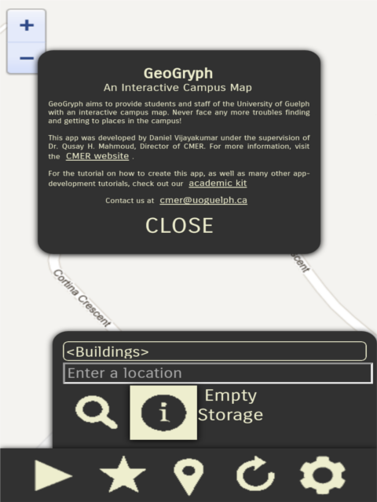
Do the same as above for the about_overlay DIV element to enable its toggle feature. You will need to work with the aboutApp function to accomplish this (note that the code for both aboutApp and toggleOptions should be very similar to each other). The figure on the left contains a screenshot demonstrating both the overlays in action.
Backend Functionality
Now let us work on the meat of the application. For the rest of this section, you will be working on main.js in the js folder unless specified otherwise. You will come across a lot of helper functions and five main points of execution (representing the main features of the application) that use the helper functions. The tutorial follows a modular approach in order to encourage this style of coding. Thus, it is not necessary to start working from the beginning. You can feel free to start from anywhere. For your convenience, the functions are separated into sections as some functions are more related to each other than others. But it is extremely important to complete one function before proceeding to the next one, even if you come across helper functions that you have not completed yet.

Introduction To The Application

Initialize The Application
We first need to deal with some start-up initializations. Take a quick look at the global variables right now. Some of them are self-explanatory while others are not, but do not worry about understanding them right now. We will discuss them as they come up during the tutorial. When the application loads, it first renders the marked up interface followed by the Google Maps object. The function initializeMap() contains various parameters and declarations for rendering and initializing the map and its various objects.
We start by initializing the Google Directions API services. Consider the two JavaScript objects polyline_options and renderer_options. These parameters modify the look and feel of any rendered path on the map. Create three properties for polyline_options: strokeColor, which is assigned as "#0000CD";strokeOpacity, which is assigned as 0.6; and strokeWeight, which is assigned as 7. Create three more properties that are of type boolean forrenderer_options: draggable, assigned as false; preserveViewport, assigned as true; and supressMarkers, assigned as true. Then instantiate thedirections_service and directions_display objects. Your code should look like this so far:
// Parameters for directions rendering
var polyline_options =
{
strokeColor: "#0000CD",
strokeOpacity: 0.6,
strokeWeight: 7
};
var renderer_options =
{
polylineOptions: polyline_options,
draggable: false,
preserveViewport: true,
suppressMarkers: true
};

directions_service = new google.maps.DirectionsService();
directions_display = new google.maps.DirectionsRenderer(renderer_options);

We will now create the actual Map object. You should be familiar with this part from Lab 1, so the code for this has already been provided. Note the extra parameters for the various map controls. The goal is to preserve the maximum screen estate on the user's device, therefore the street view and map type controls are hidden and the zoom control is shrunk and placed on the top left side of the screen. This screenshot will demonstrate it:
Note that we did not set the center of the map in mapOptions. This is because we wish the map to be centered on the user's current location right from the beginning. We can attempt to do this using the following code:

// Attempt to center the map upon loading on the user's current position
getUserLocation(
function (position)
{
var location = new google.maps.LatLng(position.coords.latitude, position.coords.longitude);
updateMarkers([markers.user], [location], location);
},
function ()
{
map.setCenter(stone_gordon);
}
);

Do not worry about understanding the helper function getUserLocation(callback, errorCallback) above as we will walk through it later. In fact, do not worry yet about understanding any other helper functions that we use in this function. For now, the names of the helper functions should be sufficient to understand their use within this function.
Next, we initialize the marker overlay objects representing the user's location and the destination location. Note the global variable markers in the top of this file. It is a JavaScript object that represents all the markers that will be created in this application. Each marker is stored as a property of markers thereby allowing various convenient operations including linear iteration as well as associative access (key-value pairs à la hashing). More on this is briefly covered in the beginning of the Create Marker section below. You must once again be familiar with the process of creating markers from Lab 1 so the code is once again provided for you. We initialize the user and destination markers in advance so that they can be worked with right off the bat by other functions. Also, note the special code for the icon image of the user and destination markers. We provide our own image files (located in the img folder) as opposed to the default google maps marker image.
One of the neat usability features of the app is the ability to click on (press on) a marker to snap the view to it, also known as centering the map on it. We already handle this in the helper function createMarker() but we will need to handle the special case of the user and destination markers. To do this, iterate through themarkers and bind a click listener for each marker that zooms in if required and centers the map on the marker. The following code demonstrates this:

// Clicking on a marker generally centers the map on it
for (marker in markers)
{
// IIFE (Immediately Invoked Function Expression) for dealing with the asynchronous nature of callback functions
!function (marker_local) // outer
{
google.maps.event.addListener(markers[marker], 'click',
function () // inner (local)
{
checkMapZoom(map.getZoom());
map.setCenter(markers[marker_local].position);
}
);
}(marker)
}

The above code might not make sense to you if you are relatively new to asynchronous programming with JavaScript. First review asynchronous programming as mentioned in the Required Tools and Configurations section of this tutorial and then read the following article that explains IIFEs (Immediately Invoked Function Expression) very well.
Moving forward, you will see a comment for some code for creating a circle that encloses an estimation of the campus area. This is very similar to creating a marker or a polyline so try doing this yourself. You will need to create an object for storing the options for the circle. Set its stroke color to #FF0000, stroke opacity to 0.6, stroke weight to 2 and fill opacit to 0.0. Then assign to it the global map object, center it on the global variable campus_center, set its radius to the global variablesearch_radius and lastly, disable its ability to be clickable (this is necessary so that the map enclosed within the circle can be interacted with). Then instantiate thecampus_area global variable object using the options you just created. Your code for this should be something like this:

// Circle enclosing the known campus area
var circle_options =
{
clickable: false,
strokeColor: "#FF0000",
strokeOpacity: 0.6,
strokeWeight: 2,
fillOpacity: 0.0,
map: map,
center: campus_center,
radius: search_radius
};
campus_area = new google.maps.Circle(circle_options);

Next, we subscribe the map object to the Google Places service as shown in the code by instantiating the places_service object and passing map as an argument. The last thing that we need to do in this function is integrate the Google Places Autocomplete object with the search text entry field from the user interface. This enhances the text field to drop down a list of place suggestions based on what the user types in real-time. While this feature sounds too complicated, all it really takes is the following piece of code:

// Create the autocomplete object and attach it to the search box
var search_bounds = new google.maps.LatLngBounds( // Limits the suggestions to places within this bounding rectangle
new google.maps.LatLng(43.518774,-80.24148),
new google.maps.LatLng(43.547739,-80.203886)
);
var search_box = document.getElementById("search");
var auto_options =
{
bounds: search_bounds,
componentRestrictions: {country: "ca"}
}
// Attaching to the search box
var autocomplete = new google.maps.places.Autocomplete(search_box, auto_options);

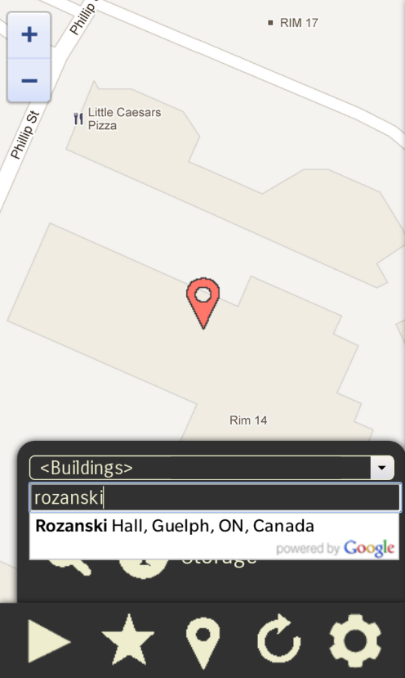
The code for actually attaching the autocomplete feature to the search box is in fact just the last line. What we really need to pay attenton to is the code prior to that. When typing a location in the search text entry field, he/she obviously expects suggestions to be in context with his/her location. For example, it would be a nuisance to see suggestions from other countries, and this is especially true on a mobile device. To address this issue, we limit the suggestions to a specified bounding rectangle. This rectangle was chosen manually with the help of the actual Google Maps web application. Additionally, the search is restricted to Canada to take care of any anomalies that might bypass the bounding rectangle. The figure on the left represents a screenshot of the search box in action.
We have now at last completed the function for initializing our application. Finally, go to the very top of the file and locate the api_key global variable. Assign to it your own Maps API key. If you do not have one, check with your instructor or get one yourself by following the link mentioned in the Required Tools and Configurations section of this tutorial.

Creation and Mutation

Create Marker
Due to the nature of the application, we will have an indefinite and sometimes large number of markers on the map. In order to efficiently work with them, we store all markers in a global JavaScript object markers, as mentioned earlier. Thus, we abstract the marker creation process into a separate function that appends newly created markers to this object. We will take advantage of the fact that JavaScript objects can function like associative arrays, so each marker is added as a property of the markers object¹.
Go to the createMarker(id, position, title, icon?) function. The first and most important step is to create the marker object. Assign to marker_optionsthe following properties: the map it belongs to; its position (a google.maps.LatLng object); and a title that briefly describes the marker. The map global variable is obviously the map; the position and title arguments of the function satisfy the next two properties. Now the icon uri that contains the image of the marker is an optional argument to the function, so we need to handle this. This can be done as follows:
if (icon !== undefined)
marker_options.icon = icon;

We need a unique identifier in order to represent each markers property as a marker object. This is satisfied via the id argument. We now have everything we need to create the marker object, so type the following code:

markers[id] = new google.maps.Marker(marker_options);

Next, we need to create an information window overlay so that when the user clicks on a marker, the name of the location can be seen. Observe the contentvariable. This string containts the HTML markup for the overlay content. You will notice that the title variable is concatenated within this string. This ensures that the title (which usually is the name of the location) of each marker appears in this overlay/window. Then, the information window is created and its content is assigned, as shown in the function. Lastly, we need to attach click listeners to activate the toggle functionality of the overlay. Notice the two listener bindings. The first one binds a click event to the created marker object. When the marker is clicked, its respective information window pops up. This is done through info_window.open(map, markers[id]);. The second listener binds a click event to the map object. When the map is clicked, any open information window is closed. This works well because the only interactive elements of the map are the map object and the toolbar in the bottom. This is done through info_window.close();. Thus, we enable toggle functionality for the information overlays of created markers.
We also want to be able to save the location of the marker when clicked so that the user can plot a location from his/her current location to the marker's position. And as a matter of usability, we want to snap the map to the marker's position. These must all be handled by the marker's click listener. The binding code should be modified and must finally look something like this:

google.maps.event.addListener(markers[id], 'click',
function ()
{
saveToLocalStorage(position);
checkMapZoom(map.getZoom())
map.setCenter(position);

info_window.open(map, markers[id]);
}
);

For obvious reasons, we do not want to create a new marker for repeated locations. To solve this issue, simply enclose all of the existing function code into a conditional structure. Simply perform a check to see if markers already contains the marker as one of its properties. If yes, then the existing marker is simply placed on the map once again. The conditional structure should look as follows:

if (!markers.hasOwnProperty(id))
{
//
// Function code
//
}
else
markers[id].setMap(map);

We have now successfully abstracted away the marker creation process from the rest of the application.

Update Markers
Just as we developed a general method to batch create markers, we also need to be able to update the position(s) of a marker or an array of markers. Examine theupdateMarkers(markers, positions, center?) function. The first two arguments are arrays of marker objects and positions (the latter being of typegoogle.maps.LatLng. These two arrays must work in tandem, that is their orders must be reflective of each other. In other words, the marker at index 0 will be updated with the position at index 0, the marker at index 1 will be updated with the position at index 1, and so on and so forth². So iterate through the array of markers (the for loop has already been provided) and update each position with the equivalent position from the array of position. We also need to handle the case where the marker overlay is not present on the map due to clearing the map. Set the map property of each marker as the global map object. Additionally, the value of a position can be undefined. This can happen when the position of the marker does not need to change but the marker simply needs to be redrawn on the map due to being cleared prior to this. So check if the corresponding position is undefined: if not, then only do we update the position of the marker. The code for the steps so far is as follows:
if (positions[i] !== undefined)
markers[i].setPosition(positions[i]);

markers[i].setMap(map);

We now handle the optional center argument, which is of type google.maps.LatLng. You should be familiar with the general method of checking for an optional argument by now. The condition to check for is exactly the same as we did in the above function for creating markers. Check out the conditional structure that is present in the function right now and verify that it is correct. Now, if center is provided, we have two possible cases:

Snap the map to any location
When the value of center is null, we can choose any marker to be the center of the map. It is up to you how to go about choosing this marker. For the sake of simplicity (albeit at the cost of efficiency), feel free to center the map on each marker of the array. An alternative more efficient method would be to center the map on the last marker in the array, but implementing this is up to you.

Snap the map to the specified location
Otherwise, the value of center has been provided, so we simply need to center the map on center
In both of the above cases, we need to restrict the zoom level of the map. Call checkMapZoom(current_zoom) and pass to it the current level of zoom of the map. The entire code for handling the optional center argument should now look something like this:

// Optional: Center the map on a marker position
if (center !== undefined)
{
if (center == null)
{
checkMapZoom(map.getZoom());
map.setCenter(markers[i].position);
}
else
{
checkMapZoom(map.getZoom());
map.setCenter(center);
}
}

We now have a flexible function that can update the positions of markers both on an individual basis as well as a batch process.

Render Path
The render(origin, destination) helper function takes in two arguments, origin and destination, which are of type google.maps.LatLng. These obviously are the two points between which a path needs to be drawn. To create this path, we need to compute the directions from the origin point to the destination point. This is done using the Google Directions API. Note the global variables directions_service and directions_display. They were initialized asgoogle.maps.DirectionsService and google.maps.DirectionsRenderer objects respectively. These are required in order to subscribe to the Directions API, as mentioned earlier. Now get into the function and take a look at its code. The request object contains three self-explanatory properties that form the parameters for the Directions API request. We then invoke the route(request, callback) method in order to compute the directions between origin anddestination. The callback function is used to do something with the response. It needs to pass two arguments: result, which contains the results of the request, and status which indicates the status of the response. So create an anonymous function of the same signature and then create an if conditional structure that checks if status evaluates to google.maps.DirectionsStatus.OK. Within this structure (i.e. if the condition is true, then) use directions_display to render the polyline represented by the resultant directions on the map. Additionally, snap the map to the destination point (or the origin point; whichever you prefer) so that the user always sees where he/she needs to go to (or where he/she is present at the moment). Your anonymous function should look something like this:
function (result, status)
{
if (status == google.maps.DirectionsStatus.OK)
{
// Render the directions polyline
directions_display.setMap(map);
directions_display.setDirections(result);
map.setCenter(destination);
}
}
We have now created the helper function for actually rendering the polyline path between two points on the map. This function can be called by plot() if the origin must be evaluated as the user's current location. If another origin point is known, the function can be called directly as well.

Some Helpful Housekeeping

Restrict Map Zoom Level
It is normally expected that the user of a maps-based application will use the zoom feature of the map to their advantage. The problem with this lies in the way web-based applications render the map object. Each state of the map has a number of images associated with it. Whenever a new state is reached, these images must be downloaded to the applications. States are changed by zooming, panning and some other operations. If the user zooms quite often, the performance of the app is expected to reduce significantly, especially on mobile devices. Additionally, unnecessary usage expenses are incurred for those who use 2G/3G/LTE networks. In order to gain more performance as well as more usability, this application restricts how much the user can zoom in/out the map by a fixed amount.
Implementing this is very trivial. Go to the checkMapZoom(current_zoom) function. At any given state, the map is at a specific level of zoom which ranges between 1-19. The argument current_zoom contains this value, which must be passed by the caller. Note the two global variables min_zoom and desired_zoom. These parameters describe the restriction level (note that min_zoom must always be less than or equal to desired_zoom). Whenever the current zoom level is greater than or equal to the desired zoom level, we need not change the zoom level of the map. This ensures that no change of state by zooming occurs when the user has zoomed in quite a bit. But whenever it is less than the desired zoom level, we then need to check if it is also less than the minimum zoom level. If yes, then the map's zoom level is reset to the minimum zoom level. This is done to prevent the user from zooming too far out, thus preventing cases of the need to rectify excess zooming. Else, nothing needs to be done again. Here is what the code should look like:
// Restricts the possible zoom levels of the map
function checkMapZoom (current_zoom)
{
if (current_zoom < desired_zoom)
{
if (current_zoom < min_zoom)
map.setZoom(min_zoom);
}
}

Note that desired_zoom might be more appropriately named as default_zoom. Both names are semantically acceptable; it is up to your discretion which one to use. Also note that the desired zoom level and minimum zoom level parameters can be changed as desired. Additionally, a maximum zoom level parameter can also be defined and used in this function to restrict how close the user can zoom in. This is optional and is thus left to the reader to implement it if desired.
Thus, we are now able to restrict the zoom level as desired.

Refresh The Map
When the user continues using the app for a prolonged period of time without closing it, the map will eventually become cluttered with markers and polyline paths. This significantly bogs down performance and makes it hard to navigate through the map. To remedy this, we need a way to remove all overlays from the map, thereby "refreshing" it. Go to the clear() function towards the end of the code. Our goal is to 1) clear any text in the search text entry field, 2) clear all rendered markers and 3) clear all rendered paths.

Clear the search box
Get the search field element from the markup and store it in a variable search_box. Assign the value attribute⁴ as "". This effectively clears the text entry field.

Clear all rendered markers
Recall that all created markers are stored in the markers global array variable. We need to iterate through this array and bind each marker to the null map. To do this operation, invoke setMap(null) for each marker object.

Clear all rendered paths
Similar to above, we need to bind the DirectionsRenderer object to the null map. Invoke setMap(null) for the directions_display variable.
We have thus refreshed the entire map and have even cleared the search text entry field.

Empty Local Storage
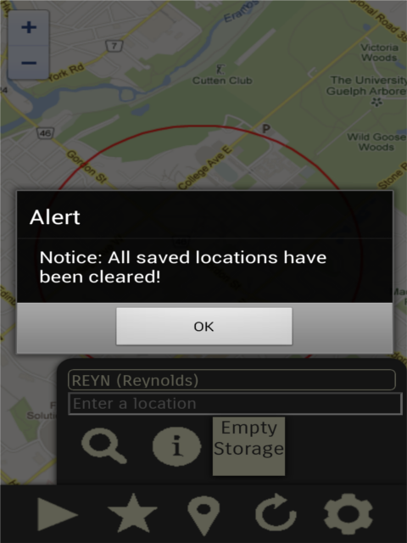
The user might want to clear their local web storage from time to time. This is similar to deleting cookies at the end of a browser session. This is very easy to accomplish. Go to the clearStorage function. All we need to do is clear the contents of the localStorage.savedLocation variable. In JavaScript, you can do this by typing delete localStorage.savedLocation;. This will set localStorage.savedLocation to undefined. It is probably advisable to notify the user of this operation, so go ahead and send an alert("Notice: All saved locations have been cleared!"); after the line.
Finally, realize that we once again can not expect all users' devices/browsers to support HTML5 local storage, so we must check for this and notify the user accordingly just as we did earlier. The screenshot on the right demonstrates this feature in action.

Geolocation and Storage

Request User's Current Location
Probably the most important functionality of the application is the ability to know the user's current location at any given time. Examine the functiongetUserLocation(callback, errorCallback) carefully. The signature indicates that it takes in two callback functions as arguments, callback anderrorCallback (which is an optional argument). You must already be familiar with using the navigator.geolocation object from the HTML5 specification. To retrieve the user's current position, one would usually just invoke the getCurrentPosition(success, error, options) method and work with the retrievedposition object in the success(position) callback function while handling errors in the error(error) callback function. But this only works for one way of using this feature. Since we will be using this feature frequently and in various use cases, we need to abstract away what we do with position from the function. Here is where the callback argument of the function plays its role. The actual processing of the user's position will be done within this callback function. Here is the signature of callback: callback(position). All we need to do is call callback within the success callback and pass position into it. All this might sound very confusing but all you really have to do is add 1 line of code. Here is what the entire code looks like so far:
// Geolocation services must be enabled
if (navigator.geolocation)
{
navigator.geolocation.getCurrentPosition(
function (position)
{
// Do something with the current position
callback(position);
}
// Deal with errors
, function (error)
{
switch(error.code)
{
case error.PERMISSION_DENIED:
alert("Error: Denied access to location services!");
break;
}
}
, {enableHighAccuracy: true});
}

Note that basic error-handling has been done that checks if location services are supported/enabled by the device. But we have not yet properly handled the case that it is not supported. Create an else structure associated with the if structure. Additionally, complete the switch structure to include the following cases:POSITION_UNAVAILABLE, TIMEOUT and UNKNOWN_ERROR. We also do not want to simply notify the user if the geolocation request returned an error, so we call theerrorCallback() function right after the switch structure to handle the error. Now, recall that the error callback function is an optional argument, therefore check if it was provided. If yes, execute it; if not, simply ignore it or notify the user that geolocation services are not supported/enabled by the device, whichever you need to do. The entire function should now look something like this:

if (navigator.geolocation)
{
navigator.geolocation.getCurrentPosition(
function (position)
{
// Do something with the current position
callback(position);
}
// Deal with errors
, function (error)
{
switch(error.code)
{
case error.PERMISSION_DENIED:
alert("Error: Denied access to location services!");
break;
//
// Perform other switch cases
//
}
// Call the error callback function if provided, else do nothing
if (errorCallback !== undefined)
errorCallback();
}
, {enableHighAccuracy: true});
}
else
{
// If the error callback function is not provided, just notify the user
if (errorCallback === undefined)
alert("Error: Geolocation services are not supported by your device!");
else
errorCallBack();
}
We now have a flexible function for retrieving the current location of the user whenever needed.

Save Location For Later Use
One of the main features of the application is to store any desired location for reuse at a later time. This means that we need data that persists even after the app has been closed. The local web storage API defined as part of the HTML5 standard is a fine (and elegant) solution to this problem. Go to thesaveToLocalStorage(location) function. It takes the location object, which is expected to be of type google.maps.LatLng, as an argument and stores it in the local web storage of the user's device. First, create a JavaScript object³ data. This object must have two properties, lat and lng, for storing the latitude and longitude of the location object separately. A google.maps.LatLng object has two methods, lat() and lng(). But these return number values, and not strings. Thus, we need to store in data the string representations of the values returned by the methods. Next, we need to convert data into a JSON object (string) because only strings can be stored in the local storage and we need a meaningful way to represent the data object. Store the resultant string in a variable storage_string. Now, consider the localStorage object that is provided as part of the API. It is a persistent object and its values do not change or reset even when the application is closed and re-opened. We obviously want to add our data somehow to this object so that it can be persistent as well. This can be done by creating a new propertysavedLocation and then storing the string representation of our data into this property. Your code should now look something like this:
// Store the latitude and longitude in a convenient object
var data =
{
lat: (location.lat()).toString(),
lng: (location.lng()).toString()
};

// Convert to a JSON string so it can be saved in local web storage
var storage_string = JSON.stringify(data);
localStorage.savedLocation = storage_string;

As a final touch, it would be nice if the map snapped to the location after saving it. This is a usability enhancement and just makes it easier for the user to be location-aware. To do this, simply center the map on the location object. Just to recall, the code for this would be:

map.setCenter(location);

We are not done yet: there is one crucial thing missing from this entire code so far. It is quite unreasonable to expect that all devices and user agents support the HTML5 local web storage API. Thus, we need to handle this and notify the user accordingly. To check for the existence of this feature, you can simply check forwindow.localStorage. When used as a predicate for a conditional structure (like an if-statement), it evaluates to true if local storage is supported and false if not. Wrap the entire code we have written for this function so far in an if structure and produce an alert for the else part. Here is an illustration:

if (window.localStorage)
{
// Enter all code for this function, including the snapping of the map
}
else
alert("Error: localStorage is not supported by your device!");

Our application is now able to store persistent data.

Load Last Saved Location
Once we have stored our data persistently, we must also be able to access it from local storage whenever its use is required. Take a look at theloadFromLocalStorage() function. Since we will be using the local web storage API once again, we obviously need to check to see if it is supported. You can see a conditional structure there exactly like the one from the saveToLocalStorage(location) function that we previously worked on. All we need to do is load the previously saved string representation of the location into a google.maps.LatLng object and then return this object to the caller. Recall that in thesaveToLocalStorage(location) function, we used the JSON.stringify(object) method to convert data to a JSON string and stored it inlocalStorage.savedLocation. So we just need to get back the data object from localStorage.savedLocation, and we can do this by parsing the string using JSON.parse(string). Store this in data, create a location object using data.lat and data.lng and then return this location. Your code should now look something like this:
var data = JSON.parse(localStorage.savedLocation);
var loaded_location = new google.maps.LatLng(data.lat, data.lng);

return loaded_location;

Our function will now load and return the last saved location, as long as the local storage API is supported. But we are missing one crucial boundary case: what if there is no previously saved location in the first place? This would be the case when the application is run for the very first time, or if the local web storage was cleared/deleted. In order to handle this, we need to check if the localStorage object has the property savedLocation. If this is not true, then notify the user and return undefined.
You will understand the reasoning behind returning undefined when we use this function later.

Main Feature Execution Points

Snap To User
The primal feature of the application is being able to snap/center the map on the user's current location. Consider the very straightforward function snap(). It requests the user's current location by calling getUserLocation(callback, errorCallback) as defined above. The returned position must then be parsed and stored as agoogle.maps.LatLng object in a location variable. The user marker object is then associated with this location and the map is snapped to this point. The code you need to write for the anonymous callback function is something like the following:
function (position)
{
var location = new google.maps.LatLng(position.coords.latitude, position.coords.longitude);
updateMarkers([markers.user], [location], location);
}

Note that the first two parameters of updateMarkers(markers, positions, center?) require arrays of markers and positions, respectively. Hence, we enclose the single entries within brackets. Also note that in this case, the optional argument for centering the map is passed, since we want to snap/center the map on the user's location.
Finally, examine the anonymous callback function that handles the error callback for getUserLocation(callback, errorCallback). If geolocation services fail for some reason, the map is centered on a predefined location. In this case (as well as the rest of the application), the location is the intersection of Stone Road and Gordon Street.
Our application can now snap to the user's location as desired. We will follow the template and general structure of this function for some other functions as well.

Save User's Current Location
An important aspect of the Trip Recorder feature is the ability to save the user's current location persistently and then access it at a later time for processing. This can be very easily accomplished following the structure of the snap() function that we just finished above. Go to the save() function and copy the contents of snap()into it. The function should at the moment look something like this:
getUserLocation(
function (position)
{
var location = new google.maps.LatLng(position.coords.latitude, position.coords.longitude);
updateMarkers([markers.user], [location], location);
},
function ()
{
map.setCenter(stone_gordon);
}
);

We are doing exactly the same thing as before with the one exception that instead of updating the position of any marker, we save the user's current location in local web storage. To do this, delete the updateMarkers line and replace it with a call to saveToLocalStorage(location). Your final code should be something like this:

getUserLocation(
function (position)
{
var location = new google.maps.LatLng(position.coords.latitude, position.coords.longitude);
saveToLocalStorage(location);
},
function ()
{
map.setCenter(stone_gordon);
}
);

As a side note, we are automatically handling the error callback due to the copying of the previous code.
Thus, our application can now save a locaton persistently in the local web storage of the user's device/browser.

Mark Building On Map
Another main feature of the application is the ability to choose a building from a provided list and draw it on the map while also snapping to it. Centering/Snapping the map on/to the building helps the user know where the building is without having to look around on the map for the marker. Go to the mark() function and examine the code that is already present there. We obtain a reference to the select drop-down element from the user interface and store it in select. The value of the actual selection, which is a string that contains the abbreviation of the selected building, is stored in value. This string could also be "null", which implies that the placeholder option was selected. The conditional structure that follows ensures that no processing is performed if value evaluates to "null".
Go to the top of the file and look for the global variable buildings. It represents an object with a (large) number of properties that represent the different buildings in the campus. Each property is an object that in turn has two properties, name and LatLng. These respectively represent the full name of the building and its location in latitude and longitude. This "list" of buildings was meticulously created by manually computing the latitude/longitude coordinates for each building using the actual Google Maps web service. Note that the abbreviation of the building serves as the property name (or id/key) for each property (building) of buildings. Now go to the function mark() and create a variable selected_building and store in it the object representing the selected building. You can access this from the buildingsobject associatively using the abbreviation stored in value.
var selected_building = buildings[value];

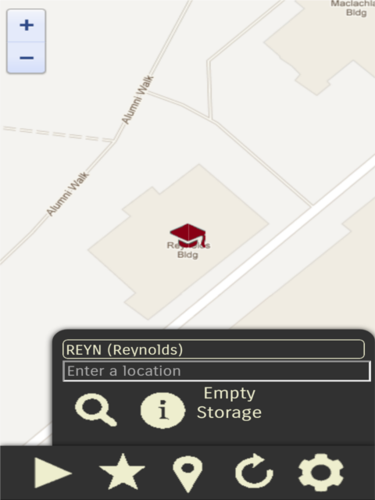
We then need to center the map on the building, so we either directly center the map on the marker represented by the selected building if it already exists, or create the marker first and then snap to it. Also, the zoom level restriction must be in effect in either case. First, check if value is currently a property of markers. If yes, then call updateMarkers(markers, positions, center?) and pass in the single building marker, undefined and null respectively. One might wonder why we would call this function and pass it these odd arguments as opposed to directly setting the center of the map object. The main reasoning behind our choice is that the function for updating markers also draws the marker overlay on the map in case it was cleared. Additionally, the zoom restriction and centering operations are performed by the function as well. Thus, we can abstract away these operations to the function which results in a more elegant solution. Now if the building markerdoes not exist, then we create it by calling createMarker(id, position, title, icon?) and passing to it the building abbreviation, location, full name and the file path (string) to a suitable image file. The location (position) and full name arguments (title) can be accessed from the selected_building object. The image file in our case is an internal resource present in the img folder. A reference to its file path has already been provided in the global variable red_university Lastly, don't forget to call checkMapZoom(current_zoom). The code thus far should like something like this:

// Snap to/Center on the marker
if (markers.hasOwnProperty(value)) // If the marker already exists
updateMarkers([markers[value]], [undefined], null);
else // Create it if it doesn't exist
{
createMarker(value, selected_building.LatLng, selected_building.name, path_images + "university.png");
checkMapZoom(map.getZoom());
}

Finally, save the marked building location persistently in local web storage. Do this by calling saveToLocalStorage(location) and passing to it the LatLng value of selected_building. We are now able to display a user-selected building on the map as well as save it in order to plot a path from another location to it whenever desired. The screenshot above shows this feature in action.

Plot Path Between Locations
Another main feature of the application is to be able to plot a path between an origin point (currently, always the user's current location) and a destination point. Examine the plot(destination) function. It is evident that the function takes in a destination location as an object, computes the user's current location and then renders the path between these two points. Note that destination is actually an optional argument, so if it is not provided, the function by default attempts to load a destination from local web storage. So first check if the argument was provided; if not, then call the loadFromLocalStorage() function and store its return value indestination. You can do this as follows:
// If a destination has not been provided, load from local web storage (HTML 5)
if (destination === undefined)
destination = loadFromLocalStorage();

We now need to retrieve the user's current location. As usual, call getUserLocation(callback) and pass in an anonymous function that is quite similar to the one in the snap() function. Make sure first that the latitude and longitude values from the returned position are stored in a variable origin as opposed to location from previous functions (this is just for easier readability). We now have all the information we need to draw a path between the two points. Call render(origin, destination and pass the two arguments appropriately. This renders a blue polyline from the origin point to the destination point but does not draw any markers on the map. To do this we need to update the positions of the user (markers.user) and destination (markers.destination) objects (as opposed to creating brand new objects, which is inefficient). Thus, we create an array containing the markers markers.user and markers.destination. Create another array containing the positions origin and destination. Now call updateMarkers(markers, positions, center?) and pass the two arrays in the correct order, omitting the third argument. The anonymous function should look something like this:

function (position)
{
// Retrieve user's current location
var origin = new google.maps.LatLng(position.coords.latitude, position.coords.longitude);

render(origin, destination);

var markers_array = [markers.user, markers.destination];
var positions_array = [origin, destination];
updateMarkers(markers_array, positions_array);
}

The main functionality is now complete but we need to check for one erroneous case: when destination is undefined, i.e. no destination was passed as an argument nor is there any destination stored in the local web storage. We have already handled the former case but in the case of the latter, note thatloadFromLocalStorage() returns undefined if there was no location previously saved in the local web storage. This should make it clear why this case needs to be handled, which is very easy to do so. Simply put the portion after the former check within a conditional structure that checks if destination is not undefined. Your conditional structure should be something like this:

if (destination !== undefined) // Ensure that a destination does exist
{
getUserLocation(
function (position)
{
// etc. etc. as instructed above
}
),
function ()
{
map.setCenter(stone_gordon);
}
);
}

Thus, we can now plot a path between two locations on the map.

Search For POIs
The final and perhaps most interesting feature of the application is the ability to search for any point of interest whatsoever that exists within the general area of the university campus. We will be using the Google Places API to implement this. Also remember that we integrated a search autocompletion box that drops down suggestions in real-time as a user types in text in initializeMap(). The function we are about to write will particularly demonstrate how easy it is to develop rich features with minimal effort, thanks to robust web technologies and APIs. Go to the search function at the very end of the file. To perform a search using the Places API, we need to first build a request and then query the API for a response containing search results. The Places API allows us to define a circular bound on the map within which only a search is performed. This circle has a center (google.maps.LatLng) and a radius (string or number, depending on the usage) that is measured in meters. First, the text value (string) of the text entry field in the user interface is stored in value. The global variable campus_center contains the latitude and longitude of the estimated center of the campus (this was meticulously determined manually through the actual Google Maps web application). The global variablesearch_radius contains a number that represents the radius of the bounding circle. We now have all the data we need to build the search request. Create a JavaScript object request and assign to it the following properties: keyword, which is assigned input; location, which is assigned campus_center; and radius, which is assigned the string representation (toString()) of search_radius.
We are now ready to invoke the Places API search by keyword. Recall that we subscribed the map object to the Places service object places_service. This object contains a method search(request, callback) that takes in two arguments, the search request and a callback function that handles the query response. This callback function takes three arguments: results, which is the object that contains the search results; status, which contains status information of the response; and pagination, which is a navigational object that allows accessing multiple pages of search results (the maximum number of search results per call is 20, therefore we use the pagination feature to go through multiple pages of results. The ultimate maximum including multiple pages is 60 search results). So call the search method and prepare the skeleton of the anonymous function that we will use as our callback function. Your code for the entire function thus far should look something like this:
// Search for points of interest and display them on the map
function search ()
{
var input = document.getElementById("search").value;

var request =
{
keyword: input,
location: campus_center,
radius: search_radius.toString()
};

places_service.search(request,
function (results, status, pagination)
{
}
);
}
We will now work on the anonymous callback function. As with all API queries, we must check if the status of the response was fine. Check if status isgoogle.maps.places.PlacesServiceStatus.OK. If yes, carry on and if not, notify the user of the error. It is up to you how to check for the error conditions (hint: they are ZERO_RESULTS, INVALID_REQUESTS, OVER_QUERY_LIMIT, REQUEST_DENIED, UNKNOWN_ERROR and the good old-fashioned ERROR), so let us focus on the rest of the function. The results object is an array of JavaScript objects that represent a point of interest. We will iterate through all these points of interest and work with each one of them. Create a for loop to facilitate this. Inside the loop, we can call a point of interest a place, so create a variable place and assign to itresults[i]. Now paste the following code right after:

// Temporary fix: The icons are scaled down to half since the icons provided from the API results are too big
var shrink_icon = new google.maps.MarkerImage(
place.icon,
new google.maps.Size(71, 71), // Assumes that the original image is 71x71
new google.maps.Point(0, 0), // origin point of the image (usually 0,0)
new google.maps.Point(17, 34), // anchor point, i.e. where it points to the location (usually in the bottom middle, so at (floor(max_x/2),max_y))
new google.maps.Size(34, 34) // final dimensions of scaled image
);

This fix addresses a problem with the huge icons provided by Google in the results object by shrinking them to half the size. It is an optional snippet of code so feel free to discard it if you wish. Recall that this is very similar to the calibration done on the custom marker image for the user's marker in initializeMap().
Moving forward, we need to create a marker for each place so that each point of interest can be displayed on the map. Go ahead and call createMarker(id, position, title, icon) and pass to it place.id, place.geometry.location, place.name and shrink_icon respectively. The meaning and context of each of these variables is straightforward. One particular note is that the identifier string in place.id is guaranteed to be unique for every point of interest that exists and also the same for each point of interest forever. This is what makes it extremely useful for use as the unique identifier representing its marker in the markersobject. As a usability boon, we want to snap the map to the last result of the search so that the user does not have to move around the map to locate the markers representing the points of interest. This also works very well for searches that produce only 2 or 3 results as they are more likely to be located close to each other thereby providing the user with a good view of most (if not all) points of interest in one glance. So check if the counter has reached the last index and then callsaveToLocalStorage(location) while passing to it place.geometry.location. The anonymous callback function should look something like this so far:

function (results, status, pagination)
{
if (status == google.maps.places.PlacesServiceStatus.OK)
{
for (var i = 0; i < results.length; i++)
{
var place = results[i];

// Temporary fix: The icons are scaled down to half since the icons provided from the API results are too big
var shrink_icon = new google.maps.MarkerImage(
place.icon,
new google.maps.Size(71, 71), // Assumes that the original image is 71x71
new google.maps.Point(0, 0), // origin point of the image (usually 0,0)
new google.maps.Point(17, 34), // anchor point, i.e. where it points to the location (usually in the bottom middle, so at (floor(max_x/2),max_y))
new google.maps.Size(34, 34) // final dimensions of scaled image
);

createMarker(place.id, place.geometry.location, place.name, shrink_icon);
// Save the last result into local storage
if (i == results.length - 1)
saveToLocalStorage(place.geometry.location);

}
}
else if (status == google.maps.places.PlacesServiceStatus.ERROR)
alert("Error: There was a problem contacting the Google servers!");
// else if etc. etc. for other error conditions...
}

Lastly, we need to use the pagination object to access the next few "pages" of search results. Check if there is a next page; if yes, then invoke a sleep command for 2 seconds and then call the search(request, callback) once again by invoking the nextPage() method of the pagination object. We impose a 2-second delay before we search again because Google imposes a 2-second delay between each search request. Your last few lines of code for the entire function should look like this:

// The response contains max 20 locations per request; we must scroll through the remaining 'pages' of results
if (pagination.hasNextPage)
{
sleep:2; // Google imposes a 2-second delay between each search request
pagination.nextPage(); // nextPage() calls this callback function once again
}

That is all there is to the implementation of the search feature. All we did was query the Places API and handle its response and we are able to have a search-enabled smart feature.
Conclusion
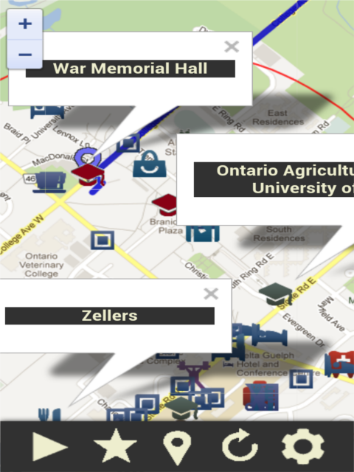
And there you have it: a feature-rich location-aware application all in a day's work (your mileage may vary depending on how much time and energy you devoted to this project). Your final steps would be to package and sign your application and then publish it to the app-store but before that, spend some time thinking about ways you can improve the application. Are there any features that came to your mind as you were working? Are there any obvious instances of inefficient coding that can be rectified? Can you think of more efficient ways to approach the problem? Take the time to implement them as well. Once you are done, follow the instructions in the section "Finalizing your application" of Lab 1.

Appendix A: Further Learning

Associative Arrays in JavaScript
There is an interesting connection between JavaScript objects and associative arrays. Read these articles to obtain a better understanding: 1, 2

A More Elegant Approach
Instead of having the markers and positions arrays as two separate objects, create one JavaScript array object to pass as a single argument that encompasses both the markers and their positions.
// Here is the modified function
function updateMarkers (points_of_interest, center)
{
for (var poi in points_of_interest)
{
if (poi.position !== undefined)
poi.marker.setPosition(poi.position);

poi.marker.setMap(map);

// Continue the rest of the function accordingly...
}

}
// Assume we are plotting a path between the user's current location and a destination point
// We are in the plot() function and are calling the updateMarkers() function
// We would thus create the following array of objects...
var points_of_interest =
[
{
marker: markers.user,
position: new_user_location
},
{
marker: markers.destination,
position: new_destination_location
},
{
// etc. etc. for as many markers as needed
}
];

// ...and then pass it into updateMarkers as follows
updateMarkers(points_of_interest, position);

JavaScript Object vs. JSON Object
They are not the same. Read the answer to this question on Stack Overflow.

Attribute vs. Property
There is a slight distinction between a (pre-defined/inherited) attribute and a (custom defined) property of an object. Here is another Stack Overflow reference.

