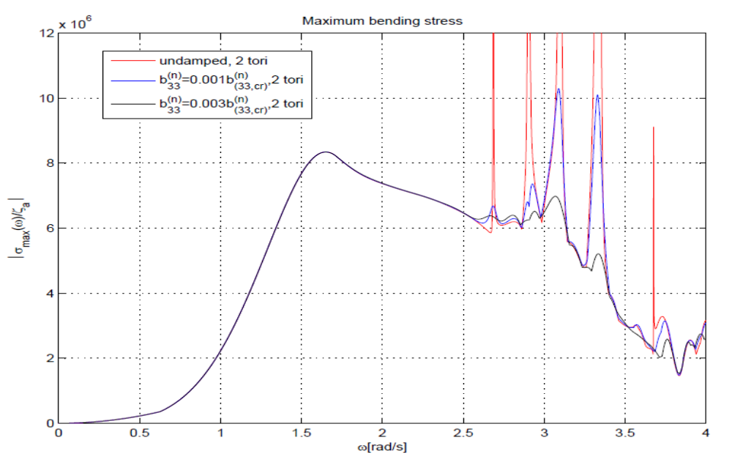
Transfer function for maximum bending stress in the floater for 2 tori
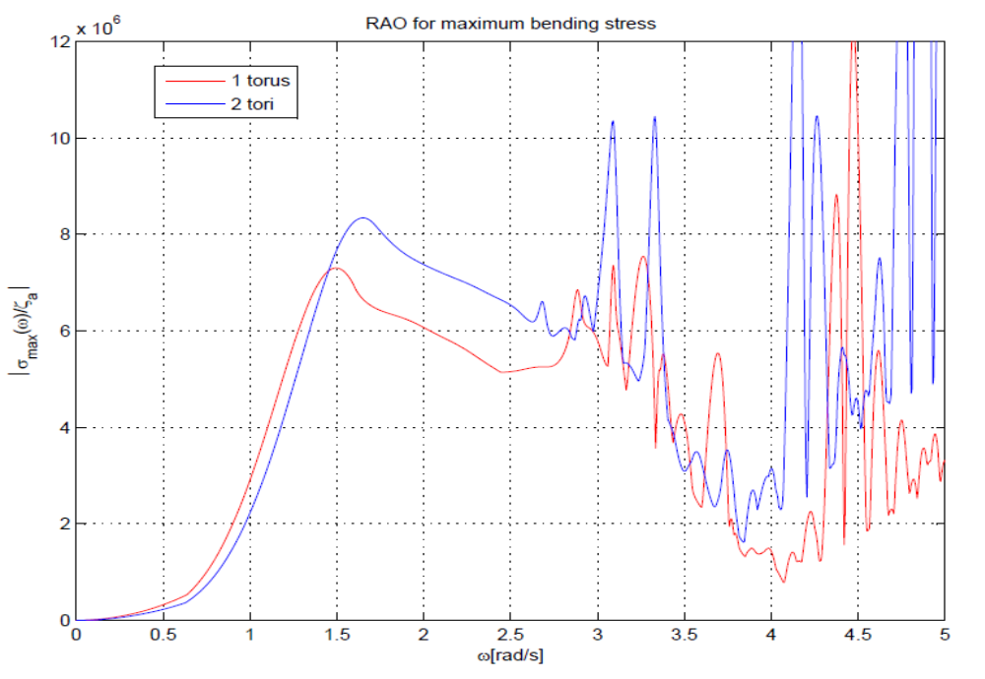
Transfer function for the maximum bending stress in the floater for 1 torus and 2 tori
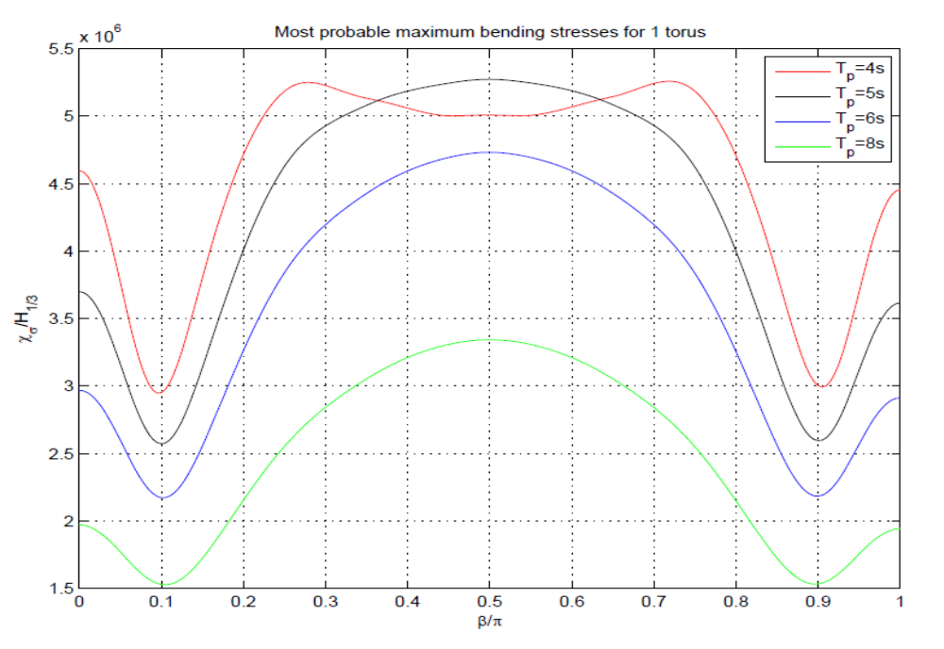

Most probable maximum bending stress for 1 torus
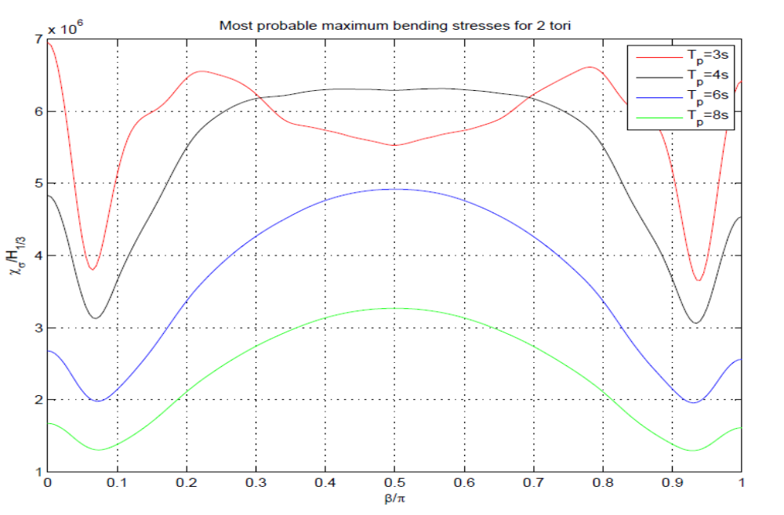

Most probable maximum bending stress for 2 tori
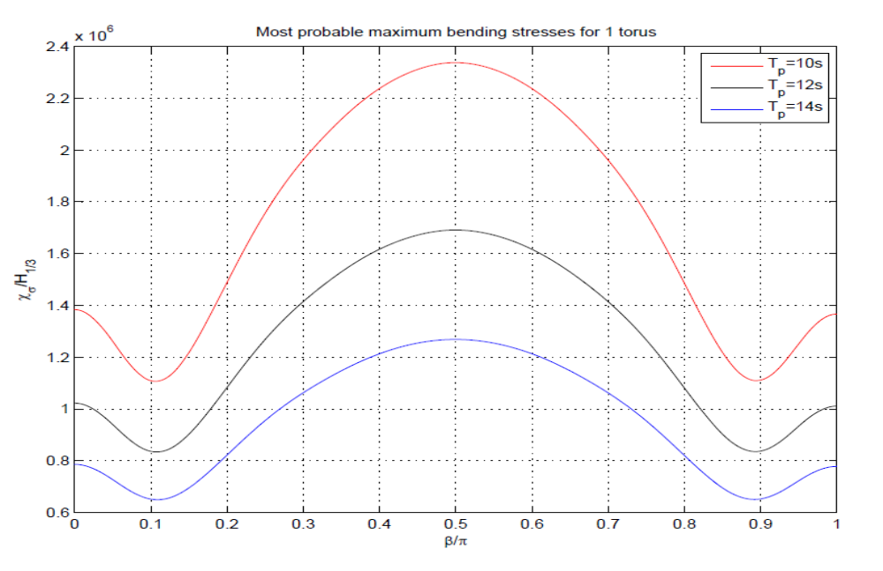
Most probable maximum bending stress for 1 torus
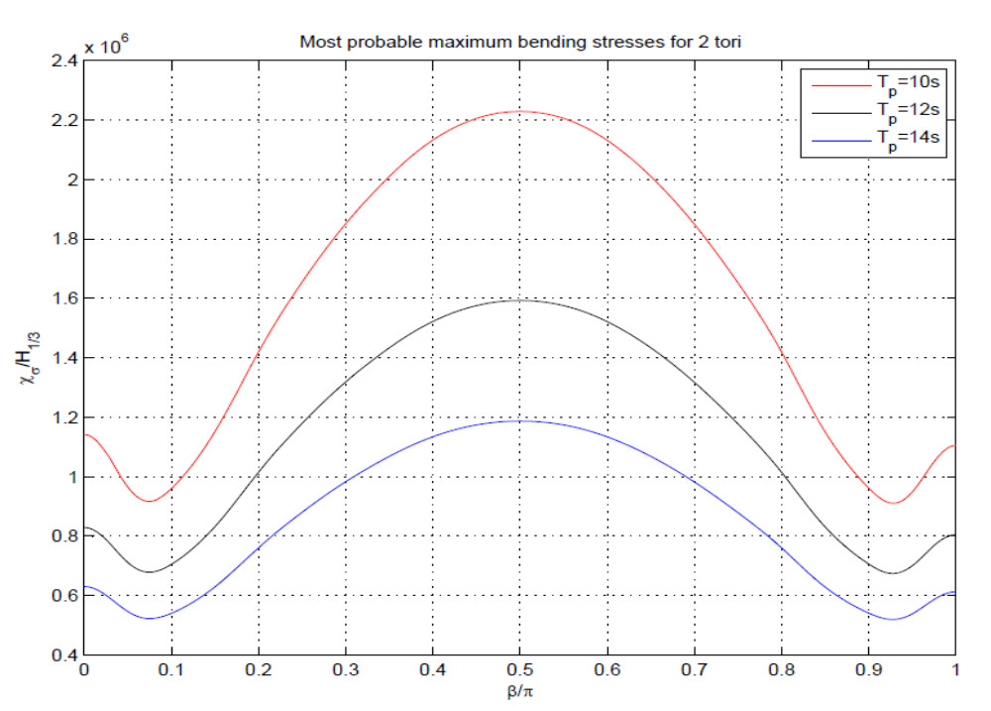
Most probable maximum bending stress for 2 tori
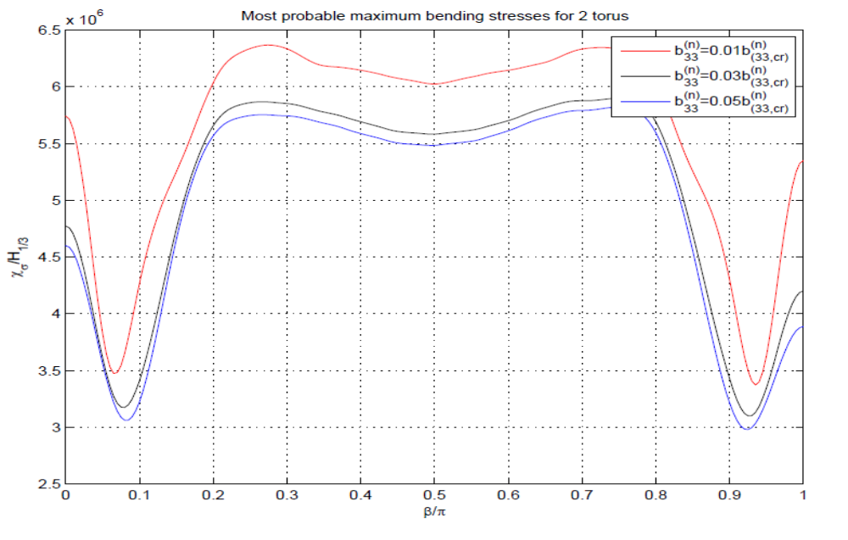
Most probable maximum bending stress as a function of position on the floater for 2 tori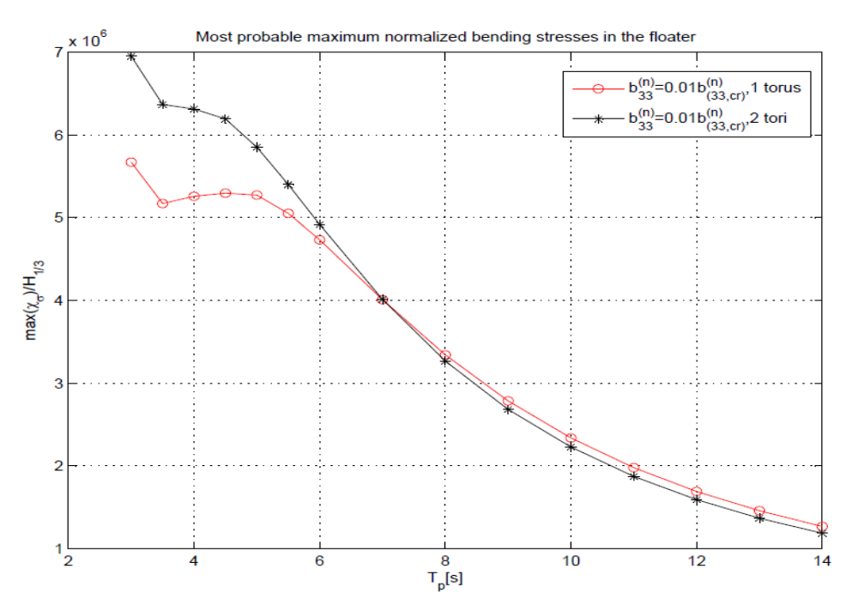
Most probable maximum bending stress as a function of spectral peak period
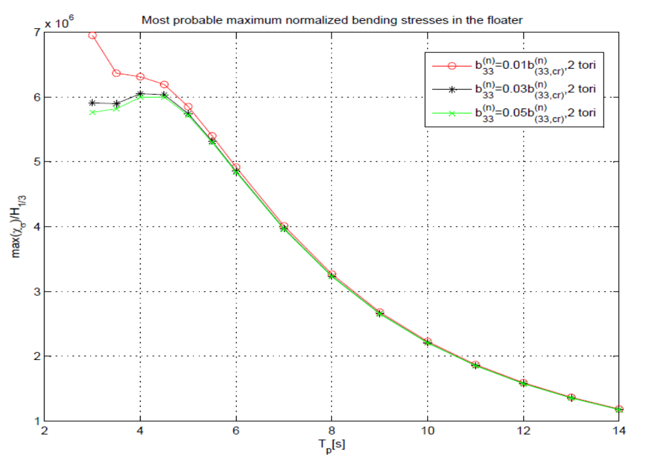
Most probable maximum bending stress as a function of spectral peak period

