- yr Contour surface
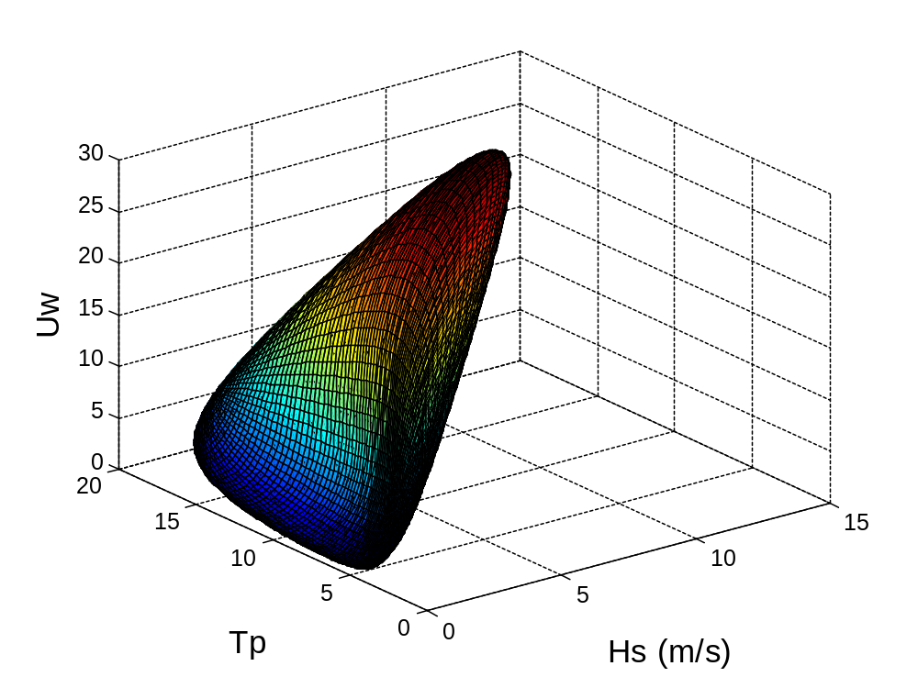
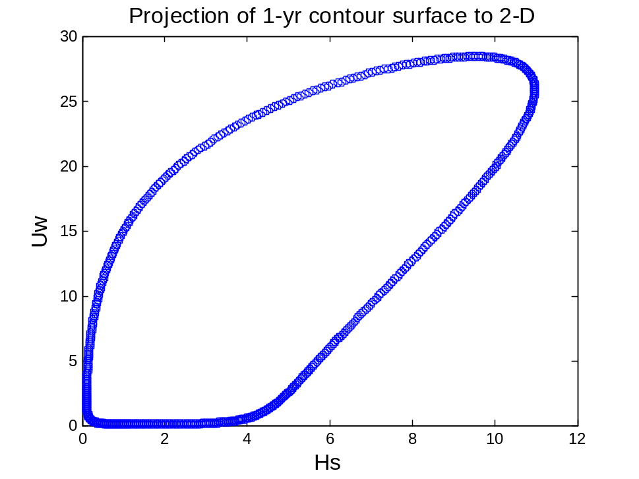
Since the responses of floating spar is less sensitive to the Tp, three cases are selected on the Uw-Hs contour line

 | Uw | Hs | Tp
CASE1 | 25.87 | 10.97 | 14.18
CASE2 | 28.43 | 9.53 | 12.90
CASE3 | 27.80 | 10.60 | 13.71
The significant wave height fora 1-hour simulation Hs=k2*Hs1, k2=1.09
Uw is extrapolated to the hub height with power factor 0.14, plus a 10% increase in wind speed for scaling the 1-hour average wind speed to 10-min average wind speed.
The real cases run
 | Uw | Hs | Tp | Sigma
Sea state1 | 38.7 | 12.0 | 14.2 | 0.12
Sea state2 | 42.5 | 10.4 | 12.90 | 0.12
Sea state3 | 41.6 | 11.6 | 13.71 | 0.12

- hour long simulation is run, the seed num for each 15 min wind and wave sim. Is different.
Turbulence intensity is a function of wind speed. The U
Sensitivity of the response to the blade azimuth angle position1,2,3
Case1 Standstill-feathered_wind41.7_Hs13.33Tp14.4_no direction
Motion | Tp(s) | f(rad/s)
Surge | 115 | 0.055
Sway | 125 | 0.05
Heave | 31.4 | 0.2
Roll/pitch | 32.7 | 0.19
Yaw | 7.5 | 0.838

Wave freq. =0.436 rad/s
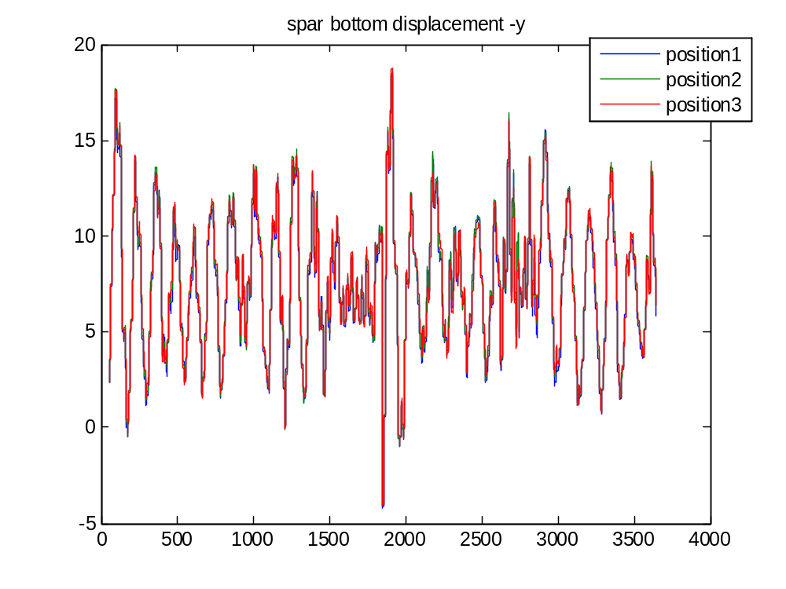

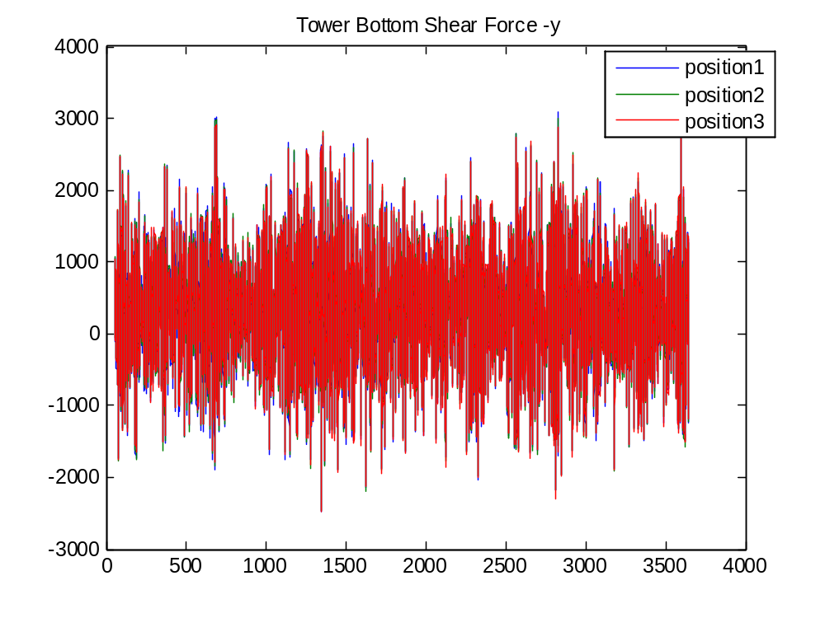
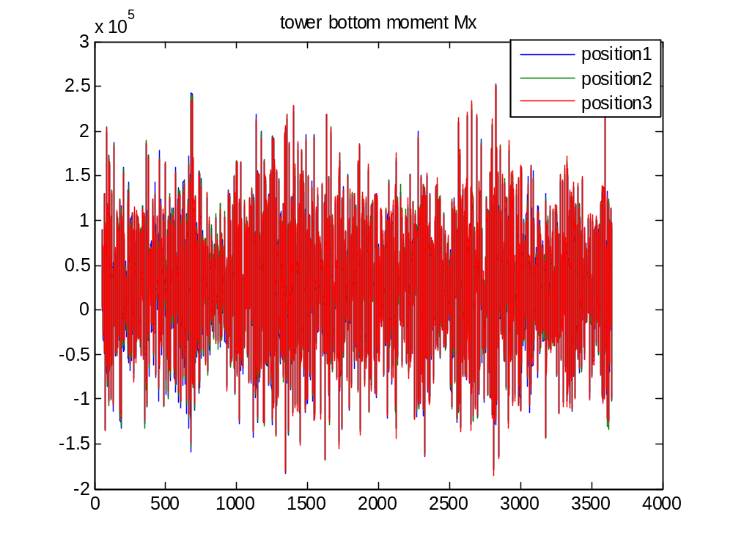
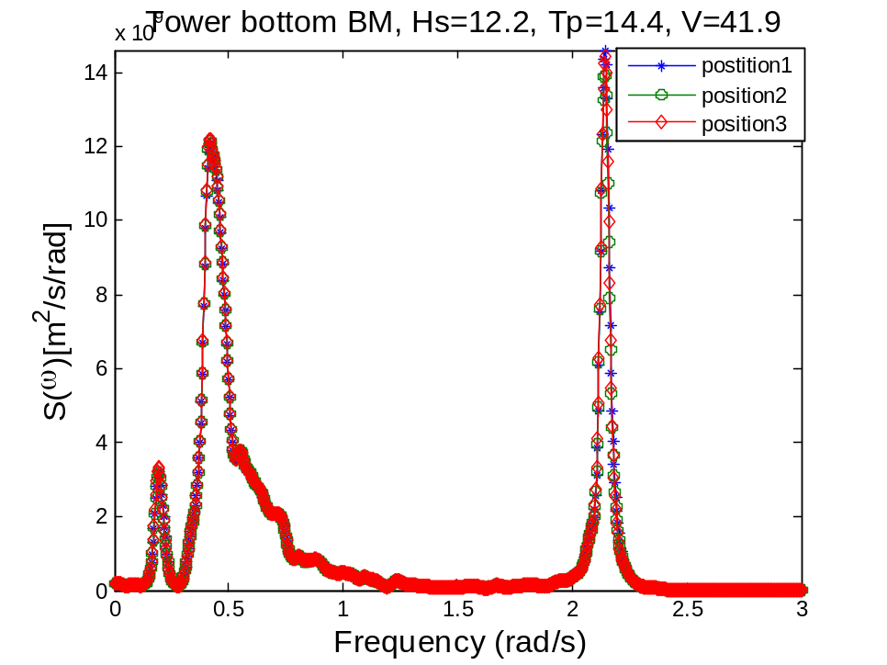
Mx
Wp1=0.20 (pitch resonance), wp2=0.42(wave freq.), wp3=2.14?
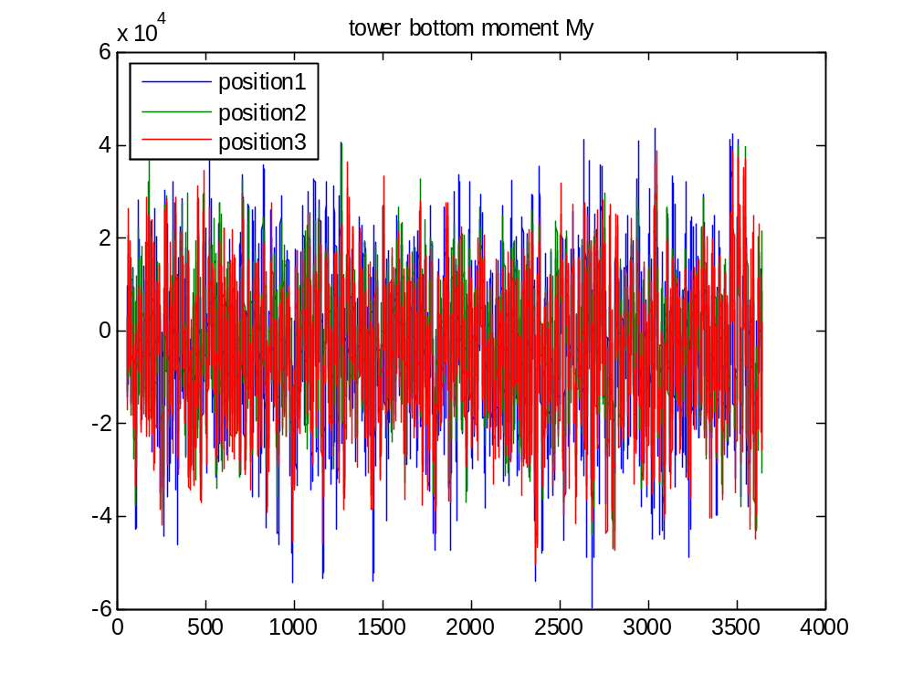
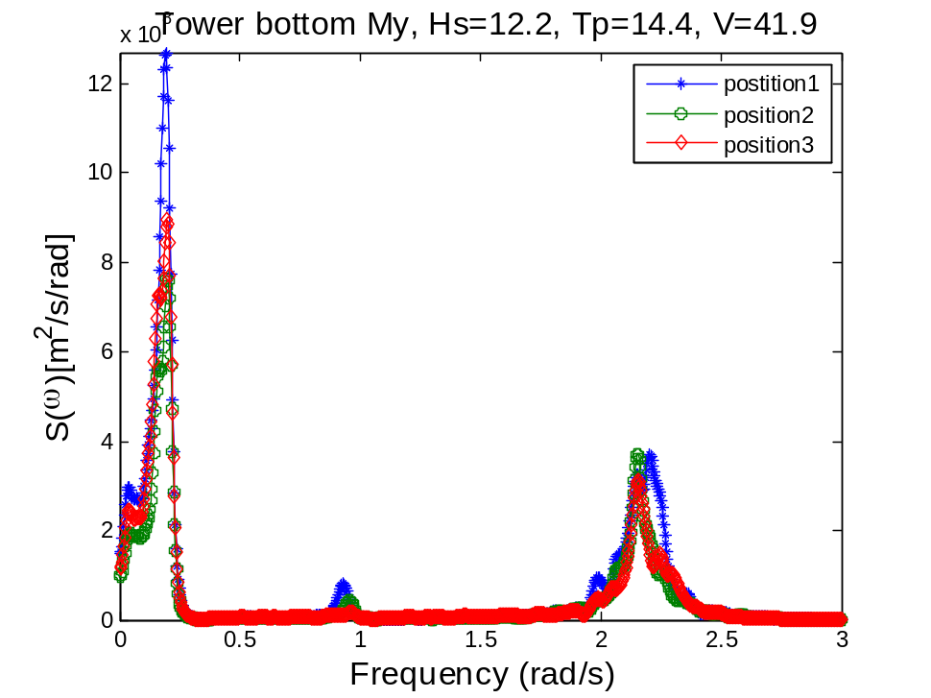
wp1=0.2 rad/s, wp2=0.94 rad/s, wp3=2.16 rad/s
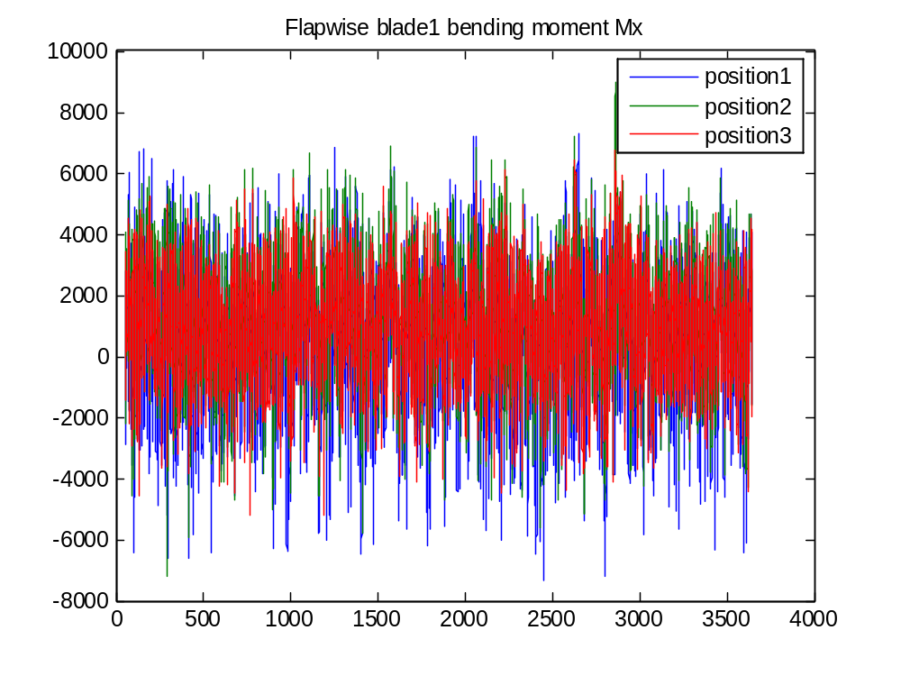
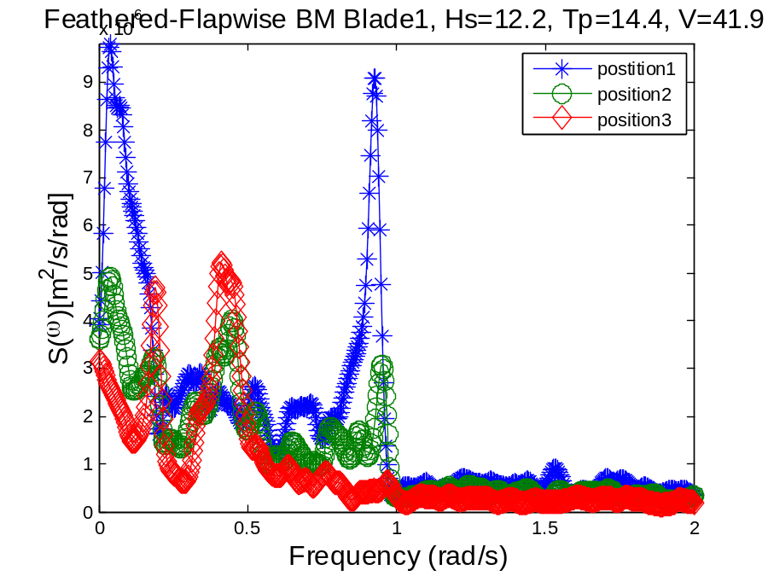
Blade resonance
The variance of the total root bending moment fluctuations is equal to the sum of the resonant and background response variances.
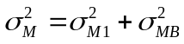
It would be interesting to look at the root bending moment.
Since the lowest natural frequency of the blades in the flapwise and edgewise modes are below 1 Hz, the resonant response might be significant.
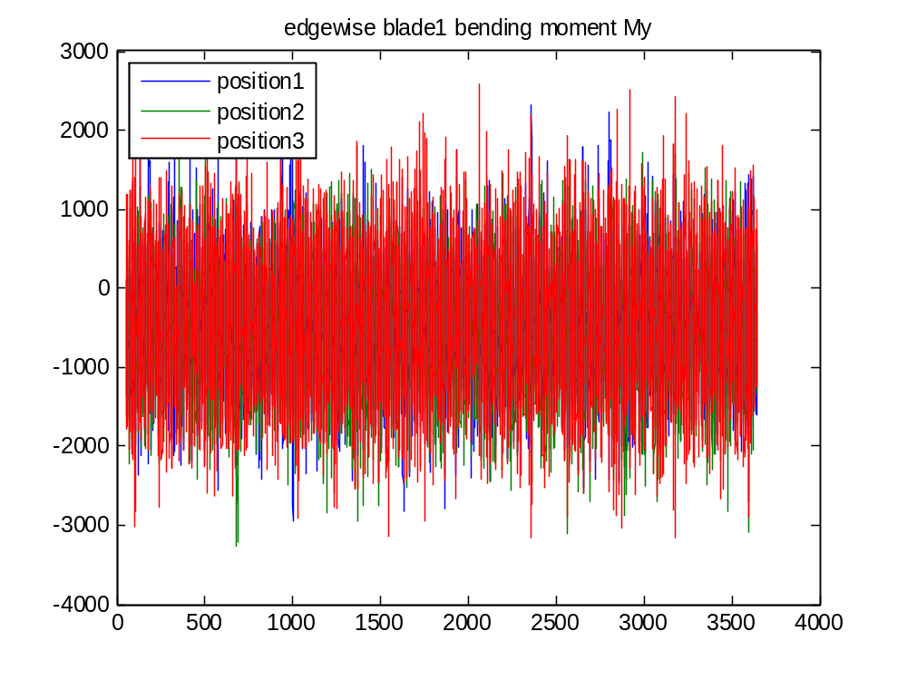
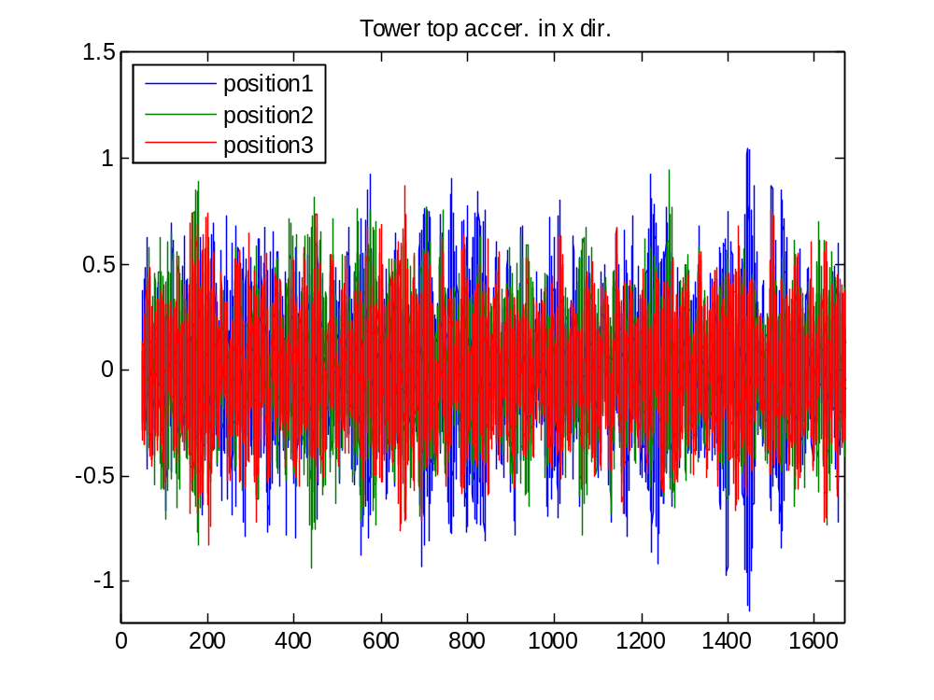

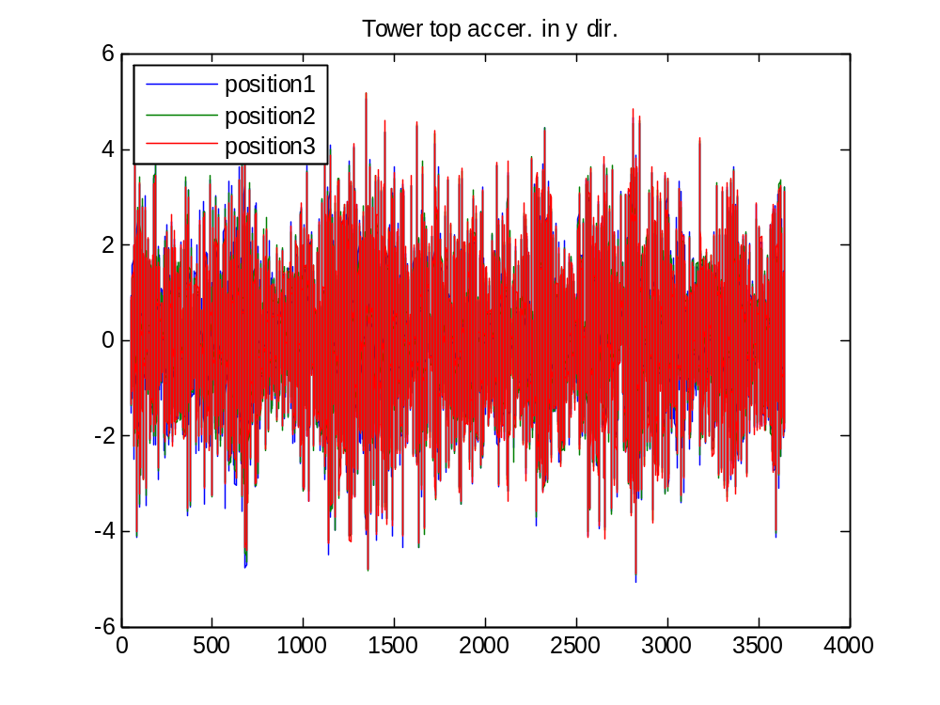
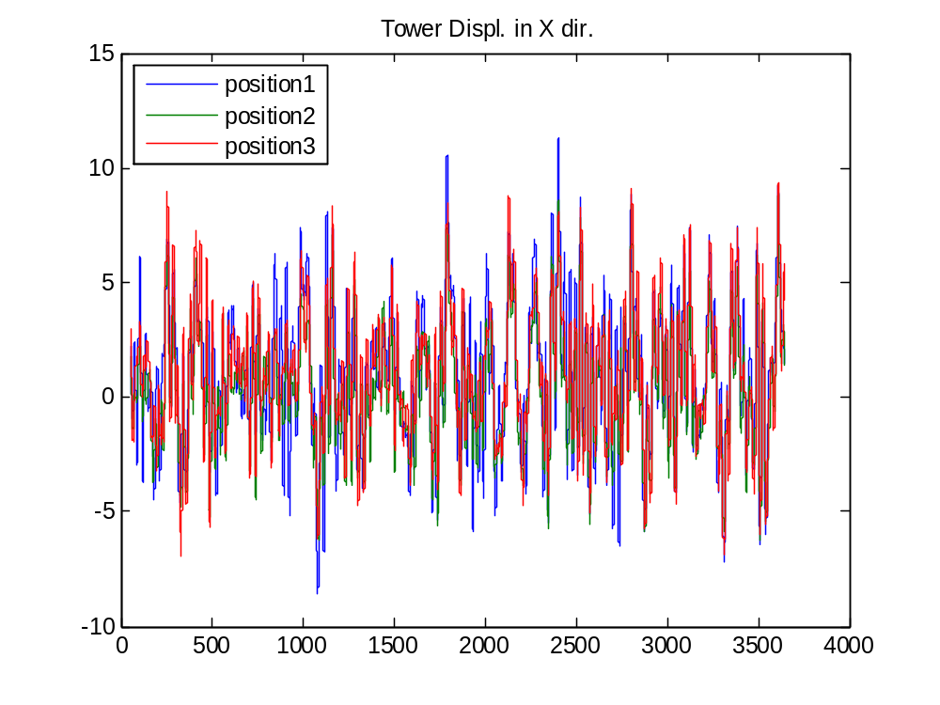
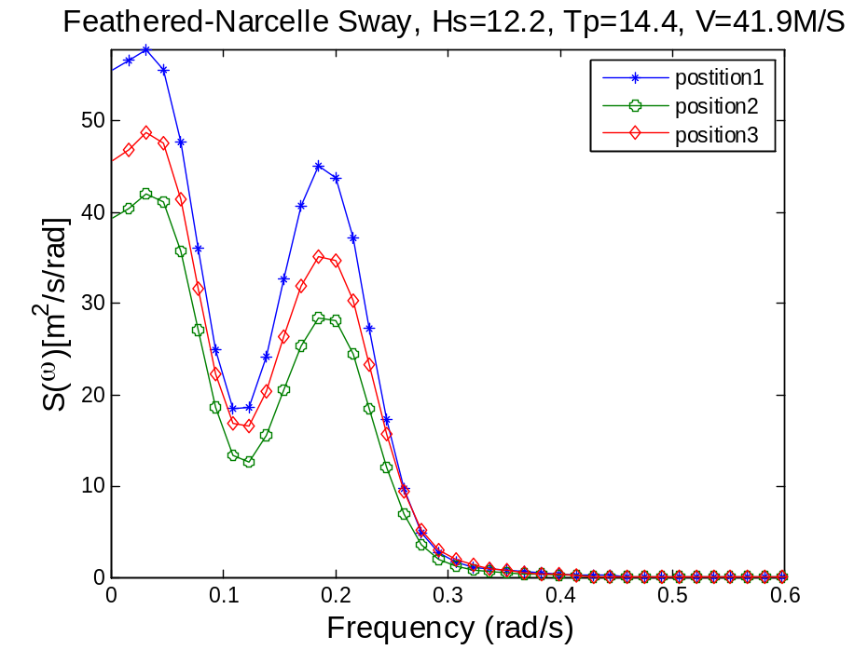
Wp1=0.03 rad/s, close to the sway nat. freq.=0.05 rad/s
Wp2=0.19 rad/s, close to the roll nat. freq.=0.192
The responses in –x directions are more sensitive to the azimuth angle of the blade.
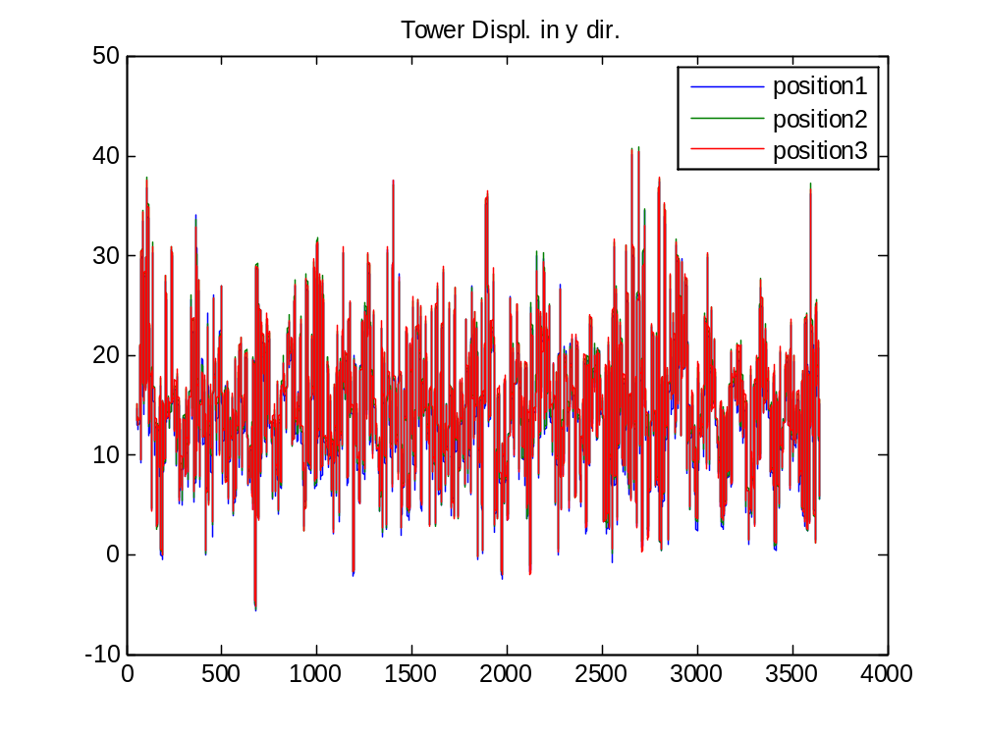
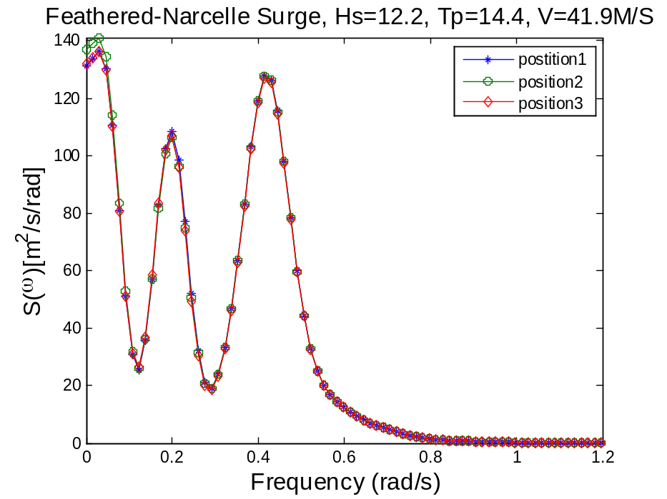
Wp1:surge, wp2:pitch, wp3: wave freq. 0.44rad/s
Conclusion: When the blades are feathered, the responses are not sensitive to the azimuth angle.
Case2 Standstill-blade2seized_wind41.7_Hs13.33Tp14.4_no direction

Case2 Standstill-blade2seized_wind41.7_Hs13.33Tp14.4_no direction
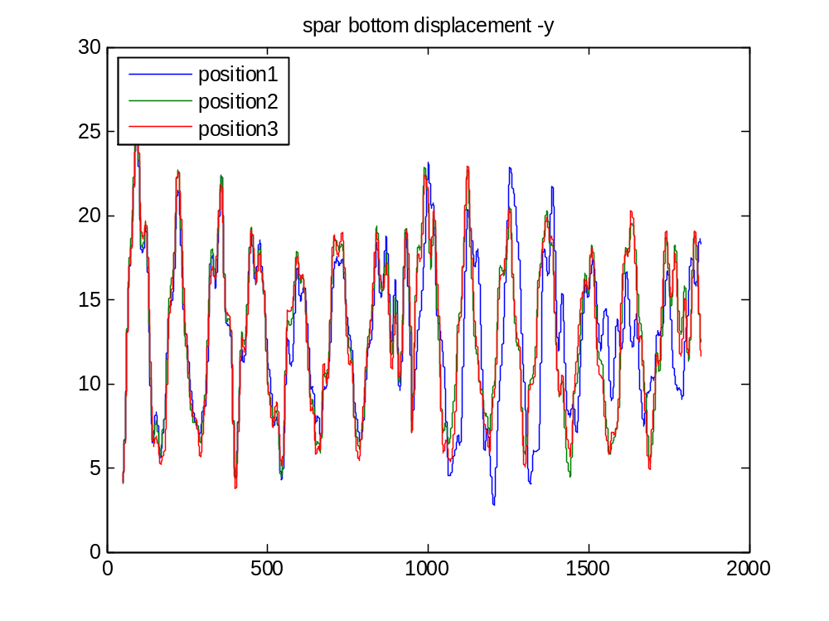
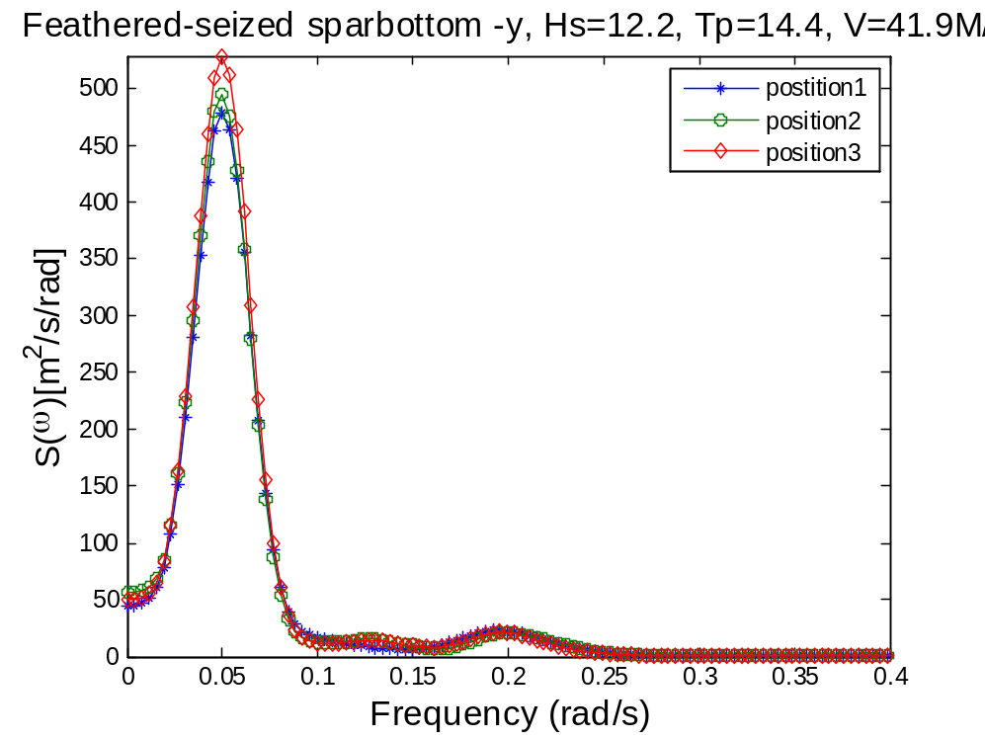
Wp1: surge wp2:pitch

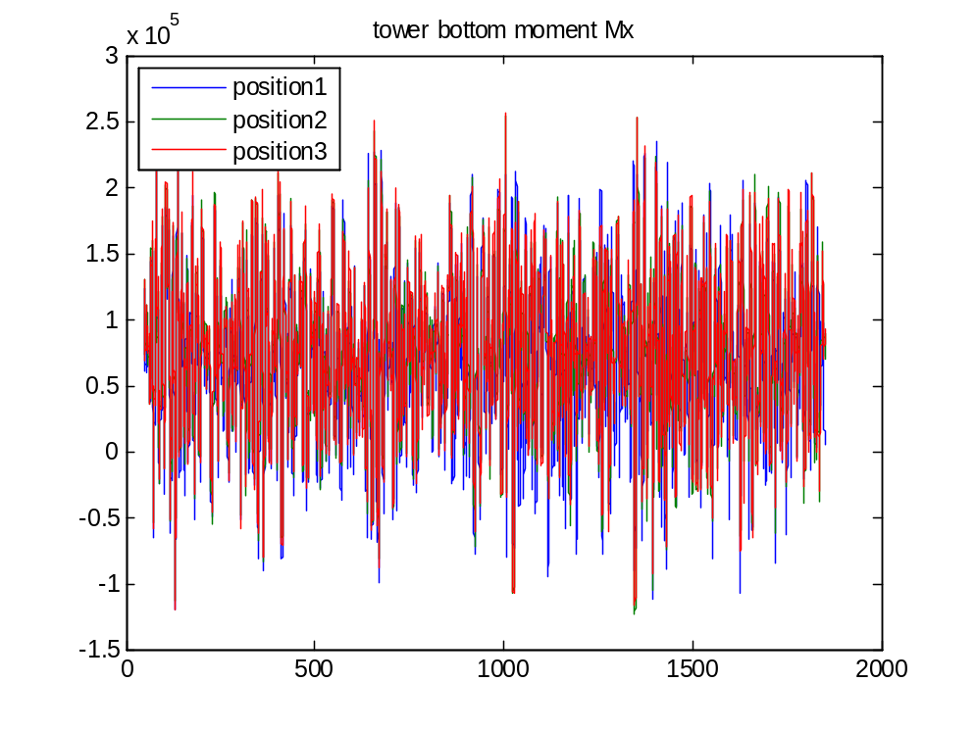
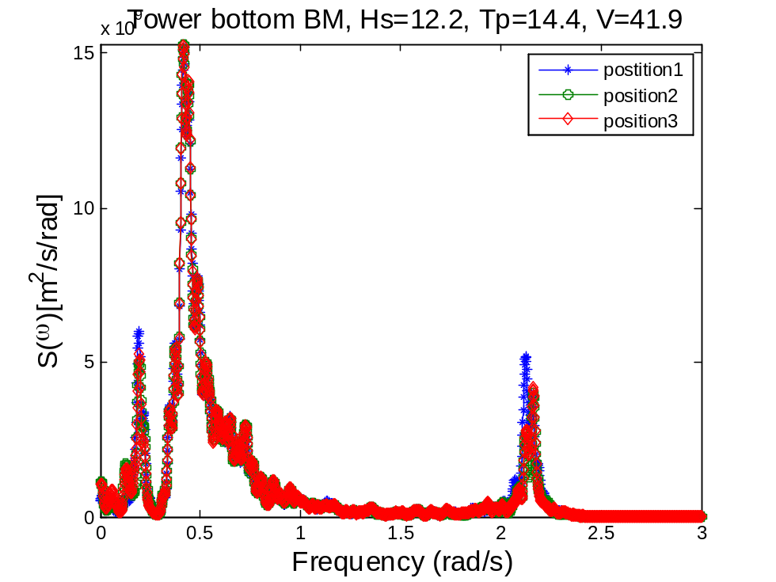

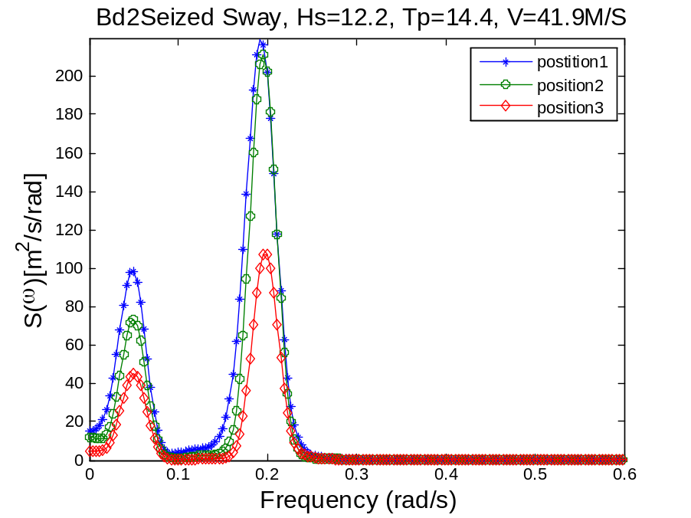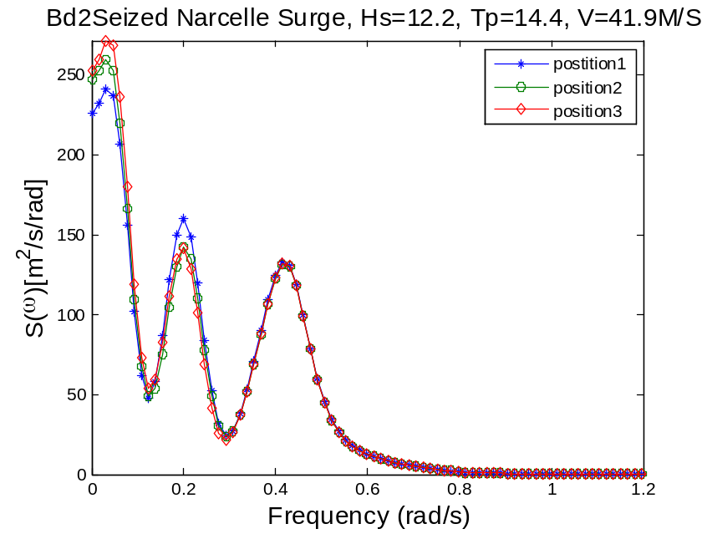

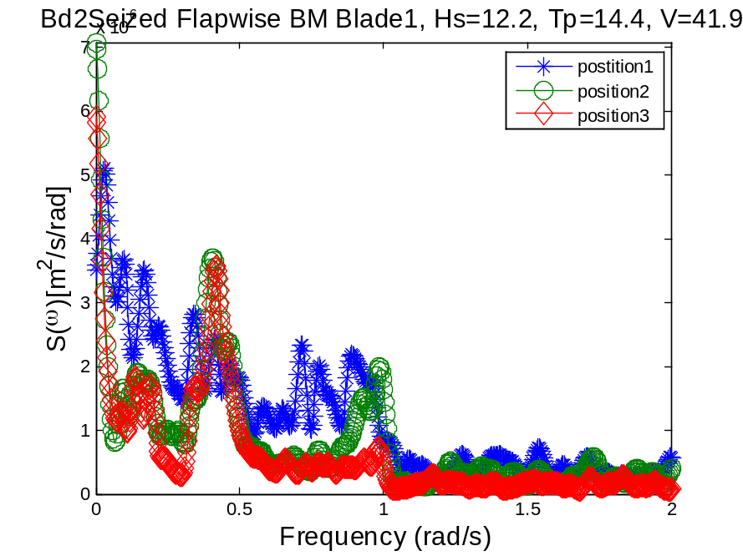
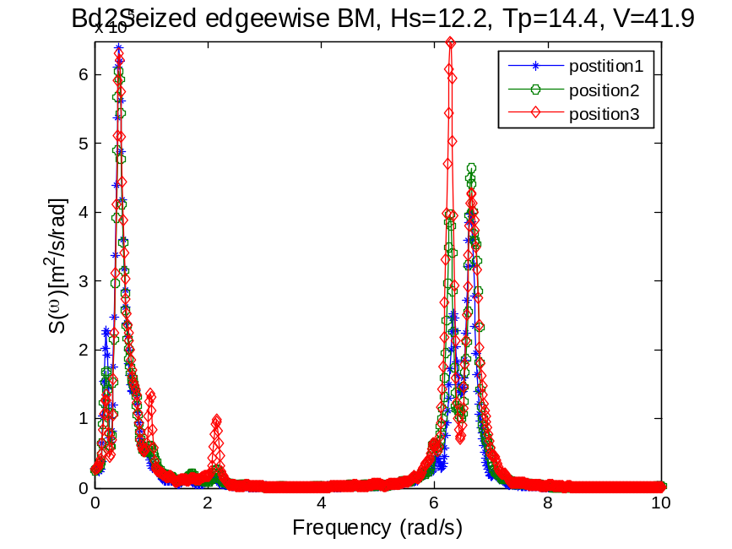

Comparison between feathered and seized case, p1
Spar bottom –y
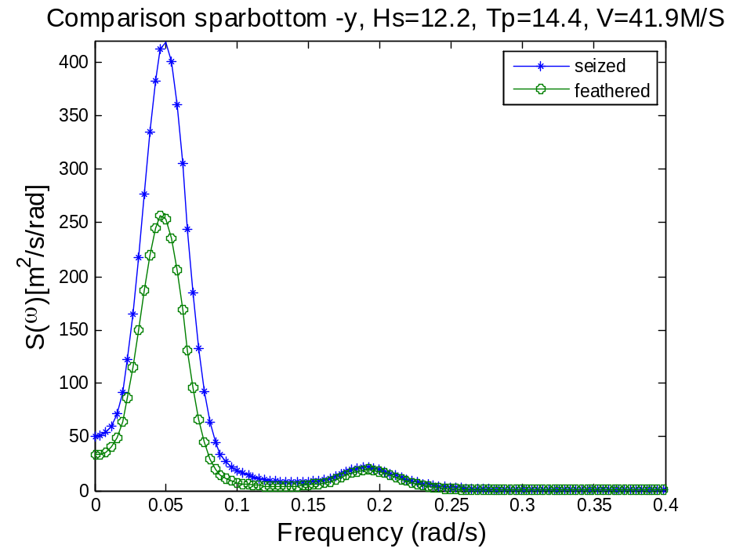
Nacelle Surge –y
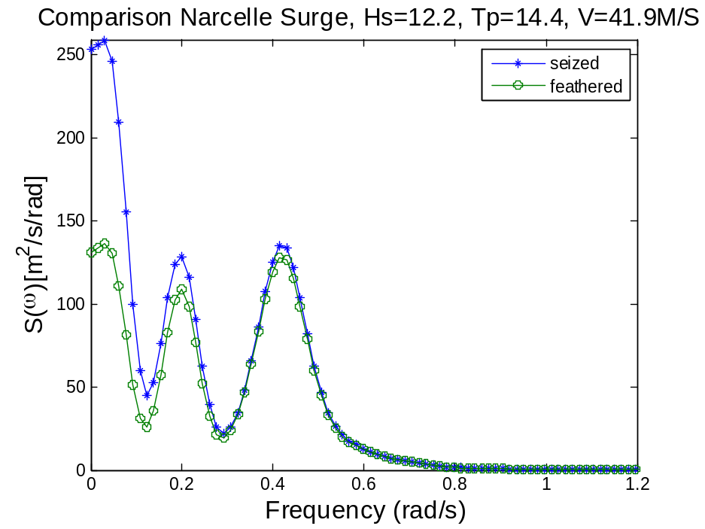
Nacelle Sway –x

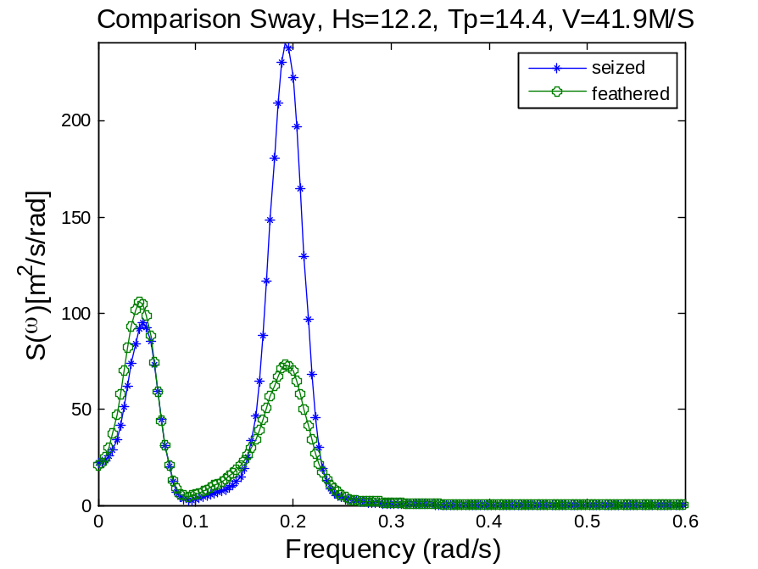
Nacelle accer. –y

Tower bottom Mx
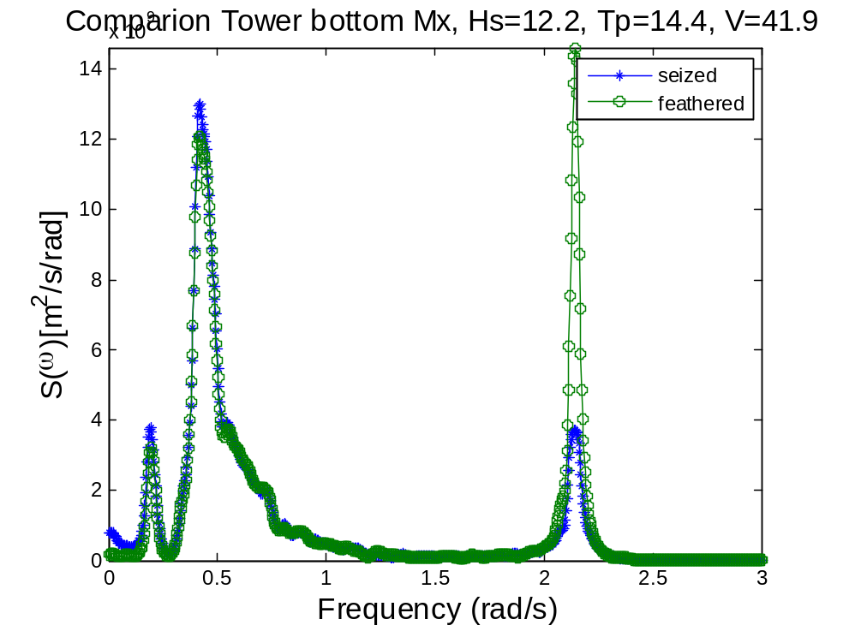
Tower bottom My
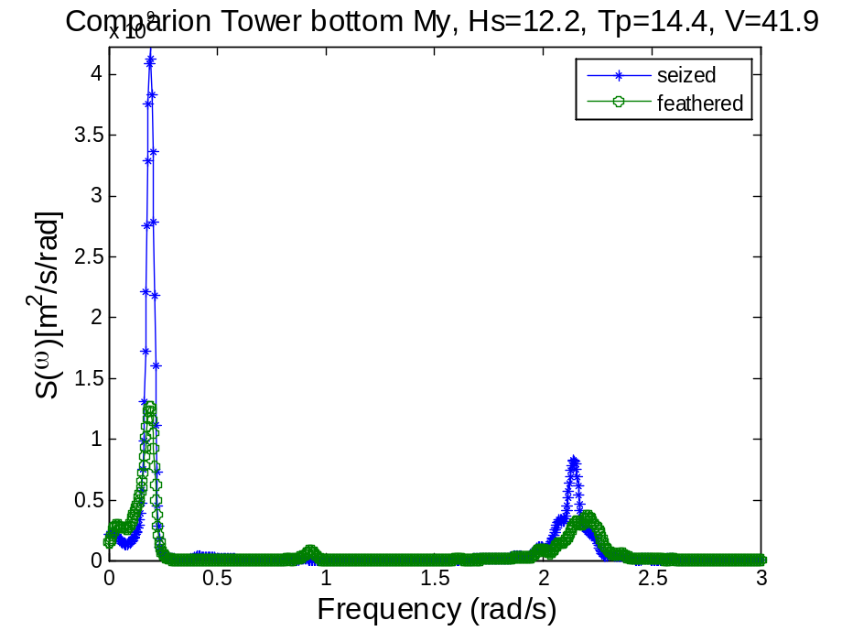
Blade1 Mx
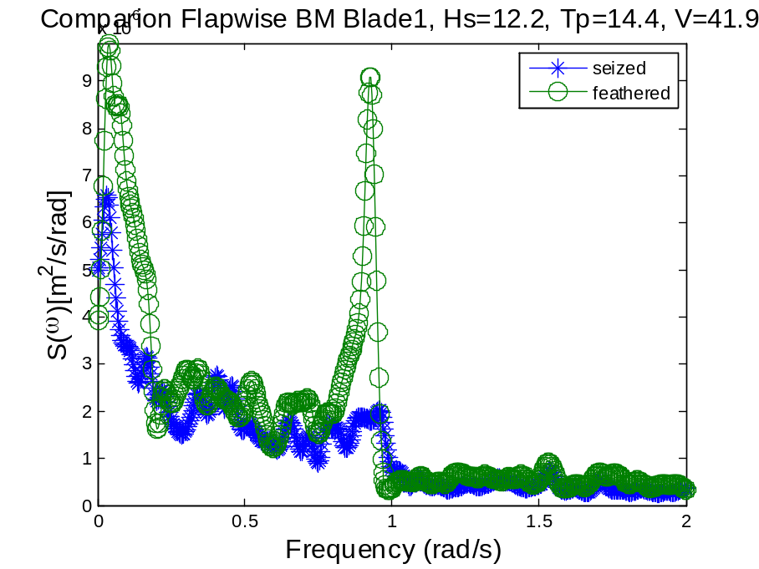
Blade1 My
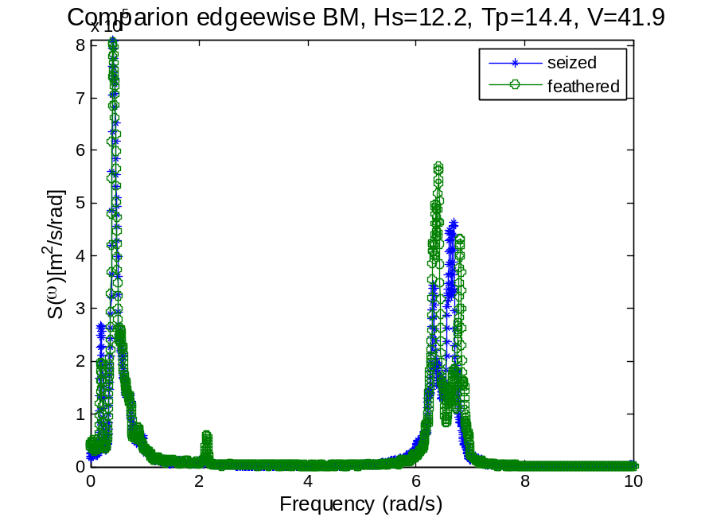
Blade2 Mx

Blade2 My

