ENGLISH

Problem 1 [Agents. Answer 1(True) or 0 (False) for each of the following sentences.]

- Simple reflex agents often use situation-actions rules for their reasoning. (T)
- Simple reflex agents have an internal model of the current state of the world. (F)
- An agent’s utility function is essentially internalization of the performance measure.(T)
- In order to be rational an agent should have a utility function. (F) Not necessarily. For ex, Simple vacuum cleaner does not have one but behaves rationally.
- In a learning agent the learning element is responsible for selecting the external action to be executed next. (F)
- Taxi driving happens in a stochastic, sequential, partially observable, and continuous environment. (T)
- Agents need an internal model to cope with partially observable environments. (T)
- An agent system has an agent function that selects the next action and a state transition fuction which computes what the next state of the environment would be when an action is executed.(T)
- The action selection in model based agents uses as input the currently sensed data as well as the internal representation of the environment. ((T)
- In goal-based agents, rationality of the agents is measured based on the utility function. (F)

Problem 2 [General Questions about Search and Logic. Answer 1(True) or 0 (False) for each.]

- Depth-first search is more space efficient than Breadth-first search. (True)
- The basic Genetic Algorithm is Stochastic Beam Search supplemented with a crossover operator. (True)
- Iterative Deepening search is more space efficient than Breadth-first search? (True)
- One of the main reasons why Texas Hold’em poker is harder for AI than chess is that there are 52 cards in a deck, but only 32 pieces on a chessboard. (False)
- Simulated Annealing is Best-First search supplemented with a temperature variable. (False)
- All of the following are traditionally classified as Informed Search methods: A*, Iterative Deepening and Hill Climbing. (False)
- To use a resolution theorem prover, all logical expressions must first be converted into horn-clause form. (False)
- In first-order logic, a sentence is satisfiable if and only if there is at least one interpretation and one variable assignment in which it is true. (True)
- PROLOG is a computer language that relies heavily on backward chaining. (True)
- Skolemization is an important step of resolution theorem proving in both propositional logic and first-order logic. (False)

Problem 3
Assume the following predicates:

  - S(x) – x is a student
  - E(y) – y is an exam
  - Q(x) – x is a question.
  - EQ(x,y) – y is a question on exam x
  - K(x,y) – x knows the answer to question y.

and the following expressions:

1. ∀x: S(x) ⇒ { ∃ y, z: E(y) ∧ EQ(y,z) ∧ ¬ K(x,z) }
2. ∀x,y: E(x) ∧ EQ(x,y) ⇒ { ∃ z: S(z) ∧ ¬ K(z,y) }
3. ∀x,y,z: E(x) ∧ Q(y) ∧ S(z) ⇒ { K(z,y) ⇒ EQ(x,y) }

Part 1:
For each logical expression, select the one natural-language sentence below that best captures its meaning:

- There are some students who miss every question on all exams.
- All exams have at least one question that no student can answer correctly.
- Every student gets everything correct on at least one exam.
- No student is perfect.
- No exam question is correctly answered by every student.
- Students do not know the answers to questions that are not on exams.
- Given any student, question and exam, the student can answer the question if it is on the exam.
- Each exam has a question that every student can answer correctly.

Answers:
1: D
2: E
3: F

Part 2:
One of the three logical sentences above yields the following expression when converted to Conjunctive Normal Form (CNF), where F and G are skolem functions:

{¬S(x) ∨ E(F(x))} ∧ {¬S(x) ∨ EQ(F(x),G(x)))} ∧ {¬S(x) ∨ ¬K(x,G(x))}

Which one of the three logical sentences is it?

(Answer: #1)

Part 3:
What is the resolvent clause when the binary resolution rule is applied to the following two clauses (where F is a skolem function and Karen is a constant symbol)?

¬S(x) ∨ E(F(x)) ∨ Q(y)
S(Karen)

Answer: E(F(Karen)) ∨ Q(y)

Problem 4

Figure 1 displays a search tree generated by Minimax search. Inside of each leaf node is its evaluation. Child nodes are always generated and evaluted from left to right in the tree.

List all of the leaf nodes that will NOT be generated if Minimax is run again, but this time with alpha-beta pruning.
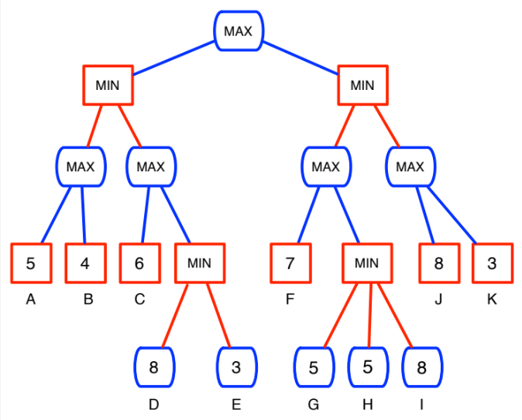
Figure 1: Minimax Search Tree

Answer: Nodes D, E, H, I, K

Problem 5

Figure 2 shows part of a tree built during A* search. The task is to rearrange the blocks to achieve the goal state while minimizing the total distance travelled by the blocks, where the width of each block has a distance = 1. The only legal operator is to switch the positions of two blocks. The heuristic is simply the total of the distances of all blocks from their goal locations.

Fill in all missing f, g and h values in the figure.

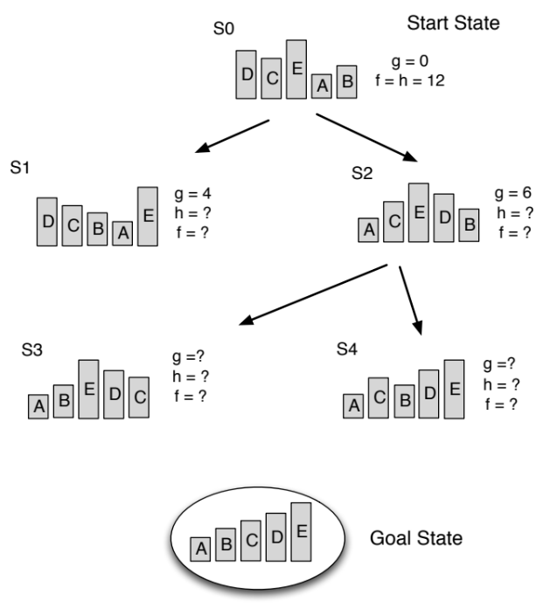
Figure 2: A* Search Tree

Answer: S1: h = 8, f = 12 S2: h = 6, f = 12
S3: g = 12, h = 4, f = 16 S4: g = 10, h = 2, f = 12

Problem 6

Figure 3 displays the use of model checking to test whether the following is a valid logical expression (using the formal definition of logical validity):

{A ⇒ (B ⇒ C)} ⇒ {A ⇒ C}

Fill in all missing cells of the table with a 1 (True) or 0 (False).
Next, based on the completed table, tell whether or not the expression is valid.

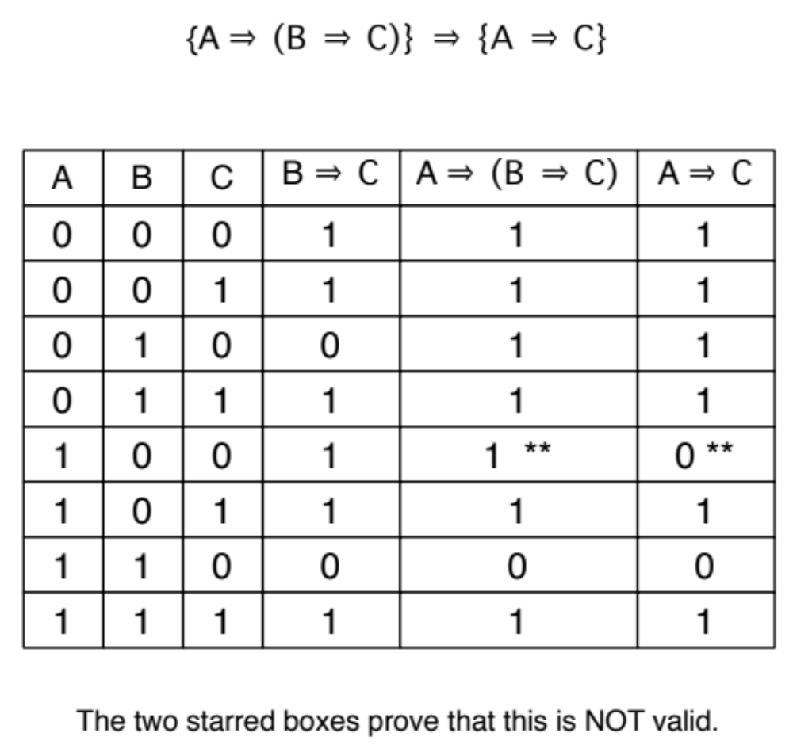
Figure 3: Model Checking

Problem 7 [Constraint Satisfaction Problems (CSPs)]

Part 1:
Figure 4 shows a simple CSP involving 3 integer-valued variables and 3 constraints. The AC-3 (Arc consistency 3) algorithm is applied to the problem, and this involves several calls to the REVISE algorithm. The first 4 of these calls are shown. Fill in the updated domain for the variable listed after each call.

The right of the figure shows one complete solution to the CSP. Are there others? If so, list them.

Part 2:
Figure 5 shows a second CSP, with 3 integer-valued variables and 3 constraints. The solution method is local search, beginning with the state (3,3,3), and using the MIN-CONFLICTS algorithm to determine the best new value for each randomly-chosen variable. Assuming that the first variable chosen is Z, followed by Y, determine the missing values in the two states (2 and 3) shown in the figure. In this problem, a conflict is a constraint that is violated.

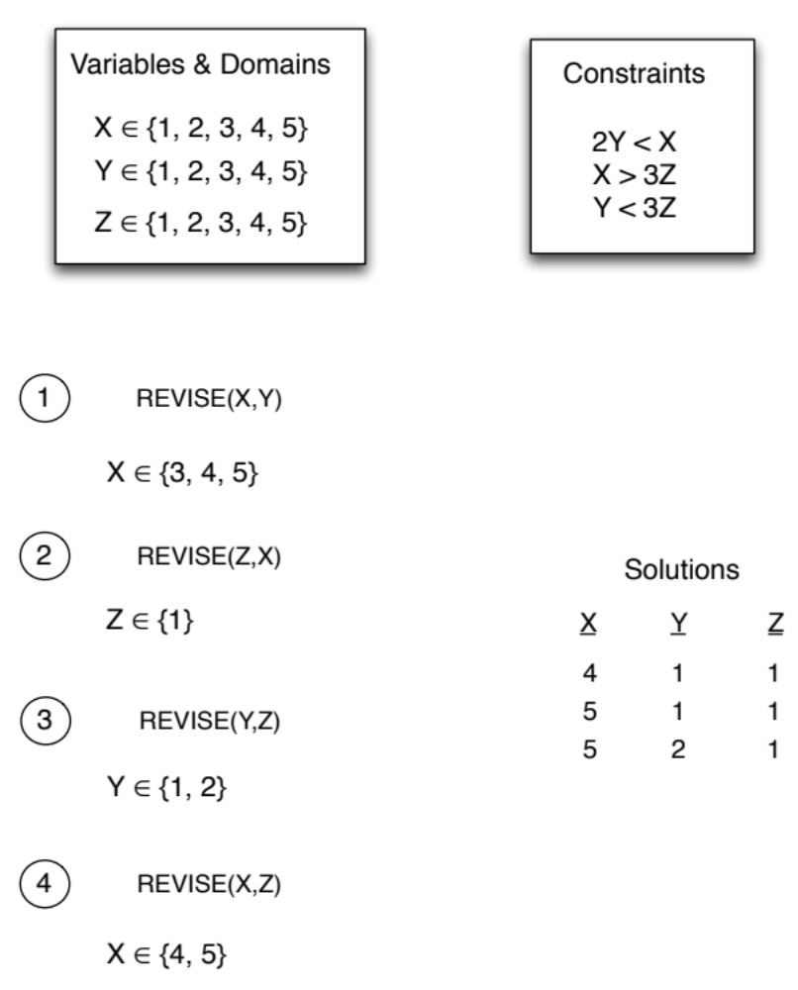
Figure 4: AC-3 and REVISE

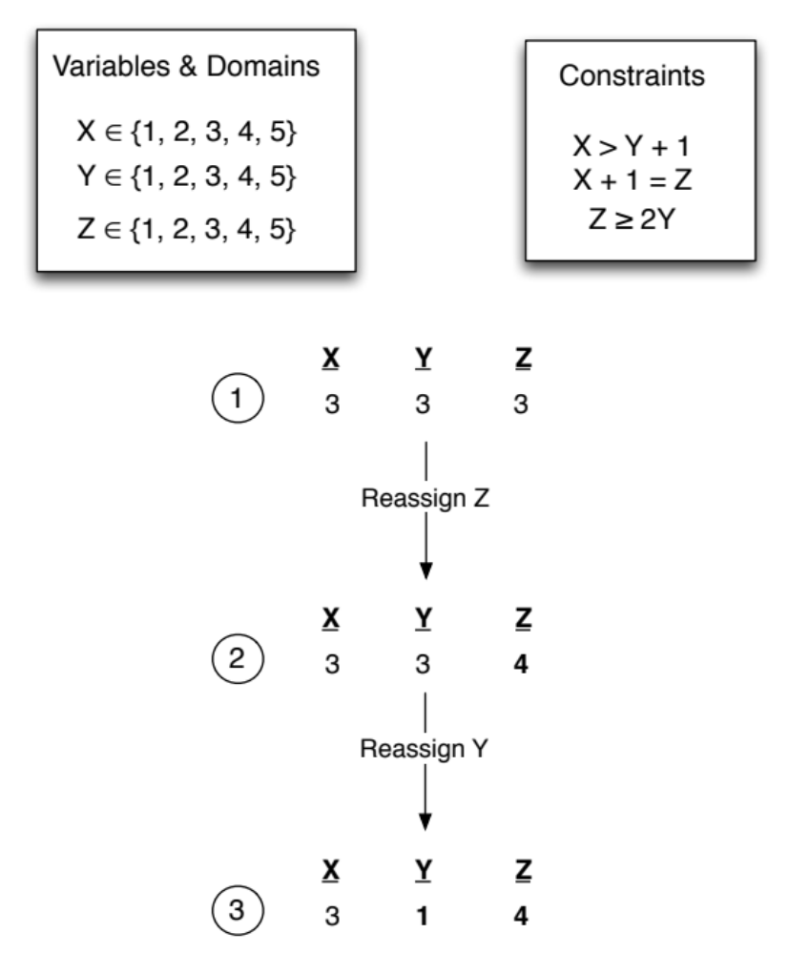
Figure 5: MIN-CONFLICTS

Problem 8 [Planning graphs]

Rob and Mary are at home. Rob has to get to work and has two options: either he walks or he uses the car. Mary needs to get to the airport and her only option is to use the car. The car needs fuel before it can be used. For the sake of brevity we will used the following simple string description for the states and actions.

robAtHome Rob is at home
maryAtHome Mary is at home
fuel there is fuel in the car
car car is at home

The actions to be modelled are:

Walk {
precond: robAtHome
add: robAtWork
del: robAtHome
}

GetFuel {
precond:
add: fuel
del:
}

DriveAirport{
precond: maryAtHome, fuel, car
add: maryAtAirport
del:maryAtHome, car
}

DriveWork{
precond: robAtHome, fuel, car
add: robAtWork
del:robAtHome, car
}

The goal : robAtWork, maryAtAirport
The initial condition: robAtHome, maryAthome, car

Figure 6 illustrates the incomplete planning graph. The dashed lines at A0 level show the mutex relations. The gray boxes mean ”no operation”.

Part 1:
Mark the following mutex relationships either ”correct” or ”wrong” according to whether they are mutex at stage A1 or not, respectively. It is recommended that you find the mutex relations at S1 first.

- (Walk, robAtHome)
- (Walk, robAtWork)
- (DriveAirport, DriveWork)
- (DriveAirport, car)
- (robAtWork, DriveWork)
- (robAtWork, ¬robAtWork)
- (maryAtAirport,car)
- (¬fuel, DriveWork)
- (DriveWork, ¬robAtHome)
- (DriveWork,fuel)

Part 2:
Is there a need to expand the graph after S2? Explain why (not) with 1 ( or max 2) sentences.

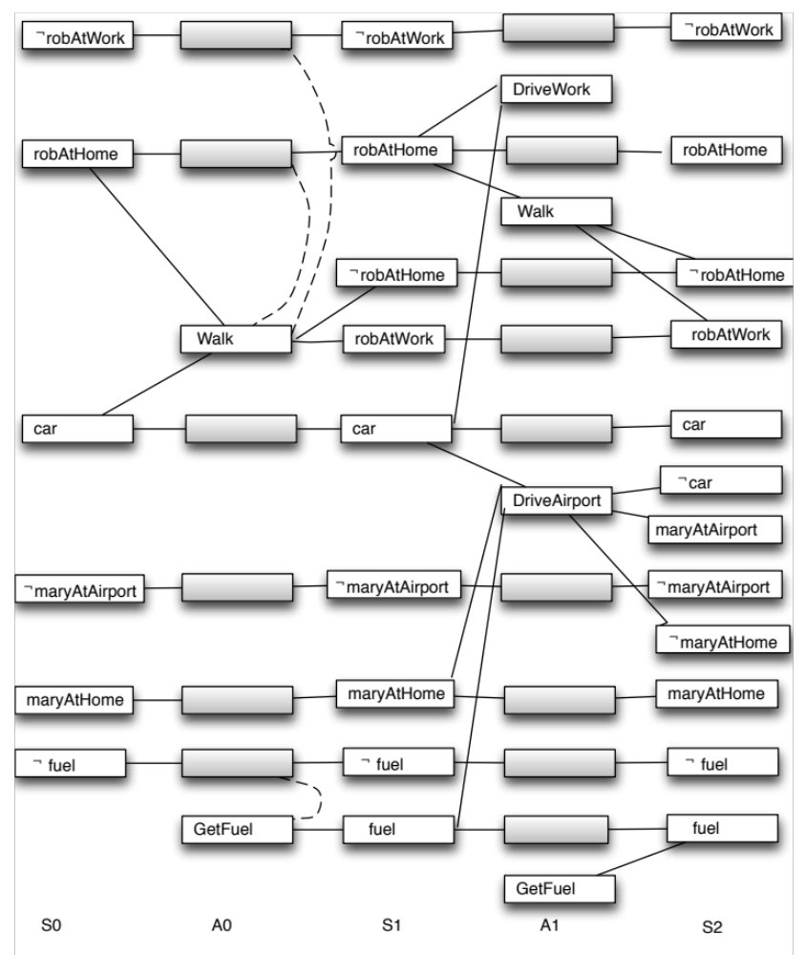
Figure 6 Planning graph for Problem 8

ANSWER:

Her er utskrift av alle lag med mutex relasjoner:

S0

-robAtWork
car
robAtHome
-maryAtAirport
maryAtHome
-fuel

A0

robAtHome
-maryAtAirport
car
Walk
maryAtHome
-fuel
GetFuel
-robAtWork

mutex:
(Walk,-robAtWork)
(Walk,robAtHome)
(-fuel,GetFuel)

S1

-robAtHome
-robAtWork
robAtWork
car
fuel
robAtHome
-maryAtAirport
maryAtHome
-fuel

mutex:
(-robAtHome,-robAtWork)
(-robAtHome,robAtHome)
(-robAtWork,robAtWork)
(robAtWork,robAtHome)
(fuel,-fuel)

A1:
robAtHome
DriveAirport
-maryAtAirport
car
-robAtHome
fuel
Walk
maryAtHome
DriveWork
robAtWork
-fuel
GetFuel
-robAtWork

mutex:
(Walk,-robAtWork)
(Walk,-robAtHome)
(Walk,DriveWork)
(Walk,robAtHome)
(Walk,robAtWork)
(DriveAirport,DriveWork)
(DriveAirport,-fuel)
(DriveAirport,-maryAtAirport)
(DriveAirport,maryAtHome)
(DriveAirport,car)
(robAtWork,DriveWork)
(robAtWork,-robAtWork)
(robAtWork,robAtHome)
(-fuel,DriveWork)
(-fuel,fuel)
(-fuel,GetFuel)
(DriveWork,-robAtWork)
(DriveWork,-robAtHome)
(DriveWork,robAtHome)
(DriveWork,car)
(-robAtWork,-robAtHome)
(robAtHome,-robAtHome)

S2

-car
-robAtHome
-robAtWork
robAtWork
maryAtAirport
car
fuel
-maryAtHome
robAtHome
-maryAtAirport
maryAtHome
-fuel

mutex:
(-car,car)
(-car,-fuel)
(-robAtHome,-robAtWork)
(-robAtHome,robAtHome)
(-robAtWork,robAtWork)
(robAtWork,robAtHome)
(maryAtAirport,car)
(maryAtAirport,-maryAtAirport)
(maryAtAirport,maryAtHome)
(maryAtAirport,-fuel)
(car,-maryAtHome)
(fuel,-fuel)
(-maryAtHome,-maryAtAirport)
(-maryAtHome,maryAtHome)
(-maryAtHome,-fuel)

Alle mål I S2 er oppnådd. Ingen expansion etter det.

Problem 9 [Knowledge representation languages.]

Part 1:
How would a Question Answering system answer the question ”What is the color of bird?” if it operates on the semantic network shown in Figure 7?

  - It is white.
  - It is yellow.
  - It is red.
  - It is red or white or blue.
  - Don’t know .

ANSWER: E ”I don’t now” – ”bird” har ikke farge attribute , heller ikke animal.
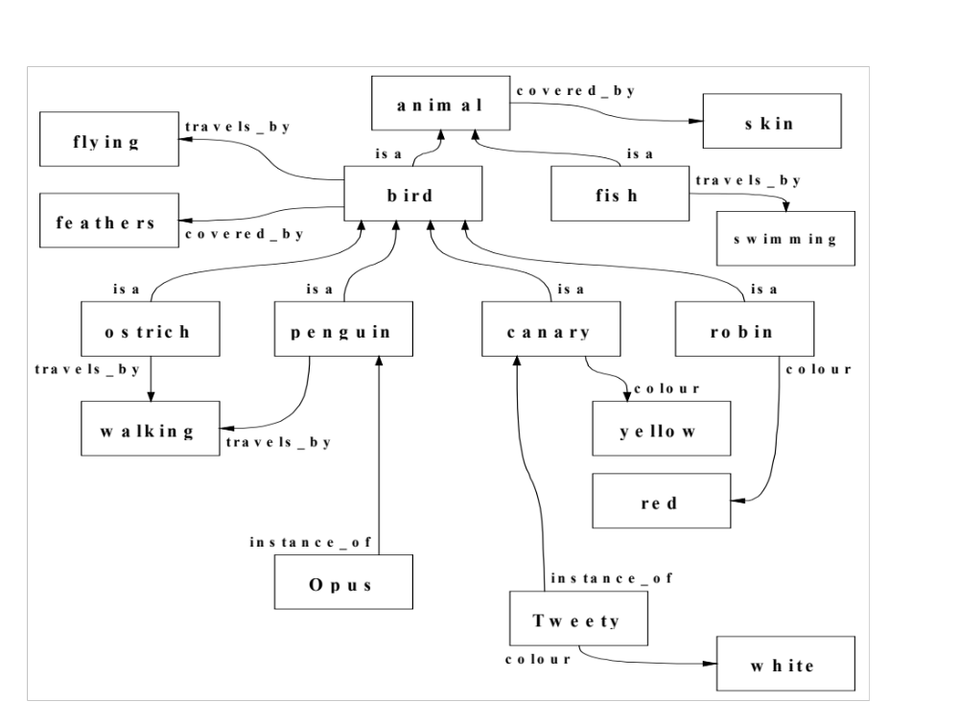
Figure 7. Semantic Network for ”bird”

Part 2:
Which of the following is (are) true for the knowledge base shown in Figure 8?
    - Apple-1 weighs 10 gram.
    - Apple-1 weighs 50 gram.
    - Apple-1 weighs 100 gram.
    - Apple-1 weighs 200 gram.
    - Apple-1 is green or red.

ANSWER: E, Apple-1 is green or red

Part 3:
You will represent the sentence “Jack kidnapped Billy on August 5” be as an event in a frame-based language. Write down the frame.

ANSWER:

Kidnap1
Is-a: Kidnapping event
perpetrator: Jack
victim: Billy
date: August 5

ikke nødvendigvis disse attribute navnene trenges. Noe som har same funkjon/rolle blir/telles riktig.

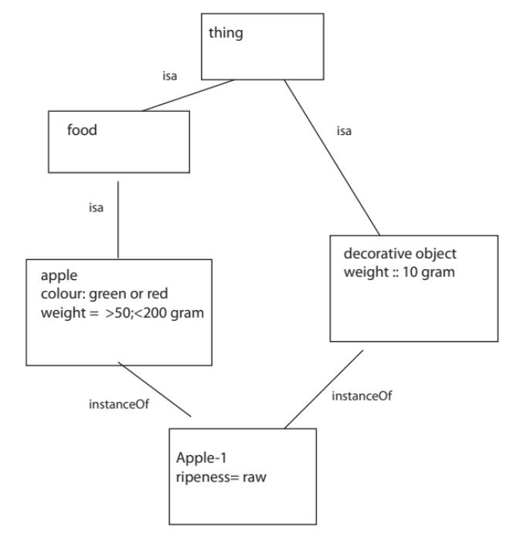

Figure 8 Apple model

Problem 10 [General, mixture of chapters 10-13 &22 and the ”An Overview of Knowledge Acquisition” (Musen) paper].

Fill in the blanks in the following questions:

- You are a knowledge engineer and are working on a problem where the system’s reasoning mechanism relies on prototypical objects in the world.
”…FRAME/FRAME-BASED lang.….” would be the most appropriate representation language to use for
this problem.

- Sentiment analysis is a form of text ”…CATEGORIZATION………………….”.

- Knowledge elicitation (as described in Musen’s paper) involves a knowledge engineer and a “ DOMAIN…………” expert.

- Taste, smell and color of a cake are its ”…INTRINSIC….……….” properties while weight and shape are its ”…EXTRINSIC………….” properties.

- ”…PARTITIONS……………..” are both disjoint and exhaustive decomposition of categories.

- In natural language processing, information ”…EXTRACTION…………..” is the process of acquiring knowledge from text.

- ”…TURING………” test is the most known scenario for testing the intelligence of an articial intelligence system.

- ”…PRECISION……………” is a measure used to evaluate IR systems and measures the proportion of documents in the result set that are actually relevant.

- In frame-based languages, default reasoning is facilitated by inheritance of ”…ATTRIBUTE/SLOT………..” values.

- In rule based systems, a depth first approach can be implemented by using ”RECENCY………..” as the conflict resolution strategy when selecting between the candidate rules that can fire at a certain time point.

END of QUESTIONS

GOOD LUCK!

