

Examination in

TDT4210 – Health Informatics

Wednesday 12 December 2012, Hours 09:00 - 13:00
Assignments prepared by teacher Pieter Toussaint. Contact person during the examination is Pieter Toussaint (cell phone 40646586)
Language: English
Allowed aids: Dictionary

Read the text of each assignment carefully. Make sure that you understand the assignment.

If you consider the information given in an assignment incomplete or inaccurate, then make a note of the assumptions you find it necessary to make in order to solve the assignment.

Task 1
A patient is scheduled for an operation at 8.15 in the morning. The day before he has been admitted to a ward in the hospital where he spent the night. Het got a light meal at 18.00 and after that he was not allowed to eat anything untill the operation. At 6.30 in the morning of the operation day he is woken up by a nurse. He drinks a bit of water and after that the preparation for the operation starts. This includes given some medication (known as: pre-med) and dressing the patient in clothes proper for the operation.
At 7.45 the patient is picked up at the ward by someone from the patient transport service (known as a porter). He brings the patient to the operation room. Outside the operation room two operation nurses take over the patient and bring him into the room. There the preparations for the operation start. At 8.10 the anesthesiologist comes in and starts the sedation of the patient. At 8.15 the surgeon arrives and the operation starts.
After one hour the operation is ready and the anestesiologist starts waking up the patient. The recovery is called to inform them that the patient will be brought down any minute. Also the cleaning service is called to tell them that the operation room must be cleaned. Two operation nurses take the patient to the recovery where he will stay untill he is fully awake and the surgeon has come to visit him. This visit is meant to inform the patient about the operation and to check how he is doing. After two hours at the revovery the ward is called that the patient will be brought back again. Someone from the transport service is ordered to take the patient to the ward.

a) Discuss at least three 'mistakes' in the model.

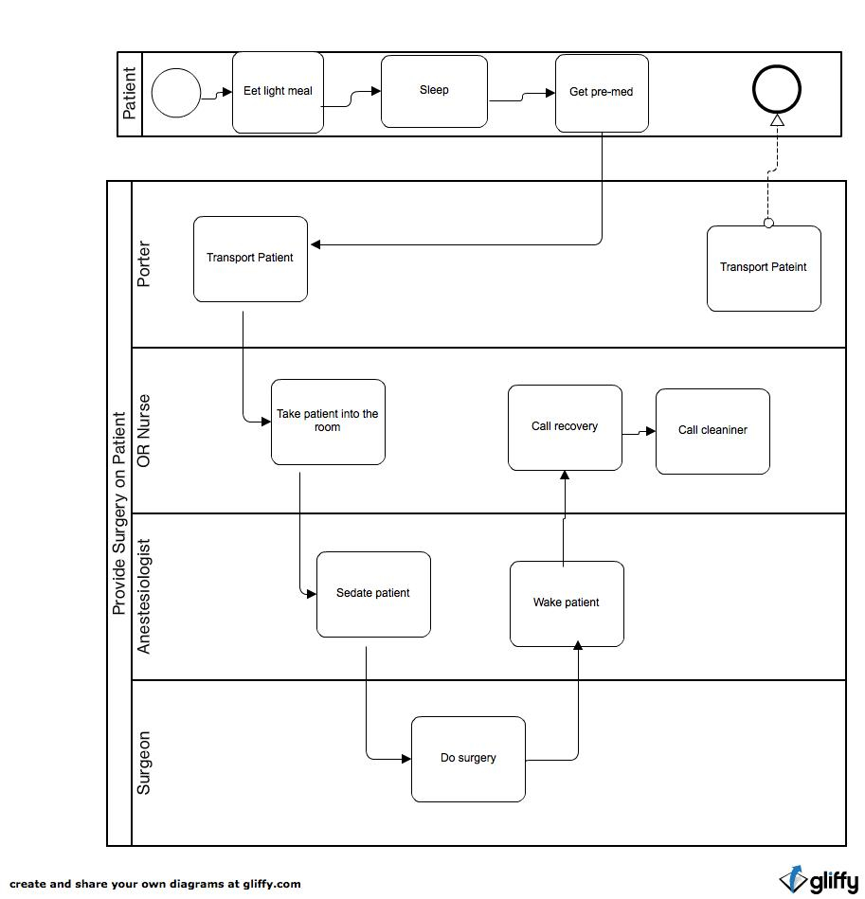

Task 2

In the current situation there are two main logistical challenges with respect to the execution of the operation plan in the hospital.

- Floating start times - Due to many factors, operations often don't start at the time they were scheduled to start. A reason can be that the preparation at the ward takes longer than planned, that an operation before is delayed or that an emergency operation had to be done. It happens that patients are brought to the Operation Room but have to be taken back again, or that they were given pre-med while the operation is cancelled. But it also happens that the people at the operation room are waiting for a patient that does not show up.
- Floating end times - Delays and changes in duration are main reasons for a change in a planned end time of an operation. Often complications arise during an operation which cause the operation to take longer or shorter than planned. For both the cleaning service and the recovery it is important to know about these changes in end time with respect to their own work planning.

It is decided to develop an information system that informs all the stakeholders involved about changes in start en end times. The system will not just inform that start en end times have changed, but will also give an indication of new times. The information system offers the following functionality:

- By means of their hospital smart phone, hospital staff can subscribe to specific operations in the schedule they want to be informed about.
- If start and/or end times change for a specific operation, a notification is send to the smart phone of all users that subscribed to this operation.
- The user can ask for an indication of new times. These indications are based on either planned new times or estimates derived from the analysis of historical data (a large number of previous operations).

a) Describe the information system using Alter's framework.

b) Describe briefly three evaluation studies that could have been performed during the life cycle of the information system. Indicate for each study: the objective, in which phase of the life cycle it was performed and whether the effects you want to measure/observe are outcome or process measures.

Task 3

a) In his lecture, Professor Faxvaag discussed two core clinical processes. Which two processes are these?

b) In both of these processes he identified the same stages. These stages were represented in a combined graphical model of both core processes. Give the model Faxvaag presented.

c) Indicate which stages of the core processes can be supported by ICT in your opinion. Explain your choices.

Task 4

a) Describe at least two advantages and two disadvantages of a paper-based medical record.

b) Give the main advantages of an electronic medical record.

c) Discuss the several roles an electronic medical record can play in supporting clinical care.

Task 5

a) In his lecture, Professor Klein gave a model for clinical decision support. Present and explain this model.

b) Computer-based protocol systems, as described by Coiera in chapter 13 of his book, are examples of decision support systems. Coiera describes two ways in which these systems can be applied in clinical practice. How do these two ways relate to the Klein's model?

Task 6

In Part 6 of the book Coiera discusses communication systems in healthcare. The concept of an 'interruption' is mentioned. Are all interruptions necessarily bad? What would the consequence be of a 'no interruption' policy in a busy clinical setting?

