|  |  |
| --- | --- |
| **Title** | *Technical Test* |
| **Project** | *Students Directory* |
| **Author** | *David Villasante* |
| **Version** | *1.0* |

1. The application runs on VS 2019 (.NET CORE 3.1)
2. Make sure that “sudentDirectory” and “Web” projects are set to start simultaneously from the solution properties:

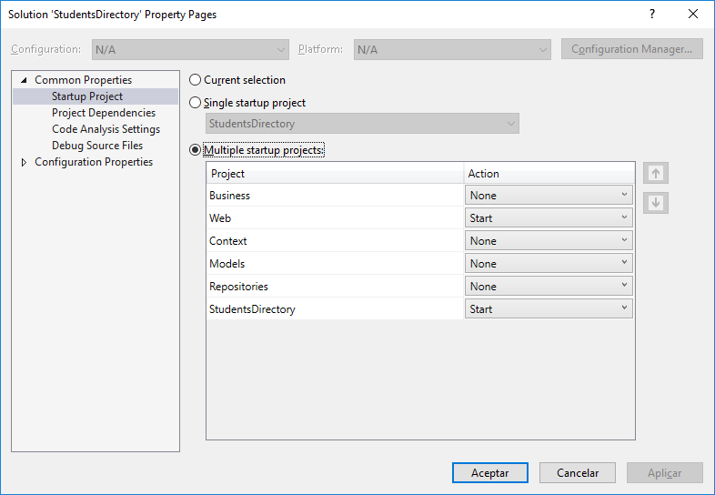

1. The required packages to run this app should be automatically downloaded from NuGet after the first build .
2. There’s 2 pre-loaded users with a different roles each:

User: admin /Password: admin: **Full control**.  
  
User : user /Password: user: **Only reading Access**

1. The web api layer uses Entity Framework “**In memory database**” for data persistence. Data will persist only during runtime.  
   For testing purposes a couple records are seeded right after web api Project is executed.
2. The app provides a role based Access contro using JWT