- Streamlit app home screen: Upload CISI dataset files attached in the zip
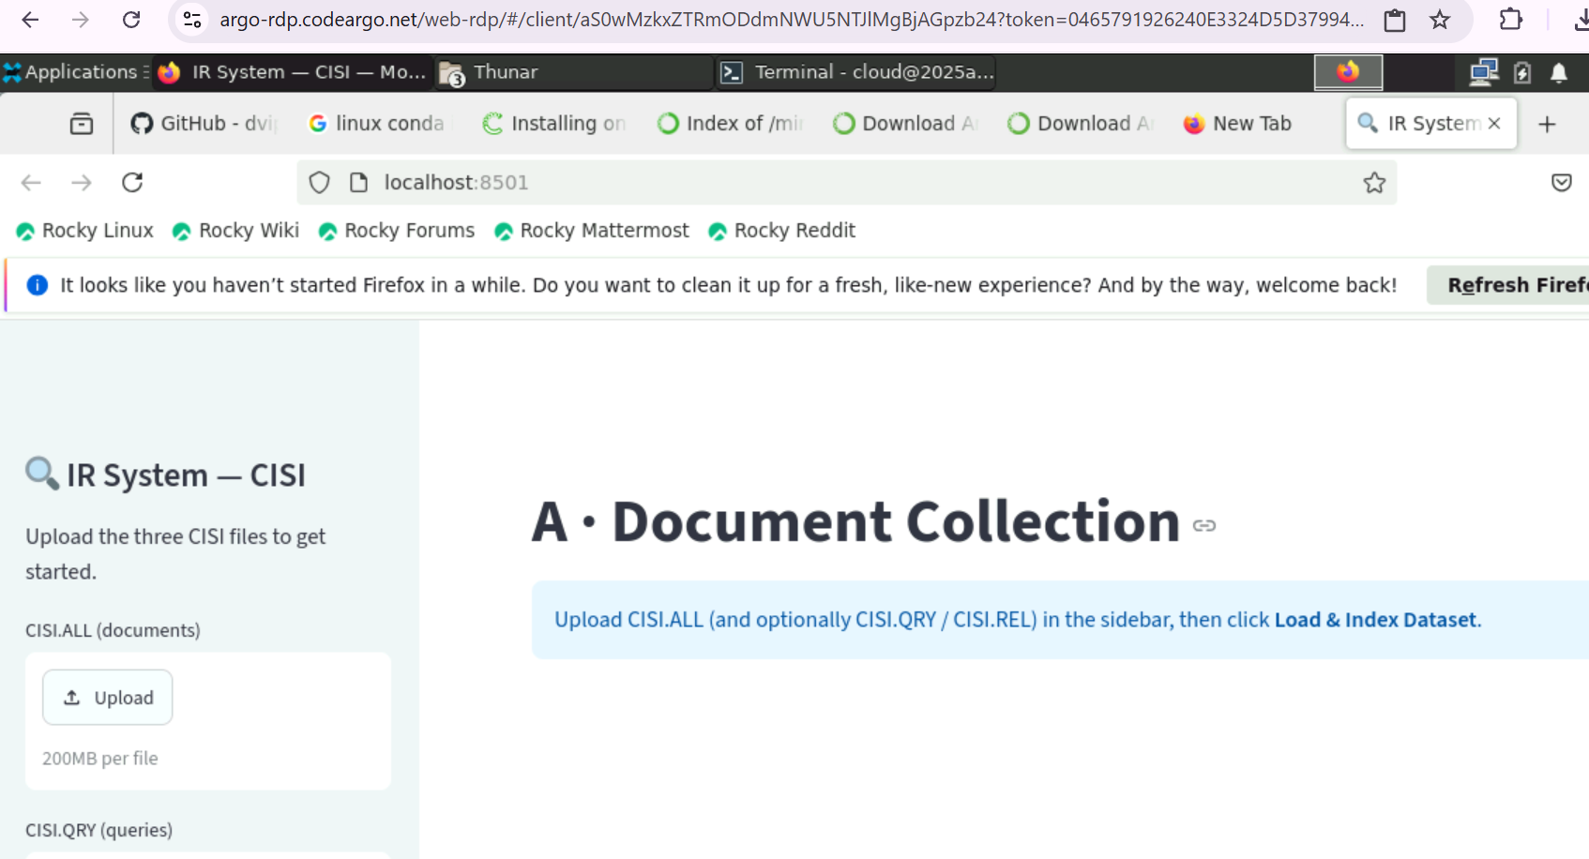

- Documents: Uploaded CSIS dataset

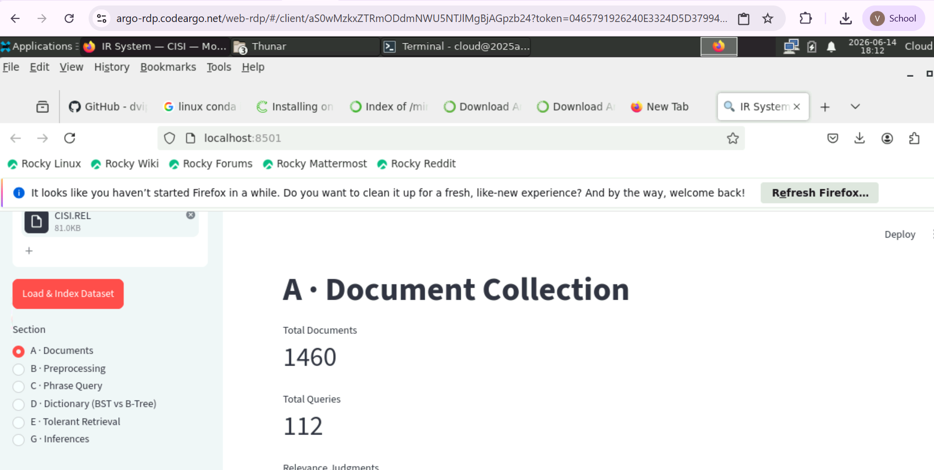

- Preprocessing: Using Stemming, Normalization, Lemmatization and Hyphen Removal
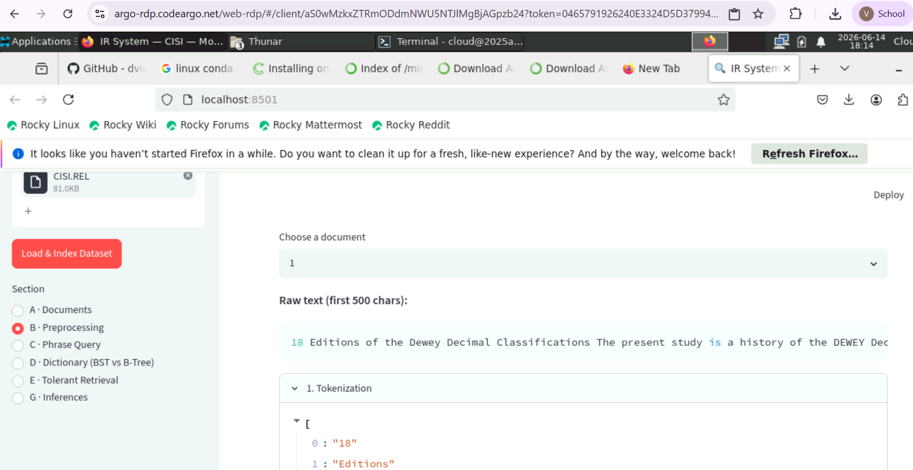

- Phrase Query
Biword Indexing and the document frequency
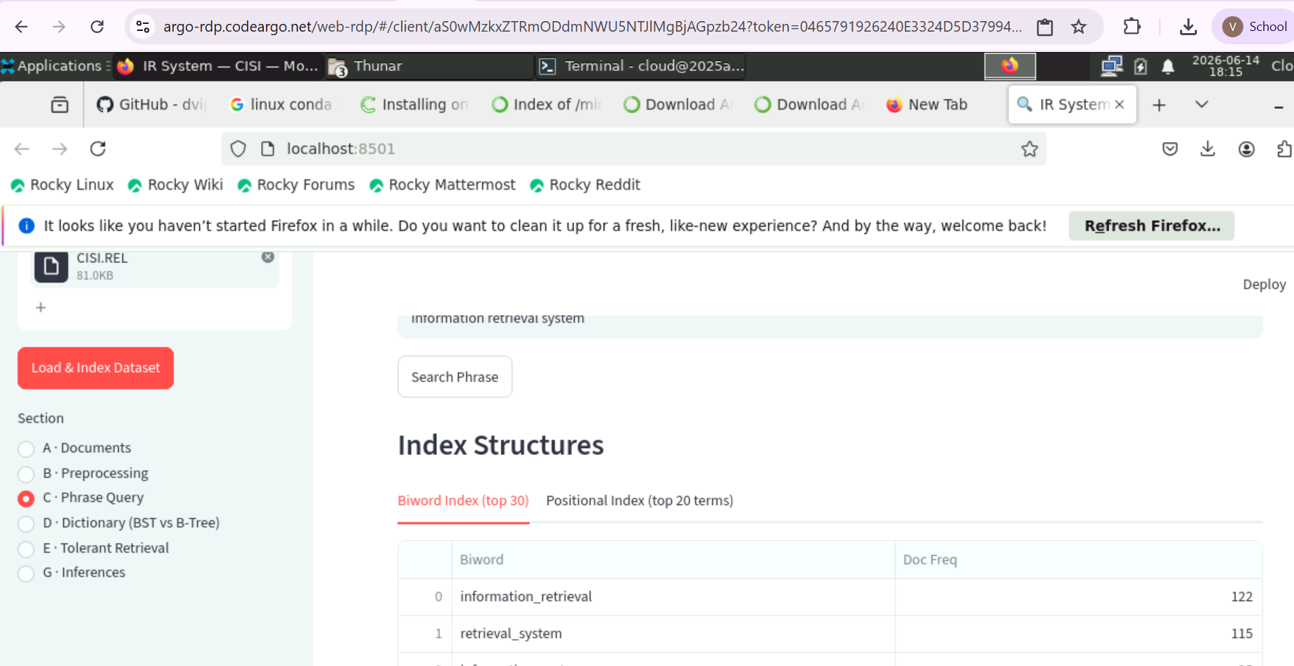
Positional Indexing: document frequency and the positions of the term in the document
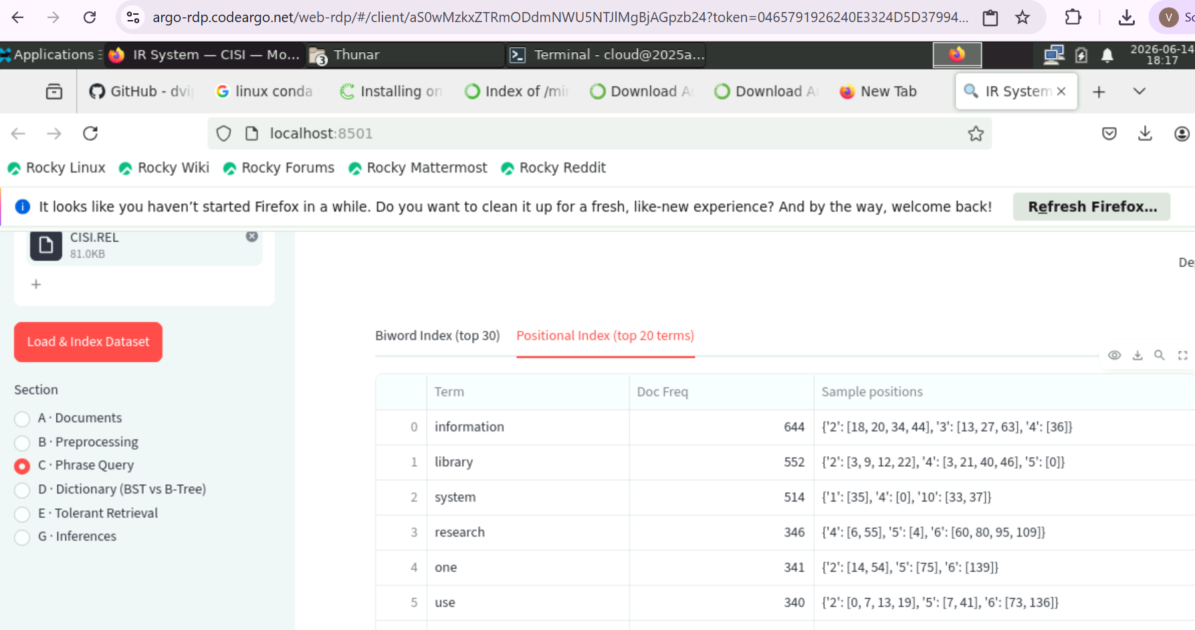

- Dictionary (BST vs B-Tree): Comparison Count for both BST and B-Tree
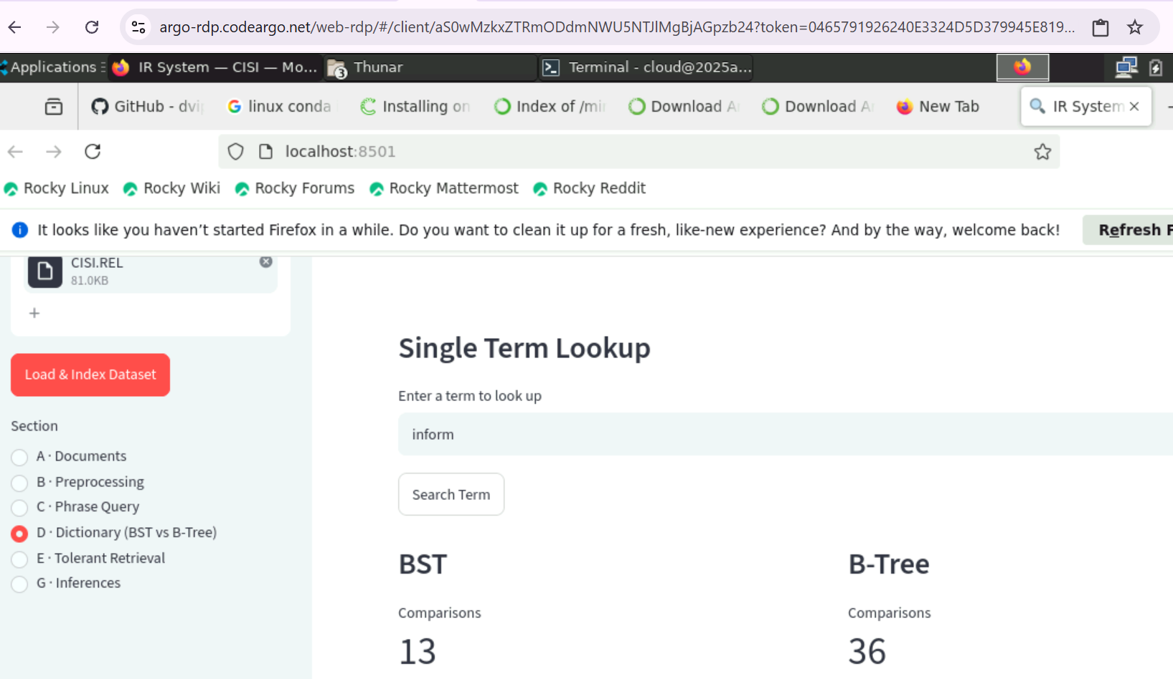

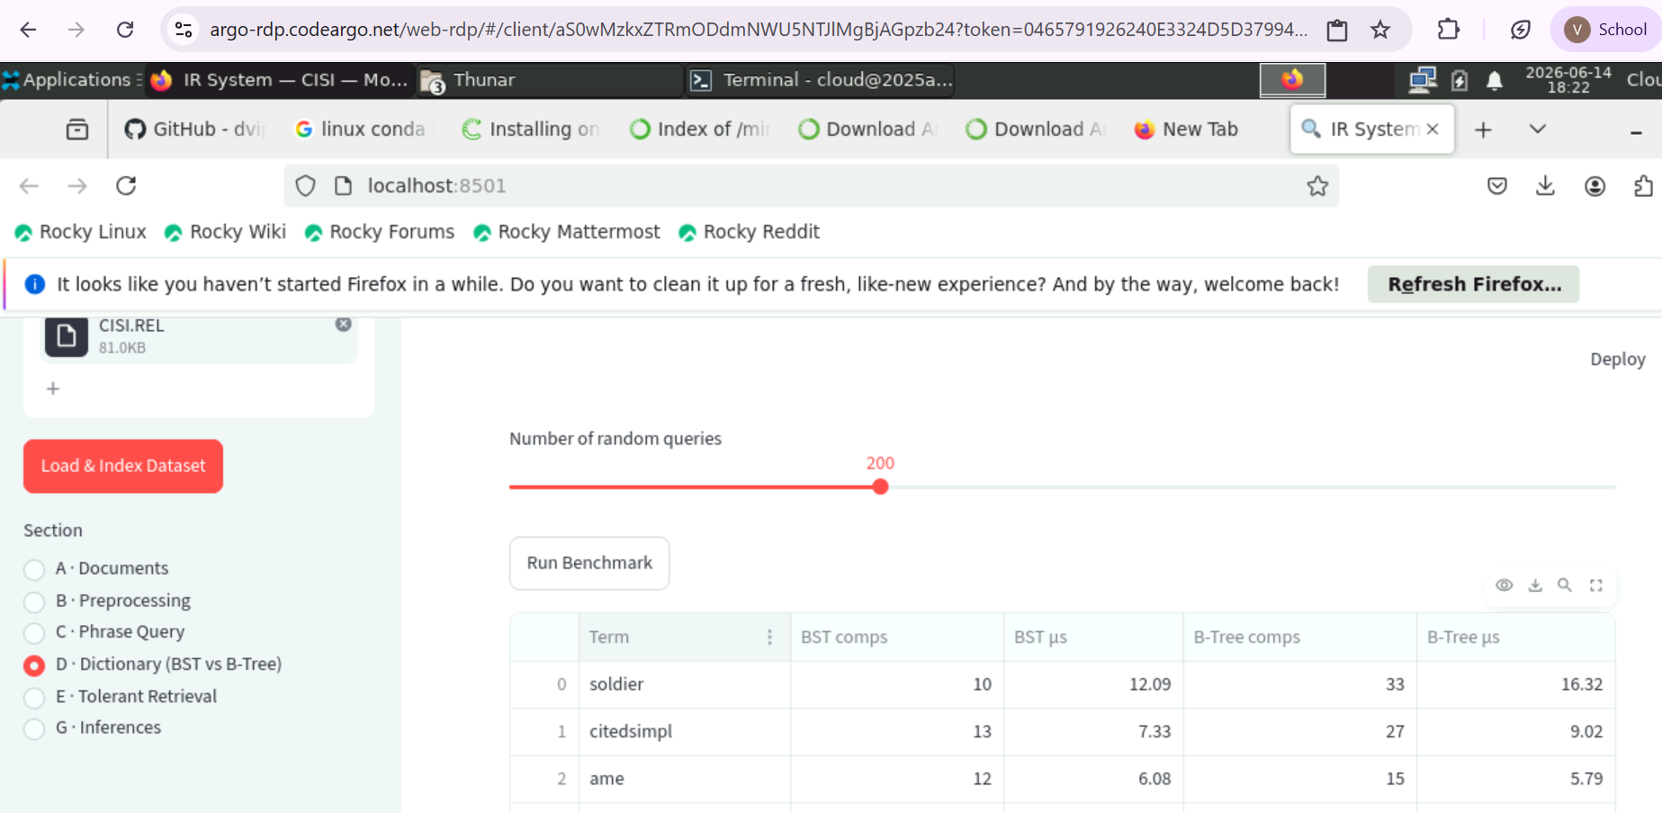

- Tolerant Retrieval: tolerant retrival Using 3-gram
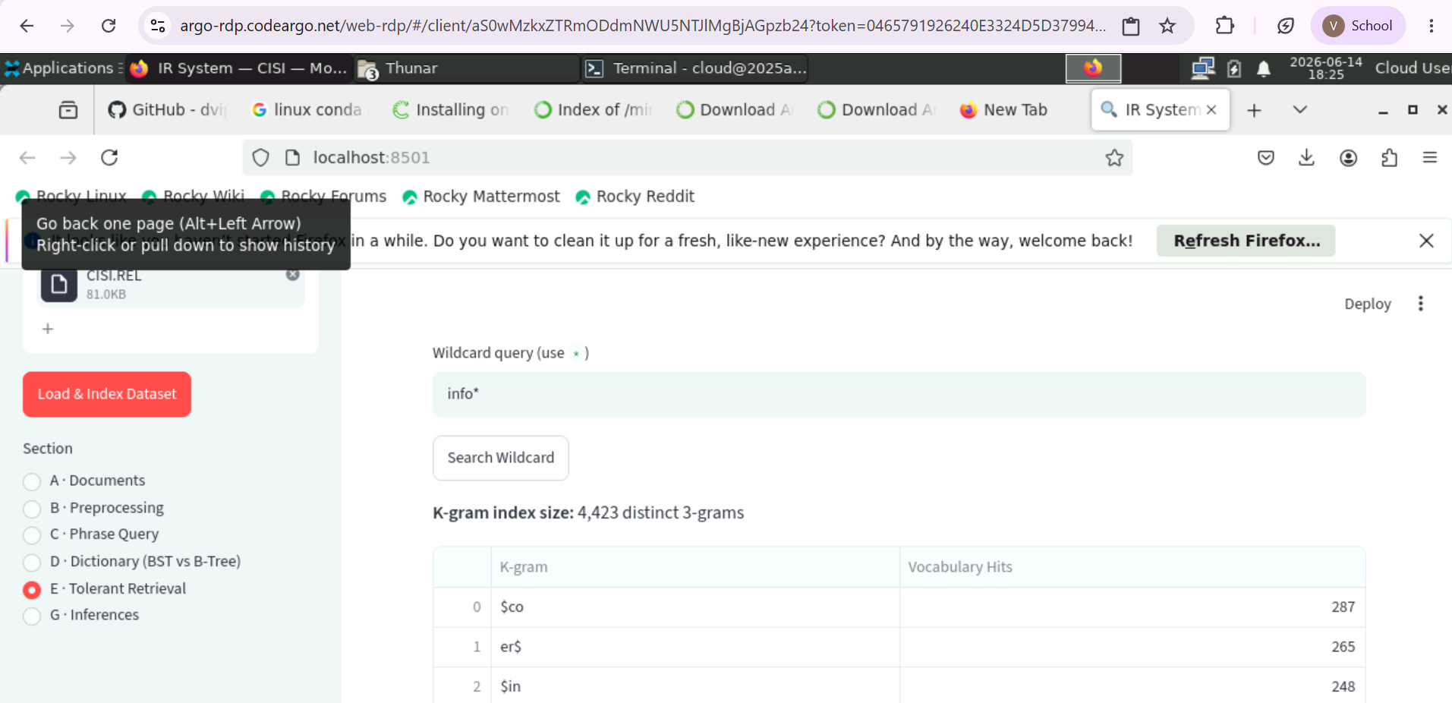

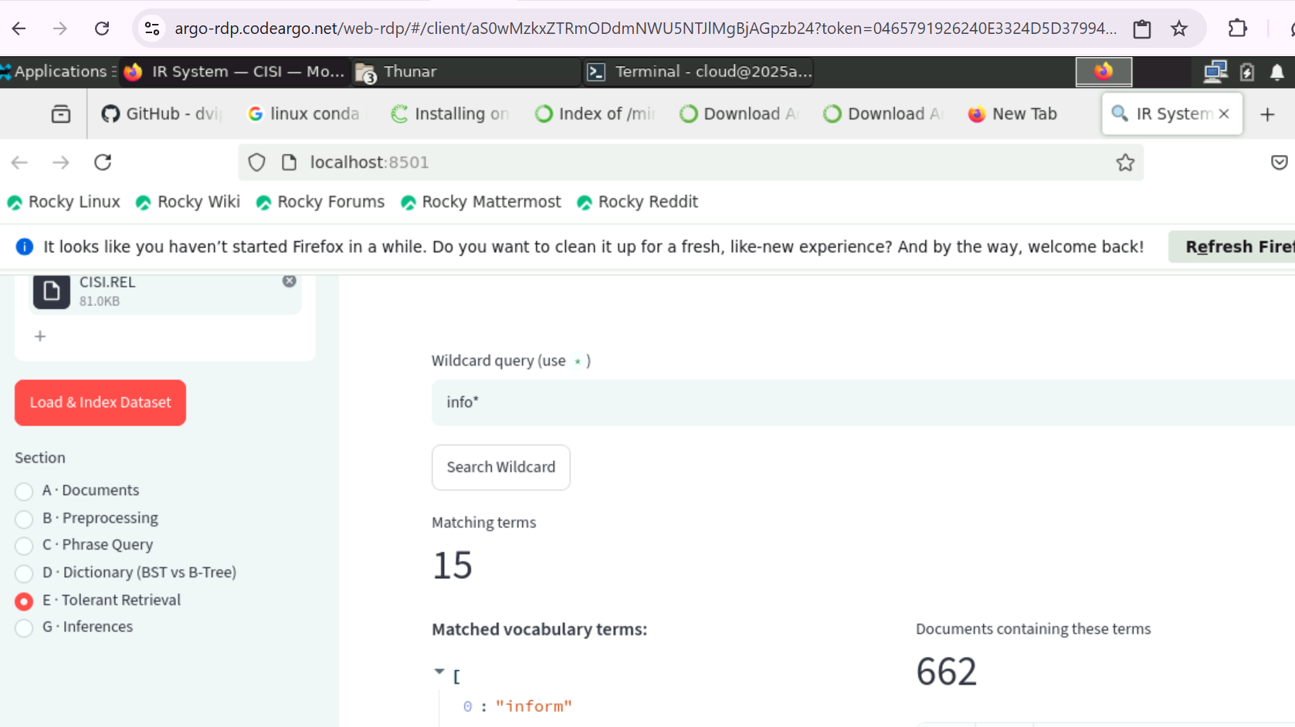

Edit Distance:
Edit distance = 2
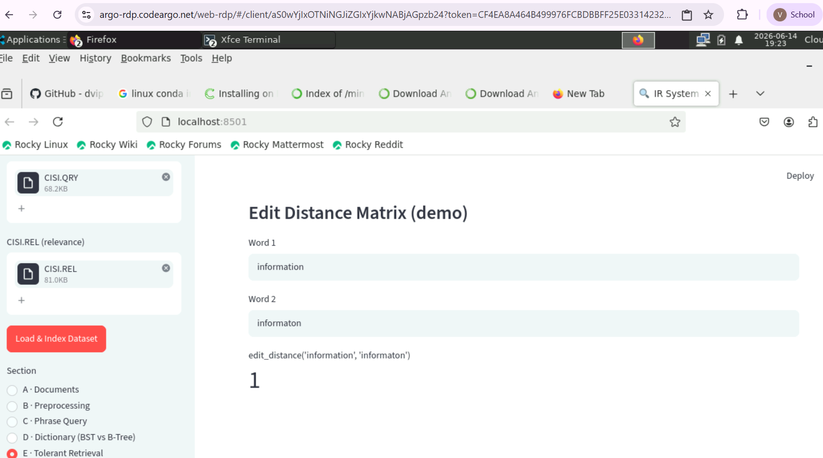

Edit Distance = 3

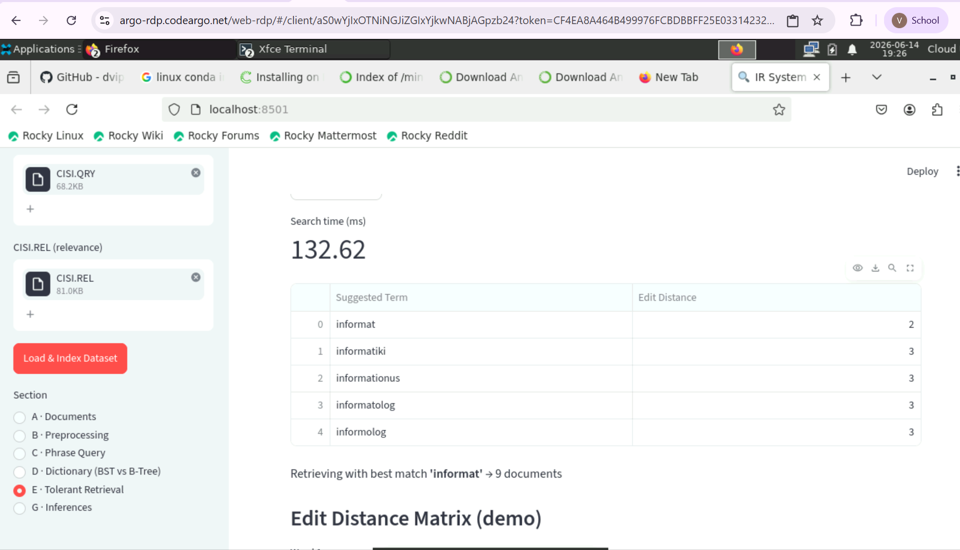

Phonetic similarity:
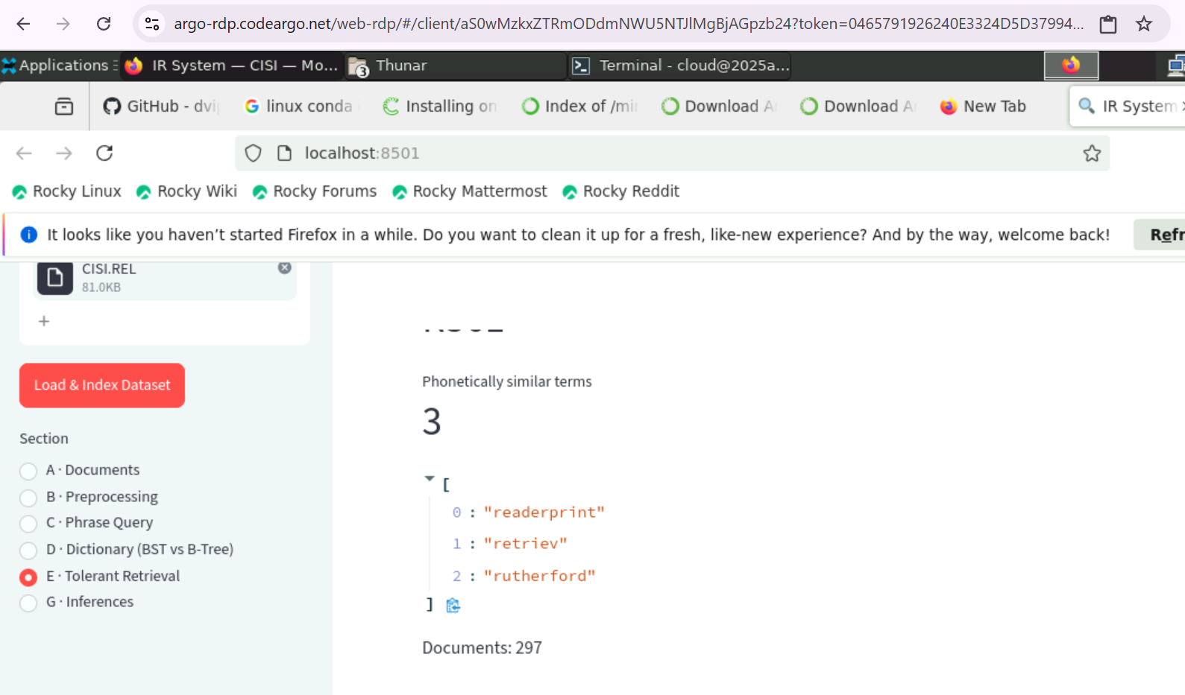

Combined Approach : (Edit Distance + Phonetic Similarity)

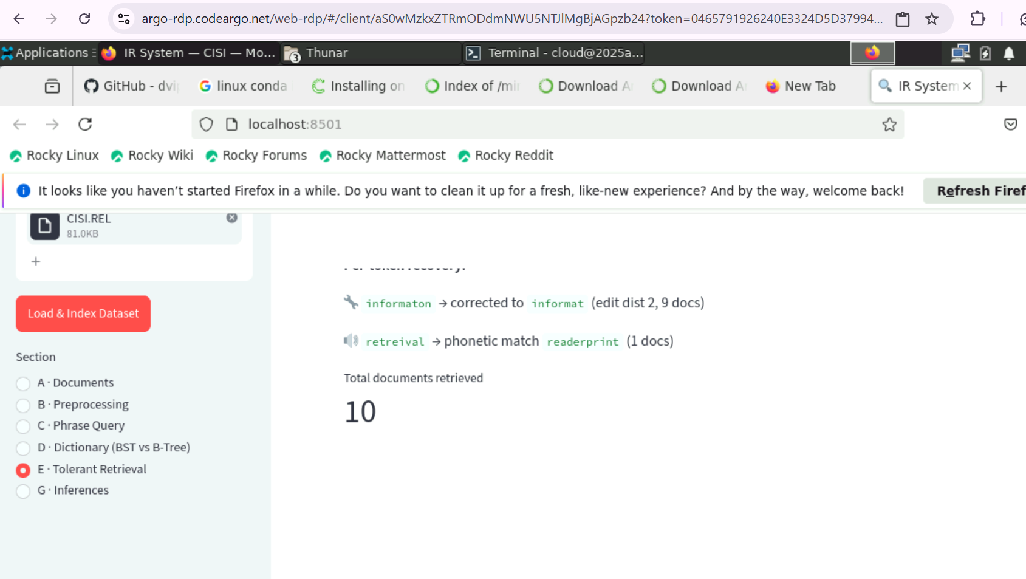

G. Inference from above Experiment
Question No | Question | Answer
1 | Which preprocessing technique improved retrieval quality? | Stop-word removal: Largest impact, removed ~180 high-frequency words, improved precision. Lowercase normalization: Ensured case-insensitive matching. Hyphen handling: Improved recall for scientific terms (e.g., co-operation → cooperation).
2 | Was stemming or lemmatization better? | Stemming (Porter): Slightly higher recall, minor precision loss; beneficial for CISI’s controlled vocabulary. Lemmatization: Preserves word sense, better for conversational text. Conclusion: Stemming preferred for CISI corpus.
3 | Which phrase query index was more accurate? | Positional Index: More accurate, eliminates false positives. Biword Index: Generates false positives when terms are not consecutive. Conclusion: Positional Index is superior.
4 | Which tree structure was faster? | B-Tree (order 50): Fewer comparisons, height ≤ 3 for ~7,000 terms. BST: Degenerates to right-skewed list, O(n) worst case. Conclusion: B-Tree faster and more efficient.
5 | How tolerant was the retrieval model? | Wildcard (k-gram): Handles prefix/suffix/infix (e.g., info*, *tional). Edit-distance correction: Recovers misspellings up to distance 2. Soundex phonetic: Handles phonetically similar errors. Combined pipeline: Token-level recovery with fallback strategies. Performance: Recovered all single-character deletions, most transpositions.
6 | Limitations | No ranking/TF-IDF (Boolean only). BST degeneracy (needs AVL/Red-Black). Edit-distance is brute force of order O(|vocab| × |q| × |t|). Biword index cannot handle phrase gaps. Stemming over-collapses the terms and hence false positives .
7 | How can the system be improved? | Add TF-IDF / BM25 ranking. Replace BST with AVL/Red-Black tree. Neural re-ranking with sentence-transformers can improve the system a lot.

