● ● ● ●
Multi-Agent Battle Royale
Design Document — competitive self-play sumo in MuJoCo

Course | Workshop in Autonomous Systems Simulation (20973)
Course Coordinator | Roi Wexler
Team | Oshri Belay (323021121) · Dvir Gilad (213741028)
Document | Final project design document
Submission deadline | August 31st, 2026

Contents
(In Word: right-click the field below → Update Field to generate page numbers.)
Update this field in Word to generate the table of contents.

1. Project Overview
This project implements a Multi-Agent Battle Royale simulation using MuJoCo as the physics engine and Gymnasium / PettingZoo as the environment interface. N robot agents (configurable 4–8) are spawned inside a circular arena and compete in a free-for-all: an agent is eliminated when it is pushed out of the ring, and the last one inside wins. Agents are trained with self-play Proximal Policy Optimisation (PPO) — a single policy, shared by every agent, trained against a rolling pool of its own past checkpoints. No opponent behaviour is hand-coded; all strategy emerges through competition.
The project is a custom topic under the MuJoCo track, extending the spirit of the “AI-Controlled Robotic Soccer Players” suggestion toward competitive multi-agent dynamics, emergent-behaviour analysis, and policy generalisation across agent counts. Each agent is modelled as a puck: a cylinder on two orthogonal slide joints, actuated by a 2-D force, with a visual-only humanoid drawn over the collision body for rendering.
Design goal (the KPIs, in one line)
A single shared policy that, in the hard multi-agent melee (n ≥ 4), exhibits three measurable behaviours: balance (N identical copies each win ≈ 1/N), dominance (1 trained agent beats N−1 untrained ones), and active pushing (agents win by shoving opponents out, not by outlasting a shrinking boundary).

2. Project Requirements

2.1 Functional Requirements
- Simulate N agents (configurable 4–8) in a circular arena simultaneously.
- Drive each agent with a policy that receives only local, egocentric observations.
- Detect and handle elimination (an agent pushed out of the ring).
- Train via self-play against a snapshot pool of past policy checkpoints.
- Log training metrics (win rate, episode length, Elo) in real time.
- Render and export episodes to video for qualitative analysis.
- Configure agent count, arena/physics parameters and reward weights from a YAML file.

2.2 Technical Requirements
- Simulation platform: MuJoCo (≥ 3.6, via the mujoco Python package).
- Environment interface: Gymnasium; PettingZoo for the multi-agent view.
- Training framework: Stable-Baselines3 (PPO).
- Experiment tracking: Weights & Biases, with an offline stdout logger fallback.
- Language: Python 3.12; Poetry for dependency management.
- Code follows SOLID and Clean Architecture; all modules typed and documented.
- README + runbook with install/run instructions; automated tests with a ≥80% coverage gate.

2.3 Constraints
- Training must be feasible on a single CPU in a reasonable time (target < 1 hour).
- The environment must be deterministic given a fixed seed (reproducibility).
- No external pretrained models — every policy is trained from scratch.

2.4 Expected Outcomes
- A single shared self-play policy that meets the three behaviour KPIs at n = 4 and n = 6 (see §6).
- Zero-shot generalisation: a policy trained on 4 agents remains competent at 6 and 8.
- A reproducible pipeline (one YAML → the headline policy) with documented design rationale.

3. System Architecture & Key Components

3.1 High-Level Architecture
The system follows a layered Clean Architecture: dependencies point inward, and inner layers know nothing of outer ones. Physics (MuJoCo) sits behind an interface, so the learning code never imports the simulator directly; the reward and observation are pure functions of game state, so they are unit-tested exhaustively and behave identically in training, evaluation and rendering. This makes it cheap to swap the RL algorithm or the simulator, and is what keeps the balance demonstration well-posed (all agents are interchangeable instances of one policy).
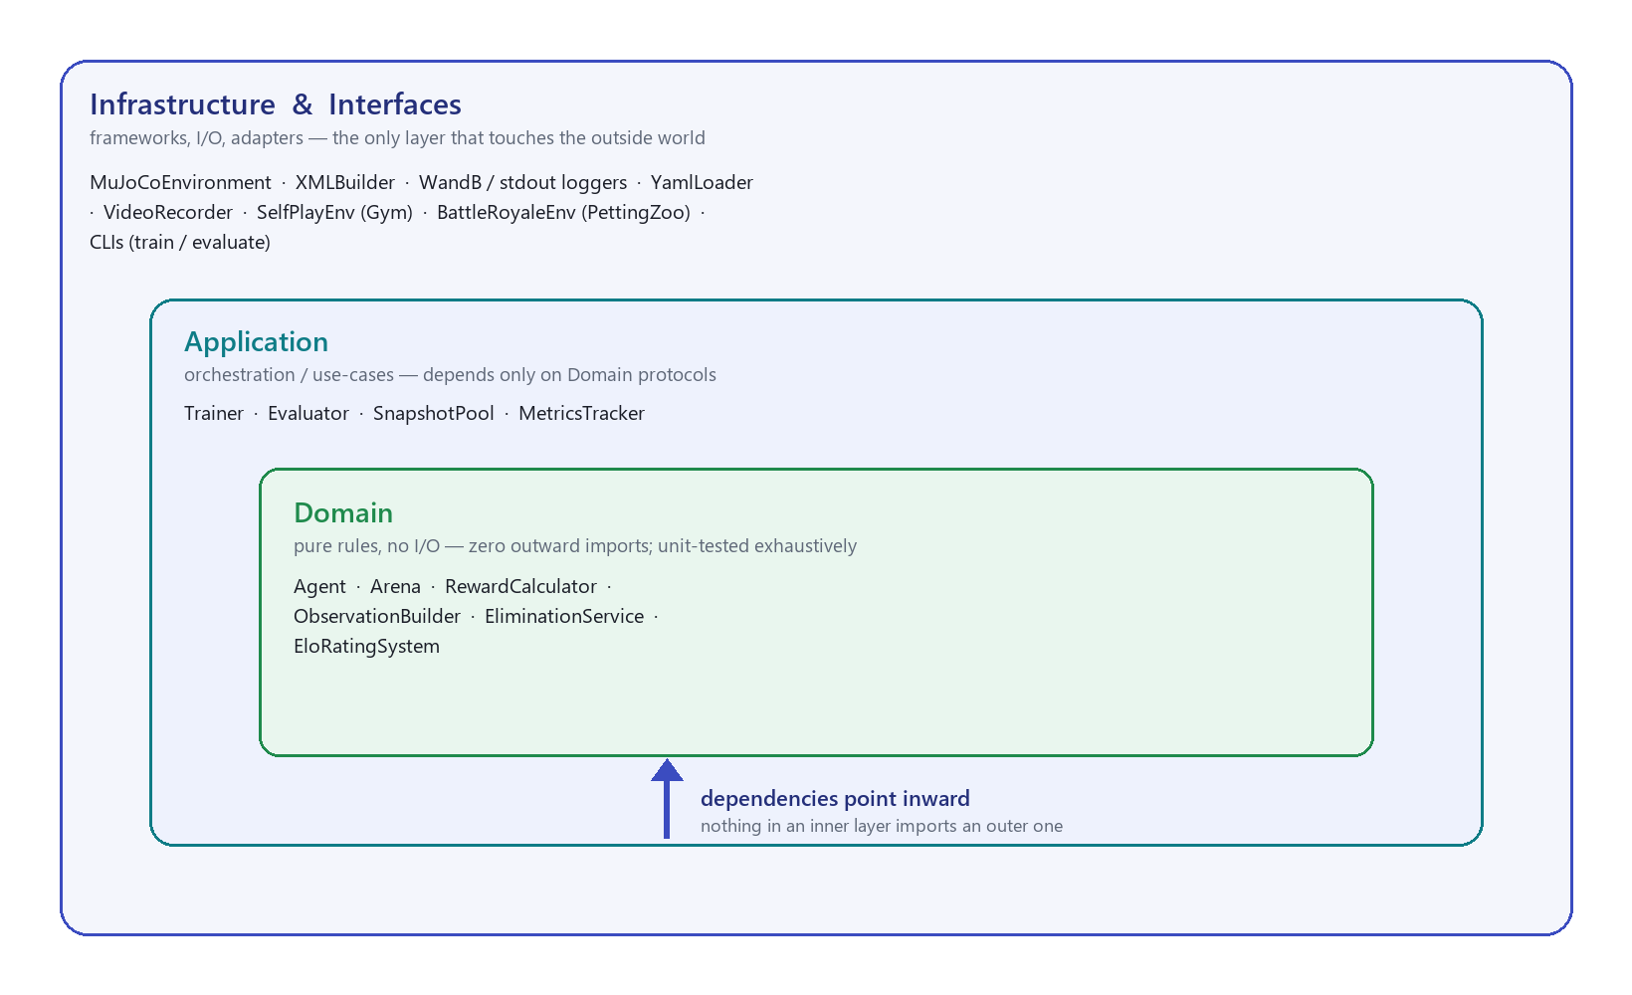
Figure 1 — Clean Architecture: nested layers, dependencies pointing inward toward the pure Domain.

3.2 Module Descriptions
Module | Responsibility | Owner
MuJoCoEnvironment | Steps the physics; applies actions; exposes agent state | Dvir
XMLBuilder | Generates MJCF for the ring + N agents (spawns, colours, mass) | Dvir
ObservationBuilder | Builds the 17-D egocentric observation per agent | Dvir
RewardCalculator | Pure reward per agent per step from game state | Dvir
EliminationService | Out-of-bounds detection; freezes eliminated agents | Dvir
SelfPlayEnv | Single-agent Gym view: one learner vs frozen opponents | Oshri
Trainer | Wraps SB3 PPO; curricula; snapshotting; callbacks | Oshri
SnapshotPool | Saves / samples / evicts past-policy checkpoints | Oshri
MetricsTracker + EloRatingSystem | Win-rate and learner-vs-pool Elo | Oshri
YamlLoader (Config) | Typed config dataclasses from YAML | Both
VideoRecorder + main.py | Renders episodes to MP4 | Oshri

3.3 SOLID Principles
Principle | Application in this project
Single Responsibility | RewardCalculator only computes reward; EliminationService only detects out-of-bounds.
Open/Closed | New reward terms / arena mechanics (storm, draw penalty) are added via config, not edits to callers.
Liskov Substitution | Any policy satisfying the IPolicy protocol drops into SelfPlayEnv as an opponent.
Interface Segregation | IBattleRoyaleEnv, IPolicy and ILogger are separate, minimal protocols.
Dependency Inversion | Trainer depends on domain protocols, never on MuJoCo or WandB concretes.

3.4 Design Alternatives
Two architectural approaches were considered for the training pipeline.
Option A — Shared-policy self-play (selected). One network plays every slot; the learner is updated while opponents are frozen samples from the snapshot pool (decentralised execution). Trade-offs: simpler, lower memory, naturally handles variable N (same weights for any count), and is proven in competitive tasks (OpenAI Sumo); but the policy cannot specialise per role.
Option B — Independent per-agent policies. Each agent keeps its own network and buffer. Trade-offs: allows role specialisation, but costs N× memory/compute, grows unstable with N, and makes coordination between optimisers hard (agents may cycle or diverge).
Decision & rationale: Option A. The reduced complexity and cost are decisive for a workshop-scoped project, and shared weights are exactly what makes the balance KPI (N interchangeable copies each winning ≈ 1/N) well-posed — you cannot measure a fair equilibrium among agents that are not identical. Option B is noted as future work.

3.5 Sequence Chart
One training episode, end to end. The Trainer drives PPO; SelfPlayEnv presents the melee as a single-agent problem (one learner vs frozen opponents from the pool); MuJoCoEnv advances the physics and the pure Domain services compute observation, elimination and reward.
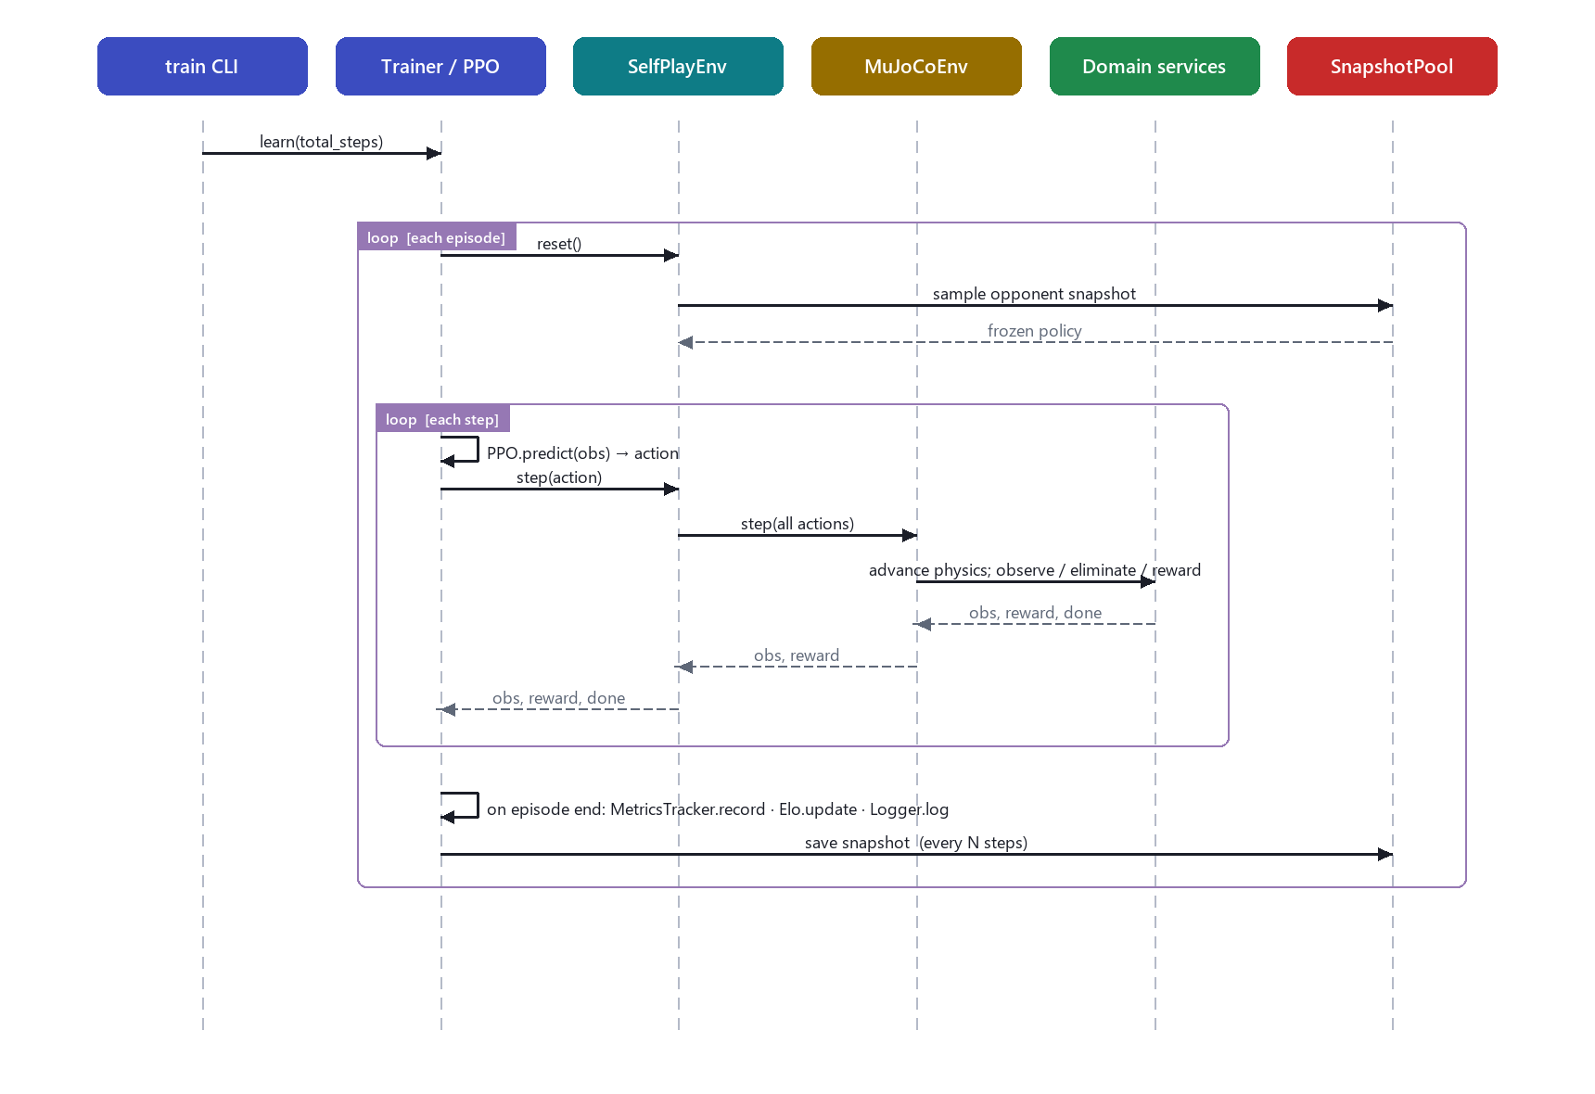
Figure 2 — Training-loop sequence: reset → sample opponent → per-step act/step/observe → record metrics → snapshot.

4. Game Model & Key Design Decisions
This section records the engineering decisions behind the simulation — the physics, the observation, the reward, and the self-play scheme — and the rationale for each. (The full derivations and the experiments that motivated them are in docs/METHODOLOGY.md.)

4.1 Physics of an agent
Each agent is a MuJoCo body on two slide joints (x, y): planar translation, no rotation, no vertical motion. A cylinder (radius 0.15 m, half-height 0.05 m) is the collision + mass shape; two motors apply force F = gear·u, u ∈ [−1,1], gear = 14 N. Per axis, with linear joint damping c = 4, the dynamics are m·v̇ = F − c·v, giving a bounded terminal velocity v∞ = F/c = 3.5 m/s.
Design decision — damping. With no damping the arena is frictionless: any net force integrates into unbounded velocity and agents slide off the edge uncontrollably (the task is unlearnable). Damping bounds the speed and lets an agent stop, turning the problem into a controllable sumo.
Design decision — agent mass (the braking-distance constraint)
A key sizing constraint: an agent must be able to stop inside the ring. Cutting thrust, velocity decays with time-constant τ = m/c, so the braking distance is d = v∞·τ = F·m/c² — proportional to mass. At MuJoCo's default density (ρ = 1000, m ≈ 7 kg) d ≈ 5.5 m ≫ the ~1.2 m arena: an agent at speed physically cannot stop in the ring, forcing caution and self-ejection. We therefore expose the cylinder density and set ρ = 150 (m ≈ 1.1 kg) → d ≈ 0.96 m < arena. v∞ is unchanged and lighter opponents are displaced more per shove, so pushing gets easier at the same time.

4.2 Arena boundary & elimination
The boundary can optionally shrink over time (a “storm”): R(t) = R₀·(1 − (1−f)·min(t/T,1)); f = 1 gives a fixed arena. Design decision: the headline configuration runs with no storm (f = 1). With no boundary shrinking to eliminate anyone “for free”, pushing an opponent out is the only way to win, so the active-pushing KPI measures genuine ejection rather than a survival timer. EliminationService marks an agent out when ‖position‖ > R(t); eliminated agents are frozen and dropped from neighbour observations but kept in the roster for stable indexing.

4.3 Observation (17-D, egocentric)
[ own_x, own_y, own_vx, own_vy, # self pos + vel (4)
R(t) − ‖pos‖, # distance to boundary (1)
3 nearest live opponents × (rel_pos 2 + rel_vel 2) (12) → total 17

- Nearest-3, sorted by distance → fixed width and permutation-invariant, so one network plays any N = 2–8.
- Relative neighbour coordinates → translation-invariant.
- Whole-arena rotation randomised each episode → the one absolute term (own x,y) can't be memorised; without it one slot won ~80% of an all-identical match instead of 1/N.

4.4 Reward design
Per step for an agent alive last step. The push and approach terms are potential-based (Ng et al. 1999), so they accelerate learning without changing the optimal policy.
Term | Value | Design purpose
Win bonus | +10 (sole survivor) | make winning (≈+13) dominate turtling (≈−1.2)
Elimination / Death | +1 / −1 | reward ejecting an opponent; penalise self-ejection
Survival / Time | +0.001 / −0.003 | anti-suicide floor; idling mildly unprofitable
Push shaping | +2.0 · Δ(opp radius) | dense gradient toward ejecting (win signal is too sparse)
Approach shaping | +0.4 · Δ(−gap) | learn to hunt a passive target (to beat a random baseline)
Edge penalty | −1 · outer-ring depth | stop overshooting your own edge while chasing
Draw penalty | −(= death) on timeout | make a timed-out draw cost like a loss — kills the stall equilibrium

The reward is tuned to guarantee one inequality: win (≈ +13) ≫ turtle (≈ −1.2) > suicide (−1).

4.5 Self-play training scheme
- Snapshot pool (δ-uniform self-play). Up to 100 past checkpoints; opponents sampled uniformly across the whole history — avoids cycling against a single moving target.
- Agent-count curriculum. Start at n=2 (where committing to a shove has ~zero exposure) and ramp to n=4, carrying the shove skill into the melee.
- Draw = loss + high γ (0.997). A timed-out draw is charged like a death; γ gives it an effective reach of ~333 steps, so caution stops paying in the mid-game where the commit-or-wait decision is made.
- Opponent curriculum. Warm up against random opponents (learn to hunt), decay into mostly self-play (learn to compete).
- PPO. MlpPolicy 2×64, lr 3e-4, n_steps 2048, batch 64, clip 0.2, 10 epochs, γ 0.997; ~1.5 M steps ≈ 30–40 min on CPU.

5. Simulation Scenarios

Scenario 1 — 4-agent free-for-all (primary)
Four agents spawn evenly on the ring. The primary training and evaluation scenario; every ablation is measured here. Real-world analogy: multi-robot sumo.

Scenario 2 — Dominance (1 trained vs 3 random)
One trained agent against three untrained (random) agents — the skill test, reported as edge = WIN − LOSS. Rendered with the trained agent in red so it can be followed at a glance.

Scenario 3 — Zero-shot generalisation (train on 4, test on 6 & 8)
The policy is trained only on 4-agent episodes and evaluated at 6 and 8, unseen during training — the primary academic contribution. The permutation-invariant, fixed-width observation is what makes a single network valid at any count.

6. Performance Metrics (KPIs)
Because the game is a symmetric free-for-all, the classic “>60% win-rate vs the pool” target is ill-posed (identical policies each win 1/N at equilibrium). The KPIs below measure what is meaningful and achievable. Targets were set at design time; the Result column reports the achieved value for the final policy (config/sumo_light.yaml) at the n=4 training scale.
KPI | Target | Result (n=4) | How measured
Active pushing — self-play resolution rate (no storm) | > 0.5 | 0.91 | N identical copies, fraction of games resolved by a push-out
Dominance — edge vs random (WIN − LOSS) | > 0 | +0.98 | 1 trained vs N−1 random, 100 matches
Balance — per-slot win share vs 1/N | within ±10% | ≈ 0.25 | N identical copies, per-slot win rate
Generalisation — competent at n=6 / n=8 (unseen) | holds | 0.78 / +0.56 | self-play resolution / dominance edge; n=6 gives 0.79 / +0.85, n=8 gives 0.78 / +0.56 (loss 0.01)
Reproducibility / stability | stable | 1.0–1.5 M | seeded; metrics stable across checkpoints

All primary KPIs are met by a single policy; the balance share carries a small, fully-explained residual bias (Appendix A). Full result tables at n = 2/4/6 are in RESULTS.md.

7. Challenges & Risks
Design-time risks and the mitigations built into the system.
Challenge | Likelihood | Impact | Mitigation
Reward hacking — passive circling / turtling | High | High | potential-based shaping + a win bonus that dominates turtling + draw = loss
Melee caution at n ≥ 3 (committing exposes you) | High | High | agent-count curriculum (n=2→N) + draw = loss + high γ
Agents cannot stop in the ring (braking > arena) | High | High | size agent mass so braking distance < arena radius (density param)
Training instability with N > 2 | Medium | High | start at N=2, validate, then ramp the agent count
Policy collapse to a single strategy | Medium | Medium | maintain a 100-deep δ-uniform snapshot pool
Compute limits — slow CPU training | Medium | Low | lightweight MLP policy; ~30–40 min for 1.5 M steps

8. Prototype & Demo
A working prototype validated the pipeline end-to-end before investing in training: the MJCF arena builds and steps N agents without physics errors, elimination fires on out-of-bounds, a random-policy baseline runs a full episode, and metrics log live. The final system renders episodes to MP4 with a framed tracking camera and a visual humanoid over each (invisible) collision cylinder, so rendering never changes the physics.
- Captioned results reel: media/battle_royale_results.mp4 — all three behaviours + the design rationale (~80 s).
- Raw clips: media/sumo_light_n4.mp4 · _n6.mp4 · _n8.mp4 — self-play push-outs at n = 4 / 6 / 8.
- Dominance render: main.py --dominance — the red trained agent ejecting the untrained field (n = 4 and n = 8).

9. Evaluation Criteria
How the project's success is measured, aligned to the course grading criteria.
Criterion | Status | Evidence
Environment correctness & robustness | Met | episodes run to completion; 134 tests; ≥80% coverage gate
Meeting KPIs / performance goals | Met | §6 — pushing 0.91, dominance +0.98, balance ≈ 1/N at n=4
Emergent behaviour | Met | genuine push-outs at n=4/6 (video + 0.91 resolution)
Generalisation | Met | trained on 4; holds at 6 & 8 (push 0.79 / 0.78, dom +0.85 / +0.56)
Code quality & SOLID | Met | Clean Architecture, typed, Ruff + CI
Project structure & design | Met | layered design; pure domain; config-driven
Reproducibility | Met | seeded; one YAML reproduces the headline policy
Documentation & developer experience | Met | this document, METHODOLOGY, RUNBOOK, README, videos

10. Work Split & Timeline

Work split
Area | Dvir | Oshri
Environment: MJCF arena, physics, observation, reward, elimination | ●
Training: self-play loop, PPO, snapshot pool, Elo, metrics |  | ●
Config loader, ablations, video export, documentation | ● | ●

Timeline
Phase | Work | Deliverable
Env bring-up | MJCF arena, multi-agent env, elimination, random baseline | Working environment + prototype
Self-play | PPO self-play loop, snapshot pool, WandB/stdout logging | Training run with logged metrics
Scale & ablate | n=6/8 generalisation; reward, storm, physics ablations | Ablation results
Tuning | agent-mass sizing + draw=loss → all three KPIs met | Headline policy (config/sumo_light.yaml)
Finalise | documentation, video, design document, README, tests | Final submission (Aug 31st)

11. References
- Bansal et al. Emergent Complexity via Multi-Agent Competition. ICLR 2018.
- Ng, Harada & Russell. Policy Invariance under Reward Transformations. ICML 1999.
- Heinrich & Silver. Deep RL from Self-Play in Imperfect-Information Games (fictitious self-play). 2016.
- Yu et al. The Surprising Effectiveness of PPO in Cooperative Multi-Agent Games (MAPPO). NeurIPS 2022.
- Schulman et al. Proximal Policy Optimization Algorithms. arXiv 2017.
- MuJoCo — https://mujoco.readthedocs.io · Gymnasium — https://gymnasium.farama.org
- Stable-Baselines3 — https://github.com/DLR-RM/stable-baselines3
- Martin, R.C. Clean Architecture. Prentice Hall, 2017.

Appendix A — Reflective Analysis
A short retrospective on what was hard and what we learned. The full narrative, with every experiment and the supporting mathematics, is in docs/METHODOLOGY.md.

The key insight: the bottleneck was physics, not reward
For much of the project, agents at n ≥ 3 collapsed into cautious draws or self-elimination, and no reward change fixed it. The real cause was dynamical: at the default agent mass the braking distance from top speed (~5.5 m) far exceeded the arena (~1.2 m), so an agent that committed to any real speed physically could not stop in the ring. Recognising this as a sizing constraint — and lightening the agents so braking distance fits the arena — is what turned a −0.26 dominance ceiling into +0.98. The lesson: in a physics-based task, verify the dynamical feasibility of the behaviour you are rewarding before tuning the reward.

An honest negative result: balance perfection is fragile
The final policy's per-slot win share is slightly uneven (≈ [.20 .19 .32 .29] at n=4) due to an observation tie-break on the perfectly symmetric spawn. We tried three fixes (spawn jitter ×2, neighbour-shuffle); all evened the balance but collapsed the aggressive behaviour, because the draw-penalty optimum is fragile to any training-time stochasticity. We therefore document the bias as a fully-explained artifact (within ±7% of ideal) rather than trading away the primary KPIs. A genuinely permutation/rotation-equivariant policy architecture would remove it — a worthwhile future extension.

What we would do differently
- Probe the dynamical limits (braking distance, reachability) before reward tuning.
- Adopt an equivariant policy/observation from the start to get exact balance for free.
- Budget more compute to test whether the aggressive optimum becomes robust to noise at scale.

