DIGITAL ZOOM

* Project description:
* 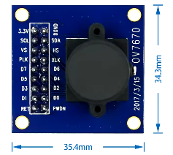
  1. Camera – video operation on VGA monitor
  2. Zoom x 2
  3. Issue and solution:
     1. Issue: Pixelation
     2. Solution: Filter (Bilinear interpolation) – WIP
* Project’s Steps:
  1. Architecture:
     1. A diagram of a computer

        AI-generated content may be incorrect.
  2. Code implementation:
  3. Simulations
  4. Synthesis
  5. P & R - .xdc
* Main modules:
  1. Capture – collects camera data.
  2. BRAM – Storages frame
  3. Controller – camera configuration
  4. Cntl – sync..
  5. VGA – projects on the monitor
* Data Flow:
  1. FPGA ⬄ CAMERA
     1. FPGA provides clk to the camera and configures the camera
     2. Camera sends frame data to the FPGA
        + In the FPGA:
          - Capture => BRAM => VGA => Monitor.
          - (Here add 1 code line)
* Challenges and insights:
  1. Timing –
  2. VGA, Camera protocols
  3. Algorithms implementation:
     1. Zoom.
     2. Bilinear interpolation.
  4. Version control and team work
     1. GIT – Tags, commits, branches, Github, fork..
* Results:
  1. Pictures + Videos of the Monitor…
* Live demo: