**Delhi Technological University**

Department Of Computer Science And Engineering



**Programming Fundamentals**

Lab File for the course CO102 (P)

**Submitted by :** Vishal Das (2K21/A8/24)

**Submitted to :** Anukriti Kaushal

**Contents**

|  |  |  |  |
| --- | --- | --- | --- |
| **S. No.** | **Program** | **Date** | **Signature** |
| 1 | Write a C program to print "Hello world" on screen | May 05, 2022 |  |
| 2 | Write a C program to take input integer from user and add one to that integer and print result |
| 3 | Write a C program to add, subtract, multiplication and division on two integers and print the result and use explicit type casting for division operation |
| 4 | Write a C program to calculate simple interest and print on the screen |
| 5 | Write a C program to perform Logical AND and OR operations on two and three variables | May 12, 2022 |
| 6 | Write a C program to perform bitwise AND and OR operations on two variables |
| 7 | Write a C program to perform relational operations on two variables |
| 8 | Write a C program to compute factorial of a number | May 19, 2022 |
| 9 | Write a C program to compute sum of a 5-digit number |
| 10 | Write a C program to reverse a 5-digit number |
| 11 | Write a C program to find whether the input number is prime or not |
| 12 | Write a program to find area of different shapes using switch case | June 09, 2022 |
| 13 | Write a program to implement following pattern :   * Half Pyramid of * * Half Pyramid of numbers * Inverted half pyramid of * * Inverted half pyramid of numbers * Full Pyramid of * |
| 14 | Write a program to convert decimal to binary and vice versa | June 16, 2022 |
| 15 | Program to generate the Fibonacci sequence | June 23, 2022 |
| 16 | Program to search a number from an array using linear search |
| 17 | Program to search a number from an array using binary search |
| 18 | Program to sort an array using Bubble sort |
| 19 | Program to sort an array using Insertion sort |
| 20 | Program to sort an array using Selection sort |
| 21 | Program to check if a given string is a palindrome or not | July 07, 2022 |
| 22 | Program to string concatenation |
| 23 | Program to string comparison |
| 24 | Program to string reverse |
| 25 | Program to convert a string from lower case to upper case and vice versa |
| 26 | Program to find factorial of a number using recursion | July 14, 2022 |
| 27 | Write a C program for the addition of two 3 x 3 matrices |
| 28 | Write a C program to multiply two 3 x 3 matrices |
| 29 | Write a C program to store the employee details using structure | July 14, 2022 |
| 30 | Write a C program to swap two numbers using pointers | July 21, 2022 |
| 31 | Write a C program to pass and return pointer to function hence calculate average of an array. |
| 32 | Write a C program to create a file called *emp.txt* and store information about a person, in terms of his name, age and salary |
| 33 | Write a C program to read a file and after converting all lower case to upper case letters write it to another file |

**Program 01 :** Write a C program to print "Hello world" on screen

**Theory :**

printf() function is used to write the C string pointed by format to the standard output.

**Algorithm :**

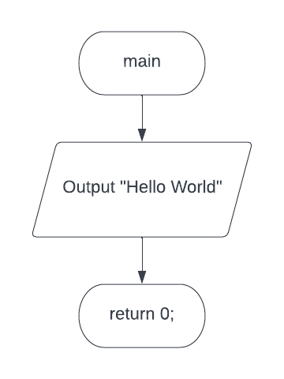

**Code :**

*/* This program is written by Vishal Das*

*(2K21/A8/24) on May 05, 2022 02:00 PM*

*for Lab File of course CO102*

*\*/*

#include <stdio.h>

int **main**(void){

**printf**("Hello World!");

return 0;

}

**Output :**

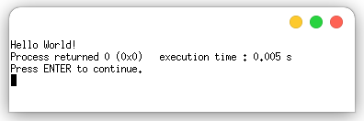

**Program 02 :** Write a C program to take input integer from user and add one to that integer and print result.

**Theory :**

scanf() function is used to read data from user input and stores them according to the parameter format into the locations pointed by the additional arguments.

**Algorithm :**

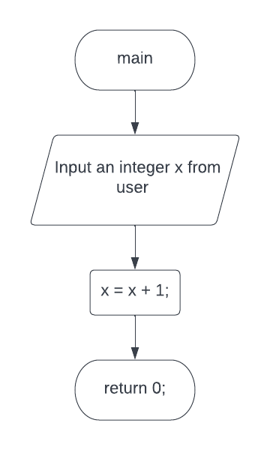

**Code :**

*/* This program is written by Vishal Das*

*(2K21/A8/24) on May 05, 2022 02:15 PM*

*for Lab File of course CO102*

*\*/*

#include <stdio.h>

int **main**(void){

int x;

**printf**("Input an integer : ");

**scanf**("%d", &x);

x = x + 1;

**printf**("The value of x + 1 is %d\n", x);

return 0;

}

**Output :**

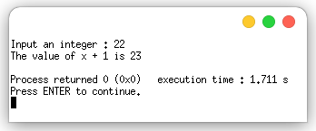

**Program 03 :** Write a C program to add, subtract, multiplication and division on two integers and print the result and use explicit type casting for division operation.

**Theory :**

Operators are used to perform various operations of addition, subtraction, multiplication and division which correspond literally to their respective mathematical operators.

Type Casting is a process in which we change a variable belonging to one data type to another one. The Implicit type casting occurs automatically while in Explicit type casting, the programmer needs to force the conversion.

**Algorithm :**

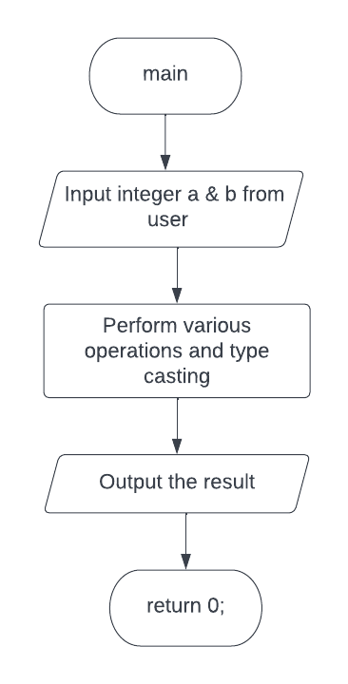

**Code :**

*/* This program is written by Vishal Das*

*(2K21/A8/24) on May 05, 2022 02:30 PM*

*for Lab File of course CO102*

*\*/*

#include <stdio.h>

int **main**(void)

{

int a, b, c;

float d;

**printf**("Enter two integers : ");

**scanf**("%d %d", &a, &b);

c = a + b; *// Addition Operation*

**printf**("Addition \t(%d + %d)\t= %d\n", a, b, c);

c = a - b; *// Subtraction Operation*

**printf**("Subtraction \t(%d - %d)\t= %d\n", a, b, c);

c = a * b; *// Multiplication Operation*

**printf**("Multiplication \t(%d * %d)\t= %d\n", a, b, c);

d = a / b; *// Division without using typecasting*

**printf**("Division without using typecasting = \t%f\n", d);

d = 1.0 * a / b; *// Division using implicit typecasting*

**printf**("Division using implicit typecasting = \t%f\n", d);

d = (float)(a) / b; *// Division using explicit typecasting*

**printf**("Division using explicit typecasting = \t%f\n", d);

return 0;

}

**Output :**

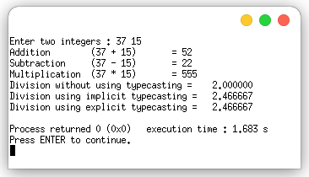

**Program 04 :** Write a C program to calculate simple interest and print on the screen.

**Theory :**

Simple interest is the interest amount for a particular principal amount of money at some rate of interest calculated by multiplying the annual interest rate by the principal, by the time period in years. Hence, we only need the basic operators of multiplication and division to be used to write a program to calculate SI.

**Algorithm :**

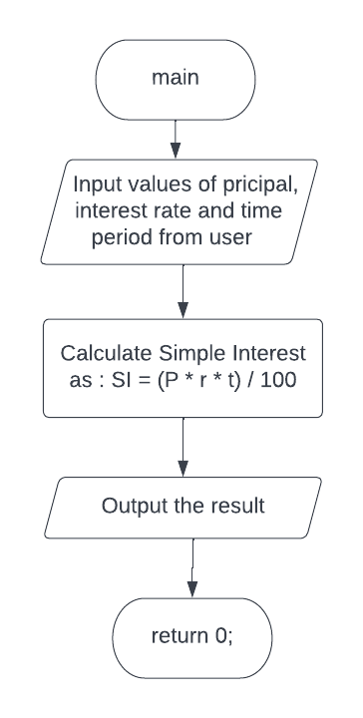

**Code :**

*/* This program is written by Vishal Das*

*(2K21/A8/24) on May 05, 2022 02:55 PM*

*for Lab File of course CO102*

*\*/*

#include <stdio.h>

int **main**(void){

float principal, rate, time_period, simple_interest;

**printf**("Enter the principal amount: ");

**scanf**("%f", &principal);

**printf**("Enter the rate of interest: ");

**scanf**("%f", &rate);

**printf**("Enter the time period: ");

**scanf**("%f", &time_period);

simple_interest = (principal * rate * time_period) / 100;

**printf**("\nThe simple interest is %f", simple_interest);

return 0;

}

**Output :**

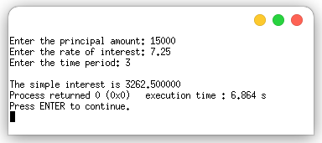

**Program 05 :** Write a C program to perform Logical AND and OR operations on two and three variables.

**Theory :**

The logical operators ***&&*** and ***||*** are used when evaluating two expressions to obtain a single relational result. The operator *&&* corresponds to the Boolean logical operation AND, which yields true if both its operands are true, and false otherwise. The operator *||* corresponds to the Boolean logical operation OR, which yields true if either of its operands is true, thus being false only when both operands are false.

**Algorithm :**

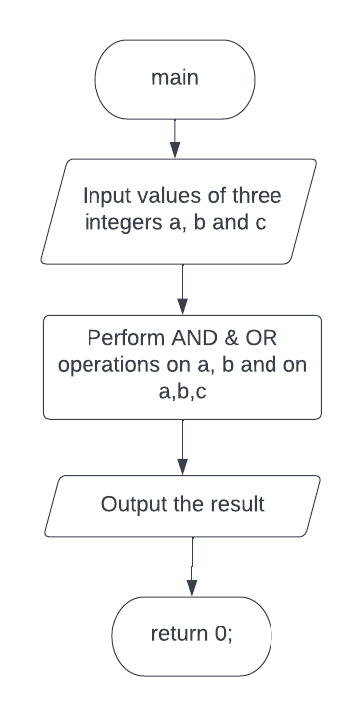

**Code :**

*/* This program is written by Vishal Das*

*(2K21/A8/24) on May 12, 2022 02:10 PM*

*for Lab File of course CO102*

*\*/*

#include <stdio.h>

int **main**(void){

int a = 1, b = 0, c = 0;

**printf**("Input the values for a, b and c (0 or 1) : ");

**scanf**("%d %d %d", &a, &b, &c);

**printf**("a && b = %d\n", a && b);

**printf**("a || b = %d\n", a || b);

**printf**("a && b && c = %d\n", a && b && c);

**printf**("a || b || c = %d\n", a || b || c);

return 0;

}

**Output :**

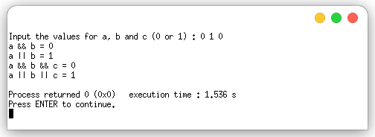

**Program 06 :** Write a C program to perform Bitwise AND and OR operations on two variables.

**Theory :**

Bitwise operators modify variables considering the bit patterns that represent the values they store. Bitwise AND is performed using operator “**&**”while Bitwise OR is performed using operator “**|**”.

**Algorithm :**

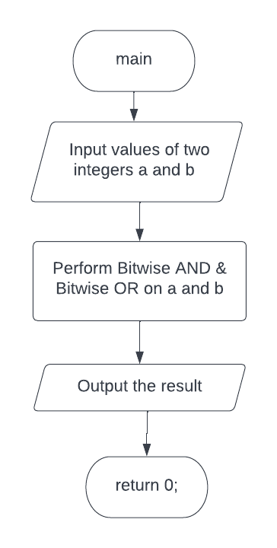

**Code :**

*/* This program is written by Vishal Das*

*(2K21/A8/24) on May 12, 2022 02:45 PM*

*for Lab File of course CO102*

*\*/*

#include <stdio.h>

int **main**(void)

{

int a, b;

**printf**("Input the values for a and b : ");

**scanf**("%d %d", &a, &b);

**printf**("a & b = %d\t(Bitwise AND)\n", a & b);

**printf**("a | b = %d\t(Bitwise OR)\n", a | b);

return 0;

}

**Output :**

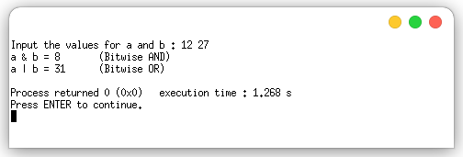

**Program 07 :** Write a C program to perform relational operations on two variables.

**Theory :**

Two expressions can be compared using relational and equality operators. The result of such an operation is either true or false (Boolean value). The relational operators available are == (equal to), != (not equal to), > (greater than), < (smaller than), >= (greater than or equal to) and <= (smaller than or equal to)

**Algorithm :**

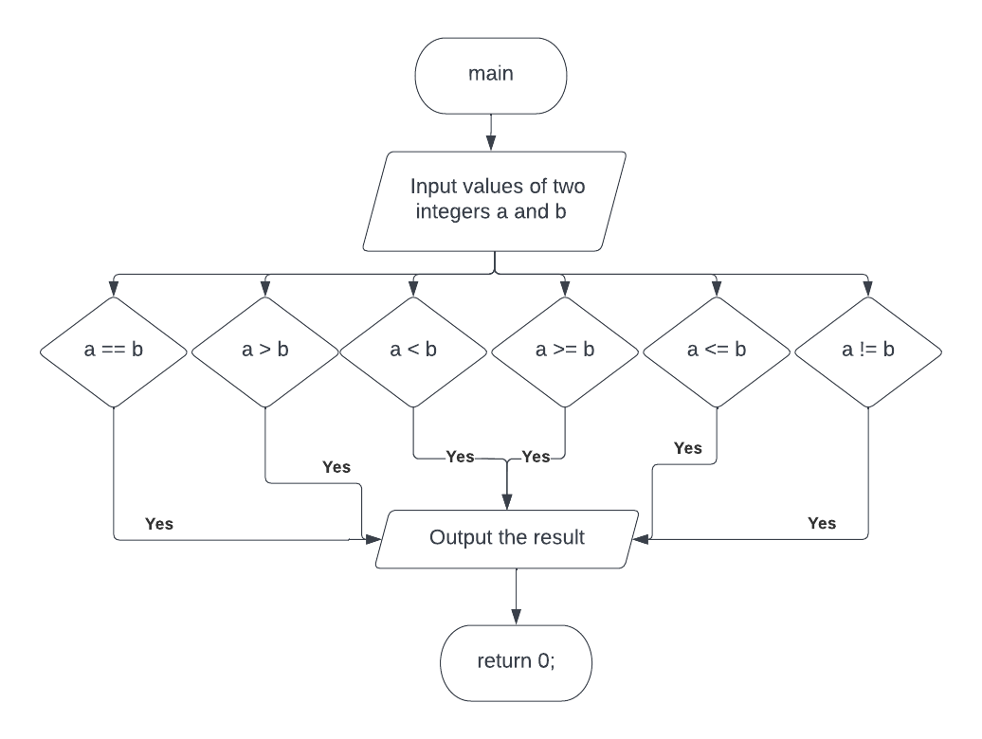

**Code :**

*/* This program is written by Vishal Das*

*(2K21/A8/24) on May 12, 2022 03:15 PM*

*for Lab File of course CO102*

*\*/*

#include <stdio.h>

int **main**(void){

int a=5, b=6;

**printf**("Input values of a and b to compare : ");

**scanf**("%d %d", &a, &b);

if(a==b)

**printf**("a is equal to b\n");

if(a>b)

**printf**("a is greater than b\n");

if(a<b)

**printf**("a is smaller than b\n");

if(a<=b)

**printf**("a is either smaller or equal to b\n");

if(a>=b)

**printf**("a is either greater or equal to b\n");

if(a!=b)

**printf**("a is not equal to b\n");

return 0;

}

**Output :**

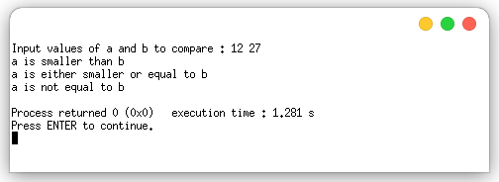

**Program 08 :** Write a C program to compute factorial of a number.

**Theory :**

Factorial is the product of all positive integers less than or equal to a given positive integer and denoted by that integer and an exclamation point.

**Algorithm :**

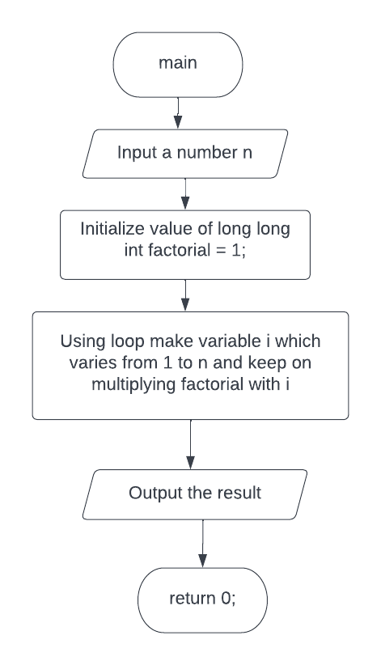

**Code :**

*/* This program is written by Vishal Das*

*(2K21/A8/24) on May 19, 2022 02:10 PM*

*for Lab File of course CO102*

*\*/*

#include <stdio.h>

int **main**(void){

long long int factorial=1;

int n;

**printf**("Input an integer : ");

**scanf**("%d", &n);

for(int i=1;i<=n;i++)

factorial *= i;

**printf**("\nThe factorial of %d is %d", n, factorial);

return 0;

}

**Output :**

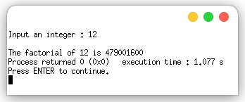

**Program 09 :** Write a C program to compute sum of digits of a 5-digit number.

**Theory :**

Sum of digits of a number can be calculated by calculating the sum of rightmost digit of number each time shifting it one place to the right till the number exhausts or becomes zero.

**Algorithm :**

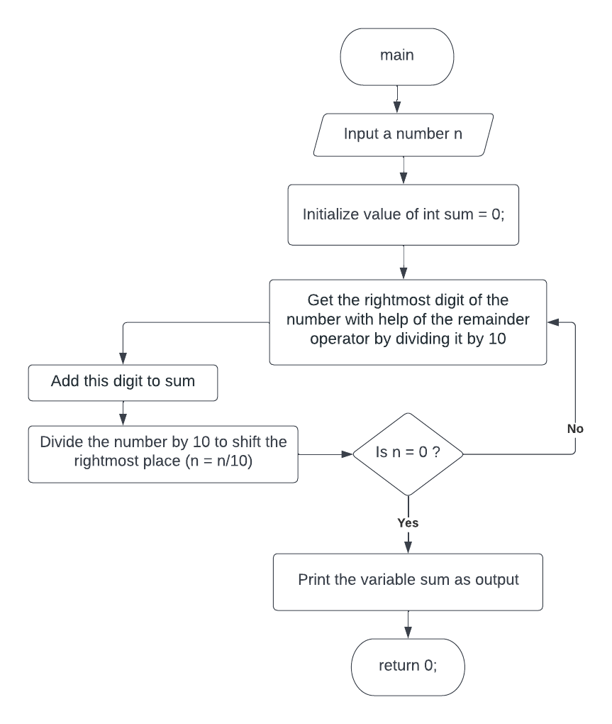

**Code :**

*/* This program is written by Vishal Das*

*(2K21/A8/24) on May 19, 2022 02:40 PM*

*for Lab File of course CO102*

*\*/*

#include <stdio.h>

int **main**(void){

int n;

int sum = 0;

**printf**("Input an 5-digit integer : ");

**scanf**("%d", &n);

while (n)

{

sum += n % 10;

n = n / 10;

}

**printf**("\nThe sum of digits is %d\n", sum);

return 0;

}

**Output :**

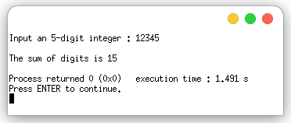

**Program 10 :** Write a C program to reverse a 5-digit number.

**Theory :**

To reverse a number we can add rightmost digit of the original number each time shifting reversed number one place to left and original number one place to the right till the number exhausts or becomes zero.

**Algorithm :**

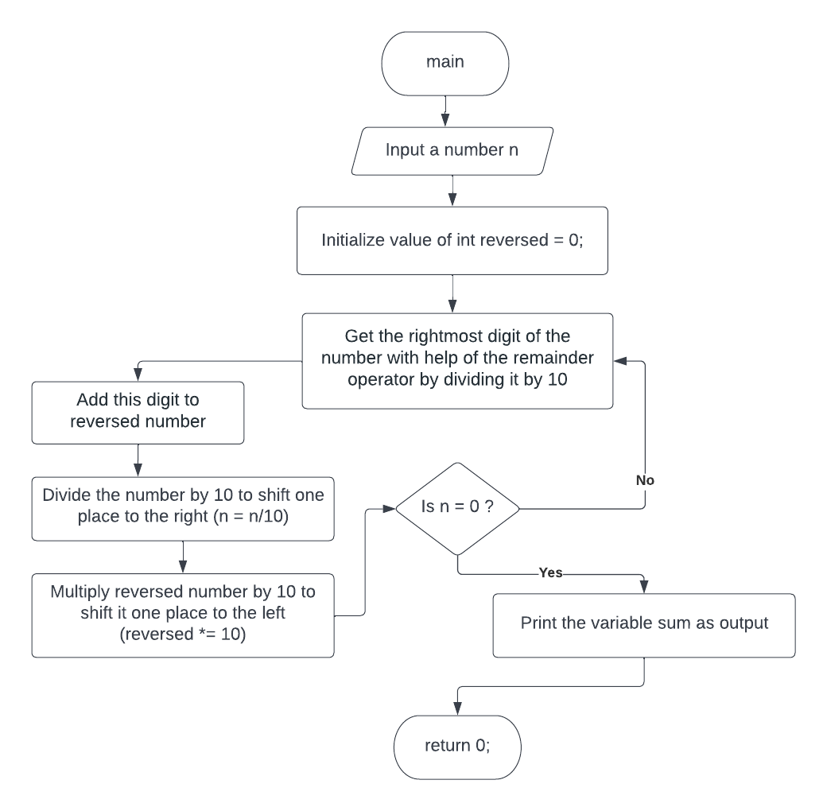

**Code:**

*/* This program is written by Vishal Das*

*(2K21/A8/24) on May 19, 2022 03:10 PM*

*for Lab File of course CO102*

*\*/*

#include <stdio.h>

int **main**(void){

int n;

int reversed = 0;

**printf**("Input an 5-digit integer : ");

**scanf**("%d", &n);

while (n)

{

reversed *= 10;

reversed += n % 10;

n = n / 10;

}

**printf**("\nThe reversed number is %d\n", reversed);

return 0;

}

**Output :**

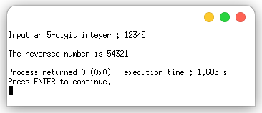

**Program 11 :** Write a C program to find whether the input number is prime or not.

**Theory :**

A number is said to be prime if it only have exactly two factors i.e., 1 and the number itself. 1 is not prime because it have only one factor. Other numbers can be checked if prime or not by dividing them with numbers in between 2 and the half of the number because factors repeat after the middle point.

**Algorithm :**

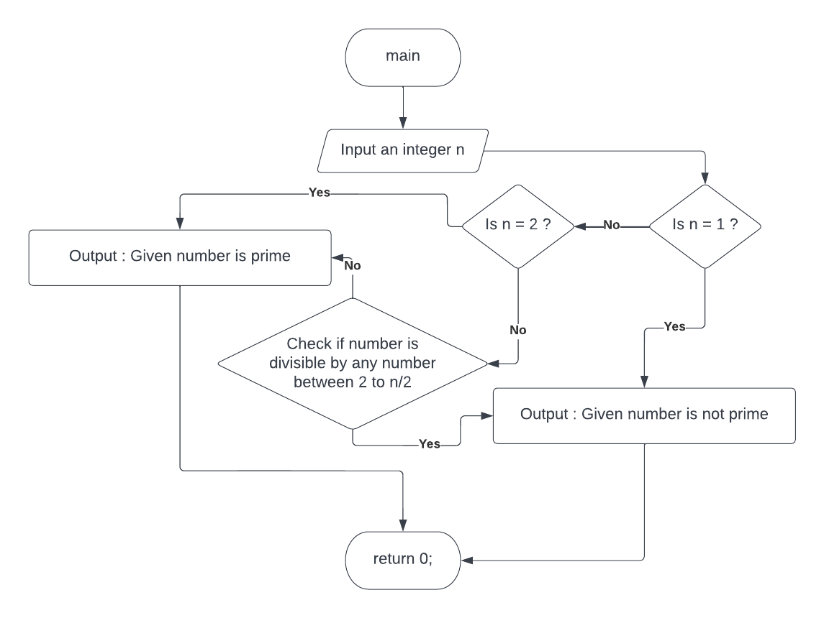

**Code :**

*/* This program is written by Vishal Das*

*(2K21/A8/24) on May 19, 2022 03:30 PM*

*for Lab File of course CO102*

*\*/*

#include <stdio.h>

int **main**(void)

{

int n;

**printf**("Input an integer : ");

**scanf**("%d", &n);

if (n == 1){

**printf**("1 is not a prime number\n", n);

return 0;

}else if (n == 2){

**printf**("2 is a prime number\n", n);

return 0;

}

for (int factor = 2; factor <= n / 2; factor++)

if (n % factor == 0){

**printf**("%d is not a prime number\n", n);

return 0;

}

**printf**("%d is a prime number\n", n);

return 0;

}

**Output :**

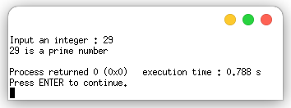

**Program 12 :** Write a program to find area of different shapes using switch case.

**Theory :** Switch-Case purpose is to check for a value among a number of possible constant expressions. It is something similar to concatenating if-else statements, but limited to constant expressions. If the value of expression did not match any of the previously specified constants (there may be any number of these), the program executes the statements included after the default: label, if it exists.

**Algorithm :**

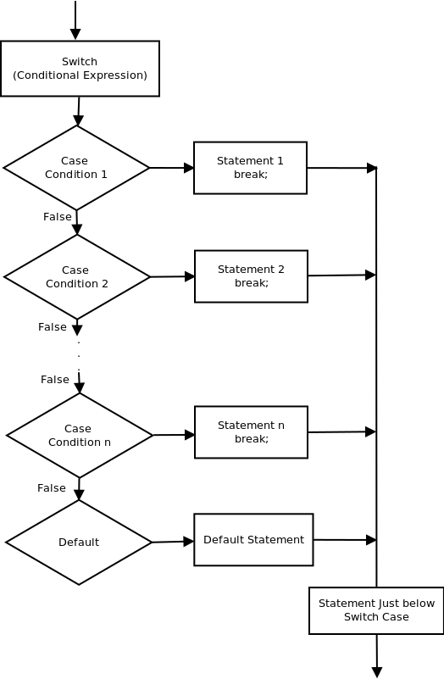

**Code :**

*/* This program is written by Vishal Das*

*(2K21/A8/24) on June 02, 2022 02:00 PM*

*for Lab File of course CO102*

*\*/*

#include <stdio.h>

int **main**(void){

char shape;

float area;

**printf**("Please input the shape of figure :\n\tT - Triangle\n\tS - Square\n\tR - Rectangle\n\tC - Circle\n");

**scanf**("%c", &shape);

**printf**("\n");

switch(shape){

case 'T':

float b, h;

**printf**("Base Length and Height of Triangle : ");

**scanf**("%f %f", &b, &h);

area = 0.5 * b * h;

break;

case 'S':

float side;

**printf**("Side length of Square : ");

**scanf**("%f", &side);

area = side * side;

break;

case 'R':

float l, w;

**printf**("Base Length and Width of Rectangle : ");

**scanf**("%f %f", &l, &w);

area = l * w;

break;

case 'C':

float r;

**printf**("Radius of Circle : ");

**scanf**("%f", &r);

area = 3.1415 * r * r;

break;

default:

**printf**("Invalid shape"); return 0;

}

**printf**("\nArea of given figure is %f\n", area);

return 0;

}

**Output :**

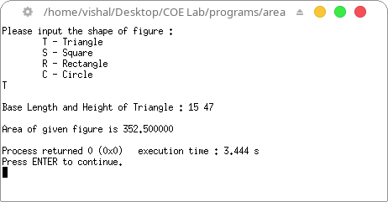

**Program 13 :** Write a program to implement following pattern

1. Half Pyramid of *
2. Half Pyramid of Numbers
3. Inverted Half Pyramid of *
4. Inverted Half Pyramid of Numbers
5. Full Pyramid of *

**Theory :** Nesting of loops is the feature in C that allows the looping of statements inside another loop. If a loop exists inside the body of another loop, it's called a nested loop. We can use the nested loop to create patterns like full pyramid, half pyramid, inverted pyramid, and so on.

**Algorithm :**

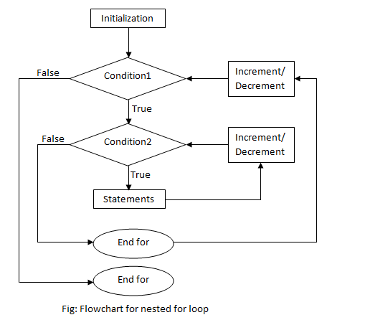

**Code and Output :**

1. Half pyramid of *

#include <stdio.h>

int **main**(void){

int n = 5;

for(int i=0;i<=n;i++){

for(int j=1;j<=i;j++){

**printf**("* ");

}

**printf**("\n");

}

return 0;

}

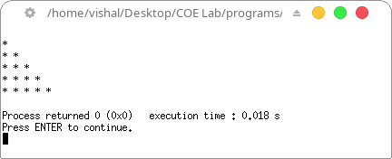

2. Half Pyramid of Numbers

#include <stdio.h>

int **main**(void){

int n = 5;

for(int i=0;i<=n;i++){

for(int j=1;j<=i;j++){

**printf**("%d ", j);

}

**printf**("\n");

}

return 0;

}

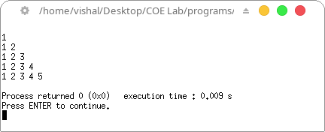

3. Inverted Half Pyramid of *

#include <stdio.h>

int **main**(void){

int n = 5;

for(int i=0;i<=n;i++){

int k = n-i;

for(int j=1;j<=k;j++){

**printf**("* ");

}

**printf**("\n");

}

return 0;

}

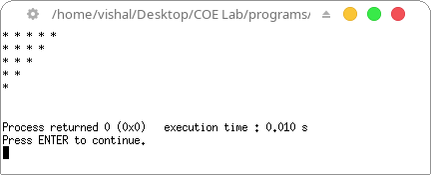

4. Inverted Half Pyramid of Numbers

#include <stdio.h>

int **main**(void){

int n = 5;

for(int i=0;i<=n;i++){

int k = n-i;

for(int j=1;j<=k;j++){

**printf**("%d ", j);

}

**printf**("\n");

}

return 0;

}

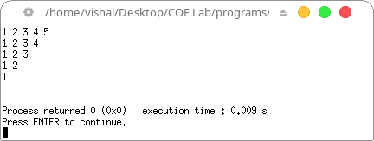

5. Full Pyramid of *

#include <stdio.h>

int **main**(void){

int n = 5;

int k;

for(int i=0;i<=n;i++){

k = n-i;

for(int j=1;j<=k;j++){

**printf**(" ");

}

k = 2*i-1;

for(int j=1;j<=k;j++){

**printf**("* ");

}

**printf**("\n");

}

return 0;

}

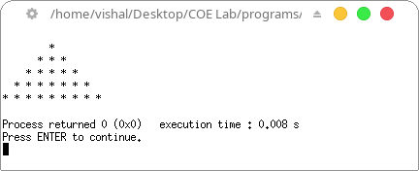

**Program 14 :** Write a program to convert

1. Decimal to Binary Number
2. Binary to Decimal Number

**Theory :** Binary numbers are composed of only 0 and 1, whereas, decimal numbers are composed of digits from 0 to 9. The binary number system is also called the base-2 number system and the decimal number system is known as the base-10 number system. A number given in the binary number system can be converted to its equivalent in the decimal number system and vice versa by appropriate algorithm as discussed.

1. **Decimal to Binary Number**

**Algorithm :**

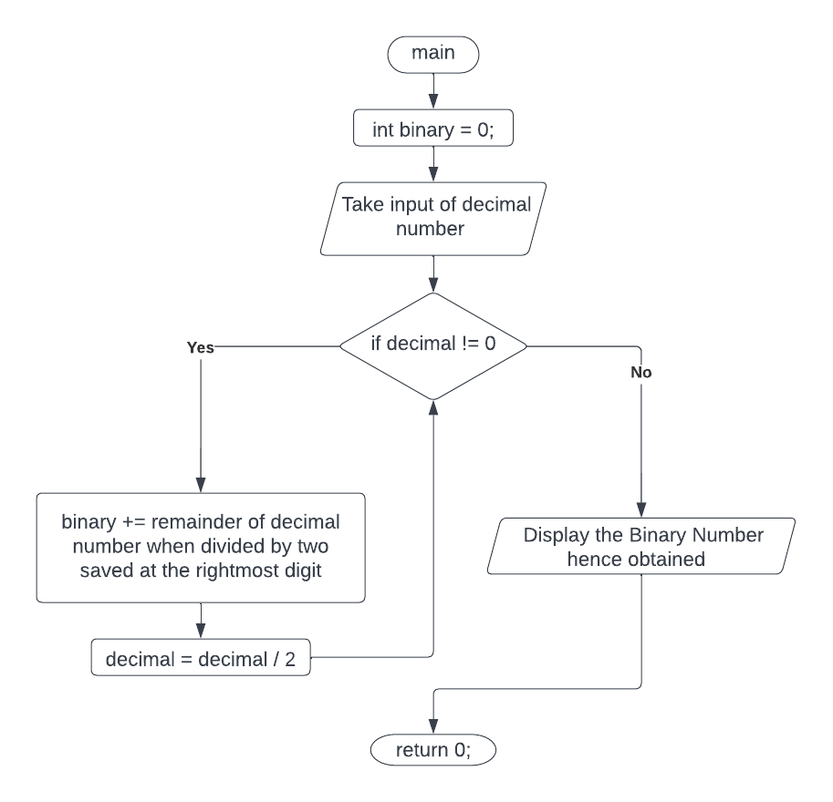

**Code :**

*/* This program is written by Vishal Das*

*(2K21/A8/24) on June 02, 2022 03:00 PM*

*for Lab File of course CO102*

*\*/*

#include <math.h>

#include <stdio.h>

int **main**(void)

{

int decimal, binary = 0, i = 0;

**printf**("Enter a decimal number : ");

**scanf**("%d", &decimal);

while (decimal != 0)

{

binary += decimal % 2 * **pow**(10, i++);

decimal /= 2;

}

**printf**("Binary number : %d\n", binary);

return 0;

}

**Output :**

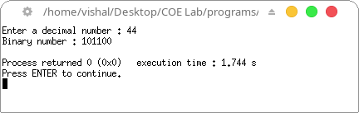

1. **Binary to Decimal Number**

**Algorithm :**

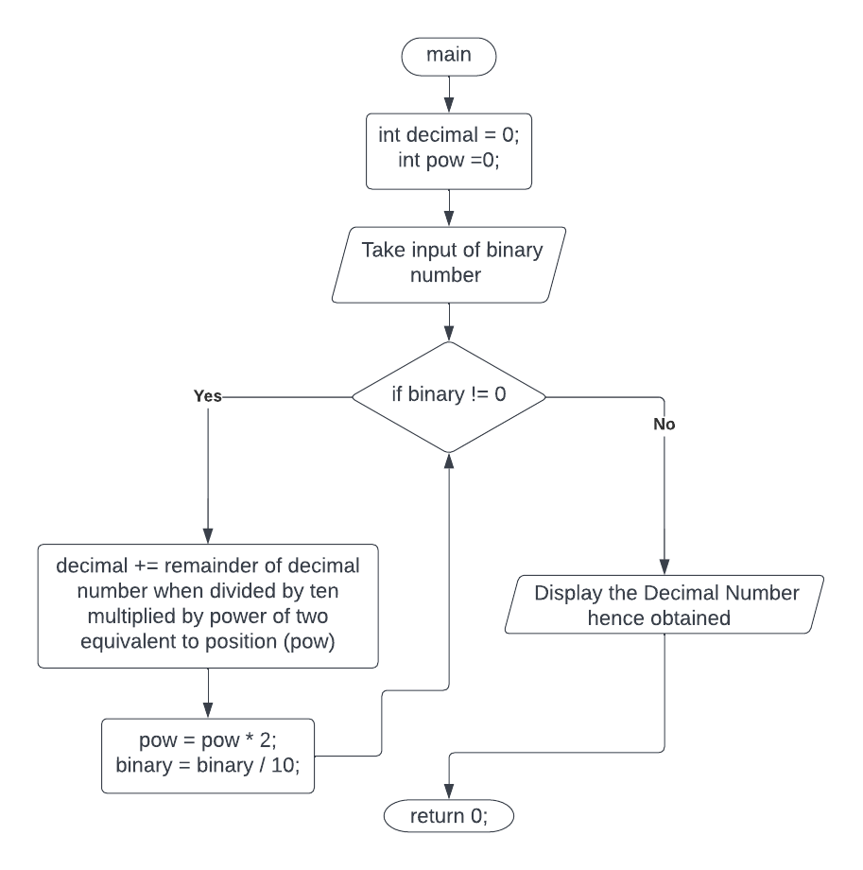

**Code :**

*/* This program is written by Vishal Das*

*(2K21/A8/24) on June 02, 2022 03:20 PM*

*for Lab File of course CO102*

*\*/*

#include <stdio.h>

int **main**(void){

int binary, pow = 1, decimal = 0;

**printf**("Enter a binary number : ");

**scanf**("%d", &binary);

while (binary != 0){

decimal += (binary % 10) * pow;

pow *= 2;

binary /= 10;

}

**printf**("Decimal number : %d\n", decimal);

return 0;

}

**Output :**

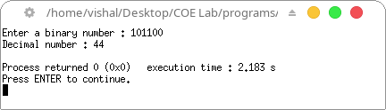

**Program 15 :** Program to generate the Fibonacci sequence

**Theory :**

Fibonacci sequence, in which each number is the sum of the two preceding ones. The sequence commonly starts from 0 and 1.

**Fn = Fn-1 + Fn-2**

**Algorithm :**

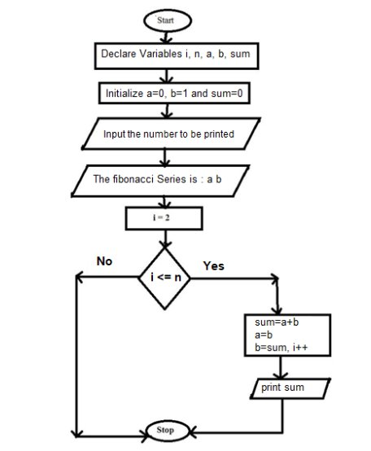

**Code :**

*/* This program is written by Vishal Das*

*(2K21/A8/24) on July 07, 2022 03:00 PM*

*for Lab File of course CO102*

*\*/*

#include <stdio.h>

int **main**() {

int i, n;

int t1 = 0, t2 = 1;

int nextTerm = t1 + t2;

**printf**("Enter the number of terms : ");

**scanf**("%d", &n);

**printf**("Fibonacci Series : %d, %d, ", t1, t2);

for (i = 3; i <= n; ++i) {

**printf**("%d, ", nextTerm);

t1 = t2;

t2 = nextTerm;

nextTerm = t1 + t2;

}

return 0;

}

**Output :**

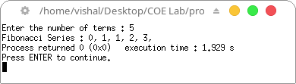

**Program 16 :** Program to search a number from an array using linear search

**Theory :**

In a linear search, we start searching an element from the left most element of the array and one by one compare the required element with each element of array

**Algorithm :**

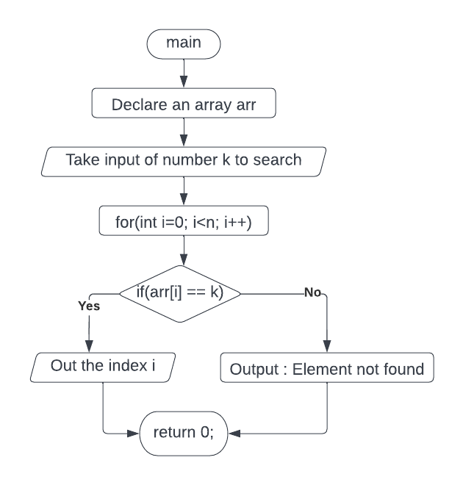

**Code :**

*/* This program is written by Vishal Das*

*(2K21/A8/24) on July 07, 2022 03:10 PM*

*for Lab File of course CO102*

*\*/*

#include <stdio.h>

int **main**(void){

int n;

int arr[] = {10,6,5,8,9,75,26,64}; *// array size = 8*

**printf**("Input the number which you want to search : ");

**scanf**("%d", &n);

for(int i=0; i<8; i++)

{

if(arr[i]==n){

**printf**("\nFound %d at index %d\n", arr[i], i);

return 0;

}

}

**printf**("\nThe number does not exists in the array\n");

return 0;

}

**Output :**

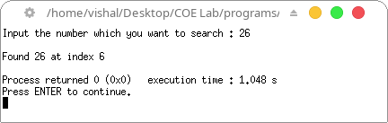

**Program 17 :** Program to search a number from an array using binary search

**Theory :**

Binary Search is a searching algorithm used in a sorted array by repeatedly dividing the search interval in half. The idea of binary search is to use the information that the array is sorted and reduce the time complexity to O(Log n).

**Algorithm :**

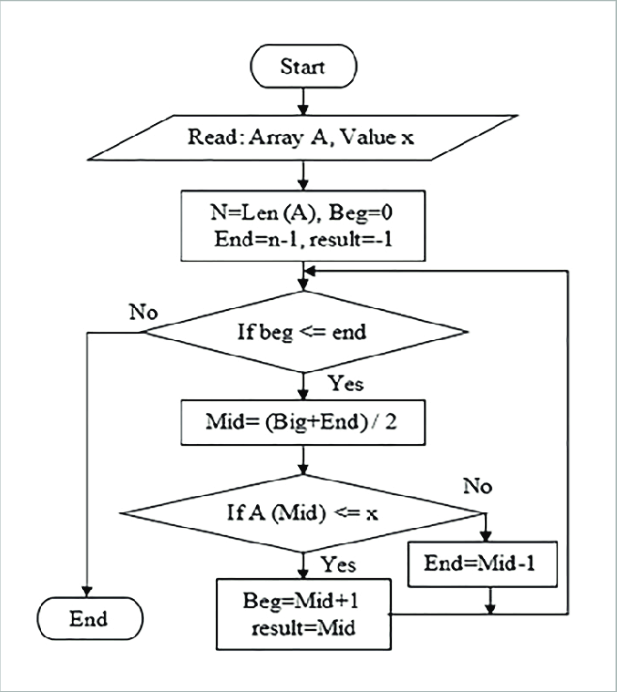

**Code :**

*/* This program is written by Vishal Das*

*(2K21/A8/24) on July 07, 2022 03:00 PM*

*for Lab File of course CO102*

*\*/*

#include <stdio.h>

int **binarySearch**(int arr[], int l, int r, int x){

if (r >= l){

int mid = l + (r - l) / 2;

if (arr[mid] == x)

return mid;

if (arr[mid] > x)

return **binarySearch**(arr, l, mid - 1, x);

return **binarySearch**(arr, mid + 1, r, x);

}

return -1;

}

int **main**(void){

int arr[] = {5,6,8,9,10,26,64,75};

int n = sizeof(arr) / sizeof(arr[0]);

int x;

**printf**("Input the number which you want to search : ");

**scanf**("%d", &x);

int result = **binarySearch**(arr, 0, n - 1, x);

if(result == -1){ **printf**("\nElement is not present in array\n"); }

else{ **printf**("\nElement is present at index %d\n", result); }

return 0;

}

**Output :**

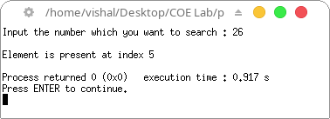

**Program 18 :** Program to sort an array using Bubble sort

**Theory :**

In this sorting algorithm is comparison-based algorithm in which each pair of adjacent elements is compared and the elements are swapped if they are not in order.

**Algorithm :**

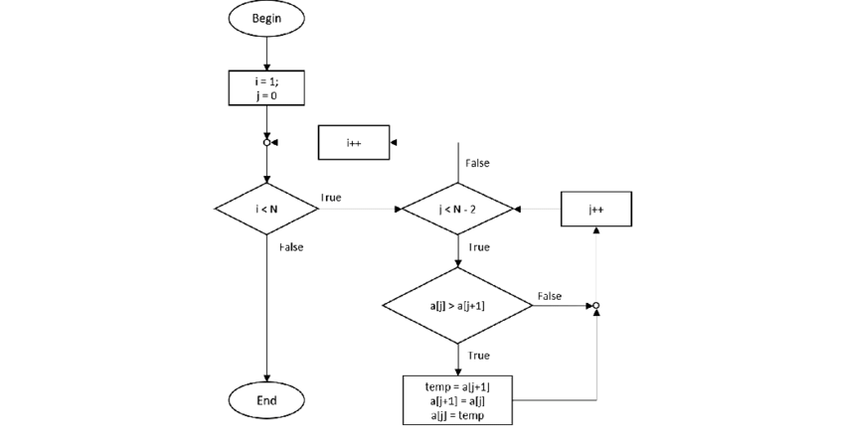

**Code :**

*/* This program is written by Vishal Das*

*(2K21/A8/24) on July 07, 2022 03:30 PM*

*for Lab File of course CO102*

*\*/*

#include <stdio.h>

int **main**(void){

int arr[20], num, x, y, temp;

**printf**("Please Enter the Number of Elements in the array : ");

**scanf**("%d", &num);

**printf**("Please Enter the Value of Elements : ");

for(x = 0; x < num; x++)

**scanf**("%d", &arr[x]);

for(x = 0; x < num - 1; x++){

for(y = 0; y < num - x - 1; y++){

if(arr[y] > arr[y + 1]){

temp = arr[y];

arr[y] = arr[y + 1];

arr[y + 1] = temp;

}

}

}

**printf**("\nArray after implementing bubble sort: ");

for(x = 0; x < num; x++){

**printf**("%d ", arr[x]);

}

**printf**("\n");

return 0;

}

**Output :**

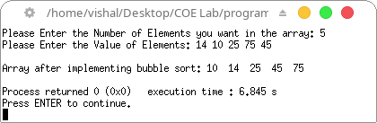

**Program 19 :** Program to sort an array using Insertion sort

**Theory :**

Insertion sort is a simple sorting algorithm that works similar to the way you sort playing cards in your hands. The array is virtually split into a sorted and an unsorted part. Values from the unsorted part are picked and placed at the correct position in the sorted part.

**Algorithm :**

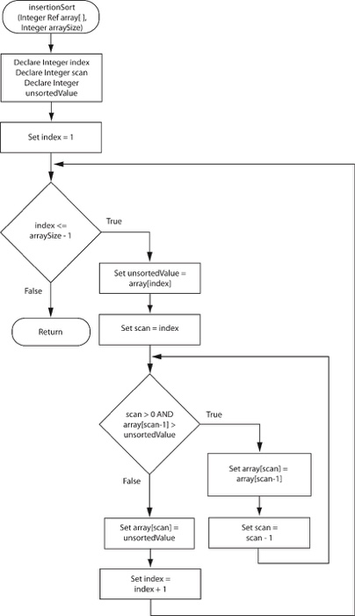

**Code :**

*/* This program is written by Vishal Das*

*(2K21/A8/24) on July 07, 2022 03:10 PM*

*for Lab File of course CO102*

*\*/*

#include <math.h>

#include <stdio.h>

void **insertionSort**(int arr[], int n){

int i, key, j;

for (i = 1; i < n; i++) {

key = arr[i];

j = i - 1;

while (j >= 0 && arr[j] > key) {

arr[j + 1] = arr[j];

j = j - 1;

}

arr[j + 1] = key;

}

}

void **printArray**(int arr[], int n){

int i;

for (i = 0; i < n; i++)

**printf**("%d ", arr[i]);

**printf**("\n");

}

int **main**(){

int arr[] = { 12, 11, 13, 5, 6 };

int n = sizeof(arr) / sizeof(arr[0]);

**printf**("Array before insertion sort : ");

**printArray**(arr, n);

**insertionSort**(arr, n);

**printf**("\nArray after insertion sort : ");

**printArray**(arr, n);

return 0;

}

**Output :**

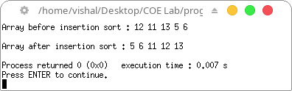

**Program 20 :** Program to sort an array using Selection sort

**Theory :**

In this sorting algorithm is an in-place comparison-based algorithm in which the list is divided into two parts, the sorted part at the left end and the unsorted part at the right end. Initially, the sorted part is empty and the unsorted part is the entire list.

**Algorithm :**

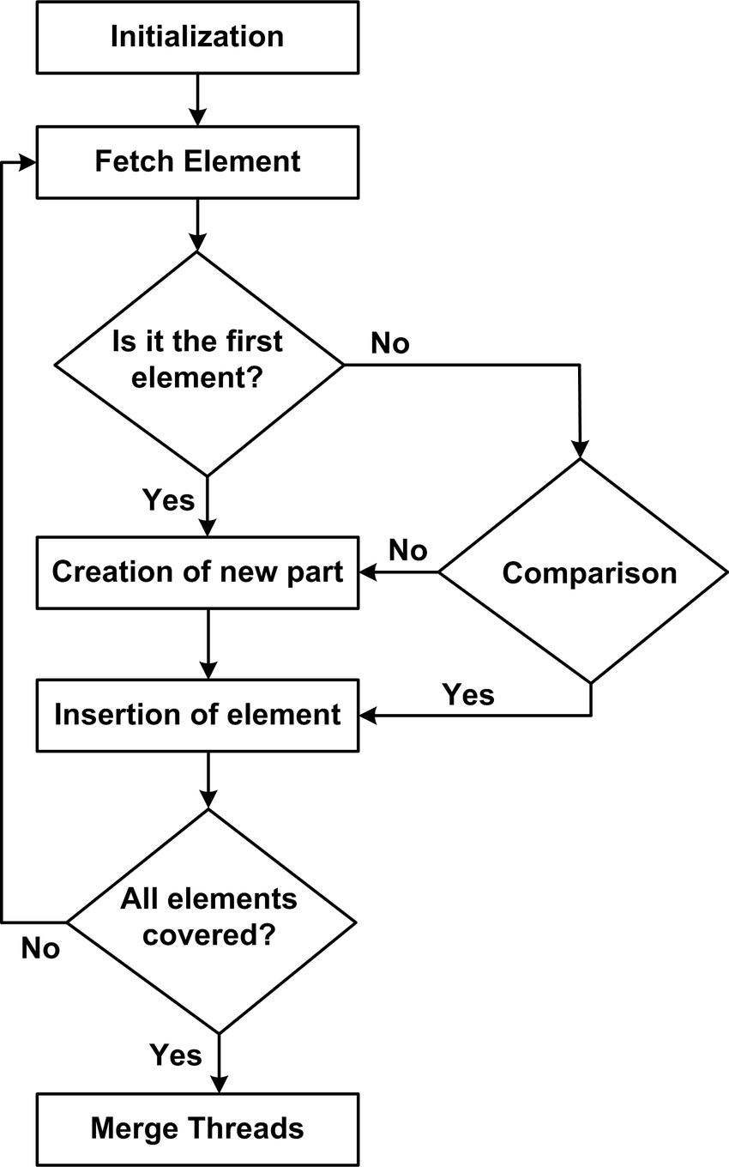

**Code :**

*/* This program is written by Vishal Das*

*(2K21/A8/24) on July 07, 2022 03:10 PM*

*for Lab File of course CO102*

*\*/*

void **swap**(int *xp, int *yp){

int temp = *xp;

*xp = *yp;

*yp = temp;

}

void **selectionSort**(int arr[], int n){

int i, j, min_idx;

for (i = 0; i < n-1; i++)

{

min_idx = i;

for (j = i+1; j < n; j++)

if (arr[j] < arr[min_idx])

min_idx = j;

**swap**(&arr[min_idx], &arr[i]);

}

}

void **printArray**(int arr[], int size){

int i;

for (i=0; i < size; i++)

**printf**("%d ", arr[i]);

**printf**("\n");

}

int **main**(){

int arr[] = {64, 25, 12, 22, 11};

int n = sizeof(arr)/sizeof(arr[0]);

**printf**("Array before insertion sort : ");

**printArray**(arr, n);

**selectionSort**(arr, n);

**printf**("\nSorted array : ");

**printArray**(arr, n);

return 0;

}

**Output :**

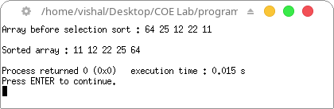

**Program 21 :** Program to check if a given string is a palindrome or not

**Theory :** A string is said to be palindrome if it is written the same as original string on reversal.

**Algorithm :**

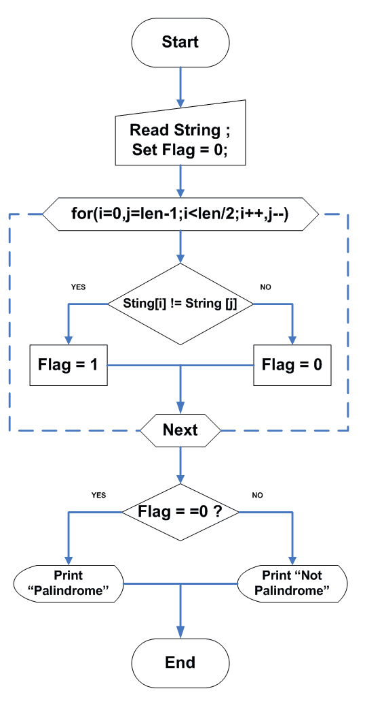

**Code :**

*/* This program is written by Vishal Das*

*(2K21/A8/24) on July 07, 2022 03:15 PM*

*for Lab File of course CO102*

*\*/*

#include <stdio.h>

#include <string.h>

int **main**(){

char str[20];

int len, temp=0;

**printf**("Input a string : ");

**scanf**("%s", str);

len = **strlen**(str);

for(int i=0; i < len ; i++){

if(str[i] != str[len-i-1]){

temp = 1;

break;

}

}

if (temp==0){ **printf**("\nString is a palindrome\n"); }

else{ **printf**("\nString is not a palindrome\n"); }

return 0;

}

**Output :**

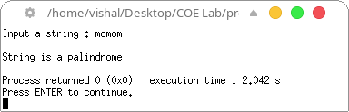

**Program 22 :** Program to string concatenation

**Theory :**

In C, string concatenation is the operation of joining character strings end-to- end. It’s very easy to use + operator for string concatenation. Strings are immutable, therefore, whenever it is concatenated, it is assigned to a new variable. We can also use % operator for string concatenation. It’s useful when we want to concatenate strings and perform simple formatting. Here, the % Operator combine the string that is stored in the string variable. The %s denotes string data type.

**Algorithm :**

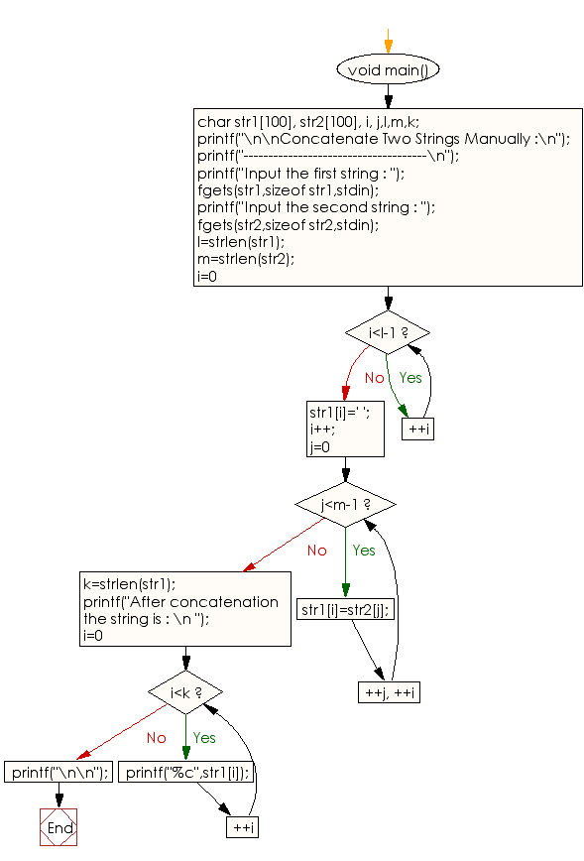

**Code :**

*/* This program is written by Vishal Das*

*(2K21/A8/24) on July 07, 2022 03:40 PM*

*for Lab File of course CO102*

*\*/*

*/* This program is written by Vishal Das*

*(2K21/A8/24) on July 07, 2022 03:40 PM*

*for Lab File of course CO102*

*\*/*

#include <stdio.h>

int **main**(){

char first_string[20];

char second_string[20];

**printf**("Input the first string : ");

**scanf**("%s",first_string);

**printf**("\nInput the second string : ");

**scanf**("%s",second_string);

int i;

for(i=0; first_string[i]!='\0'; i++);

for(int j=0; second_string[j]!='\0'; j++){

first_string[i]=second_string[j];

i++;

}

first_string[i]='\0';

**printf**("\nAfter concatenation, the string would look like: %s\n", first_string);

return 0;

}

**Output :**

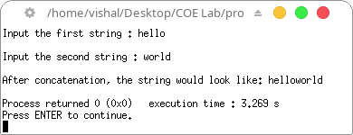

**Program 23 :** Program to string comparison

**Theory :**

Two strings are said to be equal if their string length are equal and ASCII value of each character in both string are equal respectively.

**Algorithm :**

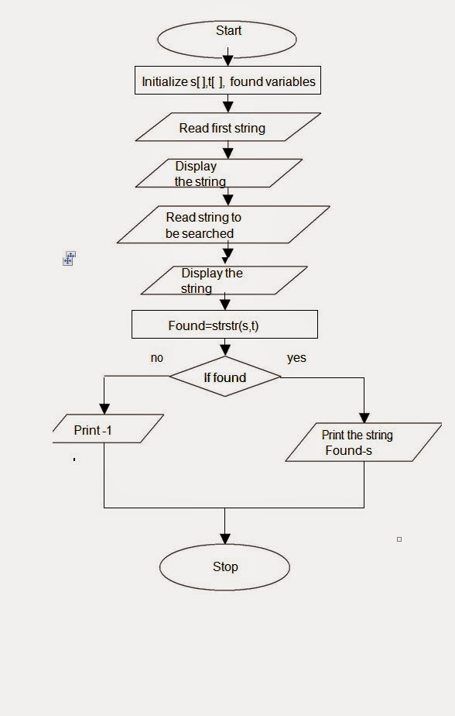

**Code :**

*/* This program is written by Vishal Das*

*(2K21/A8/24) on July 07, 2022 03:50 PM*

*for Lab File of course CO102*

*\*/*

#include <stdio.h>

#include <string.h>

int **str_compare**(char* str1, char* str2) {

int str1_len = **strlen**(str1);

int str2_len = **strlen**(str2);

if (str1_len != str2_len)

return -1;

for (int i = 0; i < str1_len; i++) {

if (str1[i] != str2[i])

return -1;

}

return 1;

}

int **main**() {

char s1[] = "hello world";

char s2[] = "hello world";

char s3[] = "hEllo World";

**printf**("s1 : %s\ns2 : %s\ns3 : %s", s1, s2, s3);

**printf**("\n\ns1 and s2 are ");

**printf**((**str_compare**(s1,s2)==1) ? "equal strings" : "unequal strings");

**printf**("\ns1 and s3 are ");

**printf**((**str_compare**(s2,s3)==1) ? "equal strings" : "unequal strings");

**printf**("\n");

return 0;

}

**Output :**

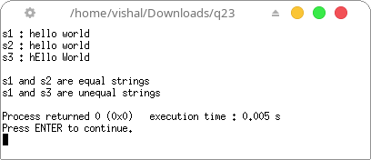

**Program 24 :** Program to reverse string

**Theory :**

Reversing a string is the technique that reverses or changes the order of a given string so that the last character of the string becomes the first character of the string and so on

**Algorithm :**

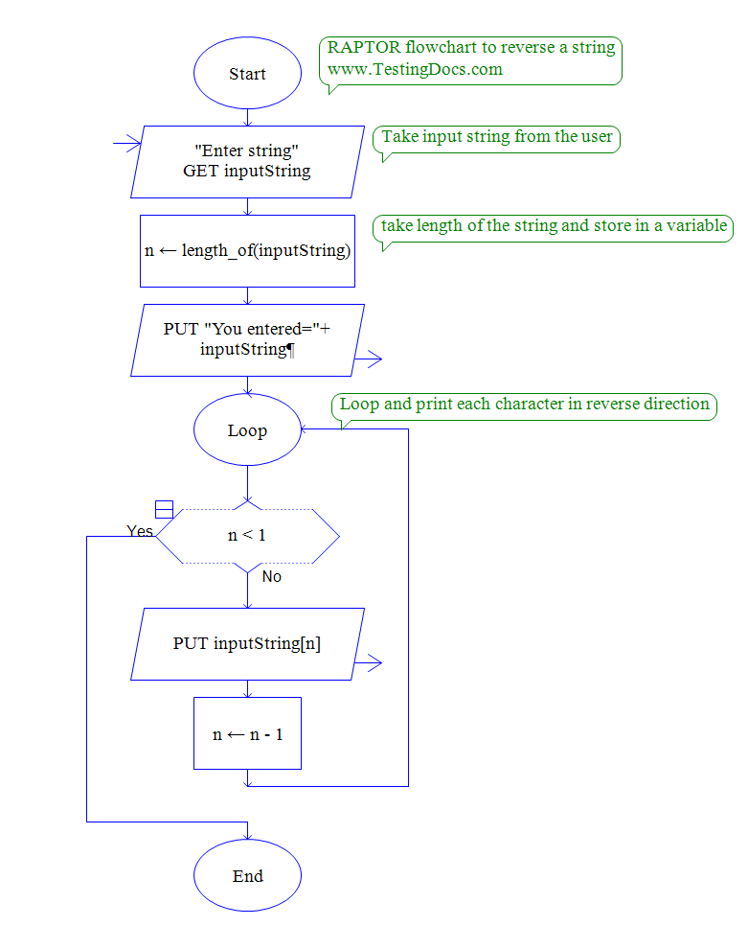

**Code :**

*/* This program is written by Vishal Das*

*(2K21/A8/24) on July 07, 2022 04:10 PM*

*for Lab File of course CO102*

*\*/*

#include <stdio.h>

#include <string.h>

void **revstr**(char *str1){

int i, len, temp;

len = **strlen**(str1);

for (i = 0; i < len/2; i++){

temp = str1[i];

str1[i] = str1[len - i - 1];

str1[len - i - 1] = temp;

}

}

int **main**(){

char str[50];

**printf** ("Enter the string: ");

**gets**(str);

**printf** ("\nBefore reversing the string: %s \n", str);

**revstr**(str);

**printf** ("After reversing the string: %s\n", str);

return 0;

}

**Output :**

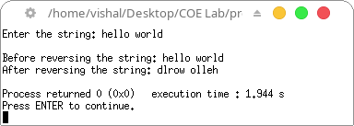

**Program 25 :** Program to convert a string from lower case to upper case and vice versa

**Theory :**

The ASCII values of lowercase alphabets range from a=97 to z=122 and ASCII values of uppercase alphabets ranges from A=65 to Z=90. This means that the difference between any particular alphabet it its uppercase and lowercase format is 32. So, to convert uppercase to lowercase or vice versa, this difference of 32 is crucial.

**Algorithm :**

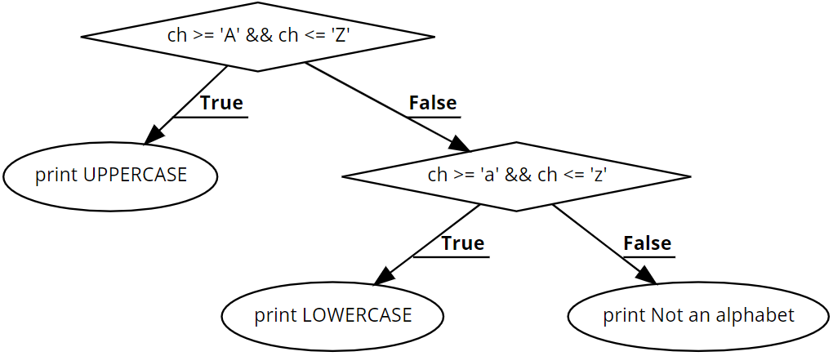

**Code :**

*/* This program is written by Vishal Das*

*(2K21/A8/24) on July 07, 2022 04:20 PM*

*for Lab File of course CO102*

*\*/*

#include <stdio.h>

#include <string.h>

int **main**(void){

char string[100];

int difference = 'A'-'a';

**printf**("Input your string : ");

**fgets**(string, sizeof(string),**stdin**);

for(int i = 0 ; i < **strlen**(string); i++){

if(string[i]>='A'&&string[i]<='Z')

{ string[i] -= difference; }

else if(string[i]>='a'&&string[i]<='z')

{ string[i] += difference; }

}

**printf**("Case Changed : %s", string);

return 0;

}

**Output :**

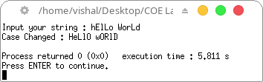

**Program 26 :** Program to find factorial of a number using recursion

**Theory :**

A recursive function is a function that calls itself. The factorial function can be written as a recursive function call. Recall that factorial(n) = n × (n – 1) × (n – 2) × … × 2 × 1. The factorial function can be rewritten recursively as factorial(n) = n × factorial(n – 1).

**Algorithm :**

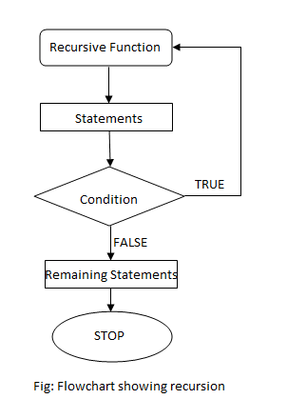

**Code :**

*/* This program is written by Vishal Das*

*(2K21/A8/24) on July 14, 2022 03:40 PM*

*for Lab File of course CO102*

*\*/*

#include<stdio.h>

long int **multiplyNumbers**(int n) {

if (n>=1)

return n\***multiplyNumbers**(n-1);

else

return 1;

}

int **main**() {

int n;

**printf**("Enter a positive integer: ");

**scanf**("%d",&n);

**printf**("\nFactorial of %d = %ld\n", n, **multiplyNumbers**(n));

return 0;

}

**Output :**

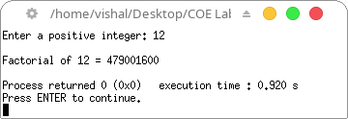

**Program 27 :** Write a C program for the addition of two 3 x 3 matrices.

**Theory :**

In mathematics, a matrix (plural matrices) is a rectangular array or table of numbers, symbols, or expressions, arranged in rows and columns, which is used to represent a mathematical object or a property of such an object. If A=[aij] and B=[bij] are two matrices of the same order mxn, then the sum of two matrix A and B is defined as C=[cij]mxn, where cij=aij+bij for all possible values of i and j.

**Algorithm :**

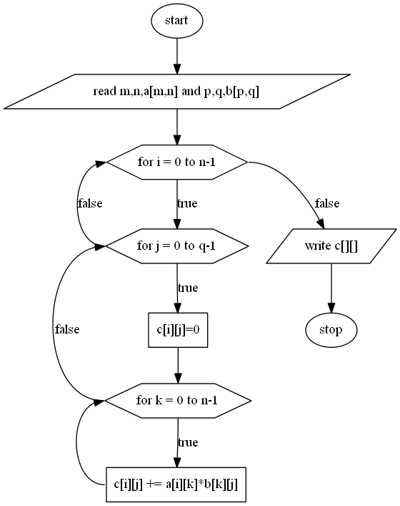

**Code :**

*/* This program is written by Vishal Das*

*(2K21/A8/24) on July 14, 2022 04:10 PM*

*for Lab File of course CO102*

*\*/*

#include <stdio.h>

void **add_mat**(int mat1[3][3], int mat2[3][3], int result[3][3]){

for (int i = 0; i < 3; i++){

for (int j = 0; j < 3; j++){

result[i][j] = mat1[i][j] + mat2[i][j];;

}

}

}

int **main**(void)

{

int mat1[3][3] = {{1,2,3}, {4,5,6}, {7,8,2}};

int mat2[3][3] = {{3,2,5}, {3,1,1}, {2,1,1}};

int out[3][3];

**add_mat**(mat1, mat2, out);

**printf**("Matrix 1 :\n");

for (int i=0; i < 3; i++){

**printf**("%d %d %d\n", mat1[i][0], mat1[i][1], mat1[i][2]);

}

**printf**("\nMatrix 2 :\n");

for (int i=0; i < 3; i++){

**printf**("%d %d %d\n", mat2[i][0], mat2[i][1], mat2[i][2]);

}

**printf**("\nMatrix Addition :\n");

for (int i=0; i < 3; i++){

**printf**("%d %d %d\n", out[i][0], out[i][1], out[i][2]);

}

**printf**("\n");

}

**Output :**

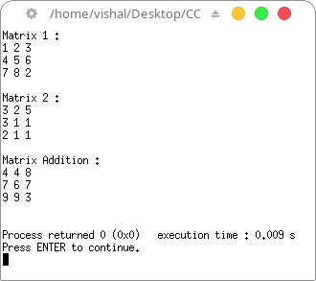

**Program 28 :** Write a C program to multiply two 3 x 3 matrices

**Theory :**

Matrix multiplication, also known as matrix product. The multiplication of two matrices, produces a single matrix. It is a type of binary operation. If A and B are the two matrices, then the product of the two matrices A and B are denoted by: X = AB. Hence, the product of two matrices is the dot product of the two matrices. To perform multiplication of two matrices, we should make sure that the number of columns in the 1st matrix is equal to the rows in the 2nd matrix. Therefore, the resulting matrix product will have a number of rows of the 1st matrix and a number of columns of the 2nd matrix.

**Algorithm :**



**Code :**

*/* This program is written by Vishal Das*

*(2K21/A8/24) on July 14, 2022 04:20 PM*

*for Lab File of course CO102*

*\*/*

#include <stdio.h>

void **mul_mat**(int mat1[3][3], int mat2[3][3], int result[3][3]){

for (int i = 0; i < 3; i++){

for (int j = 0; j < 3; j++){

int dot = mat1[i][0] * mat2[0][j] +

mat1[i][1] * mat2[1][j] +

mat1[i][2] * mat2[2][j];

result[i][j] = dot;

}

}

}

int **main**(void)

{

int mat1[3][3] = {{1,2,3}, {4,5,6}, {7,8,2}};

int mat2[3][3] = {{3,2,5}, {3,1,1}, {2,5,1}};

int out[3][3];

**mul_mat**(mat1, mat2, out);

**printf**("Matrix 1 :\n");

for (int i=0; i < 3; i++){

**printf**("%d %d %d\n", mat1[i][0], mat1[i][1], mat1[i][2]);

}

**printf**("\nMatrix 2 :\n");

for (int i=0; i < 3; i++){

**printf**("%d %d %d\n", mat2[i][0], mat2[i][1], mat2[i][2]);

}

**printf**("\nMatrix Multiplication :\n");

for (int i=0; i < 3; i++){

**printf**("%d %d %d\n", out[i][0], out[i][1], out[i][2]);

}

**printf**("\n");

}

**Output :**

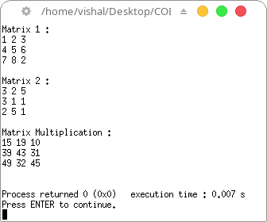

**Program 29 :** Write a C program to store the employee details using structure

**Theory :**

Structures (also called structs) are a way to group several related variables into one place. Each variable in the structure is known as a member of the structure. Unlike an array, a structure can contain many different data types (int, float, char, etc.).

**Algorithm :**

To make a struct in C, use the struct keyword inside the main() method, followed by the name of the structure and then the name of the structure variable:

struct myStructure {

  int myNum;

  char myLetter;

};

**Code :**

*/* This program is written by Vishal Das*

*(2K21/A8/24) on July 14, 2022 04:50 PM*

*for Lab File of course CO102*

*\*/*

#include <stdio.h>

#include <stdlib.h>

typedef struct{

char name[30];

int id;

double salary;

} **Employee**;

int **main**()

{

int n=2;

**Employee** employees[n];

**printf**("Enter %d Employee Details \n \n",n);

for(int i=0; i<n; i++){

**printf**("Employee %d:- \n",i+1);

**printf**("Name: ");

**scanf**("%[^\n]s",employees[i].name);

**printf**("Id: ");

**scanf**("%d",&employees[i].id);

**printf**("Salary: ");

**scanf**("%lf",&employees[i].salary);

char ch = **getchar**();

**printf**("\n");

}

**printf**("-------------- All Employees Details ---------------\n");

for(int i=0; i<n; i++){

**printf**("Name \t: ");

**printf**("%s \n",employees[i].name);

**printf**("Id \t: ");

**printf**("%d \n",employees[i].id);

**printf**("Salary \t: ");

**printf**("%.2lf \n",employees[i].salary);

**printf**("\n");

}

return 0;

}

**Output :**

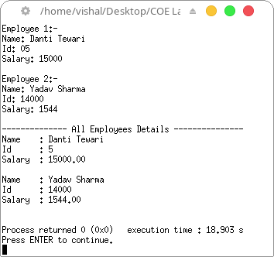

**Program 30 :** Write a C program to swap two numbers using pointers.

**Theory :**

The pointer will be used to hold the address of the variable and using pointer address of the variables will be swapped. The contents stored in the pointer variable are interchanged using a temporary variable.

**Algorithm :**

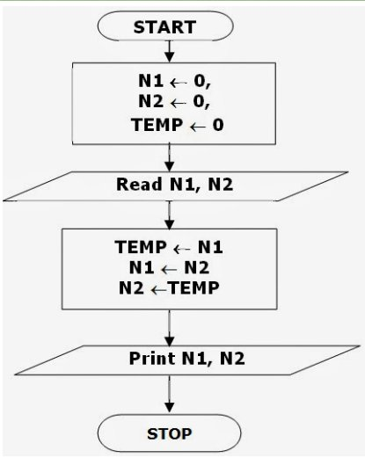

**Code :**

*/* This program is written by Vishal Das*

*(2K21/A8/24) on July 21, 2022 03:00 PM*

*for Lab File of course CO102*

*\*/*

#include <stdio.h>

void **swap**(int *x, int *y){

int temp = *y;

*y = *x;

*x = temp;

}

int **main**(void){

int a, b;

**printf**("Input values of integer a and b : ");

**scanf**("%d %d", &a, &b);

**printf**("\nBefore Swapping :\na = %d\tb = %d", a, b);

**swap**(&a, &b);

**printf**("\nAfter Swapping :\na = %d\tb = %d\n", a, b);

return 0;

}

**Output :**

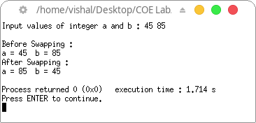

**Program 31 :** Write a C program to pass and return pointer to function hence calculate average of an array.

**Theory :**

When an array in C language is declared, compiler allocates sufficient memory to contain all its elements. Its base address is also allocated by the compiler. If we declare an array arr, variable arr will give the base address, which is a constant pointer pointing to arr[0]. Hence arr contains the address of arr[0] i.e 1000. We use a pointer to an array, and then use that pointer to access the array elements.

**Algorithm :**

In this program, we have a pointer arr that points to the 0th element of the array. Similarly, we can also declare a pointer that can point to whole array instead of only one element of the array.

**Code :**

*/* This program is written by Vishal Das*

*(2K21/A8/24) on July 21, 2022 03:15 PM*

*for Lab File of course CO102*

*\*/*

#include <stdio.h>

int **average**(int *array, int n){

int i, sum=0;

float avg;

for(i=0;i<n;i++){

sum += *(array+i);

}

avg=(float)sum/n;

**printf**("\nAverage of given array is %f\n", avg);

return avg;

}

int **main**(){

int arr[100], n, i;

**printf**("Input number of elements : ");

**scanf**("%d",&n);

**printf**("Input the elements : ");

for(i=0;i<n;i++){

**scanf**("%d", &arr[i]);

}

int *array = arr;

**average**(array, n);

return 0;

}

**Output :**

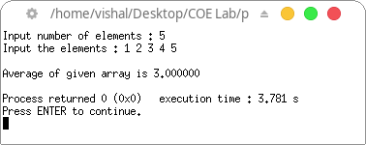

**Program 32 :** Write a C program to create a file called *emp.txt* and store information about a person, in terms of his name, age and salary.

**Theory :**

The process of file handling enables a user to update, create, open, read, write, and ultimately delete the file/content in the file that exists on the C program’s local file system. We open a file with the help of the fopen() function that is defined in the header file stdio.h.

**Algorithm :**

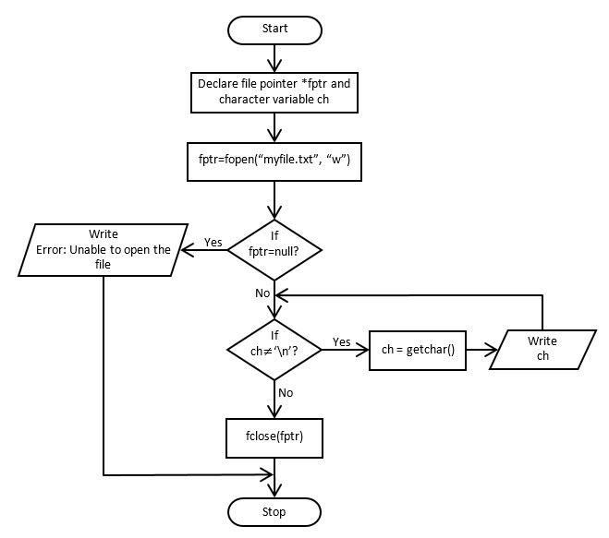

**Code :**

*/* This program is written by Vishal Das*

*(2K21/A8/24) on July 21, 2022 03:15 PM*

*for Lab File of course CO102*

*\*/*

#include <stdio.h>

int **main**(){

char name[20];

int age;

float salary;

**FILE** *emp;

emp=**fopen**("emp.txt","w+");

**printf**("Enter name : ");

**gets**(name);

**printf**("Enter age : ");

**scanf**("%d",&age);

**printf**("Enter salary : ");

**scanf**("%f",&salary);

**fprintf**(emp,"%s %d %f",name,age,salary);

**printf**("\nFile saved as emp.txt!\n");

return 0;

}

**Output :**

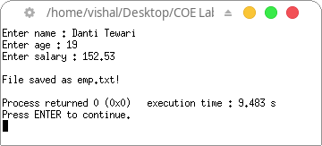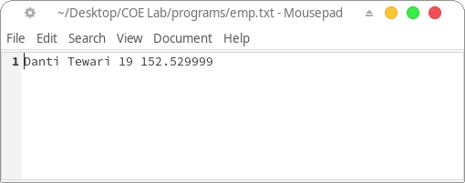

**Program 33 :** Write a C program to read a file and after converting all lower case to upper case letters write it to another file.

**Theory :**

The process of file handling enables a user to update, create, open, read, write, and ultimately delete the file/content in the file that exists on the C program’s local file system. We open a file with the help of the fopen() function that is defined in the header file stdio.h.

**Algorithm :**



**Code :**

*/* This program is written by Vishal Das*

*(2K21/A8/24) on July 21, 2022 03:15 PM*

*for Lab File of course CO102*

*\*/*

#include <stdio.h>

#include <string.h>

int **main**(){

char text[100];

**FILE** *emp, *new_file;

emp = **fopen**("text.txt","r");

new_file = **fopen**("new_file.txt", "w");

**fgets**(text, 100, emp);

**printf**("Text in File : %s\n", text);

for(int i=0;i<**strlen**(text);i++){

if(text[i]>='a' && text[i]<='z')

text[i] -= 32;

}

**printf**("Text in New File : %s\n", text);

**fprintf**(new_file,"%s", text);

**printf**("\nFile saved as new_file.txt!\n");

return 0;

}

**Output :**

