TASK SPESIAL FSW-13

1. Below is the structure of the database.

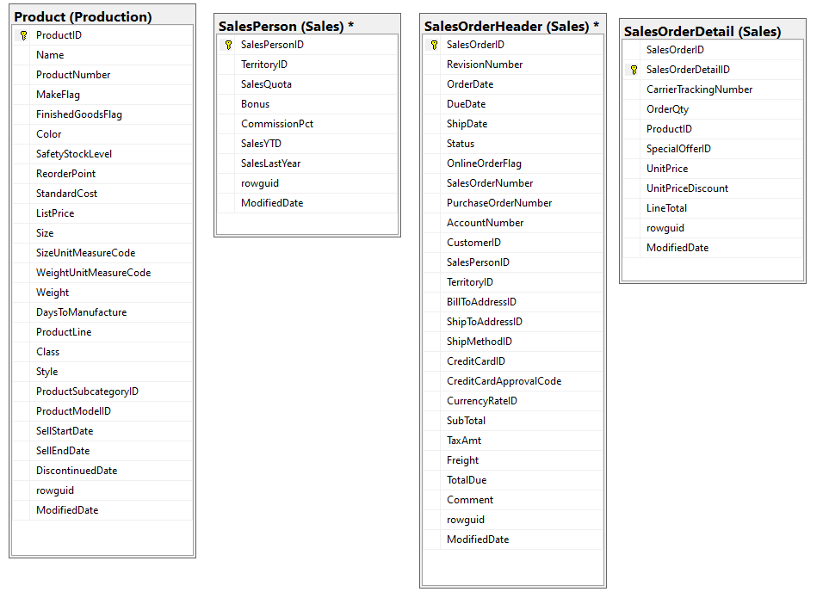

Write a query to select the top 5 SalesPersonID, SalesYTD, where the sales person has sold Wheel (“Product Name that’s contains the word Wheel”) order by the salesYTD descending. Sample output as below:

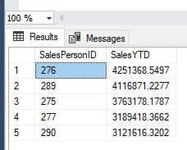

Answer:

SELECT

    SP.SalesPersonID,

    SP.SalesYTD

FROM

    SalesPerson SP

    JOIN SalesOrderHeader SOH ON SP.SalesPersonID = SOH.SalesPersonID

    JOIN SalesOrderDetail SOD ON SOH.SalesOrderID = SOD.SalesOrderID

    JOIN Product P ON SOD.ProductID = P.ProductID

WHERE

    P.ProductName LIKE ‘%Wheel%’

ORDER BY

    SP.SalesYTD DESC

    LIMIT 5

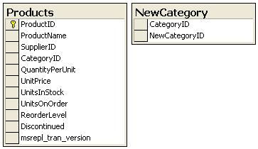

Products Sample Data

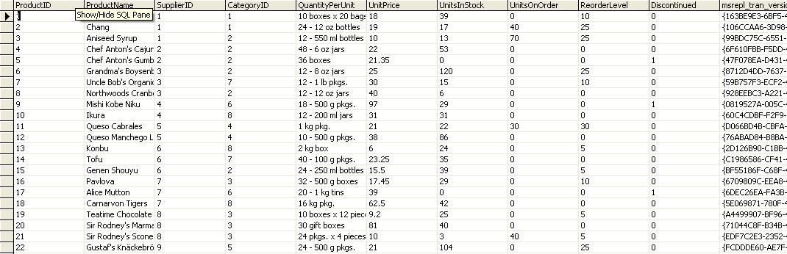

NewCategory Sample Data

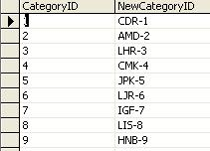

1. Based on the tables above, write a SQL script to update [Products] table (CategoryID) using the data (NewCategoryID) from [NewCategory] Table. (10 points)

Answer:

ALTER TABLE Product MODIFY COLUMN CategoryID VARCHAR(225); UPDATE Product JOIN NewCategory ON Product.CategoryID = NewCategory.NewCategoryID SET Product.CategoryID = NewCategory.NewCategoryID WHERE Product.CategoryID = NewCategory.CategoryID

|  |  |
| --- | --- |
| 1. Write a method that prints the numbers from 1 to 100, but  * when numbers that are exact multiples of 4, or that contain 4, or the sum of the numbers are multiples of 4 must print a string containing "Bull"   For example 4 -> "Bull"  For example 13 -> "Bull"  For example 45 -> "Bull"   * when numbers that are exact multiples of 8, or that contain 8, or the sum of the numbers are multiples of 8 must print a string containing "Dog"   For example 16 -> "Dog"  For example 35 -> "Dog"  For example 82 -> "Dog"  if it met both criteria (4 & 8), print BullDog (10 points) | Sample: 1 2 3  Bull …  …  37  Dog  Bull  BullDog  Bull  …  …  Dog  99 Bull |

1. The value for 100 is

* 64 is hexadecimal (base 16)
* 100 in Decimal (base 10)
* 144 in Octal (base 8)
* 0110 0100 in Binary

Create a function that accept a positive numeric value and return a base 6 (heximal) value in string **without** using any build-in math libraries.