Week 5 - Monday Questions

1. How many actors are there with the last name ‘Wahlberg’?

**select** first_name, last_name, actor_id

**from** actor

**where** last_name like 'W__%rg';

2

1. How many payments were made between $3.99 and $5.99?

**SELECT** amount, **COUNT**(amount), **sum**(amount)

**FROM** payment

**WHERE** amount **between** 3.99 **and** 5.99

**GROUP** **BY** **rollup** (amount)

**order** **by** amount **asc**;

4803 *When run in Nov 2022

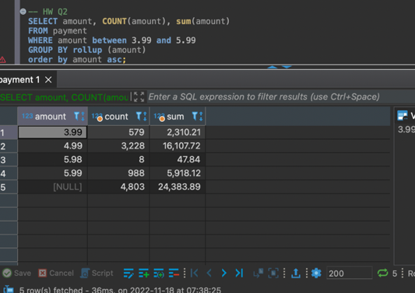

4794 * When run in January 2023

1. What film does the store have the most of? (search in inventory)

Many have 8. See results below.

1. How many customers have the last name ‘William’?

**select** first_name, last_name

**from** customer

**where** last_name **like** 'W__%ms';

0

1. What store employee (get the id) sold the most rentals?

**select** payment.staff_id, **count**(payment.rental_id)

**from** payment

**join** staff **on** payment.staff_id = staff.staff_id

**group** **by** payment.staff_id

**order** **by** **count**(payment.rental_id) **desc**;

2—7304

1. How many different district names are there?

**select** **distinct**(district), **count**(district)

**from** address

**group** **by** (district)

378

1. What film has the most actors in it? (use film_actor table and get film_id)

**select** film_actor.film_id, **count**(actor_id), film.title

**from** film_actor

**join** film **on** film_actor.film_id = film.film_id

**group** **by** film_actor.film_id, film.title

**order** **by** **count**(actor_id) **desc**;

508—film id

Lambs Cincinatti—title

1. From store_id 1, how many customers have a last name ending with ‘es’? (use customer table)

**select** customer_id, store_id, last_name

**from** customer

**where** store_id = 1 **and** last_name **like** '%es';

13

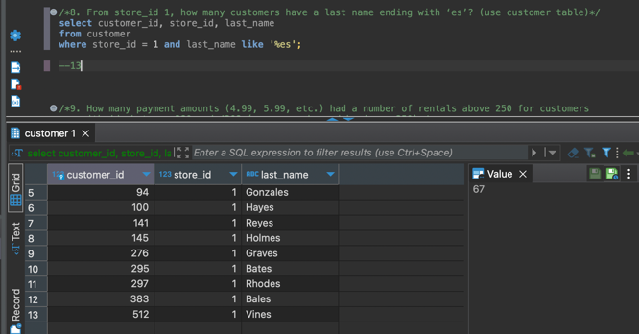

1. How many payment amounts (4.99, 5.99, etc.) had a number of rentals above 250 for customers with ids between 380 and 430? (use group by and having > 250)

**select** payment.customer_id, **count**(rental.inventory_id)

**from** payment

**join** rental **on** payment.customer_id = rental.customer_id

**where** payment.customer_id **between** 380 **and** 430

**group** **by** payment.customer_id, rental.inventory_id

**having** **count**(rental.inventory_id) > 250

0

1. Within the film table, how many rating categories are there? And what rating has the most movies total?

**select** **distinct**(rating), **count**(rating)

**from** film

**group** **by** rating

**order** **by** **count**(rating) **desc**;

5

PG-13—223

