https://www.youtube.com/watch?v=zhllkjYYUVE
.mr-right -----to move right side
.droupdown------
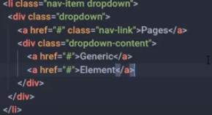
<div class="container text-center">

Padding x direction px , Padding y direction py

