https://stackblitz.com/angular/ryvbbgjmoed?file=src%2Fapp%2Fapp.component.html
<hr><h2 id="enums">Enums in binding</h2>
It href will navigate to that <div>
<a href="#enums">Enums</a><br>

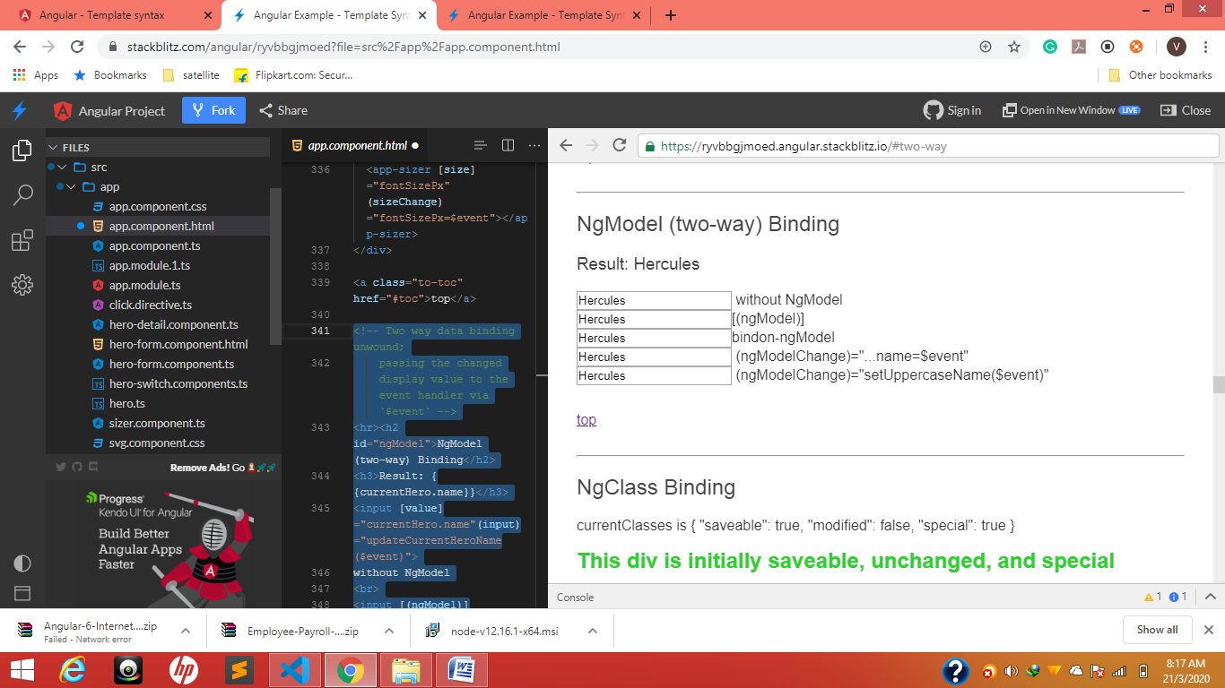

<!-- Two way data binding unwound;
passing the changed display value to the event handler via `$event` -->
<hr><h2 id="ngModel">NgModel (two-way) Binding</h2>
<h3>Result: {{currentHero.name}}</h3>
<input [value]="currentHero.name"(input)="updateCurrentHeroName($event)">
without NgModel
<br>
<input [(ngModel)]="currentHero.name">[(ngModel)]<br>
<input bindon-ngModel="currentHero.name">bindon-ngModel<br>
<input [ngModel]="currentHero.name" (ngModelChange)="currentHero.name=$event">
(ngModelChange)="...name=$event"
<br>
<input [ngModel]="currentHero.name" (ngModelChange)="setUppercaseName($event)">
(ngModelChange)="setUppercaseName($event)"
<a class="to-toc" href="#toc">top</a>

Expression context

let customer, or a template reference variable, #customerInput.
1.<ul> <li *ngFor="let customer of customers">{{customer.name}}</li> </ul>
2.<label>Type something: <input #customerInput>{{customerInput.value}} </label>

Statement context
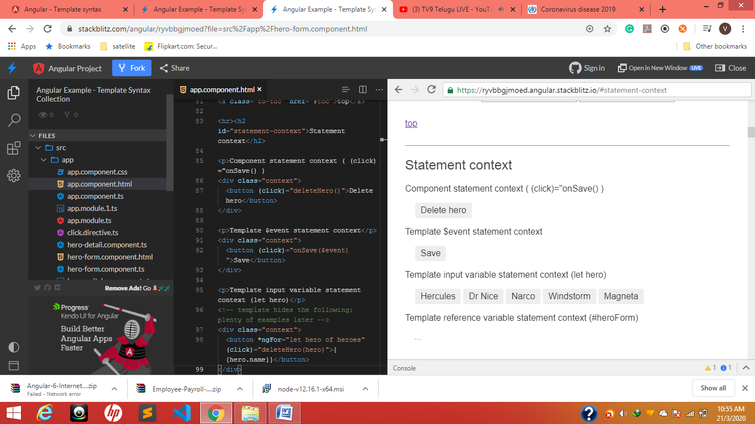

<div class="context"> <button (click)="deleteHero()">Delete hero</button> </div>

deleteHero(hero?: Hero) {
this.alert(`Delete ${hero ? hero.name : 'the hero'}.`);
}

This is how we can print from ts----------(‘${hero.name}’)-------- Html -----{{}}
console.log(`${hero.name}`)

this.alert(`Delete ${hero ? hero.name : 'the hero'}.`);
}

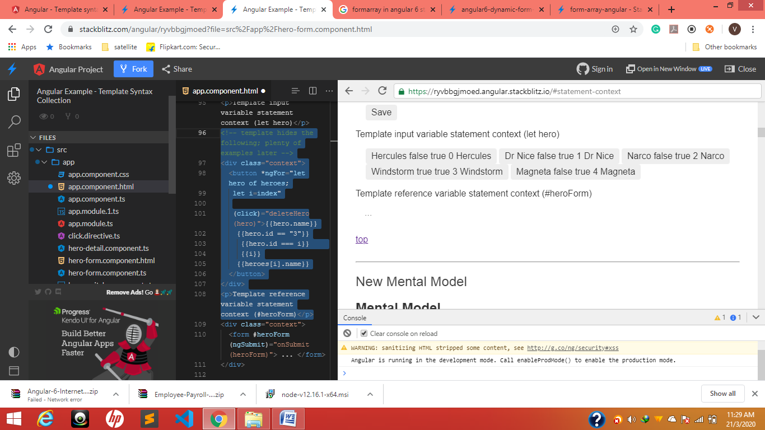
<!-- template hides the following; plenty of examples later -->
<div class="context">
<button *ngFor="let hero of heroes;
let i=index"

(click)="deleteHero(hero)">{{hero.name}}
{{hero.id == "3"}} // to get an idea
{{hero.id === i}}
{{i}}
{{heroes[i].name}}
</button>
</div>
<p>Template reference variable statement context (#heroForm)</p>

Toggle
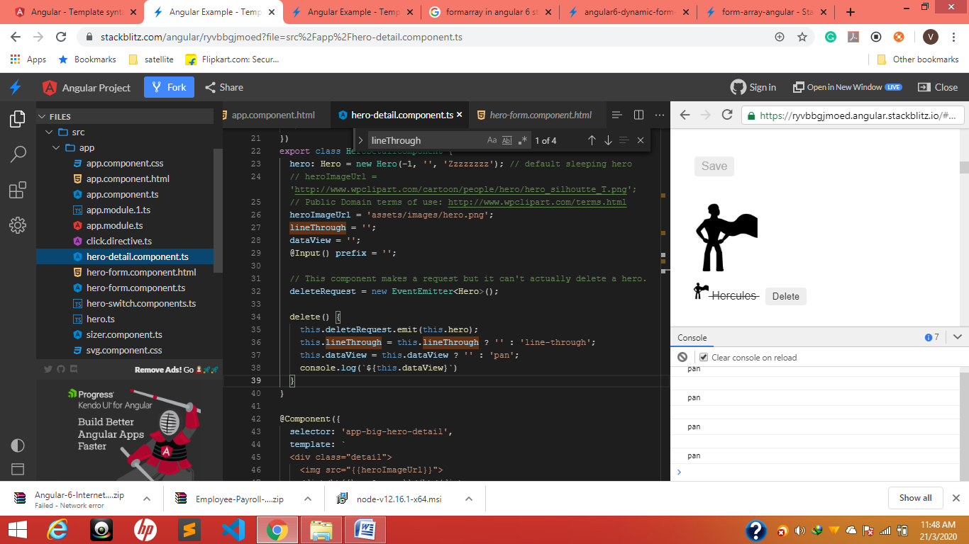
heroImageUrl = 'assets/images/hero.png';
lineThrough = '';
dataView = '';
@Input() prefix = '';

// This component makes a request but it can't actually delete a hero.
deleteRequest = new EventEmitter<Hero>();

delete() {
this.deleteRequest.emit(this.hero);
this.lineThrough = this.lineThrough ? '' : 'line-through';
this.dataView = this.dataView ? '' : 'pan';
console.log(`${this.dataView}`)
}
}

*****************************************************************************************************
myClick click me
TS
clicked = '';

HTML
<div (myClick)="clicked=$event" clickable>click me</div>
{{clicked}}

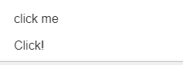
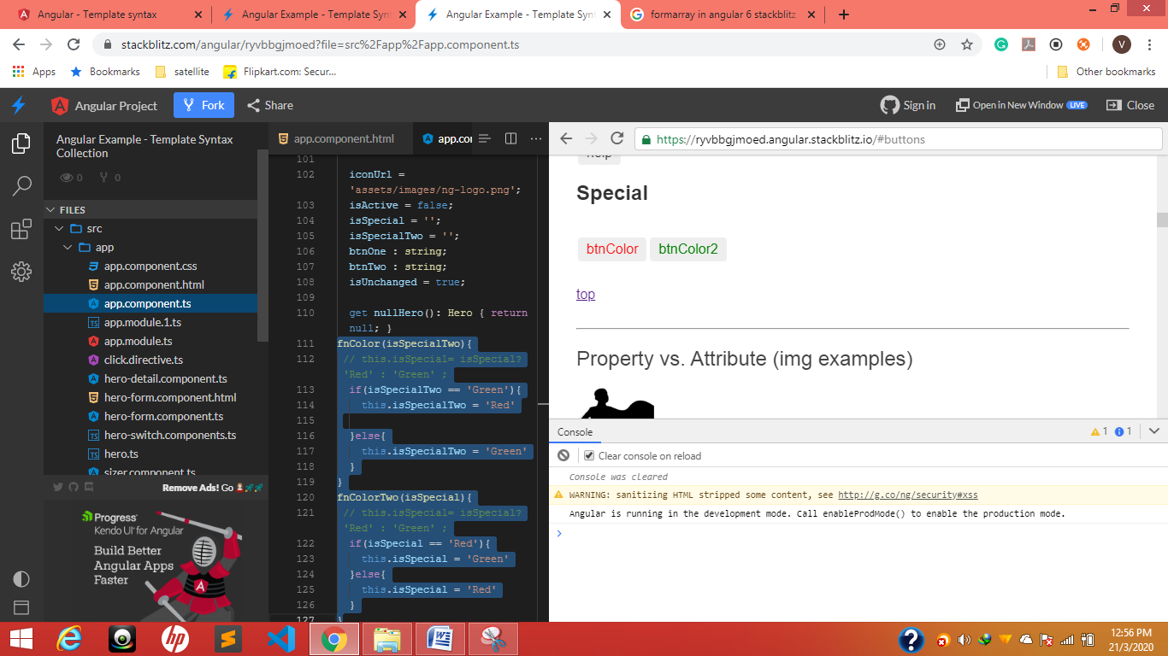

fnColor(isSpecialTwo){
// this.isSpecial= isSpecial? 'Red' : 'Green' ;
if(isSpecialTwo == 'Green'){
this.isSpecialTwo = 'Red'

}else{
this.isSpecialTwo = 'Green'
}
}
fnColorTwo(isSpecial){
// this.isSpecial= isSpecial? 'Red' : 'Green' ;
if(isSpecial == 'Red'){
this.isSpecial = 'Green'
}else{
this.isSpecial = 'Red'
}
}
HTML
button [style.color]="isSpecial" (click)="fnColor(isSpecialTwo)" >
btnColor</button>
<button [style.color]="isSpecialTwo" (click)="fnColorTwo(isSpecial)">
btnColor2 </button>

when two things think x
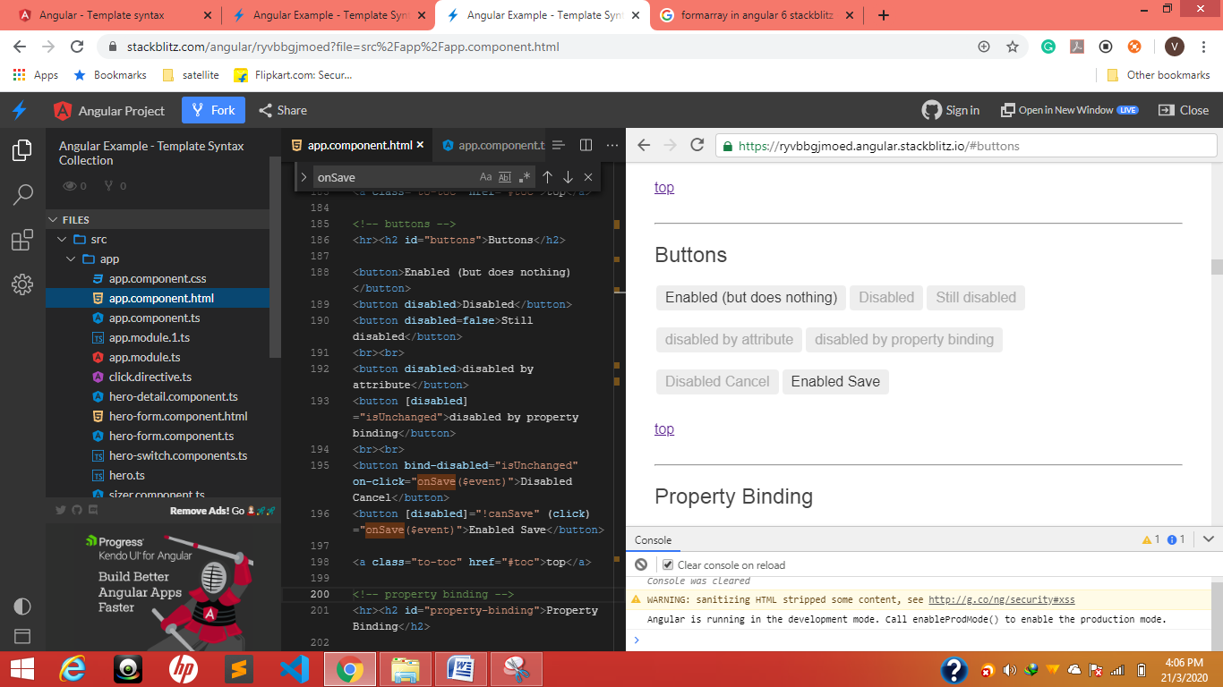
These many ways we can disable the things
<!-- buttons -->
<hr><h2 id="buttons">Buttons</h2>

<button>Enabled (but does nothing)</button>
<button disabled>Disabled</button>
<button disabled=false>Still disabled</button>
<br><br>
<button disabled>disabled by attribute</button>
<button [disabled]="isUnchanged">disabled by property binding</button>
<br><br>
<button bind-disabled="isUnchanged" on-click="onSave($event)">Disabled Cancel</button>
<button [disabled]="!canSave" (click)="onSave($event)">Enabled Save</button>

<a class="to-toc" href="#toc">top</a>

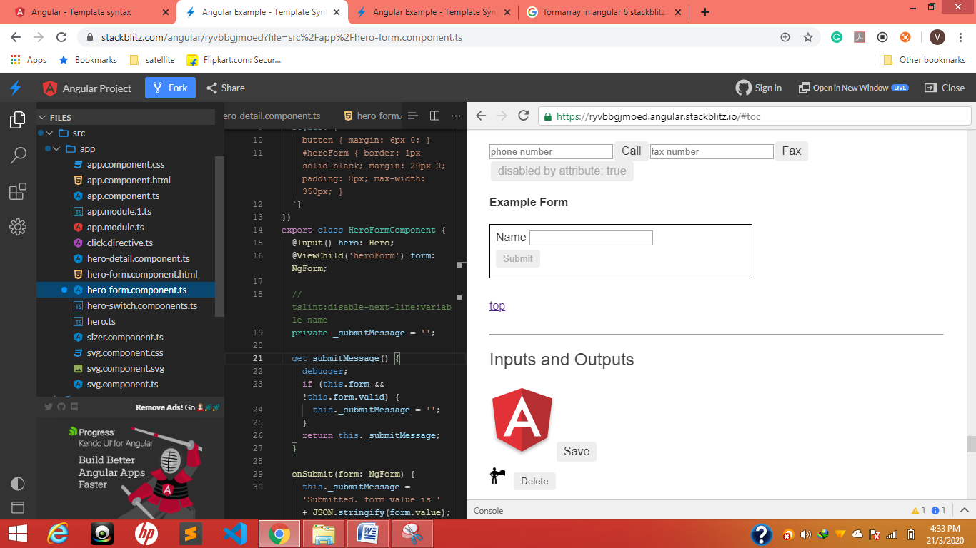
One text--one button with validation
@Input() hero: Hero;
@ViewChild('heroForm') form: NgForm;

// tslint:disable-next-line:variable-name
private _submitMessage = '';

get submitMessage() {
debugger;
if (this.form && !this.form.valid) {
this._submitMessage = '';
}
return this._submitMessage;
}

onSubmit(form: NgForm) {
this._submitMessage = 'Submitted. form value is ' + JSON.stringify(form.value);
}
}

<div id="heroForm">
<form (ngSubmit)="onSubmit(heroForm)" #heroForm="ngForm">
<div class="form-group">
<label for="name">Name
<input class="form-control" name="name" required [(ngModel)]="hero.name">
</label>
</div>
<button type="submit" [disabled]="!heroForm.form.valid">Submit</button>
</form>
<div [hidden]="!heroForm.form.valid">
{{submitMessage}}
</div>
</div>

Check
<input class="form-control" name="name" required [(ngModel)]="hero.name">
<button type="submit" [disabled]="!heroForm.form.valid">Submit</button>

<div [hidden]="!heroForm.form.valid"> {{submitMessage}}<div>

Property Binding
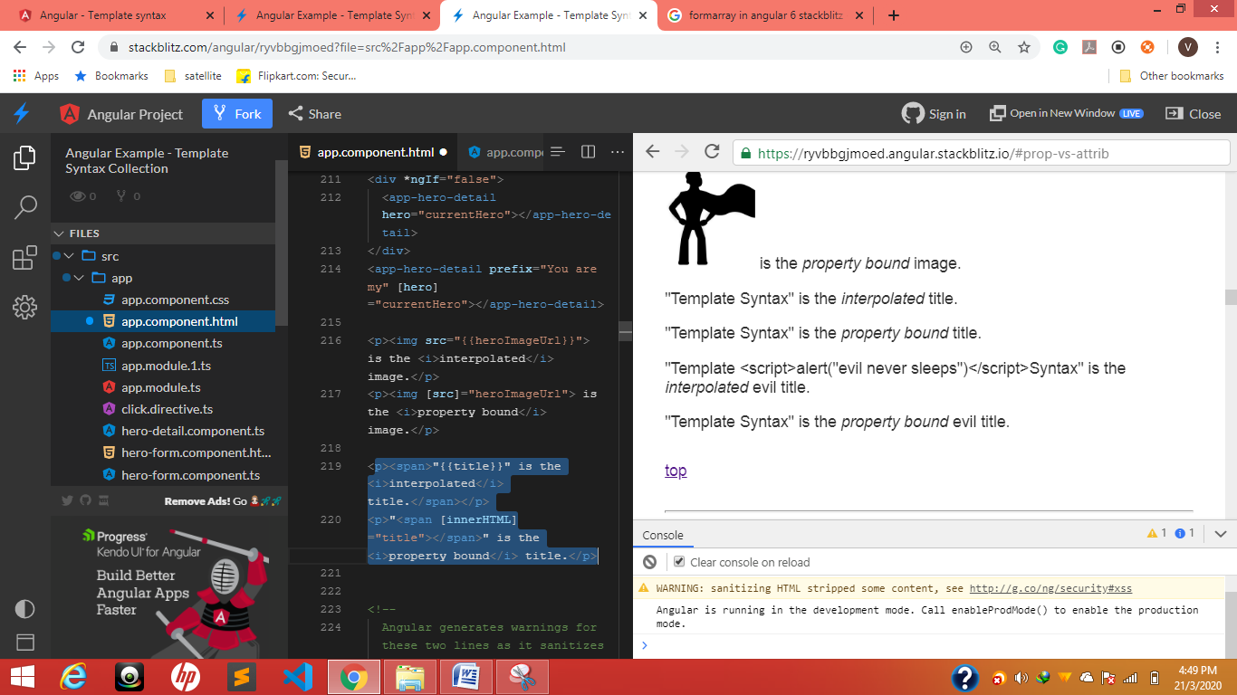

<p><span>"{{title}}" is the <i>interpolated</i> title.</span></p>
<p>"<span [innerHTML]="title"></span>" is the <i>property bound</i> title.</p>
Instead of {{}} we can print by using property binding "<span [innerHTML]="title"></span>"

2.
evilTitle = `Template Not considered script Tag inside
<script> alert("evil never sleeps")</script>
Syntax `;
We want to print only Text not <script> one then we have to go propery binding
<p><span>"{{evilTitle}}" is the <i>interpolated</i> evil title.</span></p>
<p>"<span [innerHTML]="evilTitle"></span>" is the <i>property bound</i> evil title.</p>

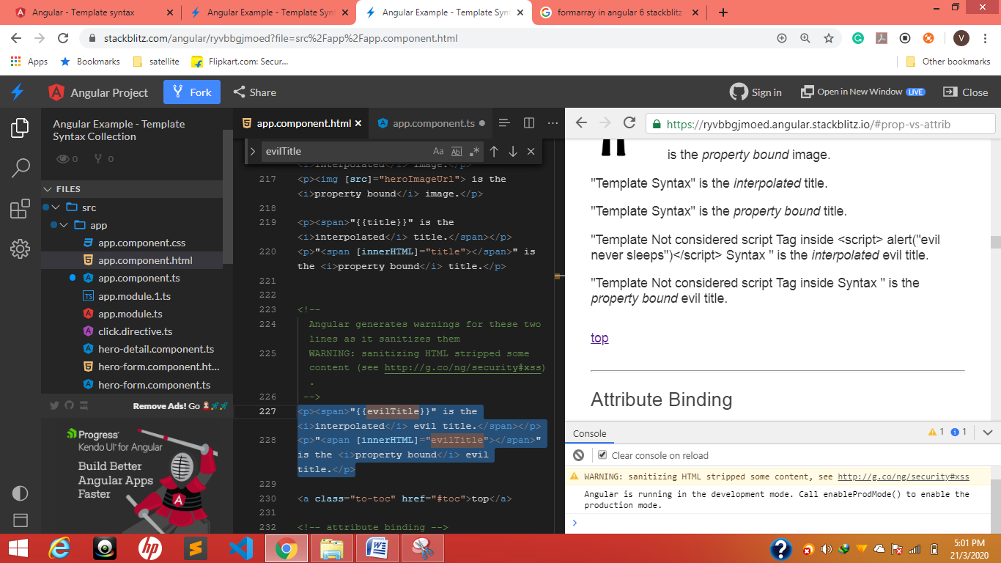
<p><span>"{{evilTitle}}" is the <i>interpolated</i> evil title.</span></p>
<p>"<span [innerHTML]="evilTitle"></span>" is the <i>property bound</i> evil title.</p>

Attribute Binding

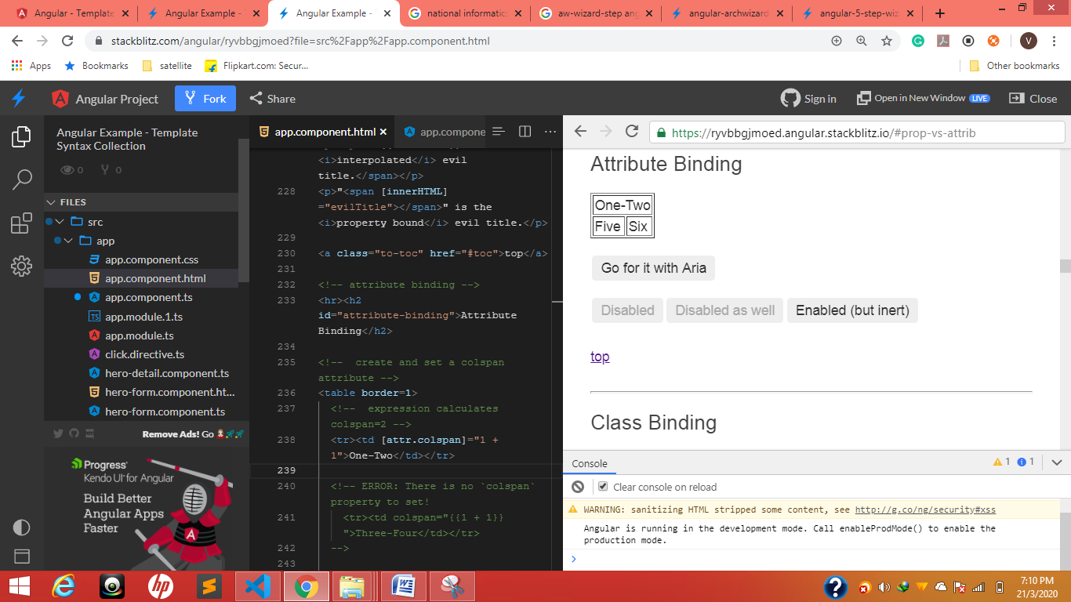
If we want to combine two columns dynamically in a table
<table border=1>
<!-- expression calculates colspan=2 -->
<tr> <td [attr.colspan]="1 + 1">One-Two</td> </tr>
<tr><td>Five</td><td>Six</td></tr>
</table>
[attr.colspan]=’1 + 1’

Style binding
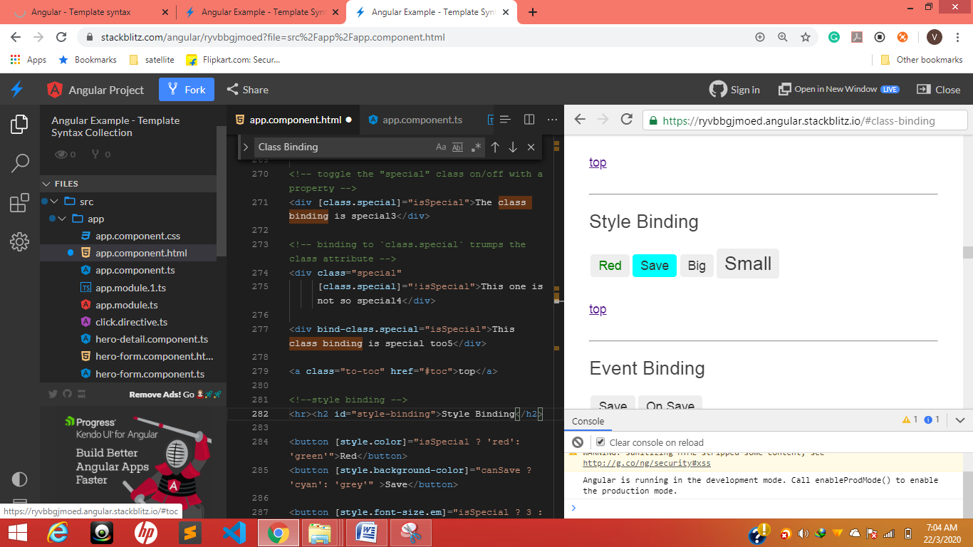
<!--style binding -->
<hr><h2 id="style-binding">Style Binding</h2>
<button [style.color]="isSpecial ? 'red': 'green'">Red</button>
<button [style.background-color]="canSave ? 'cyan': 'grey'" >Save</button>
<button [style.font-size.em]="isSpecial ? 3 : 1" >Big</button>
<button [style.font-size.%]="!isSpecial ? 150 : 50" >Small</button>

Event binding
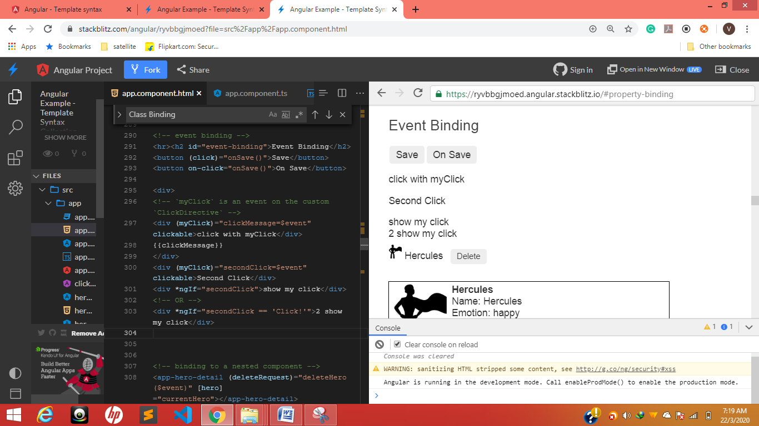
(click), on-click,(myClick)—it can be used for toggle hide and show directly
<!-- event binding -->
<hr><h2 id="event-binding">Event Binding</h2>
<button (click)="onSave()">Save</button>
<button on-click="onSave()">On Save</button>

<div>
<!-- `myClick` is an event on the custom `ClickDirective` -->
<div (myClick)="clickMessage=$event" clickable>click with myClick</div>
{{clickMessage}}
</div>
<div (myClick)="secondClick=$event" clickable>Second Click</div>
<div *ngIf="secondClick">show my click</div>
<!-- OR -->
<div *ngIf="secondClick == 'Click!'">2 show my click</div>

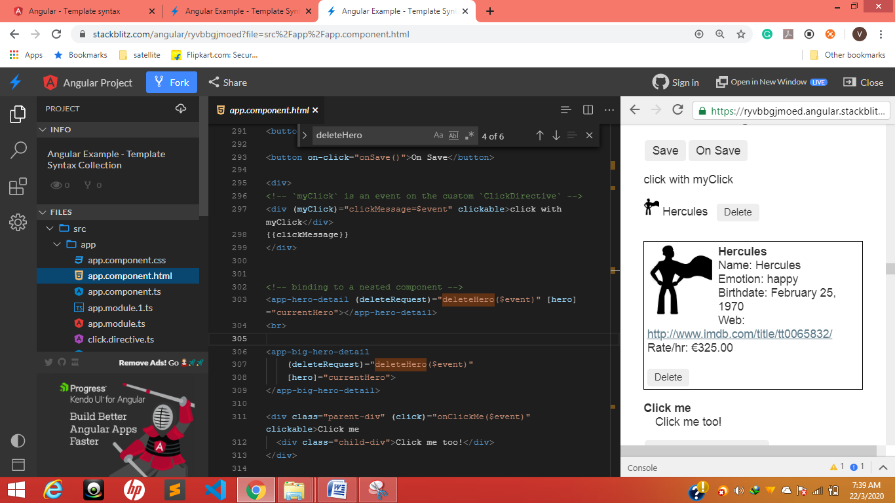
@Output (deleteRequest) from chaild
<app-hero-detail (deleteRequest)="deleteHero($event)" [hero]="currentHero"></app-hero-detail>

deleteHero(hero?: Hero) {
this.alert(`Delete ${hero ? hero.name : 'the hero'}.`);
}

From app-hero
@Output() deleteRequest = new EventEmitter<Hero>();

delete() {
this.deleteRequest.emit(this.hero);
}


<div class="parent-div" (click)="onClickMe($event)" clickable>Parent Click me
<div class="child-div">Child No click event but works Click me too!</div>
</div>

Save-once save-twice
<!-- Will save only once -->
<div (click)="onSave()" clickable>
<button (click)="onSave($event)">Save, no propagation</button>
</div>

<!-- Will save twice -->
<div (click)="onSave()" clickable>
<button (click)="onSave()">Save w/ propagation</button>
</div>

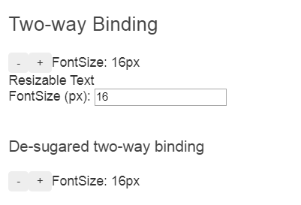
Sizer component ts’
<hr><h2 id="two-way">Two-way Binding</h2>
<div id="two-way-1">
<app-sizer [(size)]="fontSizePx"></app-sizer>
<div [style.font-size.px]="fontSizePx">Resizable Text</div>
<label>FontSize (px): <input [(ngModel)]="fontSizePx"></label>
</div>
<br>
<div id="two-way-2">
<h3>De-sugared two-way binding</h3>
<app-sizer [size]="fontSizePx" (sizeChange)="fontSizePx=$event"></app-sizer>
</div>

<a class="to-toc" href="#toc">top</a>

Sizer component
import { Component, EventEmitter, Input, Output } from '@angular/core';

@Component({
selector: 'app-sizer',
template: `
<div>
<button (click)="dec()" title="smaller">-</button>
<button (click)="inc()" title="bigger">+</button>
<label [style.font-size.px]="size">FontSize: {{size}}px</label>
</div>`
})
export class SizerComponent {
@Input() size: number | string;
@Output() sizeChange = new EventEmitter<number>();

dec() { this.resize(-1); }
inc() { this.resize(+1); }

resize(delta: number) {
this.size = Math.min(40, Math.max(8, +this.size + delta));
this.sizeChange.emit(this.size);
}
}

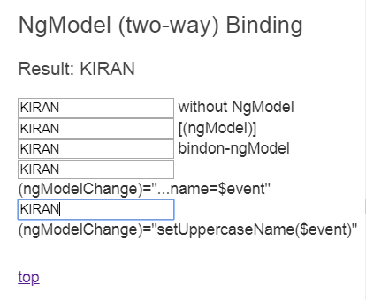
<hr><h2 id="ngModel">NgModel (two-way) Binding</h2>

<h3>Result: {{currentHero.name}}</h3>

<input [value]="currentHero.name" (input)="updateCurrentHeroName($event)"> without NgModel
<br>
<input [(ngModel)]="currentHero.name">[(ngModel)]
<input bindon-ngModel="currentHero.name">bindon-ngModel
<br>
<input [ngModel]="currentHero.name"(ngModelChange)="currentHero.name=$event"> (ngModelChange)="...name=$event"
<br>
<input [ngModel]="currentHero.name"(ngModelChange)="setUppercaseName($event)">(ngModelChange)="setUppercaseName($event)"

<a class="to-toc" href="#toc">top</a>

ngClass binding
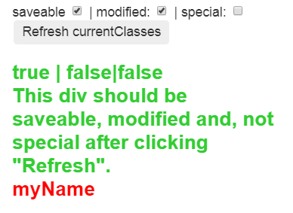
When deselected for first loaded time
Ts file
currentClasses: {};
setCurrentClasses() {
// CSS classes: added/removed per current state of component properties
this.currentClasses = {
saveable: this.canSave,
modified: !this.isUnchanged,
special: this.isSpecial
};
}
html

<p>currentClasses is {{currentClasses | json}}</p>
<div [ngClass]="currentClasses">This div is initially saveable, unchanged, and special</div>

<!-- not used in chapter -->
<br>
<label>saveable <input type="checkbox" [(ngModel)]="canSave"></label> |
<label>modified: <input type="checkbox" [value]="!isUnchanged" (change)="isUnchanged=!isUnchanged"></label> |
<label>special: <input type="checkbox" [(ngModel)]="isSpecial"></label>
<button (click)="setCurrentClasses()">Refresh currentClasses</button>
<br><br>
<div [ngClass]="currentClasses">
{{canSave}} | {{isUnchanged}}|{{isSpecial}}<br>
This div should be {{ canSave ? "": "not"}} saveable,
{{ isUnchanged ? "unchanged" : "modified" }} and,
{{ isSpecial ? "": "not"}} special after clicking "Refresh".</div>
<br><br>
For any canSave ? ‘true’: ‘false’
<br>
<label>saveable <input type="checkbox" [(ngModel)]="canSave"></label> |
<label>modified: <input type="checkbox" [value]="isUnchanged"
(change)="isUnchanged=!isUnchanged"
(change)="isSpecial=!isSpecial"></label> |
<label>special: <input type="checkbox" [(ngModel)]="isSpecial"></label>
<button (click)="setCurrentClasses()">Refresh currentClasses</button>
<br><br>
<div [ngClass]="currentClasses">
{{canSave}} | {{isUnchanged}}|{{isSpecial}}<br>
This div should be {{ canSave ? "": "not"}} saveable,
{{ isUnchanged ? "unchanged" : "modified" }} and,
{{ isSpecial ? "": "not"}} special after clicking "Refresh".<br>
<span [style.color]="isSpecial? 'Green' : 'Red' " >
<!-- {{ isSpecial ? "Green" : "Red" }} -->
myName Able to change colors Toggle
</span>
</div>

Color changed toggle no need to write functions
<label>modified: <input type="checkbox" [value]="isUnchanged" (change)="isUnchanged=!isUnchanged" (change)="isSpecial=!isSpecial"></label>
<span [style.color]="isSpecial? 'Green' : 'Red' " > myName Able to change colors Toggle </span>


This can control with [(ngModel)]="isSpecial" or (change)="isSpecial=!isSpecial"

<label>special: <input type="checkbox"
[(ngModel)]="isSpecial"
></label>
<div [ngClass]="isSpecial ? 'special' : ''">This div is special</div>

<div class="bad curly special">Bad curly special</div>
<div [ngClass]="{'bad':false, 'curly':true, 'special':isSpecial}">Curly special</div>

<a class="to-toc" href="#toc">top</a>

ngStyle binding
currentStyles: {};
setCurrentStyles() {
// CSS styles: set per current state of component properties
this.currentStyles = {
'font-style': this.canSave ? 'italic' : 'normal',
'font-weight': !this.isUnchanged ? 'bold' : 'normal',
'font-size': this.isSpecial ? '24px' : '12px'
};
}

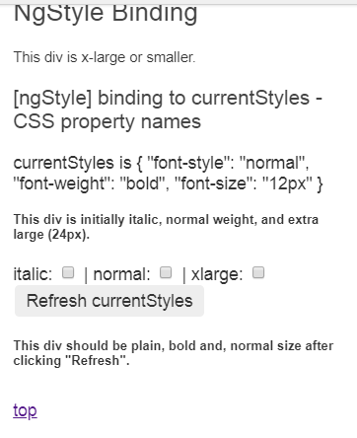
<br>
<label>italic: <input type="checkbox" [(ngModel)]="canSave"></label> |
<label>normal: <input type="checkbox" [(ngModel)]="isUnchanged"></label> |
<label>xlarge: <input type="checkbox" [(ngModel)]="isSpecial"></label>
<button (click)="setCurrentStyles()">Refresh currentStyles</button>
<br><br>
<div [ngStyle]="currentStyles">
This div should be {{ canSave ? "italic": "plain"}},
{{ isUnchanged ? "normal weight" : "bold" }} and,
{{ isSpecial ? "extra large": "normal size"}} after clicking "Refresh".</div>

<a class="to-toc" href="#toc">top</a>

Here only ngModel is used for toggle

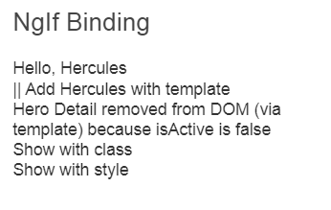
<div *ngIf="currentHero">Hello, {{currentHero.name}}</div>||
<div *ngIf="nullHero">Hello, {{nullHero.name}}</div>
<!-- isSpecial is true -->
<div [class.hidden]="!isSpecial">Show with class</div>
<div [class.hidden]="isSpecial">Hide with class</div>
<!-- HeroDetail is in the DOM but hidden -->

<div [style.display]="isSpecial ? 'block' : 'none'">Show with style</div>
<div [style.display]="isSpecial ? 'none' : 'block'">Hide with style</div>
On <div>
[style.display]…….[class.hidden]……..*ngIf
<div *ngFor="let hero of heroes; let i=index">{{i + 1}} - {{hero.name}}</div>

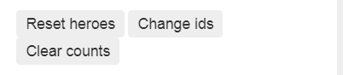
resetHeroes() {
console.log(Hero)
console.log(Hero.heroes)
this.heroes = Hero.heroes.map(hero => hero.clone());
this.currentHero = this.heroes[0];
this.hero = this.currentHero;
this.heroesWithTrackByCountReset = 0;
}
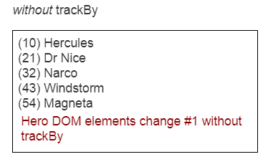
changeIds() {
this.resetHeroes();
this.heroes.forEach(h => h.id += 10 * this.heroIdIncrement++);
this.heroesWithTrackByCountReset = -1;
}

NgSwitch Binding
Printing radio button values dynamically
<div>
<label *ngFor="let h of heroes">
<input type="radio" name="heroes" [(ngModel)]="currentHero" [value]="h">{{h.name}}
</label>
</div>

ngSwithch ngSwitchCase
<div [ngSwitch]="currentHero.emotion">
<app-happy-hero *ngSwitchCase="'happy'" [hero]="currentHero"></app-happy-hero>
<app-sad-hero *ngSwitchCase="'sad'" [hero]="currentHero"></app-sad-hero>

<app-confused-hero *ngSwitchCase="'confused'" [hero]="currentHero"></app-confused-hero>
<div *ngSwitchCase="'confused'">Are you as confused as {{currentHero.name}}?</div>

<app-unknown-hero *ngSwitchDefault [hero]="currentHero"></app-unknown-hero>
</div>

Utilizations of different components in one component
Hero.switch.component
import { Component, Input } from '@angular/core';
import { Hero } from './hero';

@Component({
selector: 'app-happy-hero',
template: `Wow. You like {{hero.name}}. What a happy hero ... just like you.`
})
export class HappyHeroComponent {
@Input() hero: Hero;
}

@Component({
selector: 'app-sad-hero',
template: `You like {{hero.name}}? Such a sad hero. Are you sad too?`
})
export class SadHeroComponent {
@Input() hero: Hero;
}

@Component({
selector: 'app-confused-hero',
template: `Are you as confused as {{hero.name}}?`
})
export class ConfusedHeroComponent {
@Input() hero: Hero;
}

@Component({
selector: 'app-unknown-hero',
template: `{{message}}`
})
export class UnknownHeroComponent {
@Input() hero: Hero;
get message() {
return this.hero && this.hero.name ?
`${this.hero.name} is strange and mysterious.` :
'Are you feeling indecisive?';
}
}

export const heroSwitchComponents =
[ HappyHeroComponent, SadHeroComponent, ConfusedHeroComponent, UnknownHeroComponent ];

Template reference variables
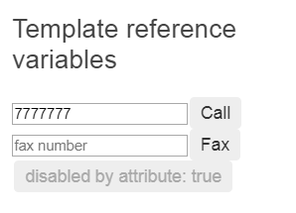
Taken Reference #phone or ref-fax or ref-phone
<input #phone placeholder="phone number">
<button (click)="callPhone(phone.value)">Call</button>

Or ref-fax
<input ref-fax placeholder="fax number">
<button (click)="callFax(fax.value)">Fax</button>


<button #btn [innerHTML]="'disabled by attribute:' +btn.disabled"> </button>
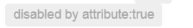
<button #btn disabled [innerHTML]="'disabled by attribute:' +btn.disabled"> </button>

Form
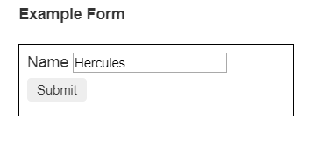
HERO.FORM
<div id="heroForm">
<form (ngSubmit)="onSubmit(heroForm)" #heroForm="ngForm">
<div class="form-group">
<label for="name">Name
<input class="form-control" name="name" required
[(ngModel)]="hero.name">
</label>
</div>
<button type="submit" [disabled]="!heroForm.form.valid">Submit</button>
</form>
<div [hidden]="!heroForm.form.valid">
{{submitMessage}}
</div>
</div>

<!--
Copyright Google LLC. All Rights Reserved.
Use of this source code is governed by an MIT-style license that
can be found in the LICENSE file at http://angular.io/license
-->

import { Component, Input, ViewChild } from '@angular/core';
import { NgForm } from '@angular/forms';

import { Hero } from './hero';

@Component({
selector: 'app-hero-form',
templateUrl: './hero-form.component.html',
styles: [`
button { margin: 6px 0; }
#heroForm { border: 1px solid black; margin: 20px 0; padding: 8px; max-width: 350px; }
`]
})
export class HeroFormComponent {
@Input() hero: Hero;
@ViewChild('heroForm') form: NgForm;

// tslint:disable-next-line:variable-name
private _submitMessage = '';

get submitMessage() {
if (this.form && !this.form.valid) {
this._submitMessage = '';
}
return this._submitMessage;
}

onSubmit(form: NgForm) {
this._submitMessage = 'Submitted. form value is ' + JSON.stringify(form.value);
}
}

/*
Copyright Google LLC. All Rights Reserved.
Use of this source code is governed by an MIT-style license that
can be found in the LICENSE file at http://angular.io/license
*/

Pipes
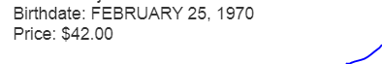
<hr><h2 id="pipes">Pipes</h2>

<div>Title through uppercase pipe: {{title | uppercase}}</div>

<!-- Pipe chaining: convert title to uppercase, then to lowercase -->
<div>
Title through a pipe chain:
{{title | uppercase | lowercase}}
</div>

<!-- pipe with configuration argument => "February 25, 1970" -->
<div>Birthdate: {{currentHero?.birthdate | date:'longDate'}}</div>

<div>{{currentHero | json}}</div>

<div>Birthdate: {{(currentHero?.birthdate | date:'longDate') | uppercase}}</div>

<div>
<!-- pipe price to USD and display the $ symbol -->
<label>Price: </label>{{product.price | currency:'USD':'symbol'}}
</div>

<a class="to-toc" href="#toc">top</a>

Non-null assertion operator !.

<div>

<!--No hero, no text -->
<div *ngIf="hero">
The hero's name is {{hero!.name}}
</div>
</div>

Non null can avoid error ! I guess

Enums in binding
export enum Color {Red, Green, Blue}
Color = Color;
color = Color.Red;
colorTwo = Color.Blue;

colorToggle() {
this.color = (this.color === Color.Red) ? Color.Blue : Color.Red;
this.colorTwo = (this.colorTwo === Color.Blue) ? Color.Red : Color.Blue;
}

<!-- enums in bindings -->
<hr><h2 id="enums">Enums in binding</h2>

<p>
The name of the Color.Red enum is {{Color[Color.Red]}}.<br>
The current color is {{Color[color]}} and its number is {{color}}.<br>
<button [style.color]="Color[color]" (click)="colorToggle()">Enum Toggle</button>
<button [style.color]="Color[colorTwo]" (click)="colorToggle()">Two Enum Toggle</button>
</p>

<a class="to-toc" href="#toc">top</a>

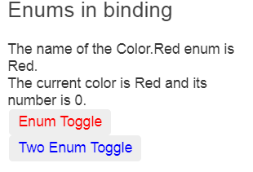
Svg
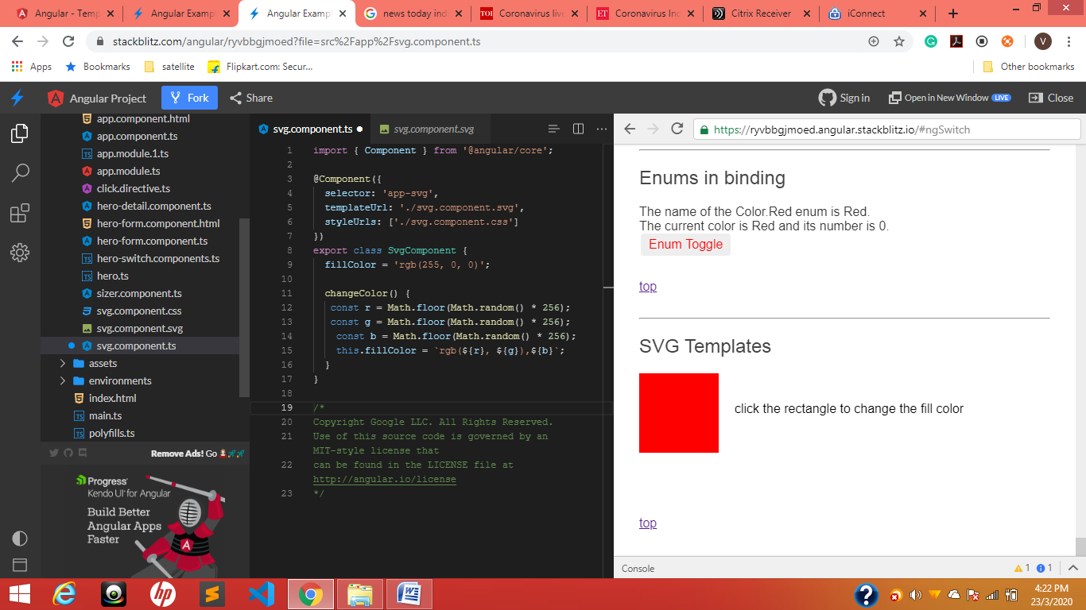
import { Component } from '@angular/core';

@Component({
selector: 'app-svg',
templateUrl: './svg.component.svg',
styleUrls: ['./svg.component.css']
})
export class SvgComponent {
fillColor = 'rgb(255, 0, 0)';

changeColor() {
const r = Math.floor(Math.random() * 256);
const g = Math.floor(Math.random() * 256);
const b = Math.floor(Math.random() * 256);
this.fillColor = `rgb(${r}, ${g}),${b}`;
}
}

/*
Copyright Google LLC. All Rights Reserved.
Use of this source code is governed by an MIT-style license that
can be found in the LICENSE file at http://angular.io/license
*/

<svg>
<g>
<rect x="0" y="0" width="100" height="100" [attr.fill]="fillColor" (click)="changeColor()" />
<text x="120" y="50">click the rectangle to change the fill color</text>
</g> s
</svg>

Css
svg {
display: block;
width: 100%;
}

Input events
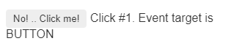
import { Component } from '@angular/core';

@Component({
selector: 'app-click-me2',
template: `
<button (click)="onClickMe2($event)">No! .. Click me!</button>
{{clickMessage}}`
})
export class ClickMe2Component {
clickMessage = '';
clicks = 1;

onClickMe2(event: any) {
let evtMsg = event ? ' Event target is ' + event.target.tagName : '';
this.clickMessage = (`Click #${this.clicks++}. ${evtMsg}`);
}
}

(click)="onClickMe2($event)
(keyup)="onKey($event)

onKey(event: KeyboardEvent) {
this.values += (event.target as HTMLInputElement).value + ' | ';
}
}

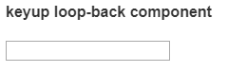
<input #box (keyup)="0">
<p>{{box.value}}</p>

Or other
<input #box (keyup)="onKey(box.value)">
<p>{{values}}</p>

values = '';
onKey(value: string) {
this.values += value + ' | ';
}

Enter
<input #box (keyup.enter)="onEnter(box.value)">
<p>{{value}}</p>

value = '';
onEnter(value: string) { this.value = value; }

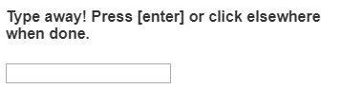
<input #box
(keyup.enter)="update(box.value)"
(blur)="update(box.value)">

<p>{{value}}</p>

value = '';
update(value: string) { this.value = value; }
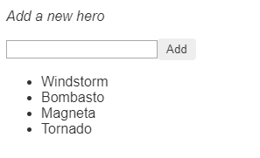
<input #newHero (keyup.enter)="addHero(newHero.value)" (blur)="addHero(newHero.value); newHero.value='' ">

<button (click)="addHero(newHero.value)">Add</button>

<ul><li *ngFor="let hero of heroes">{{hero}}</li></ul>

heroes = ['Windstorm', 'Bombasto', 'Magneta', 'Tornado'];
addHero(newHero: string) {
if (newHero) {
this.heroes.push(newHero);
}
}

Component Communication Cookbook
Hero.component
export interface Hero {
name: string;
id: number;
}

export const HEROES = [
{name: 'Dr IQ',id:1234},
{name: 'Magneta'},
{name: 'Bombasto'}
];

component parent
import { Component } from '@angular/core';

import { HEROES } from './hero';

@Component({
selector: 'app-hero-parent',
template: `
<h2>{{master}} controls {{heroes.length}} heroes</h2>
<app-hero-child

*ngFor="let hero of heroes"
[hero]="hero"

[master]="master" >
</app-hero-child>
`
})
export class HeroParentComponent {
heroes = HEROES;
master = 'Master';
}

child.component
import { Component, Input } from '@angular/core';

import { Hero } from './hero';

@Component({
selector: 'app-hero-child',
template: `
<h3>{{hero.name}} says:</h3>
<div>
{{hero.id}}{{hero.name}}
</div>
<p>I, {{hero.name}}, am at your service, {{masterName}}.</p>
`
})
export class HeroChildComponent {
@Input() hero: Hero;

@Input('master') masterName: string;

}

masterName we will assaign without creating a variable

Source code version
ngOnChanges ("Source code version")
ngONChanges

/* tslint:disable:forin */
import { Component, Input, OnChanges, SimpleChange } from '@angular/core';

@Component({
selector: 'app-version-child',
template: `
<h3>Version {{major}}.{{minor}}</h3>
<h4>Change log:</h4>
<ul>
<li *ngFor="let change of changeLog">{{change}}</li>
</ul>
`
})
export class VersionChildComponent implements OnChanges {
@Input() major: number;
@Input() minor: number;
changeLog: string[] = [];

ngOnChanges(changes: {[propKey: string]: SimpleChange}) {
let log: string[] = [];
for (let propName in changes) {
let changedProp = changes[propName];
//console.log(propName)
console.log(changedProp);
let to = JSON.stringify(changedProp.currentValue);
if (changedProp.isFirstChange()) {
log.push(`Initial value of ${propName} set to ${to}`);
} else {
let from = JSON.stringify(changedProp.previousValue);
log.push(`${propName} changed from ${from} to ${to}`);
}
}
this.changeLog.push(log.join(', '));
}
}

SimpleChange will identify the changes

Parent listens for child event ("Colonize Universe")

Should mankind colonize the Universe?
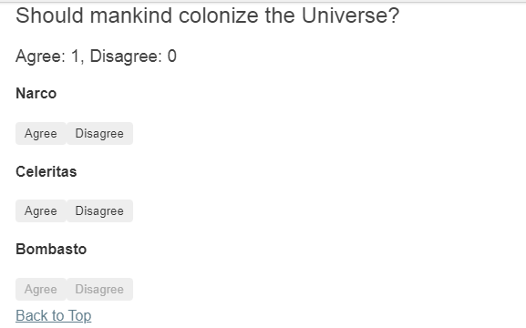
Child
import { Component, EventEmitter, Input, Output } from '@angular/core';

@Component({
selector: 'app-voter',
template: `
<h4>{{name}}</h4>
<button (click)="vote(true)" [disabled]="didVote">Agree</button>
<button (click)="vote(false)" [disabled]="didVote">Disagree</button>
`
})
export class VoterComponent {
@Input() name: string;
@Output() voted = new EventEmitter<boolean>();
didVote = false;

vote(agreed: boolean) {
this.voted.emit(agreed);
this.didVote = true;
}
}

Parent
import { Component } from '@angular/core';

@Component({
selector: 'app-vote-taker',
template: `
<h2>Should mankind colonize the Universe?</h2>
<h3>Agree: {{agreed}}, Disagree: {{disagreed}}</h3>
<app-voter *ngFor="let voter of voters"
[name]="voter"
(voted)="onVoted($event)">
</app-voter>
`
})
export class VoteTakerComponent {
agreed = 0;
disagreed = 0;
voters = ['Narco', 'Celeritas', 'Bombasto'];

onVoted(agreed: boolean) {
agreed ? this.agreed++ : this.disagreed++;
}
}

Parent to child via local variable("Countdown to Liftoff")
Parent calls ViewChild("Countdown to Liftoff")
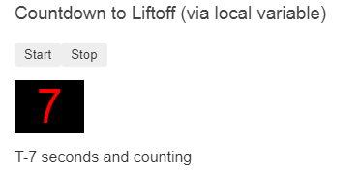
How to call a child component method in parent component @viewchild
@ViewChild(CountdownTimerComponent)
private timerComponent: CountdownTimerComponent;
start() { this.timerComponent.start(); }
stop() { this.timerComponent.stop(); }

import { AfterViewInit, ViewChild } from '@angular/core';
import { Component } from '@angular/core';
import { CountdownTimerComponent } from './countdown-timer.component';

//// Local variable, #timer, version
@Component({
selector: 'app-countdown-parent-lv',
template: `
<h3>Countdown to Liftoff (via local variable)</h3>
<button (click)="timer.start()">Start</button>
<button (click)="timer.stop()">Stop</button>
<div class="seconds">{{timer.seconds}}</div>
<app-countdown-timer #timer></app-countdown-timer>
`,
styleUrls: ['../assets/demo.css']
})
export class CountdownLocalVarParentComponent { }

//// View Child version
@Component({
selector: 'app-countdown-parent-vc',
template: `
<h3>Countdown to Liftoff (via ViewChild)</h3>
<button (click)="start()">Start</button>
<button (click)="stop()">Stop</button>
<div class="seconds">{{ seconds() }}</div>
<app-countdown-timer></app-countdown-timer>
`,
styleUrls: ['../assets/demo.css']
})
export class CountdownViewChildParentComponent implements AfterViewInit {

@ViewChild(CountdownTimerComponent)
private timerComponent: CountdownTimerComponent;

seconds() { return 0; }

ngAfterViewInit() {
// Redefine `seconds()` to get from the `CountdownTimerComponent.seconds` ...
// but wait a tick first to avoid one-time devMode
// unidirectional-data-flow-violation error
setTimeout(() => this.seconds = () => this.timerComponent.seconds, 0);
}

start() { this.timerComponent.start(); }
stop() { this.timerComponent.stop(); }
}

/*
Copyright Google LLC. All Rights Reserved.
Use of this source code is governed by an MIT-style license that
can be found in the LICENSE file at http://angular.io/license
*/

Child
import { Component, OnDestroy, OnInit } from '@angular/core';

@Component({
selector: 'app-countdown-timer',
template: '<p>{{message}}</p>'
})
export class CountdownTimerComponent implements OnInit, OnDestroy {

intervalId = 0;
message = '';
seconds = 11;

clearTimer() { clearInterval(this.intervalId); }

ngOnInit() { this.start(); }
ngOnDestroy() { this.clearTimer(); }

start() { this.countDown(); }
stop() {
this.clearTimer();
this.message = `Holding at T-${this.seconds} seconds`;
}

private countDown() {
this.clearTimer();
this.intervalId = window.setInterval(() => {
this.seconds -= 1;
if (this.seconds === 0) {
this.message = 'Blast off!';
} else {
if (this.seconds < 0) { this.seconds = 10; } // reset
this.message = `T-${this.seconds} seconds and counting`;
}
}, 1000);
}
}

