Reactive Forms
Only one text box can handle with only FormControl
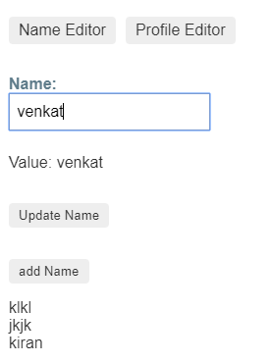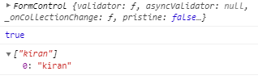
<label>
Name:
<input type="text" [formControl]="name">
</label>
<p>
Value: {{ name.value }}
</p>
<p>
<button (click)="updateName()">Update Name</button>
</p>
<p>
<button (click)="addNames()">add Name</button>
</p>
<div *ngFor="let names of namesArray">{{names}}</div>

import { Component } from '@angular/core';
import { FormControl, Validators } from '@angular/forms';

@Component({
selector: 'app-name-editor',
templateUrl: './name-editor.component.html',
styleUrls: ['./name-editor.component.css']
})
export class NameEditorComponent {
name = new FormControl('',[Validators.required]);
namesArray=[];

updateName() {
this.name.setValue('Nancy');

}

addNames(){
console.log(this.name)
console.log(this.name.valid)
this.namesArray.push(this.name.value)
console.log(this.namesArray);
this.name.reset()
}
}

Creating nested form groups
Address was nested
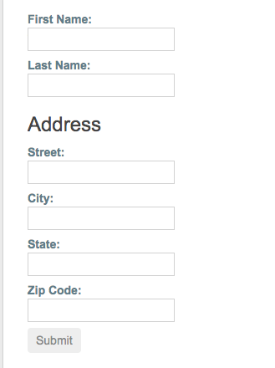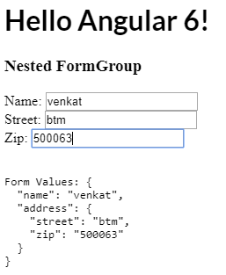
import { Component } from '@angular/core';
import { FormGroup, FormControl } from '@angular/forms';
@Component({ selector: 'app-profile-editor',
templateUrl: './profile-editor.component.html',
styleUrls: ['./profile-editor.component.css']
})
export class ProfileEditorComponent {
profileForm = new FormGroup({
firstName: new FormControl(''),
lastName: new FormControl(''),
address: new FormGroup({ street: new FormControl(''),
city: new FormControl(''),
state: new FormControl(''),
zip: new FormControl('')
}) }); }
Html
<div formGroupName="address">
<h3>Address</h3>
<label>
Street:<input type="text" formControlName="street">
</label>
<label>
City: <input type="text" formControlName="city">
</label>
<label>
State:<input type="text" formControlName="state">
</label>
<label>
Zip Code:<input type="text" formControlName="zip">
</label>
</div>

Generating form controls with FormBuilder
https://angular.io/guide/reactive-forms#creating-nested-form-groups
import { Component } from '@angular/core';
import { FormBuilder } from '@angular/forms';
@Component({ selector: 'app-profile-editor',
templateUrl: './profile-editor.component.html',
styleUrls: ['./profile-editor.component.css']
})
export class ProfileEditorComponent {
profileForm = this.fb.group({
firstName: [''], lastName: [''],
address: this.fb.group({
street: [''],
city: [''],
state: [''],
zip: [''] }), });
constructor(private fb: FormBuilder) { } }
creating form Builder

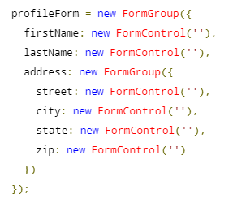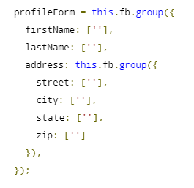
https://stackblitz.com/angular/jlqxjyojodn?file=src%2Fapp%2Fprofile-editor%2Fprofile-editor.component.ts
patchValues
updateProfile() {
this.profileForm.patchValue({
firstName: 'Nancy',
address: {
street: '123 Drew Street'
}
});
}

Auto fill update with patch values
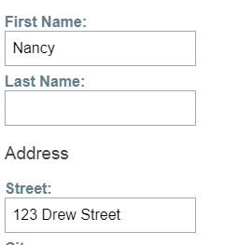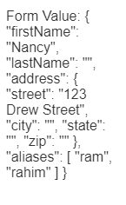
Form Group , nested form, form Array

Dynamic controls using form arrays

import { Component } from '@angular/core';
import { FormBuilder } from '@angular/forms';
import { Validators } from '@angular/forms';
import { FormArray } from '@angular/forms';

@Component({
selector: 'app-profile-editor',
templateUrl: './profile-editor.component.html',
styleUrls: ['./profile-editor.component.css']
})
export class ProfileEditorComponent {
profileForm = this.fb.group({
firstName: ['', Validators.required],
lastName: [''],
address: this.fb.group({
street: [''],
city: [''],
state: [''],
zip: ['']
}),
aliases: this.fb.array([
this.fb.control('')
])
});

get aliases() {
return this.profileForm.get('aliases') as FormArray;
}

constructor(private fb: FormBuilder) { }

updateProfile() {
this.profileForm.patchValue({
firstName: 'Nancy',
address: {
street: '123 Drew Street'
}
});
}

addAlias() {
this.aliases.push(this.fb.control(''));
}

onSubmit() {
// TODO: Use EventEmitter with form value
console.warn(this.profileForm.value);
}
}

https://angular.io/guide/reactive-forms#reactive-forms-api
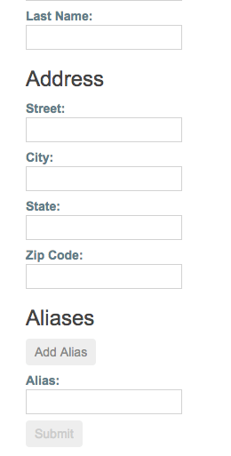
<div formArrayName="aliases">
<h3>Aliases</h3>
<button (click)="addAlias()">Add Alias</button>
<div *ngFor="let alias of aliases.controls; let i=index">
<!-- The repeated alias template -->
<label> Alias: <input type="text" [formControlName]="i"> </label>
</div>
</div>

