Advertisements
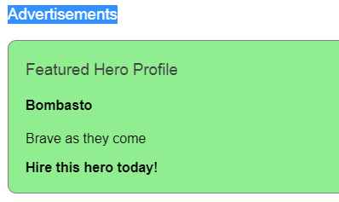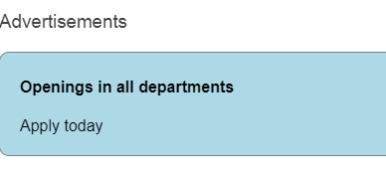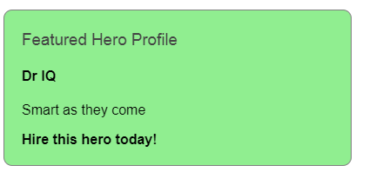
*******************************************************************
http://www.sahosofttutorials.com/Course/Angular7/200/
Dynamic component loader
If we give like this <app-comp> all will view but Requirement like load component when click or select
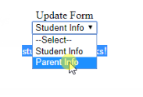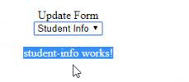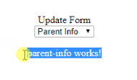
Ap.module.ts
import { BrowserModule } from '@angular/platform-browser';
import { NgModule } from '@angular/core';

import { AppComponent } from './app.component';
import { StudentInfoComponent } from './student-info/student-info.component';
import { ParentInfoComponent } from './parent-info/parent-info.component';

@NgModule({
declarations: [
AppComponent,
StudentInfoComponent,
ParentInfoComponent
],
imports: [
BrowserModule
],
providers: [],
bootstrap: [AppComponent],
entryComponents: [StudentInfoComponent,ParentInfoComponent]
})
export class AppModule { }
app.component.html
<div class="box-header with-border">
<div class="form-group voffset row">
<label for="" class="vertical-label col-sm-4 col-md-8 text-right"> Update Form</label>
<div class="col-sm-8 col-md-4">
<select (change)="selectName($event.target.value);">
<option value="0">--Select--</option>
<option [value]="obj.Id" *ngFor="let obj of data">
{{obj.Name}}
</option>
</select>
</div>
</div>
<div class="form-group voffset row">
<template #loadComponent>
</template>
</div>
</div>

App.component.ts
import {
Component,
ViewChild,
ViewContainerRef,
ComponentFactoryResolver,
ComponentRef,
ComponentFactory
} from '@angular/core';
import { StudentInfoComponent } from './student-info/student-info.component';
import { ParentInfoComponent } from './parent-info/parent-info.component';

@Component({
selector: 'app-root',
templateUrl: './app.component.html',
styleUrls: ['./app.component.css']
})
export class AppComponent {
title = 'app';
componentRef: any;
@ViewChild('loadComponent', { read: ViewContainerRef }) entry: ViewContainerRef;
constructor(private resolver: ComponentFactoryResolver) { }
createComponent(Id: number) {
this.entry.clear();
if (Id == 1) {
const factory = this.resolver.resolveComponentFactory(StudentInfoComponent);
this.componentRef = this.entry.createComponent(factory);
} else if (Id == 2) {
const factory = this.resolver.resolveComponentFactory(ParentInfoComponent);
this.componentRef = this.entry.createComponent(factory);
}
this.componentRef.instance.message = "Called by appComponent";
}
destroyComponent() {
this.componentRef.destroy();
}
data = [
{
"Id": 1,
"Name": "Student Info"
},
{
"Id": 2,
"Name": "Parent Info"
}
]
selectName(id : number) {
this.createComponent(id);
}
}

https://stackblitz.com/angular/vvmmveykakg?file=src%2Fapp%2Fhighlight.directive.ts
Attribute directives
mouse enters or leaves Text color has to change
color appears when the pointer hovers over the paragraph element and disappears as the pointer moves out.
on radio button selection color has to change
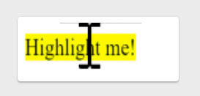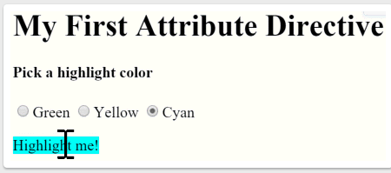
Step1
import { Directive, ElementRef } from '@angular/core';
@Directive({ selector: '[appHighlight]' })
export class HighlightDirective {
constructor(el: ElementRef) {
el.nativeElement.style.backgroundColor = 'yellow';
}
};
App.comp.html
<p appHighlight>Highlight me!</p>

Step2
import { Directive, ElementRef, HostListener, Input } from '@angular/core';

@Directive({
selector: '[appHighlight]'
})
export class HighlightDirective {

constructor(private el: ElementRef) {
this.highlight('yellow')
}
@Input() defaultColor: string;

@Input('appHighlight') highlightColor: string;

@HostListener('mouseenter') OnMouseEnter(){
this.highlight(this.highlightColor = 'red' )
}
@HostListener('mouseleave') OnMouseLeave(){
this.highlight(null)
}
private highlight(color: string) {
this.el.nativeElement.style.backgroundColor = color;
}
}
Html
<h4>Pick a highlight color</h4>

<p appHighlight="orange">Highlighted in orange</p>
<p [appHighlight]="color">Highlight me!</p>
<p [appHighlight]="color" defaultColor="violet">
Default Highlight me too!
</p>
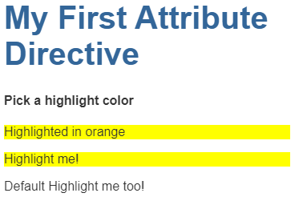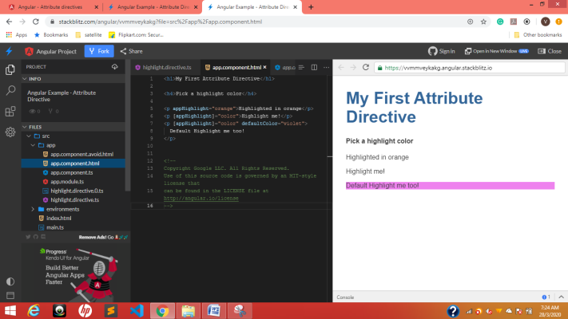
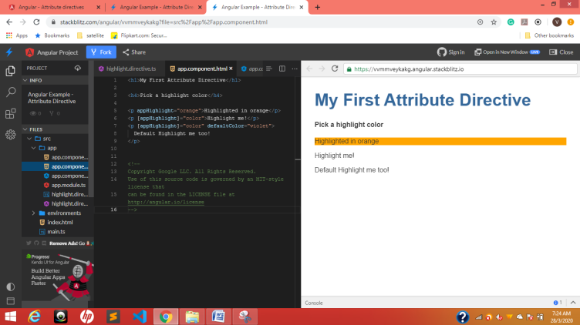
Three different colors

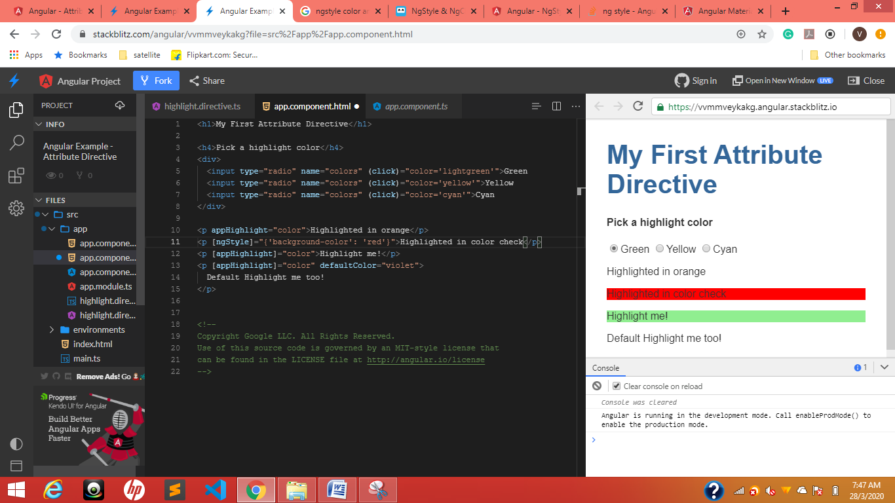
[ngStyle]=”{‘background-color’: ‘red’}”
[ngStyle]=”{‘key’: ‘value’}”
ngStyle is objective
<p appHighlight="color">Highlighted in orange</p>
<p [ngStyle]="{'color':color}">Highlighted in color check</p>
<p [appHighlight]="color">Highlight me!</p>
<p [appHighlight]="color" defaultColor="violet">
Default Highlight me too!
</p>
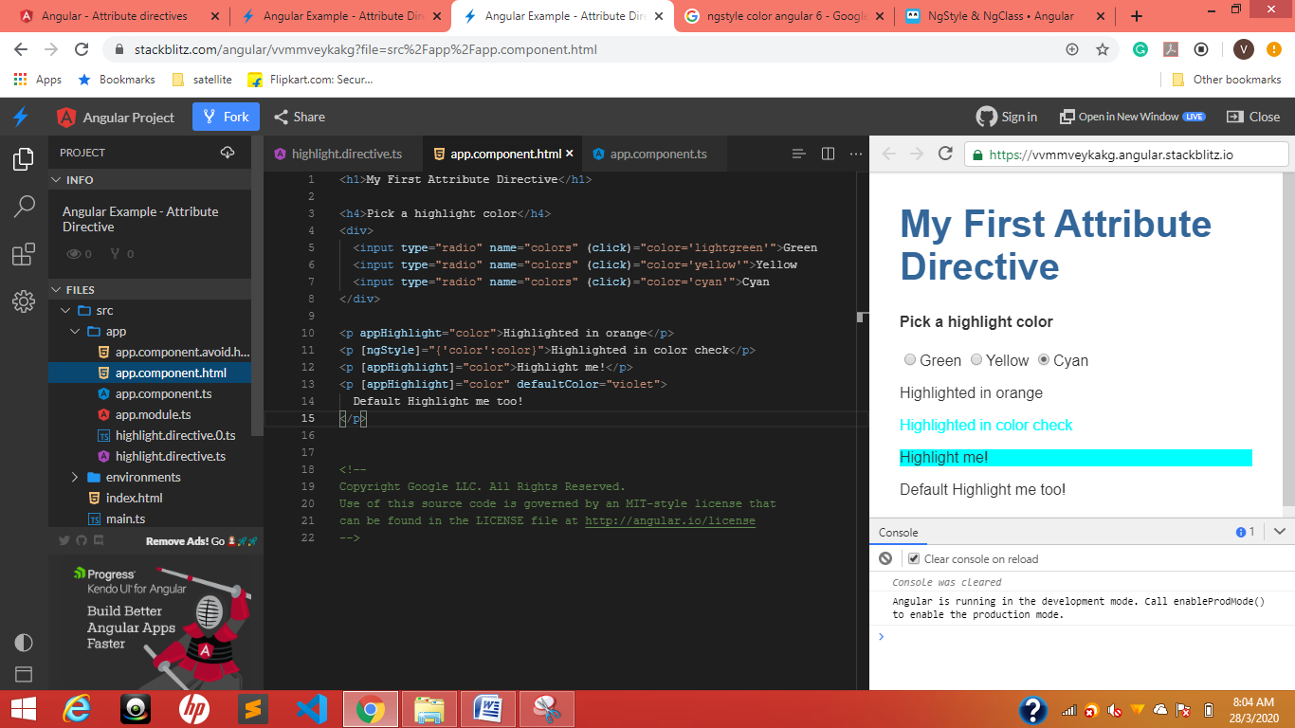

Structural directives
https://stackblitz.com/angular/ygjxdrnerky?file=src%2Fapp%2Fapp.component.html
ngIf
*ngIf="true" [style.display]="'block'” [style.display]="’none’”
<p *ngIf="true">
Expression is true and ngIf is true.
This paragraph is in the DOM.
</p>
<p *ngIf="false">
Expression is false and ngIf is false.
This paragraph is not in the DOM.
</p>

<p [style.display]="'block'">
Expression sets display to "block".
This paragraph is visible.
</p>
<p [style.display]="'none'">
Expression sets display to "none".
This paragraph is hidden but still in the DOM.
</p>

Toggle
Now conditionally exclude a select <option> with <ng-container>.

The <ng-template>
The <ng-template> is an Angular element for rendering HTML. It is never displayed directly. In fact, before rendering the view, Angular replaces the <ng-template> and its contents with a comment.
If there is no structural directive and you merely wrap some elements in a <ng-template>, those elements disappear. That's the fate of the middle "Hip!" in the phrase "Hip! Hip! Hooray!".

*ngIf="hero"
*ngIf="!hero"

<button (click)="hero = hero ? kiran : heroes[0]">Toggle hero</button>
<span *ngIf='kiran? kiran : hero'>for null check kkkkkkk</span>
Ts.file
kiran:boolean;

if selected only then show in dropdown <ng-container>
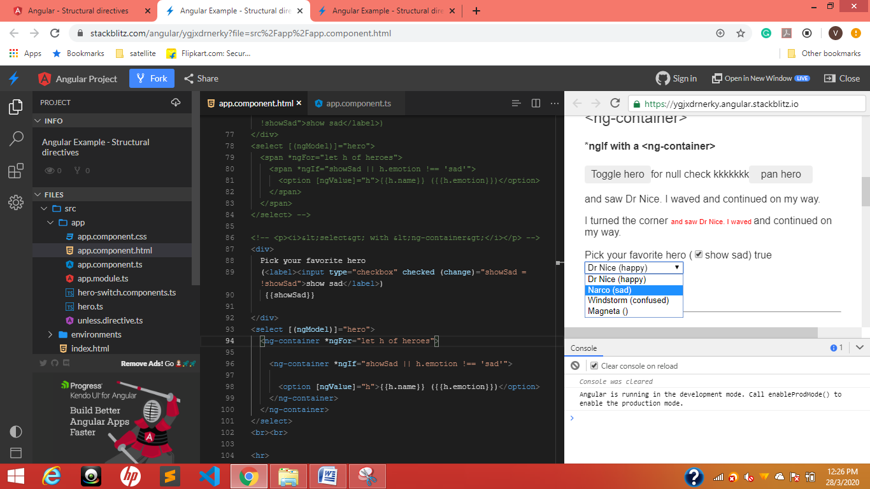

<select [(ngModel)]="hero">

<ng-container *ngFor="let h of heroes">

<ng-container *ngIf="showSad || h.emotion !== 'sad'">

<option [ngValue]="h">{{h.name}} ({{h.emotion}})</option>

</ng-container>
</ng-container>
</select>

TemplateRef and ViewContainerRef

The appUnless property

UnlessDirective

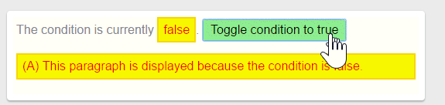
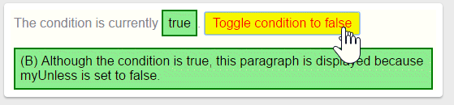
Just toggle *appUnless
<!-- start -->
<button (click)="condition = !condition" > Toggle condition to
condition ? 'false' : 'true'}} </button>
<p *appUnless="condition"> (A) This paragraph is displayed because the condition is false. </p>
<p *appUnless="!condition" > (B) Although the condition is true, this paragraph is displayed because appUnless is set to false. </p>
<p *appUnless="condition">Show this sentence unless the condition is true.</p>

<p *appUnless="condition" class="code unless">
(A) &lt;p *appUnless="condition" class="code unless"&gt;
</p>

<!-- end -->

Html
<h2 id="appUnless">UnlessDirective</h2>
<p> The condition is currently <span [ngClass]="{ 'a': !condition, 'b': condition, 'unless': true }">{{condition}}</span>.
<button (click)="condition = !condition" [ngClass] = "{ 'a': condition, 'b': !condition }" > Toggle condition to
condition ? 'false' : 'true'}} </button> </p>
<p *appUnless="condition" class="unless a"> (A) This paragraph is displayed because the condition is false. </p>
<p *appUnless="!condition" class="unless b"> (B) Although the condition is true, this paragraph is displayed because appUnless is set to false. </p>

ngFor odd even text highlet
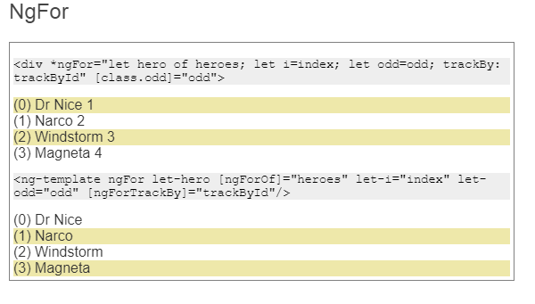
[class.odd]="even">
[class.odd]="odd"
<p class="code">&lt;div *ngFor="let hero of heroes; let i=index; let odd=odd; trackBy: trackById" [class.odd]="odd"&gt;</p>
<div
*ngFor="let hero of heroes;
let i=index;
let odd=odd;
let even=even;
trackBy: trackById"
[class.odd]="even">
({{i}}) {{hero.name}} {{hero.id}}
</div>
<p class="code">&lt;ng-template ngFor let-hero [ngForOf]="heroes" let-i="index" let-odd="odd" [ngForTrackBy]="trackById"/&gt;</p>
<ng-template ngFor let-hero [ngForOf]="heroes" let-i="index" let-odd="odd" [ngForTrackBy]="trackById">
<div [class.odd]="odd">({{i}}) {{hero.name}}</div>
</ng-template>

NgSwitch

Many components in component.ts file
import { Component, Input } from '@angular/core';
import { Hero } from './hero';

@Component({
selector: 'app-happy-hero',
template: `Wow. You like {{hero.name}}. What a happy hero ... just like you.`
})
export class HappyHeroComponent {
@Input() hero: Hero;
}

@Component({
selector: 'app-sad-hero',
template: `You like {{hero.name}}? Such a sad hero. Are you sad too?`
})
export class SadHeroComponent {
@Input() hero: Hero;
}

@Component({
selector: 'app-confused-hero',
template: `Are you as confused as {{hero.name}}?`
})
export class ConfusedHeroComponent {
@Input() hero: Hero;
}

@Component({
selector: 'app-unknown-hero',
template: `{{message}}`
})
export class UnknownHeroComponent {
@Input() hero: Hero;
get message() {
return this.hero && this.hero.name ?
`${this.hero.name} is strange and mysterious.` :
'Are you feeling indecisive?';
}
}

export const heroSwitchComponents =
[ HappyHeroComponent, SadHeroComponent, ConfusedHeroComponent, UnknownHeroComponent ];

/*
Copyright Google LLC. All Rights Reserved.
Use of this source code is governed by an MIT-style license that
can be found in the LICENSE file at http://angular.io/license
*/

<p>
<label *ngFor="let h of heroes">
<input type="radio" name="heroes" [(ngModel)]="hero" [value]="h">{{h.name}}
</label>
<label><input type="radio" name="heroes" (click)="hero = null">None of the above</label>
</p>

<h4>NgSwitch</h4>

<div [ngSwitch]="hero?.emotion">
<app-happy-hero *ngSwitchCase="'happy'" [hero]="hero"></app-happy-hero>
<app-sad-hero *ngSwitchCase="'sad'" [hero]="hero"></app-sad-hero>
<app-confused-hero *ngSwitchCase="'confused'" [hero]="hero"></app-confused-hero>
<app-unknown-hero *ngSwitchDefault [hero]="hero"></app-unknown-hero>
</div>

Pipes

Power Booster
2^10=1024
<p>Super power boost: {{2 | exponentialStrength: 10}}</p>
https://stackblitz.com/angular/yordgxmxrgo?file=src%2Fapp%2Fpower-boost-calculator.component.ts
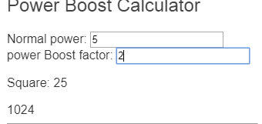

@Component({
selector: 'app-power-boost-calculator',
template: `
<h2>Power Boost Calculator</h2>
<div>Normal power: <input [(ngModel)]="power"></div>
<div>Boost factor: <input [(ngModel)]="factor"></div>
<p>
Super Hero Power: {{power | exponentialStrength: factor}}
</p>
`
})
export class PowerBoostCalculatorComponent {
power = 5;
factor = 1;
}

enterValue =Math.pow(2, 10);;

https://stackblitz.com/angular/yordgxmxrgo?file=src%2Fapp%2Fflying-heroes.component.html
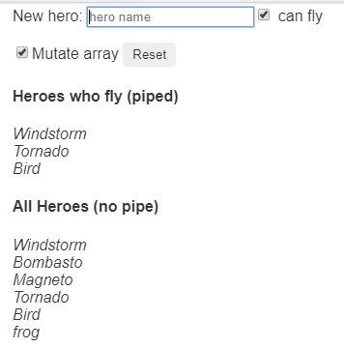
On click of check box entered value should go to respective category
<h2>{{title}}</h2>
<p>
New hero:
<input type="text" #box
(keyup.enter)="addHero(box.value); box.value=''"
placeholder="hero name">
<input id="can-fly" type="checkbox" [(ngModel)]="canFly"> can fly
</p>
<p>
<input id="mutate" type="checkbox" [(ngModel)]="mutate">Mutate array
<button (click)="reset()">Reset</button>
</p>

<h4>Heroes who fly (piped)</h4>
<div id="flyers">
<div *ngFor="let hero of (heroes | flyingHeroes)">
{{hero.name}}
</div>
</div>

<h4>All Heroes (no pipe)</h4>
<div id="all">
<div *ngFor="let hero of heroes">
{{hero.name}}
</div>
</div>

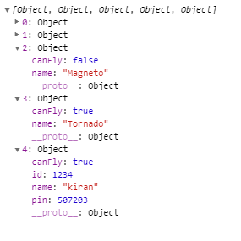
ID, pin of key and values added dynamically
import { Component } from '@angular/core';
import { HEROES } from './heroes';

@Component({
selector: 'app-flying-heroes',
templateUrl: './flying-heroes.component.html',
styles: ['#flyers, #all {font-style: italic}']
})
export class FlyingHeroesComponent {
heroes: any[] = [];
canFly = true;
mutate = true;
title = 'Flying Heroes (pure pipe)';

constructor() { this.reset(); }

addHero(name: string) {

name = name.trim();
if (!name) { return; }
let hero = {name, canFly: this.canFly, id:1234, pin:507203};
if (this.mutate) {
// Pure pipe won't update display because heroes array reference is unchanged
// Impure pipe will display
this.heroes.push(hero);
} else {
// Pipe updates display because heroes array is a new object
// this.heroes.push(hero);
this.heroes = this.heroes.concat(hero);

}
}

reset() { this.heroes = HEROES.slice(); }
}

Async Hero Message and AsyncPipe
Send message with async pipe

import { Component } from '@angular/core';
import { Observable, interval } from 'rxjs';
import { map, take } from 'rxjs/operators';

@Component({
selector: 'app-hero-message',
template: `
<h2>Async Hero Message and AsyncPipe</h2>
<p>Message: {{ message$ | async }}</p>
<button (click)="resend()">Resend</button>`,
})
export class HeroAsyncMessageComponent {
message$: Observable<string>;

private messages = [
'1You are my hero!',
'2You are the best hero!',
'3Will you be my hero?'
];
constructor() { this.resend(); }
resend() {
this.message$ = interval(1000).pipe(
map(i => this.messages[i]),
take(this.messages.length)
);
}
}

How to convert data type into json format
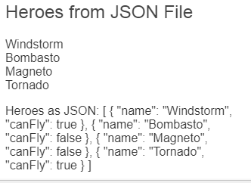
import { Component } from '@angular/core';

@Component({
selector: 'app-hero-list',
template: `
<h2>Heroes from JSON File</h2>

<div *ngFor="let hero of ('assets/heroes.json' | fetch) ">
{{hero.name}}
</div>

<p>Heroes as JSON:
{{'assets/heroes.json' | fetch | json}}
</p>`
})
export class HeroListComponent { }

