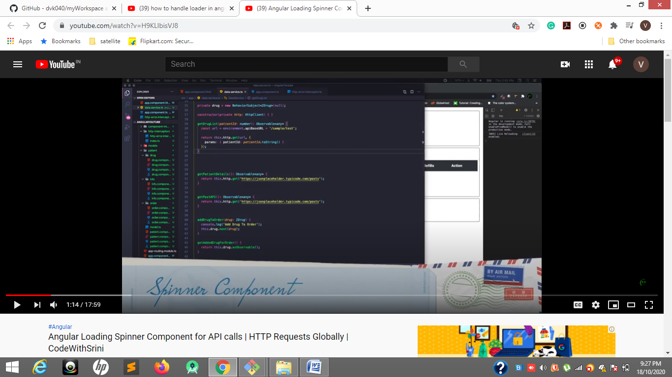
Spinner component step 1
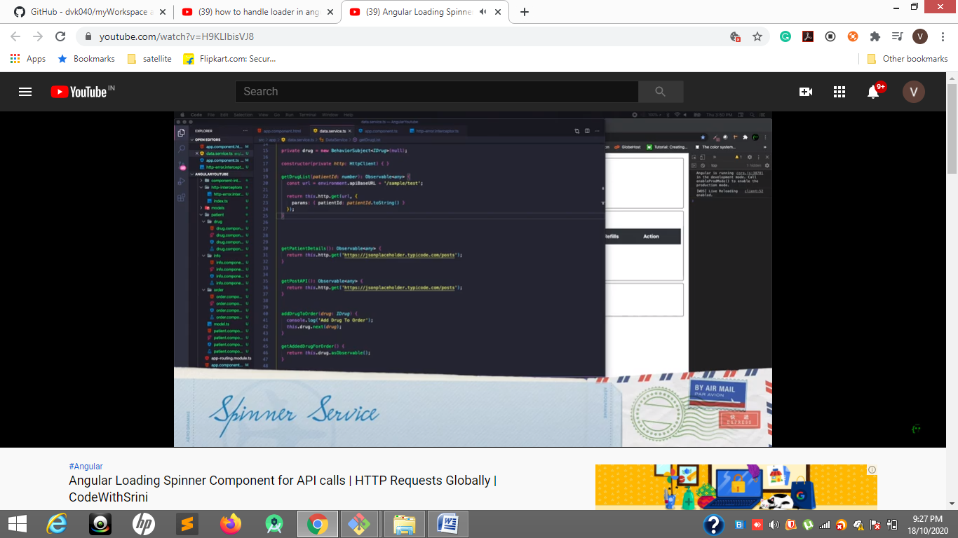
Spinner service step 2
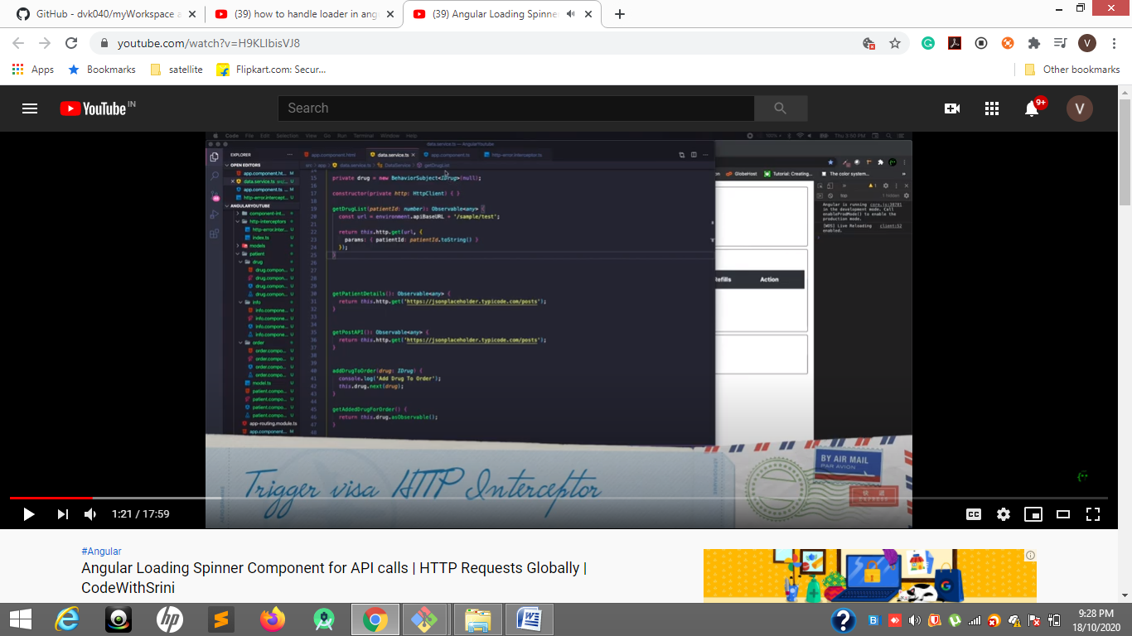
Step 3
https://gist.github.com/codewithsrini/2aae47073072b12cd21484aae47b61f9
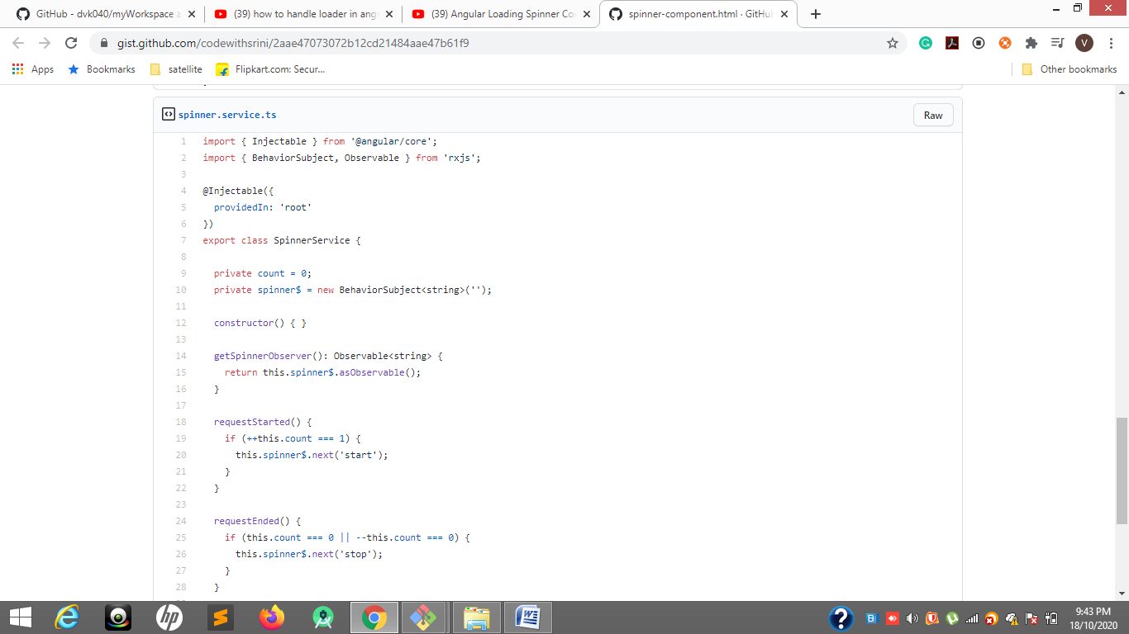
https://gist.github.com/codewithsrini/2aae47073072b12cd21484aae47b61f9
from github
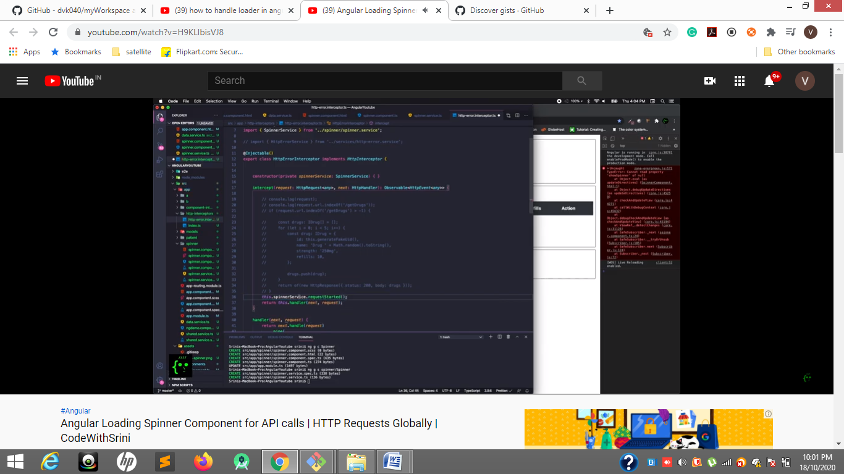
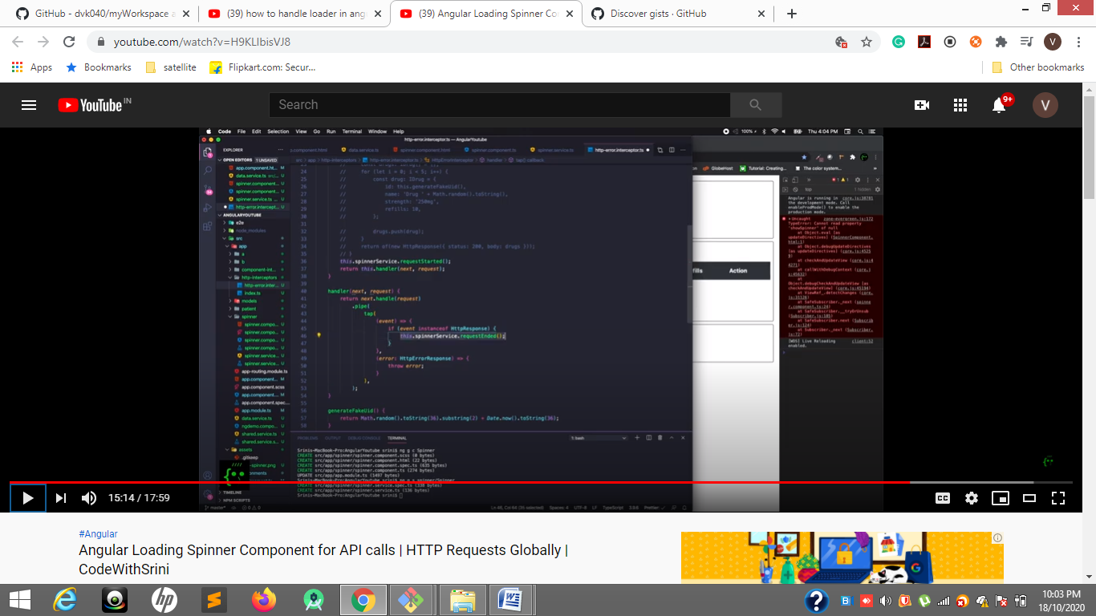
34 to start spinner and in handler 46 to stop end spinner
https://firstclassjs.com/display-a-loader-on-every-http-request-using-interceptor-in-angular-7/
with intercepter
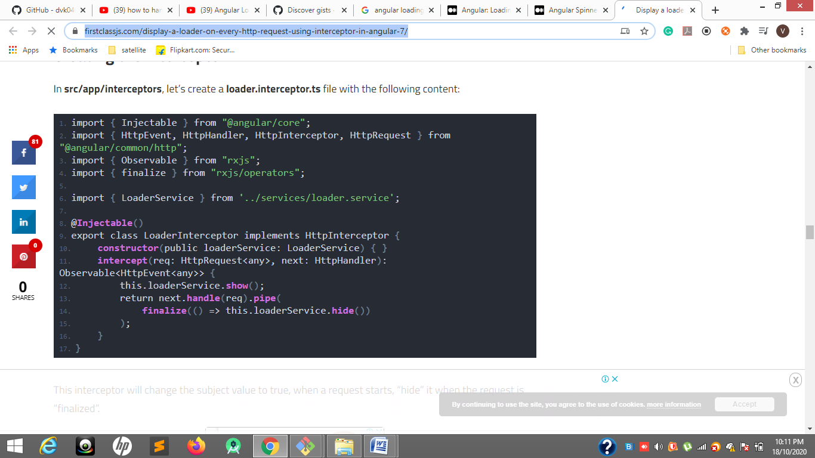

https://www.tektutorialshub.com/angular/angular-pass-data-to-route/

