Change 1push the code

Change 2push the code

Change 3push the code

**Git stash**

Change 4push the code

Git log -3

Git checkout master

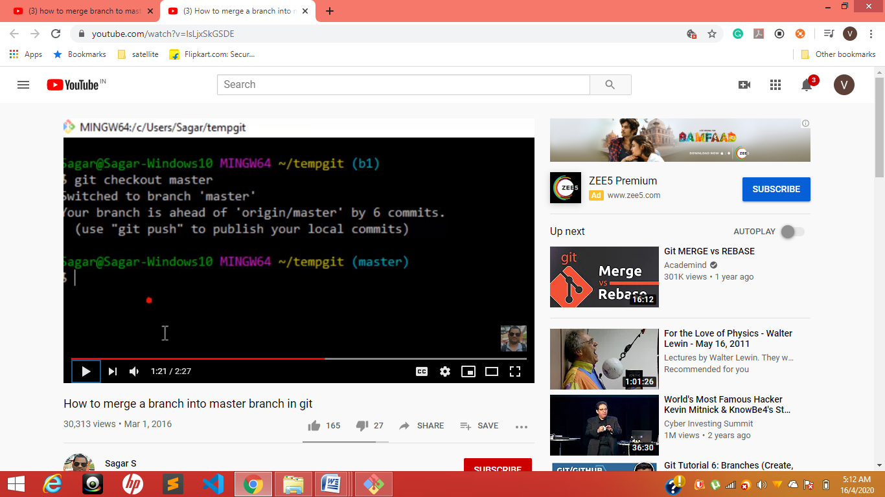

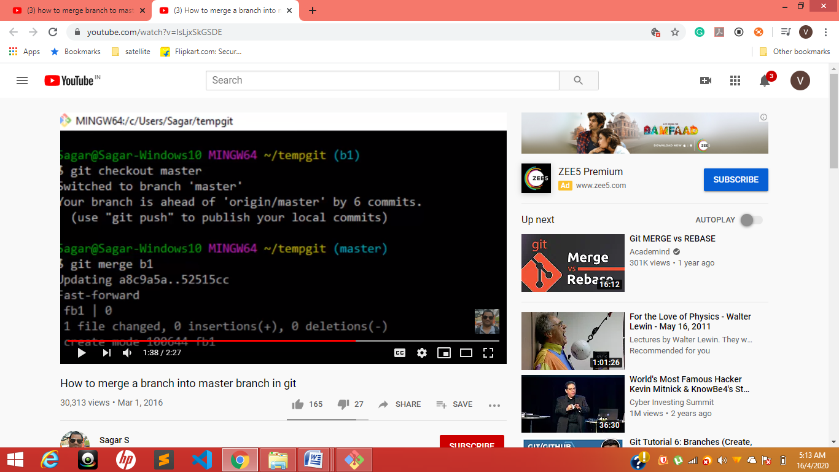

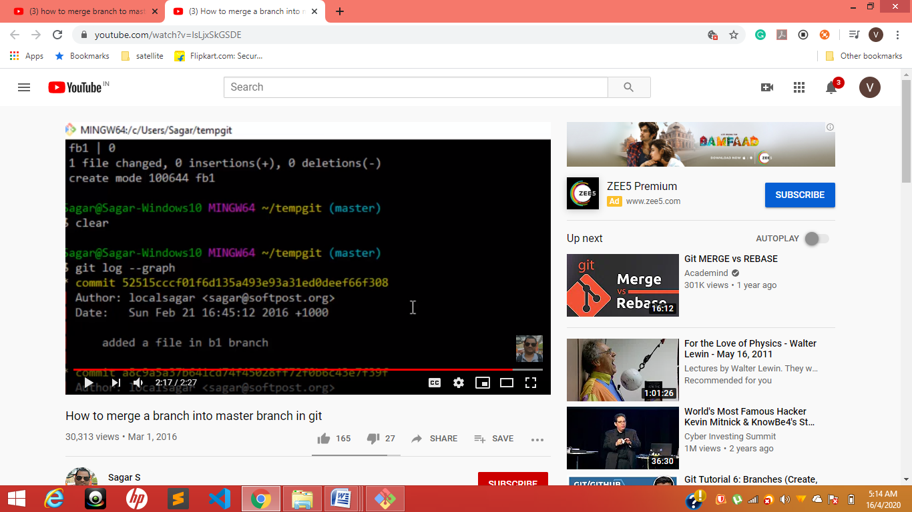

Git log --graph

Brach changes iam in branch if master I wont present

Reverse it Brach changes iam in branch if master I wont present

