<https://github.com/dvk040/myWorkspace>

1.Git stash

2.Git revert

3.Git ignore $ touch .gitignore in gitignore file other file names or *.log(all log files not added)



reverting

stash, diff, reset,revert

discard one file change we can do it by “git checkout filename”

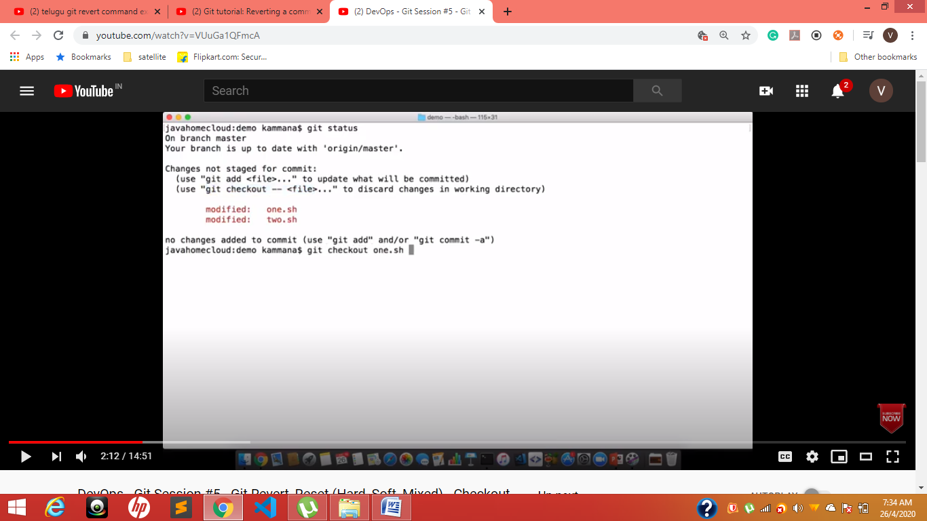

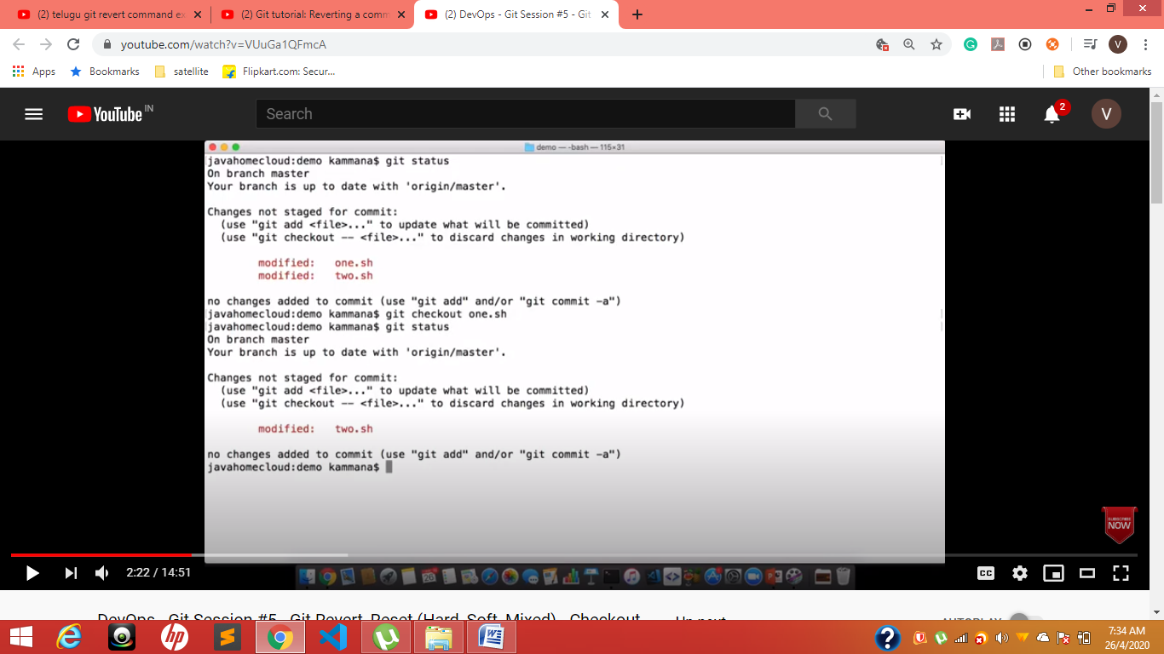

Discarded one.sh not adding changes done in one.sh

Only two.sh available;

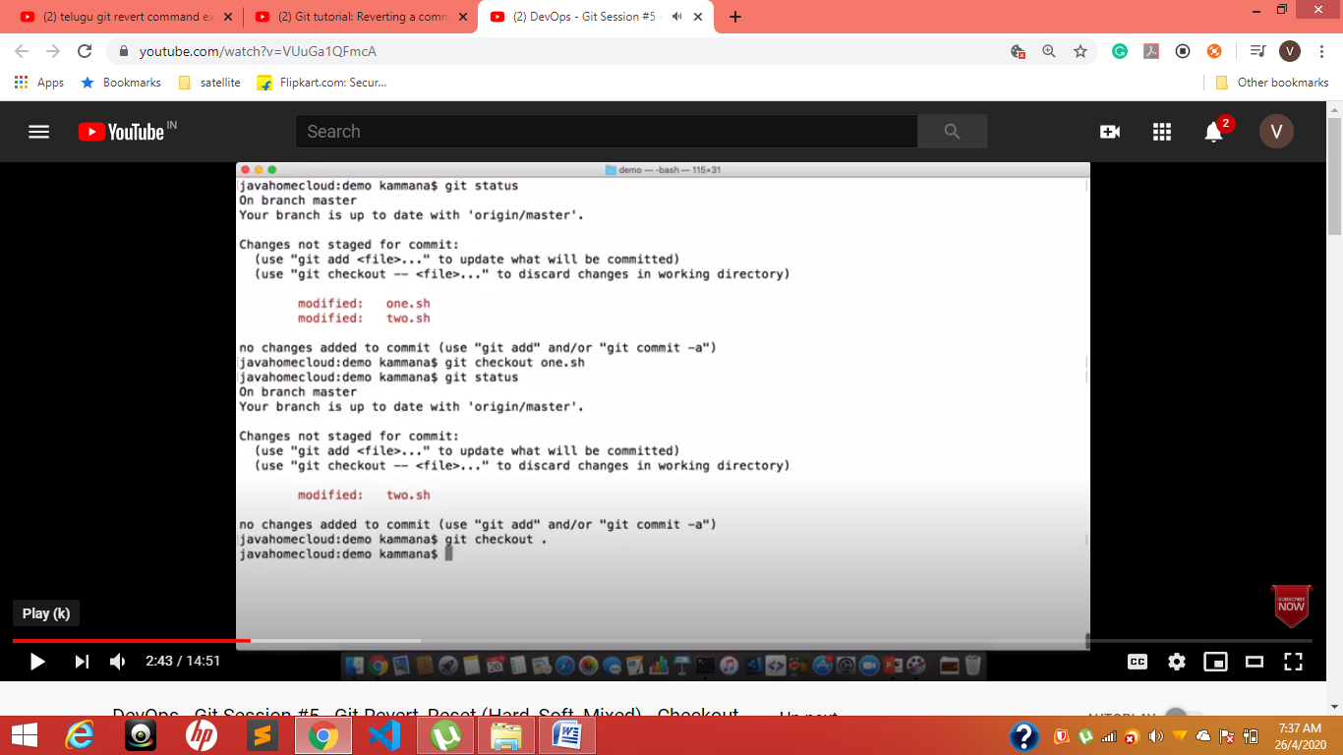

Git checkout . -----------no file will add

**git stash**

**step-1**

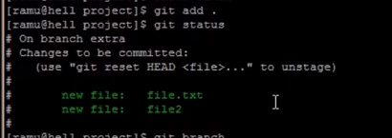

**Step-2**

**Git stash save “message”**

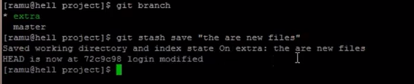

**Step-3**

**Checking status –git status –now they clean**

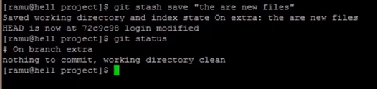

**Step-4**

**Git stash list**

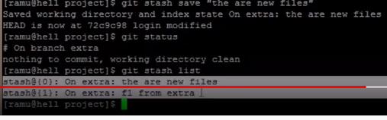

**Step-4 In master checking**

**Git stash apply so those files come to hear---- copy method**

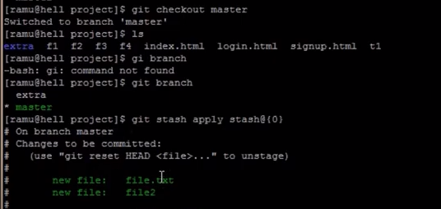

**In master**

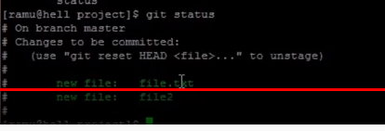

**Now cut and paste**

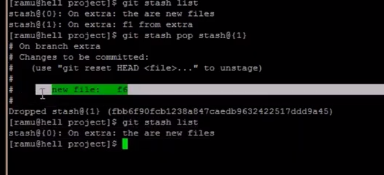

**Git clear stash**

**Git stash list**

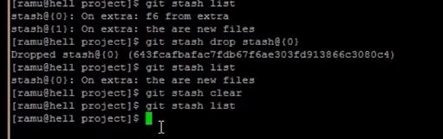

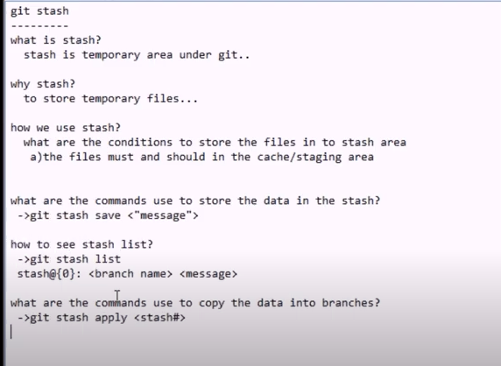

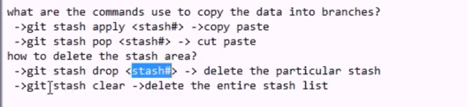

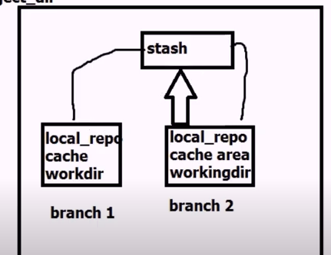

**Timesheet for this date is blocked**

**Hi sir, Unblock the timesheet**

**Git stash-----------------🡪 u changed but not finished But u have to pull code at that time use --🡪git stash save “give message”**

**Next ------🡪 git pull origin master**

**Git stash list----------🡪 to see stash list**

**Git stash show –p id-Number**

**Git stash pop will take recent stash**

**Git stash pop <stash-id>**

**After pop their will be a conflicts check it**

**Git stash drop---🡪latest stash will be drop**

**\*\*\*\*\*\*\*\*\*\*\*\*\*\*\*\*\*\*\*\*\*\*\*\*\*\*\*\*\*\*\*\*\*\*\*\*\*\*\*\*\*\*\*\*\*\*\*\*\*\*\*\*\*\*\*\*\*\*\*\*\*\*\*\*\*\*\*\*\*\*\*\*\*\*\*\*\*\*\*\*\*\*\*\*\*\*\*\*\*\*\*\*\*\*\*\*\*\*\*\*\*\*\*\*\*\*\*\*\*\*\*\*\*\*\*\*\*\*\*\*\*\*\*\*\*\*\*\*\*\*\*\*\*\*\*\*\*\*\*\*\*\*\*\*\*\*\*\*\*\*\*\*\*\*\*\*\***

**Git diff ----------------🡪 will show what are the differences**

**Git push origin branch1:branch2-----------🡪 branch2 is maintained but not shown**

**\*\*\*\*\*\*\*\*\*\*\*\*\*\*\*\*\*\*\*\*\*\*\*\*\*\*\*\*\*\*\*\*\*\*\*\*\*\*\*\*\*\*\*\*\*\*\*\*\*\*\*\*\*\*\*\*\*\*\*\*\*\*\*\*\*\*\*\*\*\*\*\*\*\*\*\*\*\*\*\*\*\*\*\*\*\*\*\*\*\*\*\*\*\*\*\*\*\*\*\*\*\*\*\*\*\*\*\*\*\*\*\*\*\*\*\*\*\*\*\*\*\*\*\*\*\*\*\*\*\*\*\*\*\*\*\*\*\*\*\*\*\*\*\*\*\*\*\*\*\*\*\*\***

**Git branch –d branchName-----------🡪 for delete branch**

**Git branch –merged it will give which branches are merged**

**Git branch --no–merged it will give which branches are Not merged**

**\*\*\*\*\*\*\*\*\*\*\*\*\*\*\*\*\*\*\*\*\*\*\*\*\*\*\*\*\*\*\*\*\*\*\*\*\*\*\*\*\*\*\*\*\*\*\*\*\*\*\*\*\*\*\*\*\*\*\*\*\*\*\*\*\*\*\*\*\*\*\*\*\*\*\*\*\*\*\*\*\*\*\*\*\*\*\*\*\*\*\*\*\*\*\*\*\*\*\*\*\*\*\*\*\*\*\*\*\*\*\*\*\*\*\*\*\*\*\*\*\*\*\*\*\*\*\*\*\*\*\*\*\*\*\*\*\*\*\*\*\*\*\*\*\*\*\*\*\*\*\*\*\*\*\***

**To skip staging -----------------🡪 which means “git add” is not doing-----🡪 directly git commit**

**Git commit –a –m “write any comment”**

**After conflicts resolved**

**You have un merge paths---------🡪enter command ------🡪 git add .--------🡪 git commit**

**Branch to master branch merge**

**Git merge branchName**

**You have un merge paths---------🡪enter command ------🡪 git add .--------🡪 git commit**

**\*\*\*\*\*\*\*\*\*\*\*\*\*\*\*\*\*\*\*\*\*\*\*\*\*\*\*\*\*\*\*\*\*\*\*\*\*\*\*\*\*\*\*\*\*\*\*\*\*\*\*\*\*\*\*\*\*\*\*\*\*\*\*\*\*\*\*\*\*\*\*\*\*\*\*\*\*\*\*\*\*\*\*\*\*\*\*\*\*\*\*\*\*\*\*\*\*\*\*\*\*\*\*\*\*\*\*\*\*\*\*\*\*\*\*\*\*\*\*\*\*\*\*\*\*\*\*\*\*\*\*\*\*\*\*\*\*\*\*\*\*\*\*\*\*\*\*\*\*\*\***

**SVN**. Also known as **Subversion**, **SVN** represents the most popular centralized version control system on the market. With a centralized system, all files and historical data are stored on a central server. And **developers commit their changes directly to that central server repository**

**Git** is the most commonly used version control system. **Git** tracks the changes you make to files, so you have a record of what has been done, and you can revert to specific versions should you ever need to. **Git** also makes collaboration easier, allowing changes by multiple people to all be merged into one source.

**Git branch**

**To create a branch**

**Git checkout –b branchName**

-b means new branch X **Git branch –d branchName-----------🡪 for delete branch**

$ touch .gitignore

Example:

secound.html

thirsdMaster.html

# It will create a gitignore file

# Git gc –auto ---------🡪 for un link files

# Git checkout –f -----🡪 all changes will comeback in files for last commit

# Git checkout filename

# If lost data to retrive

# File to make unstage

# Git restore filename----🡪 un modified to last step

git restore --stage secoundOne.docx

# after add we can make unstage

# Git init its opposite is-------🡪 rm –rf .git folder converted into normal

# Git init X rm –rf .git

# to start git in that folder

# [Ignore modified (but not committed) files in git?](https://stackoverflow.com/questions/655243/ignore-modified-but-not-committed-files-in-git)

git update-index --assume-unchanged dir-im-removing/

git update-index --assume-unchanged config/database.yml

git check-ignore [<options>] <pathname>…​

git check-ignore [<options>] --stdin

I changed observe

I what to check about stat

To know Email

<https://git-scm.com/docs/git-log>

git log --pretty=format:”%h -- %an”

*%h*

abbreviated commit hash

*%an*

author name

Placeholders that expand to information extracted from the commit:

*%H*

commit hash

*%h*

abbreviated commit hash

*%T*

tree hash

*%t*

abbreviated tree hash

*%P*

parent hashes

*%p*

abbreviated parent hashes

*%an*

author name