<https://www.youtube.com/watch?v=zhllkjYYUVE>

.mr-right -----to move right side

.droupdown------

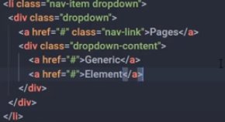

<div class="container text-center">

Padding x direction px , Padding y direction py