Advertisements

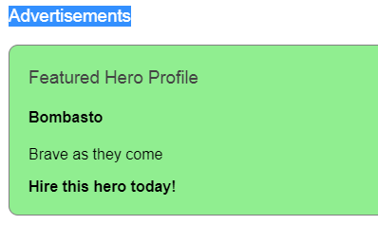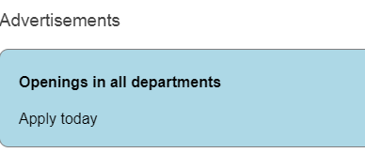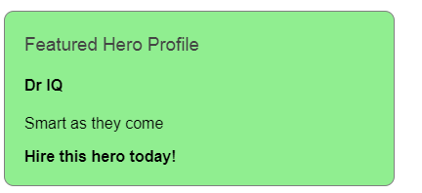

*******************************************************************

<http://www.sahosofttutorials.com/Course/Angular7/200/>

Dynamic component loader

If we give like this <app-comp> all will view but Requirement like load component when click or select

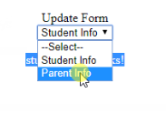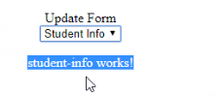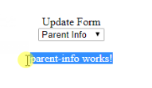

Ap.module.ts

import { BrowserModule } from '@angular/platform-browser';

import { NgModule } from '@angular/core';

import { AppComponent } from './app.component';

import { StudentInfoComponent } from './student-info/student-info.component';

import { ParentInfoComponent } from './parent-info/parent-info.component';

@NgModule({

declarations: [

AppComponent,

StudentInfoComponent,

ParentInfoComponent

],

imports: [

BrowserModule

],

providers: [],

bootstrap: [AppComponent],

**entryComponents: [StudentInfoComponent,ParentInfoComponent]**

})

export class AppModule { }

app.component.html

<div class="box-header with-border">

<div class="form-group voffset row">

<label for="" class="vertical-label col-sm-4 col-md-8 text-right"> Update Form</label>

<div class="col-sm-8 col-md-4">

<select (change)="selectName($event.target.value);">

<option value="0">--Select--</option>

<option [value]="obj.Id" *ngFor="let obj of data">

{{obj.Name}}

</option>

</select>

</div>

</div>

<div class="form-group voffset row">

<template #loadComponent>

</template>

</div>

</div>

App.component.ts

import {

Component,

**ViewChild,**

**ViewContainerRef,**

**ComponentFactoryResolver,**

**ComponentRef,**

**ComponentFactory**

} from '@angular/core';

import { StudentInfoComponent } from './student-info/student-info.component';

import { ParentInfoComponent } from './parent-info/parent-info.component';

@Component({

selector: 'app-root',

templateUrl: './app.component.html',

styleUrls: ['./app.component.css']

})

export class AppComponent {

title = 'app';

componentRef: any;

@ViewChild('loadComponent', { read: ViewContainerRef }) entry: ViewContainerRef;

constructor(private resolver: ComponentFactoryResolver) { }

createComponent(Id: number) {

this.entry.clear();

if (Id == 1) {

**const factory = this.resolver.resolveComponentFactory(StudentInfoComponent);**

**this.componentRef = this.entry.createComponent(factory);**

} else if (Id == 2) {

const **factory = this.resolver.resolveComponentFactory(ParentInfoComponent);**

**this.componentRef = this.entry.createComponent(factory);**

}

this.componentRef.instance.message = "Called by appComponent";

}

destroyComponent() {

this.componentRef.destroy();

}

data = [

{

"Id": 1,

"Name": "Student Info"

},

{

"Id": 2,

"Name": "Parent Info"

}

]

selectName(id : number) {

this.createComponent(id);

}

}

<https://stackblitz.com/angular/vvmmveykakg?file=src%2Fapp%2Fhighlight.directive.ts>

Attribute directives

**mouse enters or leaves Text color has to change**

 color appears when the pointer hovers over the paragraph element and disappears as the pointer moves out.

**on radio button selection color has to change**

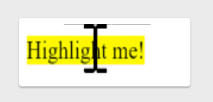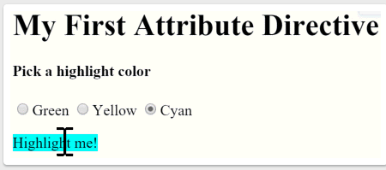

Step1

import { [Directive](https://angular.io/api/core/Directive), [ElementRef](https://angular.io/api/core/ElementRef) } from '@angular/core';

@[Directive](https://angular.io/api/core/Directive)({ selector: '[appHighlight]' })

export class HighlightDirective {

constructor(el: [ElementRef](https://angular.io/api/core/ElementRef)) {

el.nativeElement.style.backgroundColor = 'yellow';

}

};

App.comp.html

<p appHighlight>Highlight me!</p>

Step2

import { Directive, ElementRef, HostListener, Input } from '@angular/core';

@Directive({

  selector: '[appHighlight]'

})

export class HighlightDirective {

  constructor(private el: ElementRef) {

    this.highlight('yellow')

   }

   @Input() defaultColor: string;

  @Input('appHighlight') highlightColor: string;

@HostListener('mouseenter') OnMouseEnter(){

  this.highlight(this.highlightColor = 'red' )

}

@HostListener('mouseleave') OnMouseLeave(){

  this.highlight(null)

}

  private highlight(color: string) {

    this.el.nativeElement.style.backgroundColor = color;

  }

}

Html

<h4>Pick a highlight color</h4>

<p appHighlight="orange">Highlighted in orange</p>

<p [appHighlight]="color">Highlight me!</p>

<p [appHighlight]="color" defaultColor="violet">

  Default Highlight me too!

</p>

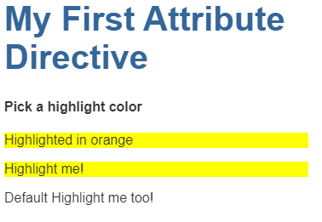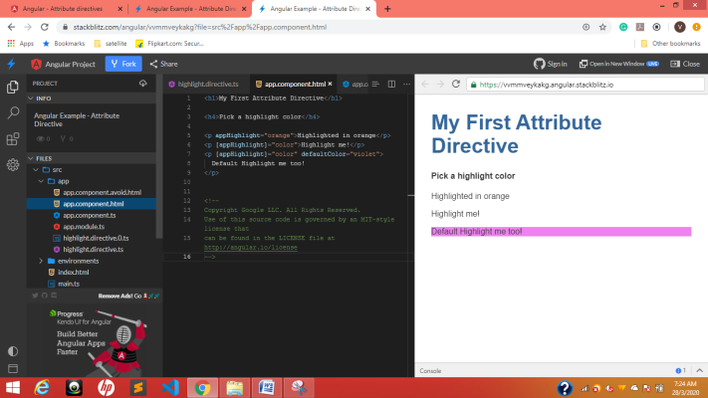

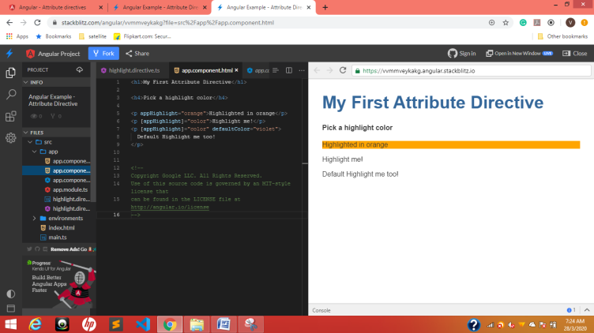

Three different colors

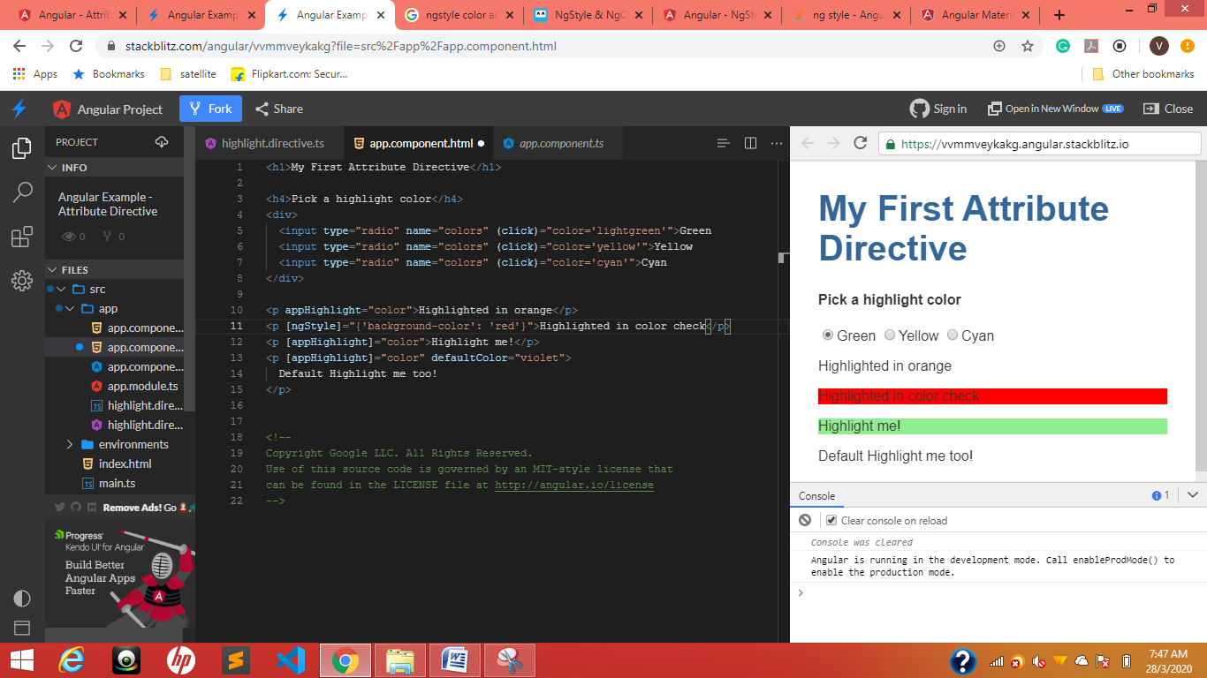

[ngStyle]=”{‘background-color’: ‘red’}”

[ngStyle]=”{‘key’: ‘value’}”

ngStyle is objective

<p appHighlight="color">Highlighted in orange</p>

<p [ngStyle]="{'color':color}">Highlighted in color check</p>

<p [appHighlight]="color">Highlight me!</p>

<p [appHighlight]="color" defaultColor="violet">

  Default Highlight me too!

</p>

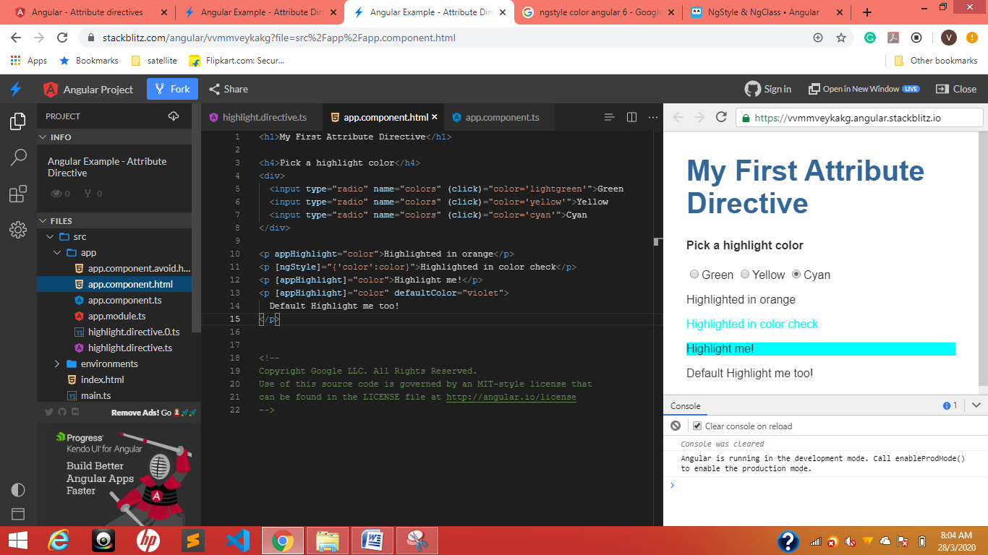

Structural directives

<https://stackblitz.com/angular/ygjxdrnerky?file=src%2Fapp%2Fapp.component.html>

ngIf

*ngIf="true" [style.display]="'block'” [style.display]="’none’”

<p *ngIf="true">

  Expression is true and ngIf is true.

  This paragraph is in the DOM.

</p>

<p *ngIf="false">

  Expression is false and ngIf is false.

  This paragraph is not in the DOM.

</p>

<p [style.display]="'block'">

  Expression sets display to "block".

  This paragraph is visible.

</p>

<p [style.display]="'none'">

  Expression sets display to "none".

  This paragraph is hidden but still in the DOM.

</p>

Toggle

Now conditionally exclude a select <option> with <ng-container>.

## The <ng-template>

The <ng-template> is an Angular element for rendering HTML. It is never displayed directly. In fact, before rendering the view, Angular replaces the <ng-template> and its contents with a comment.

If there is no structural directive and you **merely wrap some elements** in a <ng-template>, those elements disappear. That's the fate of the middle "Hip!" in the phrase "Hip! Hip! Hooray!".

*ngIf="hero"

*ngIf="!hero"

<button (click)="hero = hero ? kiran : heroes[0]">Toggle hero</button>

<span *ngIf='kiran? kiran : hero'>for null check kkkkkkk</span>

Ts.file

kiran:boolean;

if selected only then show in dropdown <ng-container>

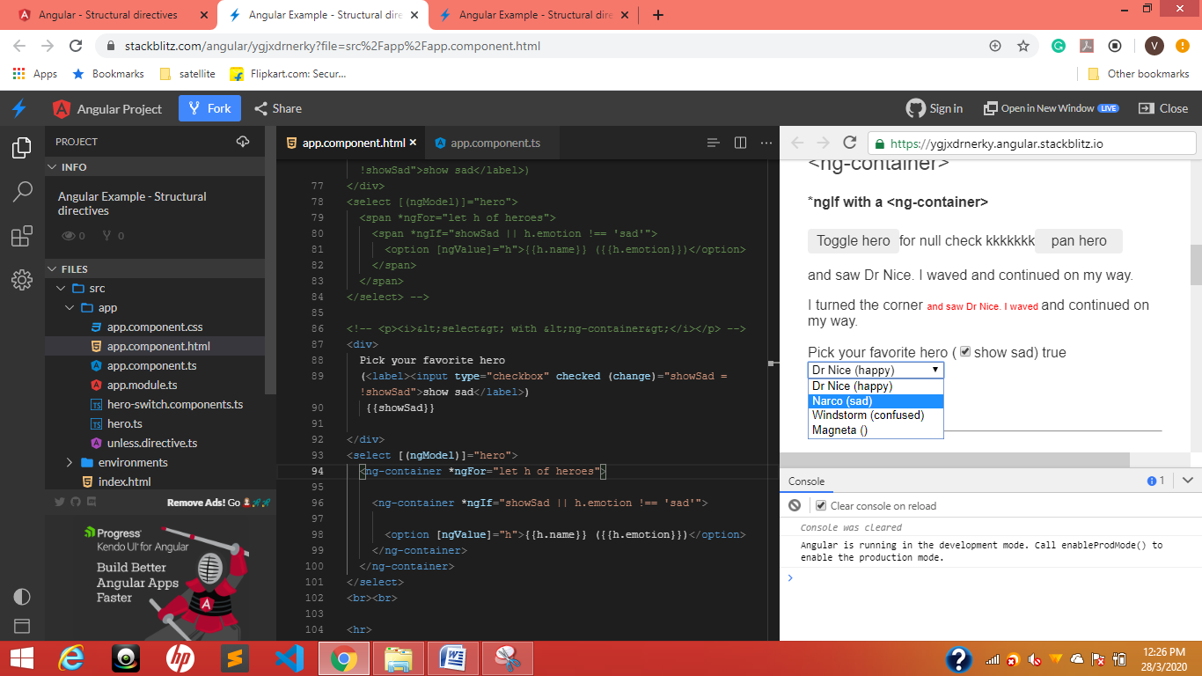

<select [(ngModel)]="hero">

  <ng-container *ngFor="let h of heroes">

    <**ng-container *ngIf="showSad || h.emotion !== 'sad'">**

**<option [ngValue]="h">{{h.name}} ({{h.emotion}})</option>**

**</ng-container>**

  </ng-container>

</select>

*TemplateRef* and *ViewContainerRef*

The *appUnless* property

## UnlessDirective

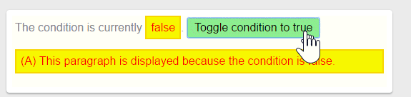

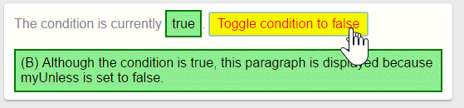

Just toggle *appUnless

<!-- start -->

<button (click)="condition = !condition"  > Toggle condition to

condition ? 'false' : 'true'}} </button>

 <p *appUnless="condition"> (A) This paragraph is displayed because the condition is false. </p>

<p *appUnless="!condition" > (B) Although the condition is true, this paragraph is displayed because appUnless is set to false. </p>

<p *appUnless="condition">Show this sentence unless the condition is true.</p>

<p *appUnless="condition" class="code unless">

  (A) &lt;p *appUnless="condition" class="code unless"&gt;

</p>

<!-- end -->

Html

<h2 id="appUnless">UnlessDirective</h2>

<p> The condition is currently <span [[ngClass](https://angular.io/api/common/NgClass)]="{ 'a': !condition, 'b': condition, 'unless': true }">{{condition}}</span>.

<button (click)="**condition = !condition**" [[ngClass](https://angular.io/api/common/NgClass)] = "{ 'a': condition, 'b': !condition }" > Toggle condition to

**condition ? 'false' : 'true'**}} </button> </p>

<p *appUnless="condition" class="unless a"> (A) This paragraph is displayed because the condition is false. </p>

<p *appUnless="!condition" class="unless b"> (B) Although the condition is true, this paragraph is displayed because appUnless is set to false. </p>

ngFor odd even text highlet

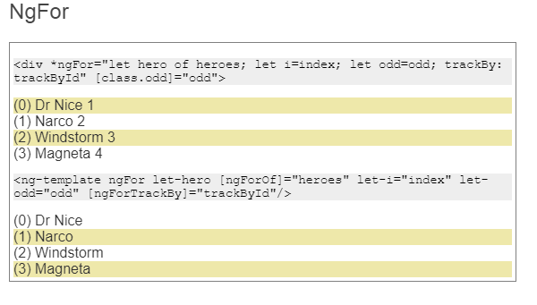

[**class.odd]="even">**

**[class.odd]="odd"**

<p class="code">&lt;div *ngFor="let hero of heroes; let i=index; let odd=odd; trackBy: trackById" [class.odd]="odd"&gt;</p>

<div

*ngFor="let hero of heroes;

let i=index;

let odd=odd;

let even=even;

trackBy: trackById"

[class.odd]="even">

({{i}}) {{hero.name}} {{hero.id}}

</div>

<p class="code">&lt;ng-template ngFor let-hero [ngForOf]="heroes" let-i="index" let-odd="odd" [ngForTrackBy]="trackById"/&gt;</p>

<ng-template ngFor let-hero [ngForOf]="heroes" let-i="index" let-odd="odd" [ngForTrackBy]="trackById">

  <div [class.odd]="odd">({{i}}) {{hero.name}}</div>

</ng-template>

## NgSwitch

Many components in component.ts file

import { Component, Input } from '@angular/core';

import { Hero } from './hero';

@Component({

  selector: 'app-happy-hero',

  template: `Wow. You like {{hero.name}}. What a happy hero ... just like you.`

})

export class HappyHeroComponent {

  @Input() hero: Hero;

}

@Component({

  selector: 'app-sad-hero',

  template: `You like {{hero.name}}? Such a sad hero. Are you sad too?`

})

export class SadHeroComponent {

  @Input() hero: Hero;

}

@Component({

  selector: 'app-confused-hero',

  template: `Are you as confused as {{hero.name}}?`

})

export class ConfusedHeroComponent {

  @Input() hero: Hero;

}

@Component({

  selector: 'app-unknown-hero',

  template: `{{message}}`

})

export class UnknownHeroComponent {

  @Input() hero: Hero;

  get message() {

    return this.hero && this.hero.name ?

      `${this.hero.name} is strange and mysterious.` :

      'Are you feeling indecisive?';

  }

}

export const heroSwitchComponents =

  [ HappyHeroComponent, SadHeroComponent, ConfusedHeroComponent, UnknownHeroComponent ];

/*

Copyright Google LLC. All Rights Reserved.

Use of this source code is governed by an MIT-style license that

can be found in the LICENSE file at http://angular.io/license

*/

<p>

  <label *ngFor="let h of heroes">

    <input type="radio" name="heroes" [(ngModel)]="hero" [value]="h">{{h.name}}

  </label>

  <label><input type="radio" name="heroes" (click)="hero = null">None of the above</label>

</p>

<h4>NgSwitch</h4>

<div [ngSwitch]="hero?.emotion">

  <app-happy-hero    *ngSwitchCase="'happy'"    [hero]="hero"></app-happy-hero>

  <app-sad-hero      *ngSwitchCase="'sad'"      [hero]="hero"></app-sad-hero>

  <app-confused-hero *ngSwitchCase="'confused'" [hero]="hero"></app-confused-hero>

  <app-unknown-hero  *ngSwitchDefault           [hero]="hero"></app-unknown-hero>

</div>

**Pipes**

## Power Booster

2^10=1024

 <p>Super power boost: {{2 | exponentialStrength: 10}}</p>

<https://stackblitz.com/angular/yordgxmxrgo?file=src%2Fapp%2Fpower-boost-calculator.component.ts>

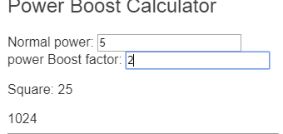

@Component({

  selector: 'app-power-boost-calculator',

  template: `

    <h2>Power Boost Calculator</h2>

    <div>Normal power: <input [(ngModel)]="power"></div>

    <div>Boost factor: <input [(ngModel)]="factor"></div>

    <p>

      Super Hero Power: {{power | exponentialStrength: factor}}

    </p>

  `

})

export class PowerBoostCalculatorComponent {

  power = 5;

  factor = 1;

}

enterValue =Math.pow(2, 10);;

<https://stackblitz.com/angular/yordgxmxrgo?file=src%2Fapp%2Fflying-heroes.component.html>

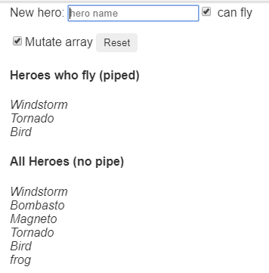

On click of check box entered value should go to respective category

<h2>{{title}}</h2>

<p>

New hero:

  <input type="text" #box

          (keyup.enter)="addHero(box.value); box.value=''"

          placeholder="hero name">

  <input id="can-fly" type="checkbox" [(ngModel)]="canFly"> can fly

</p>

<p>

  <input id="mutate" type="checkbox" **[(ngModel)]="mutate">**Mutate array

  <button (click)="reset()">Reset</button>

</p>

<h4>Heroes who fly (piped)</h4>

<div id="flyers">

  <div *ngFor="let hero of (heroes | flyingHeroes)">

    {{hero.name}}

  </div>

</div>

<h4>All Heroes (no pipe)</h4>

<div id="all">

  <div *ngFor="let hero of heroes">

    {{hero.name}}

  </div>

</div>

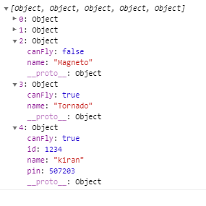

ID, pin of key and values added dynamically

import { Component }              from '@angular/core';

import { HEROES }                 from './heroes';

@Component({

  selector: 'app-flying-heroes',

  templateUrl: './flying-heroes.component.html',

  styles: ['#flyers, #all {font-style: italic}']

})

export class FlyingHeroesComponent {

  heroes: any[] = [];

  canFly = true;

  mutate = true;

  title = 'Flying Heroes (pure pipe)';

  constructor() { this.reset(); }

  addHero(name: string) {

    name = name.trim();

    if (!name) { return; }

    let hero = {name, canFly: this.canFly,  id:1234, pin:507203};

    if (this.mutate) {

    // Pure pipe won't update display because heroes array reference is unchanged

    // Impure pipe will display

    this.heroes.push(hero);

    } else {

      // Pipe updates display because heroes array is a new object

      // this.heroes.push(hero);

      this.heroes = this.heroes.concat(hero);

    }

  }

  reset() { this.heroes = HEROES.slice(); }

}

## Async Hero Message and AsyncPipe

Send message with async pipe



import { Component } from '@angular/core';

import { Observable, interval } from 'rxjs';

import { map, take } from 'rxjs/operators';

@Component({

  selector: 'app-hero-message',

  template: `

    <h2>Async Hero Message and AsyncPipe</h2>

    <p>Message: {{ message$ | async }}</p>

    <button (click)="resend()">Resend</button>`,

})

export class HeroAsyncMessageComponent {

  message$: Observable<string>;

  private messages = [

    '1You are my hero!',

    '2You are the best hero!',

    '3Will you be my hero?'

  ];

  constructor() { this.resend(); }

  resend() {

    this.message$ = interval(1000).pipe(

      map(i => this.messages[i]),

      take(this.messages.length)

    );

  }

}

How to convert data type into json format

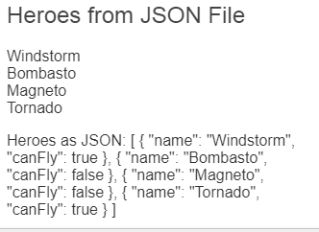

import { Component } from '@angular/core';

@Component({

  selector: 'app-hero-list',

  template: `

    <h2>Heroes from JSON File</h2>

    <div *ngFor="let hero of ('assets/heroes.json' | fetch) ">

      {{hero.name}}

    </div>

    <p>Heroes as JSON:

      {{'assets/heroes.json' | fetch | json}}

    </p>`

})

export class HeroListComponent { }