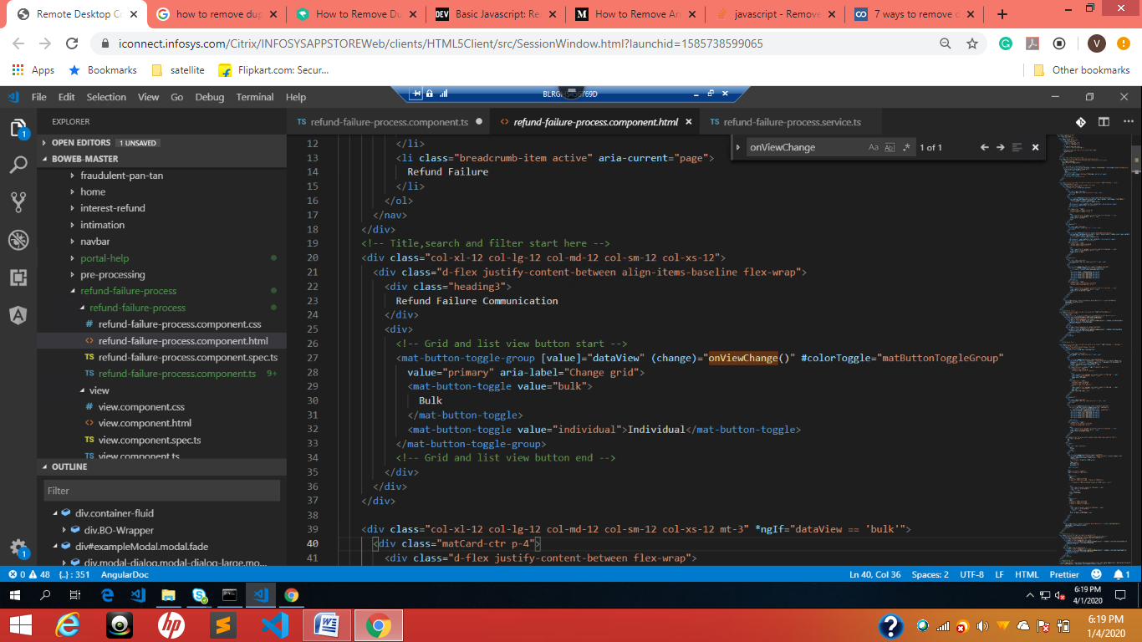

This.dataView=this.dataView === ‘bulk’? ‘individula’ : ‘bulk’