Rule builder

Create Rule:

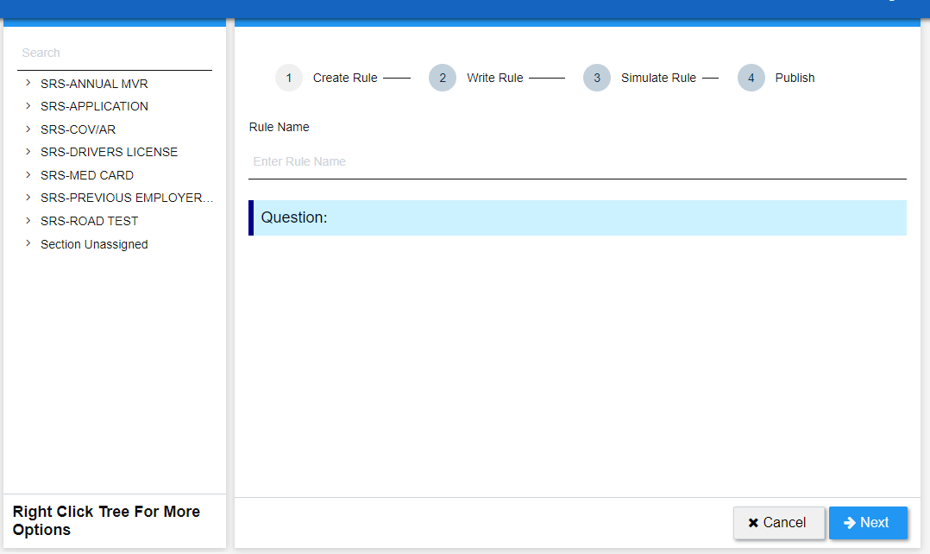
- This page is use for rules creation
Field | Type | Value | Description
Rule Name | Textbox

Action | Description
Cancel
Next | It will take to the next tab, Write rule

Write Rule:
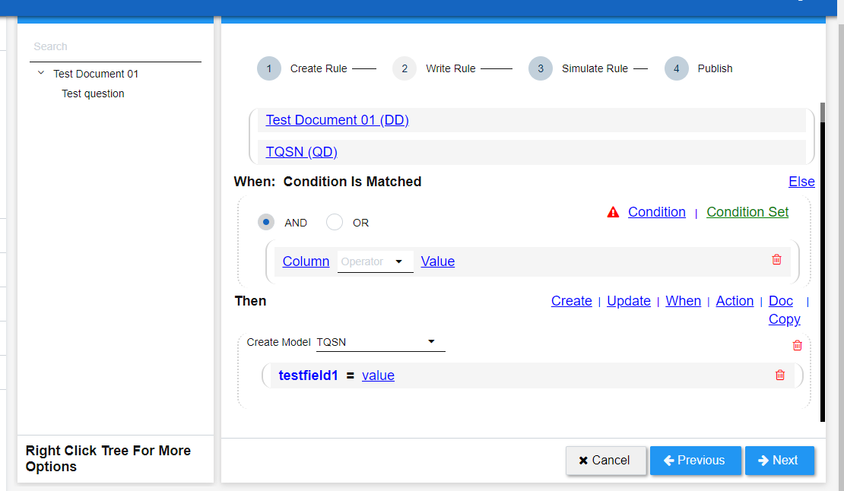

Fields | Type | Value | Description
And/or | Radio |  | Choose the condition as per requirement

Action | Description
Cancel
Next | It will take to the next tab Write rule
Previous | From this button we can go previous tab which is create rule

- Already given Rule document.
- In When Tab we have to put the condition and also select AND/OR
- Then we have a Then tab in which we have to put some actions, then click one next tab.

Simulate Rule:

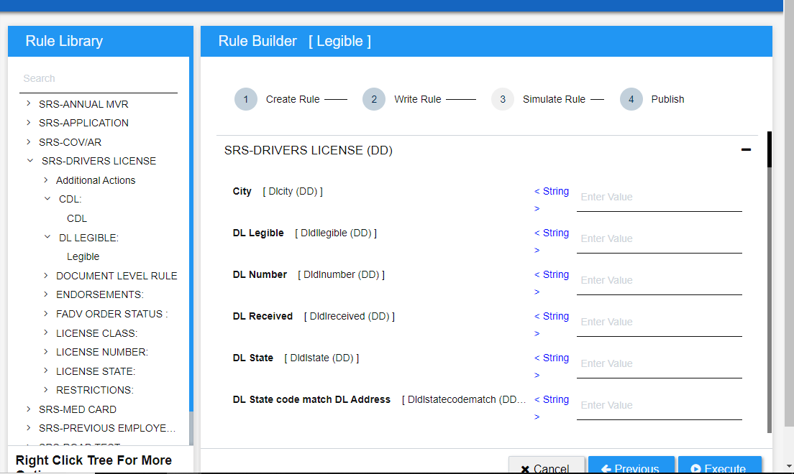
- In this Tab we have to put the values so that it can perform any task
- then click Execute, there also we will get to many actions like cancel, previous

Publish:

- Now In this tab we will get the output
- After output we can also see the documents and then click on save to save this document in library.

