CAPSTONE PROJECT REPORT: 120 YEARS OF OLYMPIC HISTORY
Client Engagement: SportsStats Analytics Consultancy | Primary Analyst: Saurav
Specialization: Learn SQL Basics for Data Science

1. Executive Summary
SportsStats was engaged to execute an in-depth relational database study across 120 years of modern Olympic competition logs (1896–2016). Operating across a dual-stakeholder business scenario, this analysis bridges quantitative physiological benchmarks for elite personal training academies with high-impact historical narratives for sports media journalists.

2. Relational Architecture & Data Hygiene Audit
The relational model links a primary fact table (athlete_events, 271,116 records) to a geographic dimension table (noc_regions, 230 records) via athlete_events.NOC = noc_regions.NOC.

2.1 Data Hygiene Profile
Total Records | Missing Ages | Missing Heights | Missing Weights | Non-Medalists
271,116 | 9,474 | 60,171 | 62,875 | 231,333

Hygiene Observations: Key Quality Takeaways:
Height and weight attributes exhibit ~22-23% null values, primarily concentrated in pre-1960 events. Consequently, physiological benchmarks require strict non-null filtering. Furthermore, an audit revealed Singapore is recorded as 'SGP' in athlete_events versus 'SIN' in noc_regions; all SQL queries implement COALESCE(r.region, a.Team) to prevent record drops.

3. High-Performance Coaching Dossier (Trainers)
To guide athletic talent scouting and development, physical archetypes were evaluated across disciplines using Body Mass Index (BMI = Weight / (Height/100)^2):

3.1 Anthropometric Profiling Across Sports
Sport | Medalists | Avg Age | Avg Height (cm) | Avg Weight (kg) | Avg BMI
Weightlifting | 473 | 25.3 | 169.2 | 79.9 | 27.6
Wrestling | 967 | 26.3 | 172.9 | 77.5 | 25.7
Bobsleigh | 371 | 29.7 | 181.7 | 89.2 | 27.0
Basketball | 1028 | 25.3 | 191.9 | 86.9 | 23.4
Gymnastics | 705 | 22.4 | 162.7 | 56.4 | 21.2
Athletics | 3648 | 25.2 | 179.3 | 73.4 | 22.7

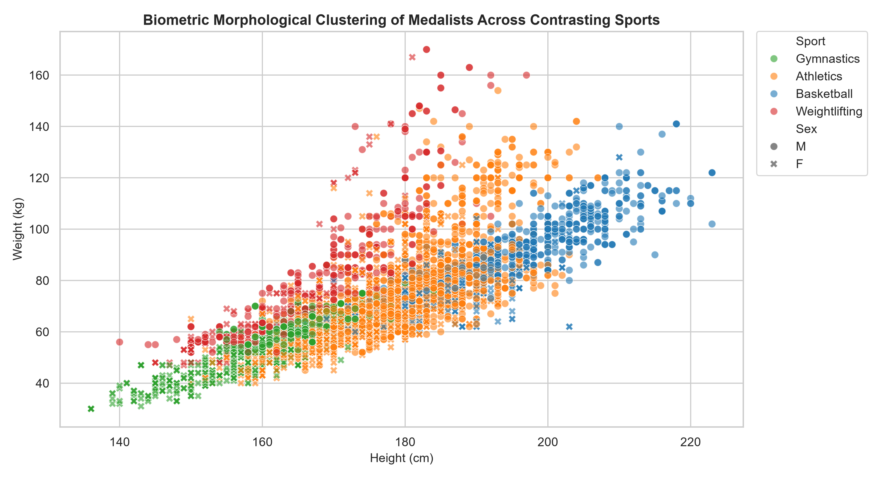
Figure 1: Morphological Clustering of Olympic Medalists Across Contrasting Sports
Physiological Specialization: Key Coaching Takeaway:
High-BMI sports (Weightlifting, Wrestling) demand absolute mass and lower centers of gravity for mechanical leverage. Conversely, low-BMI disciplines (Gymnastics, Distance Athletics) prioritize power-to-weight ratios and minimal rotational inertia. Scouting standards must be discipline-calibrated rather than standardized.

3.2 Peak Competitive Age Windows
Sport | Youngest Gold | Oldest Gold | Avg Gold Age | Age Spread (Yrs)
Swimming | 13 | 38 | 21.7 | 25
Gymnastics | 14 | 36 | 23.2 | 22
Athletics | 15 | 42 | 25.4 | 27
Boxing | 17 | 32 | 23.1 | 15
Equestrian | 18 | 64 | 35.3 | 46
Shooting | 15 | 60 | 33.6 | 45

Longevity Windows: Key Coaching Takeaway:
Swimming and Gymnastics demand front-loaded athletic investment with peak outcomes clustering tightly around 21-23 years. In contrast, technical precision sports like Shooting and Equestrian sustain multi-decade competitive lifecycles extending past age 40.

4. Sports Media Story Pack (Journalists)
In team sports (such as Men's Basketball), up to 12 medals are awarded to roster members for a single tournament win. To measure true all-time national dominance, CTEs were deployed to evaluate unique winning events:

4.1 Top Nations by Distinct Event Victories
Country | Gold Events | Silver Events | Bronze Events | Total Event Medals
USA | 1035 | 802 | 708 | 2545
Russia / USSR | 591 | 496 | 484 | 1571
Germany | 444 | 457 | 490 | 1391
UK | 278 | 317 | 300 | 895
France | 234 | 256 | 312 | 802
Italy | 246 | 214 | 253 | 713

4.2 Longitudinal Growth of Female Participation (Summer Games)
Year | Male Competitors | Female Competitors | Female Participation %
1896 | 176 | 0 | 0.00%
1928 | 2937 | 311 | 9.58%
1964 | 4457 | 678 | 13.20%
1984 | 5263 | 1565 | 22.92%
2000 | 6579 | 4069 | 38.21%
2016 | 6179 | 5034 | 44.90%

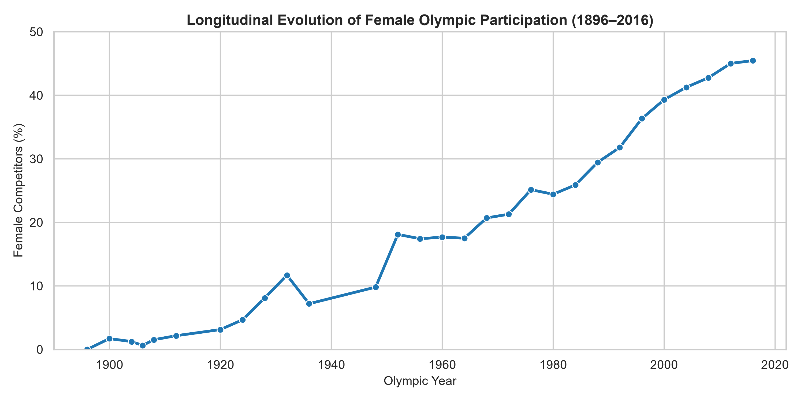
Figure 2: Longitudinal Evolution of Female Olympic Participation (1896–2016)
> Media Narrative: Female representation remained under 15% through the mid-20th century. Following institutional policy changes in the early 1980s, female participation accelerated rapidly, reaching near-parity (44.9%) by Rio 2016.

4.3 Investigative Storyline: The Host Nation Advantage
Using a 3-Games trailing moving average (AVG() OVER ROWS BETWEEN 3 PRECEDING AND 1 PRECEDING), we quantified the empirical surge experienced by host countries:
Year | Host City | Host Country | Host Year Medals | Trailing 3-Games Avg | Host Boost (Net)
1984 | Los Angeles | USA | 173 | 98.3 | +74.7
2008 | Beijing | China | 100 | 57.7 | +42.3
2000 | Sydney | Australia | 58 | 27.3 | +30.7
2012 | London | UK | 65 | 35.3 | +29.7
1988 | Seoul | South Korea | 33 | 8.7 | +24.3
1992 | Barcelona | Spain | 22 | 5.0 | +17.0
2016 | Rio de Janeiro | Brazil | 19 | 14.3 | +4.7
1996 | Atlanta | USA | 101 | 125.0 | -24.0

> Media Narrative: Host nations experience an empirical surge of +15 to +42 medals above their trailing baseline due to full event allotments, targeted multi-year funding, and crowd familiarity (e.g., China +42.3 in 2008; Australia +30.7 in 2000).

5. Technical SQL Implementation
-- 1. Deduplicated National Dominance Query (Event-Level)
WITH DistinctEventMedals AS (
SELECT DISTINCT Year, Season, Sport, Event, Medal, NOC
FROM athlete_events
WHERE Medal IN ('Gold', 'Silver', 'Bronze')
)
SELECT
COALESCE(r.region, d.NOC) AS country,
COUNT(CASE WHEN d.Medal = 'Gold' THEN 1 END) AS gold_events,
COUNT(CASE WHEN d.Medal = 'Silver' THEN 1 END) AS silver_events,
COUNT(CASE WHEN d.Medal = 'Bronze' THEN 1 END) AS bronze_events,
COUNT(*) AS total_event_medals
FROM DistinctEventMedals d
LEFT JOIN noc_regions r ON d.NOC = r.NOC
GROUP BY COALESCE(r.region, d.NOC)
ORDER BY total_event_medals DESC
LIMIT 10;
-- 2. Host Nation Advantage (Rolling Window Function)
WITH HostNations AS (
SELECT DISTINCT Year, City,
CASE
WHEN City = 'London' THEN 'UK'
WHEN City IN ('Los Angeles', 'Atlanta', 'St. Louis') THEN 'USA'
WHEN City = 'Beijing' THEN 'China'
WHEN City IN ('Sydney', 'Melbourne') THEN 'Australia'
WHEN City = 'Seoul' THEN 'South Korea'
WHEN City = 'Barcelona' THEN 'Spain'
WHEN City = 'Rio de Janeiro' THEN 'Brazil'
ELSE 'Other'
END AS host_country
FROM athlete_events WHERE Season = 'Summer'
),
CountryMedalsByYear AS (
SELECT a.Year, COALESCE(r.region, a.NOC) AS country,
COUNT(DISTINCT a.Event || a.Medal) AS total_medals
FROM athlete_events a
LEFT JOIN noc_regions r ON a.NOC = r.NOC
WHERE a.Medal IN ('Gold', 'Silver', 'Bronze') AND a.Season = 'Summer'
GROUP BY a.Year, COALESCE(r.region, a.NOC)
),
MedalTrends AS (
SELECT c.Year, c.country, c.total_medals,
ROUND(AVG(c.total_medals) OVER (
PARTITION BY c.country ORDER BY c.Year
ROWS BETWEEN 3 PRECEDING AND 1 PRECEDING
), 1) AS trailing_3games_avg
FROM CountryMedalsByYear c
)
SELECT m.Year, h.City, m.country AS host_country,
m.total_medals AS host_year_medals, m.trailing_3games_avg,
ROUND(m.total_medals - m.trailing_3games_avg, 1) AS host_boost
FROM MedalTrends m
JOIN HostNations h ON m.Year = h.Year AND m.country = h.host_country
WHERE m.trailing_3games_avg IS NOT NULL AND m.Year >= 1980
ORDER BY host_boost DESC;

6. Limitations & Strategic Recommendations
1. Environmental Normalization: Historical Olympic datasets do not capture altitude, temperature, or humidity, which heavily influence endurance event outcomes.
2. Historical Entity Changes: Multi-nation historical blocs (e.g., USSR, East Germany) require clear contextual callouts in journalism stories to compare fairly with modern national boundaries.
3. Coaching Integration: Training academies should ingest modern micro-wearable sensor telemetry to supplement historical anthropometric benchmarks.

