ID_______________________ Date______________________________

**Examine this graph and answer the following questions.**

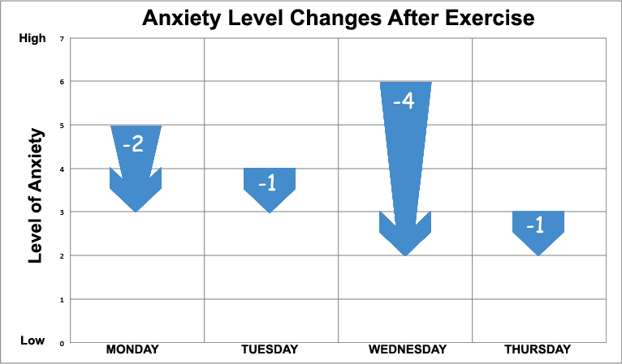

1. This individual’s general level of anxiety is highest on which day?

a. Monday

b. Tuesday

c. Wednesday

d. Thursday

e. I don’t know

2. What happens to this person’s anxiety level AFTER exercise?

a. Nothing, it stays the same

b. It increases

c. It decreases

d. I don’t know

3. Which day did this person’s anxiety level change the most?

a. Monday

b. Tuesday

c. Wednesday

d. Thursday

e. I don’t know

4. How difficult was this graph to understand?

Rating: 1 2 3 4 5 6 7 8 9 10

Not at all difficult Somewhat Very Difficult

**Examine this graph and answer the following questions.**

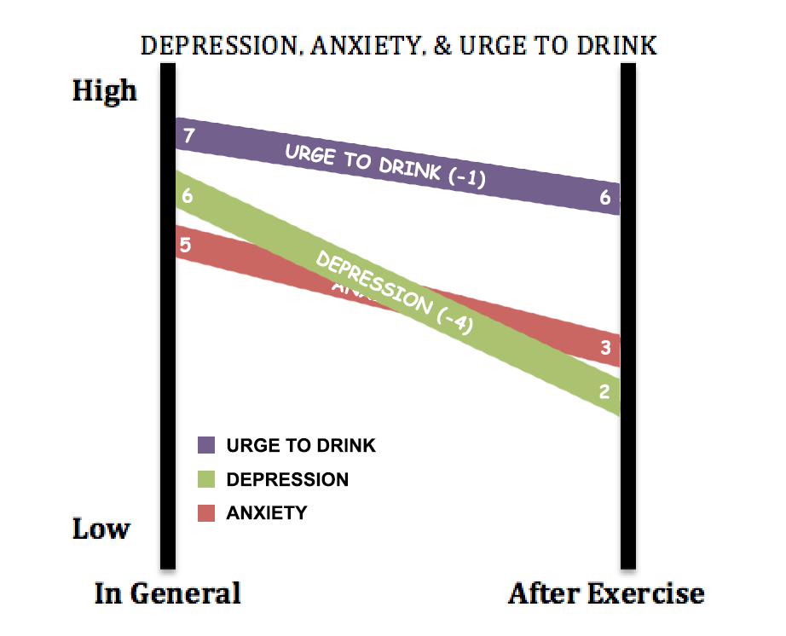

1. Which of the following is highest in general?

a. Depression

b. Anxiety

c. Urge to Drink

d. I don’t know

2. What happens to this person’s anxiety level AFTER exercise?

a. Nothing, it stays the same

b. It increases

c. It decreases

d. I don’t know

3. Which of these factors changed the most AFTER exercise?

a. Depression

b. Anxiety

c. Urge to Drink

d. I don’t know

4. How difficult was this graph to understand?

Rating: 1 2 3 4 5 6 7 8 9 10

Not at all difficult Somewhat Very Difficult